UNIVERSITA’ VITA-SALUTE SAN RAFFAELE

CORSO DI DOTTORATO DI RICERCA
IN SCIENZE COGNITIVE E COMPORTAMENTALI

ELECTROPHYSIOLOGICAL CORRELATES OF COGNITIVE FUNCTIONS IN MULTIPLE SCLEROSIS

Supervisore: Prof. Letizia Leocani
Co-supervisore: Prof. Stefano Cappa

Tesi di DOTTORATO di RICERCA di Marta Tacchini
matr. 021817
Ciclo di dottorato XXXVIII
SSD M-PSI/02

Anno Accademico 2024/2025

UNIVERSITA’ VITA-SALUTE SAN RAFFAELE

CORSO DI DOTTORATO DI RICERCA
IN SCIENZE COGNITIVE E COMPORTAMENTALI

ELECTROPHYSIOLOGICAL CORRELATES OF COGNITIVE FUNCTIONS IN MULTIPLE SCLEROSIS

Supervisore: Prof. Letizia Leocani
Co-supervisore: Prof. Stefano Cappa

Tesi di DOTTORATO di RICERCA di Marta Tacchini
matr. 021817
Ciclo di dottorato XXXVIII
SSD M-PSI/02

Anno Accademico 2024/2025

CONSULTAZIONE TESI DI DOTTORATO DI RICERCA

Il/la sottoscritta Marta Tacchini
Matricola 021817
Nata a Sondrio
Il 03/01/1997

Autore della Tesi di Dottorato di Ricerca dal titolo
Electrophysiological Correlates of Cognitive Functions in Multiple Sclerosis
× AUTORIZZA la Consultazione della Tesi
- NON AUTORIZZA la Consultazione della Tesi per …… mesi a partire dalla data di sottomissione della domanda di conseguimento titolo
Poiché:
  - l’intera ricerca o parti di essa sono potenzialmente soggette a brevettabilità;
  - ci sono parti di Tesi che sono già state sottoposte a un editore o sono in attesa di pubblicazione;
  - la Tesi è finanziata da enti esterni che vantano dei diritti su di esse e sulla loro pubblicazione.

E’ fatto divieto di riprodurre, in tutto o in parte, quanto in essa contenuto

Data 26/11/2025 Firma

DECLARATION
Questa Tesi è stata:
- Redatta da me e non è mai stata utilizzata in alcuna precedente richiesta di laurea. Nel testo si utilizza sia il pronome "io" che "noi" in modo intercambiabile.
- Scritta in conformità alle linee guida editoriali approvate dall'Università.
È stata richiesta e ottenuta l'autorizzazione all'uso di immagini e altro materiale coperto da copyright.
Tutti i risultati qui presentati sono stati ottenuti da me, ad eccezione di:
1) Analisi elettrofisiologiche (Risultati, capitoli 4.4.2, 4.4.3, 4.5, 4.6), eseguiti in collaborazione con la Dott.ssa Chiara Rossi, AIMS lab, Center for Neurosciences, Vrije Universiteit Brussel, Brussels, Belgium.
Tutte le fonti di informazione sono state riconosciute tramite citazioni bibliografiche.
Parte dei risultati presentati sono attualmente in fase di revisione nell’articolo “Event-Related Potentials and behavioural correlates of cognitive functions in MS: an EEG study during Symbol Digit Modalities Test” (Marta Tacchini, Giulia Gamberini, Michelangelo Dini, Chiara Rossi, Angela Boschetti, Letizia Turchi, Mariaemma Rodegher, Luca Chiveri, Jeroen Van Schependom, Guy Nagels, Giancarlo Comi, Letizia Leocani), sottomesso al Multiple Sclerosis Journal.

ABSTRACT
Electrophysiological methods are valuable tools for the detection and monitoring of cognitive impairment in people with Multiple Sclerosis (pwMS) and towards the evaluation of the effectiveness of treatment. The Symbol Digit Modalities Test (SDMT), the gold-standard screening tool for cognitive dysfunction in MS, is often impaired in these patients. Our aim was to investigate the electrophysiological and behavioural correlates of the SDMT as indicators of cognitive impairment in pwMS, and to evaluate their potential to monitor cognitive changes before and after rehabilitation. We developed an EEG-compatible (EEG-SDMT) paradigm. Ninety-two pwMS and twenty-eight healthy controls (HC) underwent event-related potential (ERP), time-frequency, phase-locking value, reaction time (RT), and accuracy measurements during resting-state, oddball and EEG-SDMT tasks. EEG recordings were acquired pre- and post- multidisciplinary rehabilitation treatment. EEG analyses revealed significant alterations in event-related potentials and oscillatory activity in pwMS compared to healthy controls, particularly within centro-parietal regions. PwMS showed delayed and attenuated ERP components and reduced task-related modulation of alpha and theta power, indicating impaired neural efficiency during cognitive processing. Functional connectivity analyses demonstrated altered fronto-parietal synchronization patterns, especially in cognitively impaired individuals. Importantly, cognitive rehabilitation was associated with increased functional connectivity, suggesting enhanced neural plasticity. Behavioural results were consistent with the electrophysiological findings, with pwMS with cognitive impairment showing slower RTs and higher error rates. Notably, RTs significantly improved following the multidisciplinary rehabilitation program. This study demonstrates that electrophysiological measures derived from the EEG-SDMT paradigm can detect neural alterations associated with cognitive dysfunction in pwMS. While ERP components revealed a general slowing of cognitive processing, they did not distinguish between levels of cognitive impairment nor changes following rehabilitation. In contrast, connectivity analyses and behavioural measures - particularly RTs - were sensitive to both cognitive impairment and post-rehabilitation improvements, highlighting their potential as reliable correlates for the monitoring of cognitive function and treatment efficacy in MS.

INDEX
1. Introduction 4
1.1 Multiple Sclerosis 4
1.1.1 Clinical Phenotypes 5
1.1.2 Incidence 6
1.1.3 Epidemiology and risk factors 7
1.2 Cognitive impairment in Multiple Sclerosis 7
1.3 How to measure cognitive impairment in Multiple Sclerosis 12
1.3.1 Neuropsychological assessment 12
1.3.2 Electrophysiological measures 16
1.3.3 Behavioural measures 21
2. Objectives 22
3. Methodology 23
3.1 Participants 23
3.2 Experimental procedure 23
3.3 Assessments 24
3.3.1 Neuropsychological assessment 24
3.3.2 Disability measures 24
3.3.3 Patient-Reported Outcomes 25
3.4 Cognitive rehabilitation 25
3.5 EEG recordings 26
3.6 EEG tasks 26
3.6.1 Resting-State 26
3.6.2 Visual Oddball 26
3.6.3 EEG-SDMT 27
3.7 EEG analysis 29
3.7.1 Preprocessing 29
3.7.2 Time-Frequency analysis 30
3.7.3 Event-Related Potentials 31
3.7.4 Phase-Locking Values analysis 31
3.8 Statistical analysis 32
4. Results 32
4.1 Demographics 33
4.2 Assessments 34
4.3 Concurrent validity 45
4.4 Time-Frequency analysis 45
4.4.1 Resting-State 45
4.4.2 Visual Oddball 47
4.4.3 EEG-SDMT 49
4.5 Event-Related Potentials 51
4.6 Phase-Locking Values analysis 57
4.7 Behavioural measures 72
4.7.1 EEG-SDMT 72
4.7.2 SRT 72
4.7.3 CogRT 73
4.8 Correlational analysis 76
4.8.1 Time-Frequency analysis 76
4.8.2 Event-Related Potentials 77
5. Discussion 80
5.1 Concurrent validity of the EEG-SDMT 80
5.2 Time-Frequency analysis 81
5.3 Event-Related Potentials 84
5.4 Phase-Locking Values analysis 86
5.5 Behavioural measures 88
6. Conclusions 90
7. Limitations 91
8. Future work 91
References 93

INTRODUCTION
1.1 Multiple Sclerosis
Multiple sclerosis (MS) is an inflammatory demyelinating disease of the central nervous system (CNS) that causes a wide range of neuropathological changes and is the most common cause of chronic neurological disability in early adulthood (Hauser & Oksenberg 2006). The disease is caused by an autoimmune response that corrupts myelin sheaths, ultimately leading to axonal loss and neurodegeneration (Keune et al., 2017) (Figure 1). These pathological alterations can be visualized in vivo using magnetic resonance imaging (MRI), which reveals focal white matter lesions (Figure 2), cortical and subcortical atrophy, and, in some cases, damage to deep gray matter structures, providing critical biomarkers for disease burden and progression (Granziera et al., 2021; Kolb et al., 2022). These lesions result in several deficits such as motor (Yozbatıran et al., 2006), coordination, walking and balance (Burschka et al., 2012; Keune et al., 2015a), autonomic functions (Racosta and Kimpinski, 2016), sensory disturbances (Lucassen et al., 2016), fatigue and depression (Rottoli et al., 2017), and cognition (Chiaravalloti & DeLuca 2008).

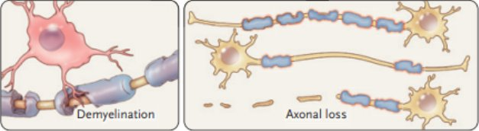Figure 1: Graphical representation of the demyelination process in the central nervous system, that eventually leads to axonal loss. Reproduced with permission from Reich et al. (2018), Copyright Massachusetts Medical Society.

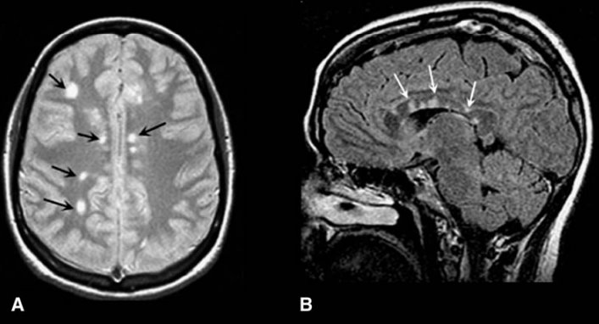Figure 2: Example of white matter lesions. (A) Axial T2-weighted MRI image; (B) Sagittal T2-weighted MRI image. Image from Hauser & Oksenberg (2006). Reproduced with permission from Elsevier.

1.1.1. Clinical Phenotypes
The clinical presentation of MS is highly heterogeneous. Clinically isolated syndrome (CIS) represents a possible initial manifestation of MS. It is defined by a single neurological episode, either a symptom or a clinical sign, lasting at least 24 hours and resulting from a demyelinating process within the CNS. Not all individuals with CIS will subsequently develop MS, as the risk of progression is influenced by several factors, including the specific characteristics of the episode and the presence of cerebral lesions detectable by MRI. In its relapsing-remitting form (RRMS), the disease is characterized by episodes of neurological dysfunction (relapses) that are either fully or partially reversible, typically lasting from several days to a few weeks. Common initial symptoms include optic neuritis, weakness affecting one or more limbs, sensory disturbances, diplopia, or ataxia. After approximately 10 to 20 years, many individuals develop a progressive disease course marked by a continuous and variable accumulation of physical and cognitive disability, known as secondary progressive MS (SPMS). Around 15% of individuals with MS exhibit a progressive disease course from the onset, referred to as primary progressive MS (PPMS). This form is characterized by a steady accumulation of neurological disability without distinct relapses or remissions, reflecting a continuous degenerative process from the very beginning of the disease (Reich et al., 2018). Lastly, the radiological detection of CNS abnormalities suggestive of a demyelinating process, in the absence of clinical symptoms, characterizes radiologically isolated syndrome (RIS). These abnormalities are often discovered when individuals undergo MRI for unrelated reasons, such as headaches, revealing lesions resembling those typically seen in MS. Ongoing research aims to better define and understand these cases, although further data are still needed. Notably, a study published in the June 2020 issue of Annals of Neurology reported that slightly more than half of individuals with RIS go on to develop MS within ten years (Lebrun-Frenay et al., 2020). A representation of the typical clinical course of MS is provided in Figure 3.

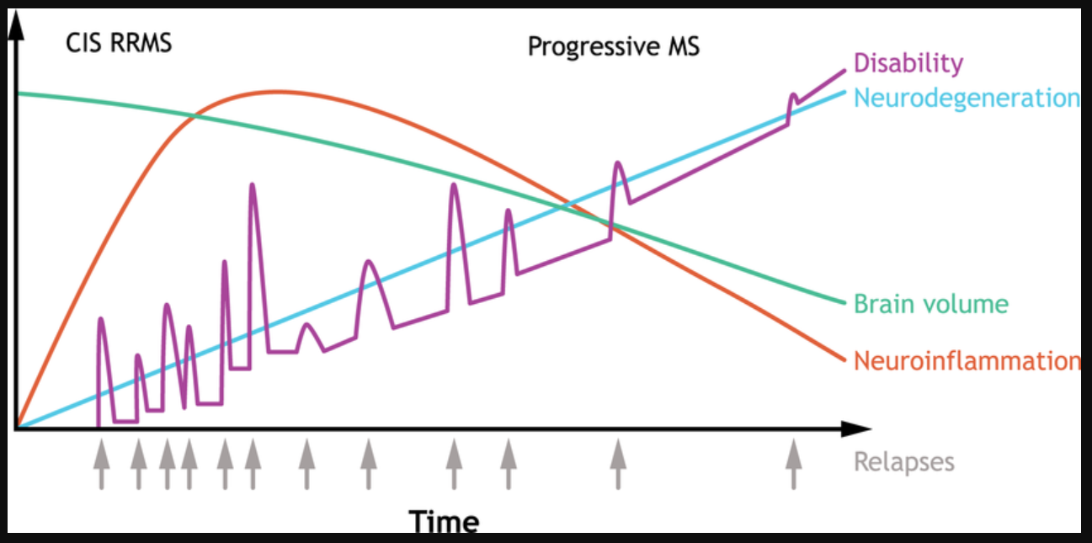Figure 3: Typical clinical course of MS. The disease shows a highly variable clinical progression. The most common form, relapsing-remitting MS (RRMS), begins with a clinically isolated syndrome (CIS) followed by alternating relapses and remissions. Some individuals experience a gradual worsening from onset, known as primary progressive MS (PPMS). Over time, many RRMS cases evolve into secondary progressive MS (SPMS), marked by increasing disability and progressive brain volume loss. Image from Hartung et al. (2023), Frontiers in Immunology (CC BY license).

1.1.2 Incidence
Approximately 2.8 million individuals worldwide are currently living with MS, with women being affected approximately two to three times more often than men, with an average age at diagnosis around 30 years (Walton et al., 2020). Longitudinal investigations have consistently reported an increase in incidence over time, a trend that can be partially attributed to enhanced public awareness, advances in healthcare infrastructure, greater availability of MS specialists and MRI technology, and evolving diagnostic criteria (The Multiple Sclerosis International Federation, Atlas of MS, 3rd Edition, September 2020; Montalban et al., 2025). Concurrently, the clinical trajectory of MS has shifted, with extended latency to disability and improved survival observed in RRMS. These modifications in disease course likely reflect more comprehensive identification of benign MS phenotypes, the implementation of disease-modifying therapies (DMTs), and lifestyle-mediated influences on the natural history of the disorder (Koch-Henriksen & Magyari 2021).
1.1.3 Epidemiology and risk factors
From an epidemiological perspective, genetic predisposition accounts for only a fraction of overall disease susceptibility, with lifestyle and environmental factors playing a central role in modulating risk. Importantly, these nongenetic contributors can influence key pathogenetic pathways, and several of them are potentially modifiable, offering opportunities for prevention strategies (Olsson et al., 2017). Among the most well-established risk factors are Epstein–Barr virus (EBV) infection (Soldan et al., 2023), cigarette smoking (Rosso et al., 2020), low vitamin D levels, and limited sun exposure (Pierrot-Deseilligny & Souberbielle 2017), with adolescent obesity emerging more recently as an additional contributor (Hedström et al., 2014). Other exposures, such as organic solvents and night shift work, have been associated with moderately increased risk (Gerhardsson et al., 2021; Hedström et al., 2015), whereas oral tobacco use, cytomegalovirus infection, and coffee intake appear to confer a protective effect (Wu et al., 2023; Grut et al., 2021; Hedström et al., 2016). The influence of many of these factors is particularly pronounced during critical developmental periods, notably adolescence, emphasizing the importance of temporal windows in disease susceptibility. Notably, certain risk factors - including EBV infection, smoking, and adolescent obesity - interact with human leukocyte antigen (HLA) alleles associated with MS, producing substantially elevated risk in genetically susceptible individuals (Sundqvist et al., 2012; Simon et al., 2010).
1.2 Cognitive impairment in Multiple Sclerosis
Cognitive impairment (CI) is a very common deficit affecting approximately 40%-70% of people with MS (pwMS). It may occur across all stages and subtypes of MS, even in the earliest phases of the disease (Chiaravalloti & DeLuca 2008; Rocca et al., 2015). Recent evidence has also revealed the presence of subtle cognitive deficits in individuals with RIS, showing a pattern similar to that typically observed in people with established RRMS (Amato et al., 2012). In CIS, estimates range from 14% to 57%, although more rigorous diagnostic criteria consistently indicate a prevalence of around 25–30%. Among individuals with RRMS, approximately 30–40% present CI. The proportion is considerably higher in SPMS, affecting 60% or more individuals. In PPMS, prevalence estimates are highly heterogeneous, from 7% to 87%, but recent studies applying stricter criteria suggest that nearly half of these individuals show CI (Amato et al., 2018) (Figure 4).
Language impairments, manifesting as semantic errors and the use of circumlocutory expressions, are less prevalent. More frequently, individuals present with deficits in sustained visual and auditory attention, visuospatial memory disturbances, and a reduction in information processing speed, particularly among patients exhibiting a higher burden of lesions in both white and gray matter, as well as more pronounced atrophy of the cerebral cortex, corpus callosum, basal ganglia, and thalamus. Executive function deficits, which are also commonly observed, are frequently correlated with extensive demyelination within the frontal lobes (Amato et al., 2018) (Figure 5). CI in pwMS has been consistently linked to a lower quality of life and to the adoption of less effective coping strategies. It also interferes with daily functioning, leading to reduced participation in work, social, and leisure activities, and is associated with an increased risk of falls and car accidents. Furthermore, cognitive difficulties may hinder communication with healthcare providers and reduce adherence to treatment, thereby limiting the potential benefits of therapy. (Langdon 2011; Goverover et al., 2008; Benedict et al., 2005). In addition, early CI may have a negative prognostic role, being associated with worse disability outcomes and a more severe disease course (Deloire et al.,2010; Moccia et al., 2016).
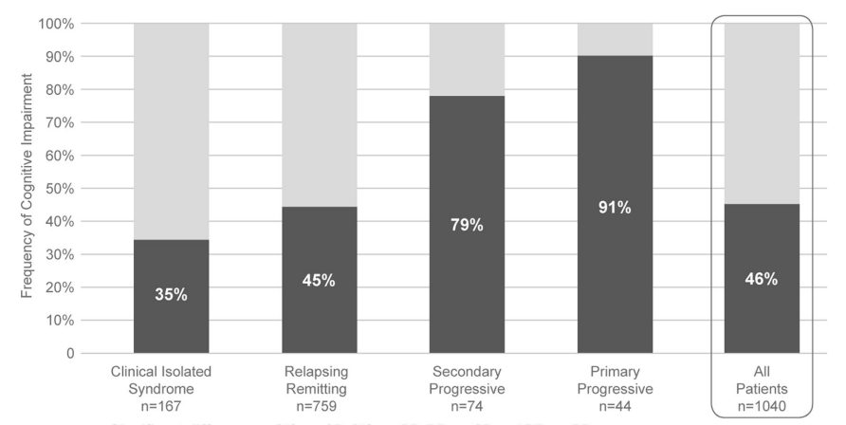
Figure 4: Frequency of CI across Multiple Sclerosis subtypes. Image from Amato et al. (2018). Reproduced with permission from Springer Nature.

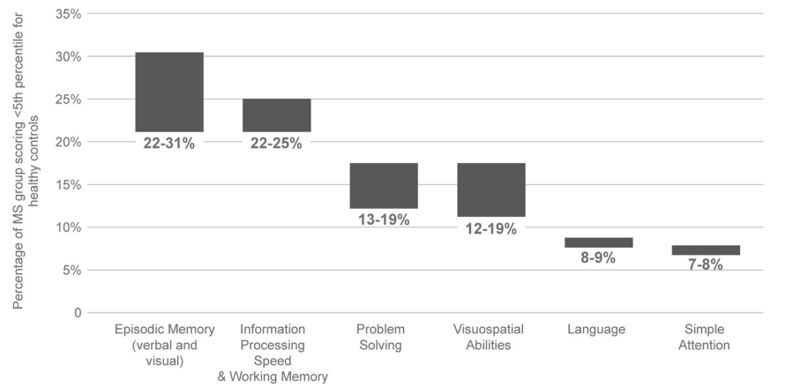Figure 5: Cognitive domains most frequently affected in Multiple Sclerosis. Image from Amato et al. (2018). Reproduced with permission from Springer Nature.

Several studies have demonstrated a significant association between CI in MS and the presence of brain lesions detected by MRI. In particular, T2-hyperintense and T1-hypointense lesions, as well as lesion load in regions such as the corpus callosum and frontal lobes, have been consistently linked to deficits in information processing speed, memory, and executive functioning (Nabizadeh et al., 2024; Lazeron et al., 2005). The spatial distribution of lesions seems to play a critical role, with involvement of white matter tracts connecting cortical and subcortical regions particularly detrimental to cognitive efficiency. However, while lesion burden correlates with cognitive performance, it only partially accounts for the variability observed among patients, suggesting that other factors, including cortical and deep gray matter damage, as well as functional reorganization processes, also contribute to the development and severity of cognitive dysfunction in pwMS (Riccitelli et al., 2011; Pravatà et al., 2017; Engl et al., 2020).
The majority of clinical and MRI investigations on cognition have relied on a binary distinction of cognitive status, categorizing individuals as either cognitively preserved or impaired. This approach has inevitably grouped pwMS with varying cognitive profiles under the single label of CI, limiting the ability to accurately identify underlying neuroanatomical correlates and to develop tailored rehabilitation interventions. Recent studies have sought to overcome these limitations by defining distinct cognitive phenotypes, which may help clinicians better understand the specific cognitive domains affected and make more informed decisions when designing personalized rehabilitation programs. For example, De Meo et al. (2021) identified five distinct cognitive phenotypes in a sample of 1212 pwMS, based on neuropsychological assessment using the Rao Brief Repeatable Battery and the Stroop Color and Word Test. The phenotypes were classified as follows: preserved cognition (19.4%), mild impairment in verbal memory and semantic fluency (29.9%), mild multidomain impairment (19.5%), severe deficits in executive function and attention (13.8%), and severe multidomain impairment (17.5%). They observed that pwMS with progressive forms of the disease were more likely to exhibit severe cognitive phenotypes (Figure 6). In particular, individuals classified with severe executive and attention deficits showed higher mean T2-hyperintense lesion volumes, while those with severe multidomain impairment presented with more extensive overall brain damage.
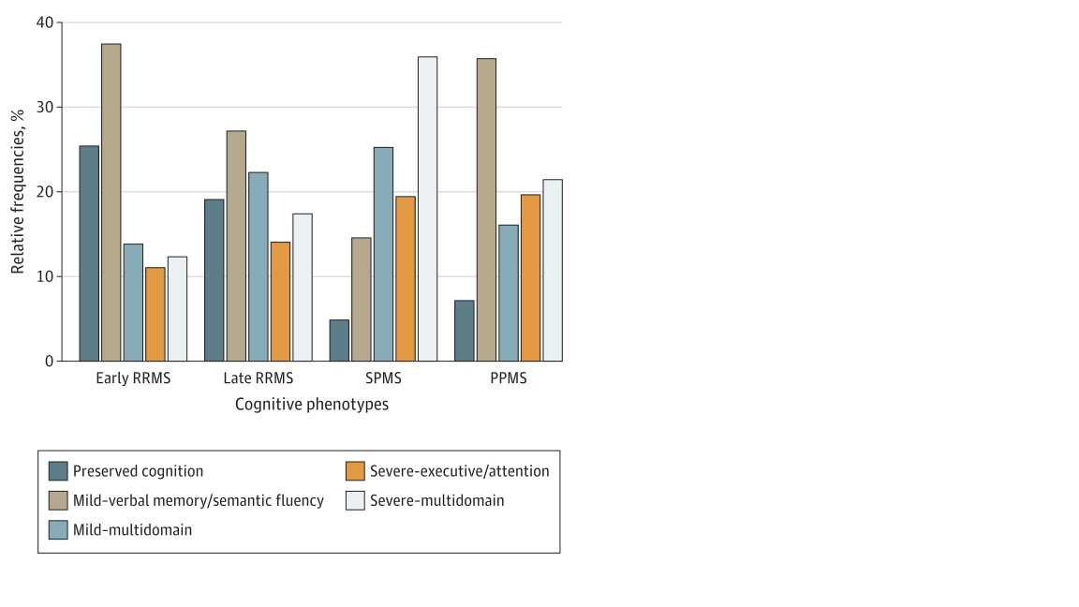
Figure 6: Relative frequencies of cognitive phenotypes across Multiple Sclerosis subtypes. Image from De Meo et al. (2021). Reproduced with permission from American Medical Association.

The management of CI in pwMS may involve strategies aimed at either preventing further decline of existing deficits or enhancing cognitive functions that have already been compromised. However, pharmacological interventions are limited and have shown inconsistent efficacy in treating cognitive symptoms (Amato et al., 2013). Roy and colleagues conducted a comprehensive review of pharmacological treatments for CI in MS, examining measurements, pathophysiology, risk factors, and clinical trials of both DMTs and symptom-management therapies (SMTs). Evidence from well-designed trials is limited. Only intramuscular interferon (IFN)-β1a, administered once a week, has shown significant benefits in information processing speed and memory. Other DMTs, such as IFN-β1b and natalizumab, appear promising but lack robust evidence. The literature on SMTs, including acetylcholinesterase inhibitors and psychostimulants, is heterogeneous, with mixed results and methodological limitations that prevent firm conclusions. Overall, while DMTs may confer some cognitive benefit, SMTs may be considered on a case-by-case basis, guided by careful assessment and monitoring of cognitive function (Roy et al., 2016). On the other hand, behavioural approaches have been explored to enhance cognitive abilities, foster the use of compensatory strategies, and increase patients’ awareness of their cognitive difficulties, thereby promoting greater autonomy in daily life. Behaviourally based cognitive interventions offer several advantages: they are non-invasive, free from side effects commonly associated with pharmacological treatments, and can be tailored to individual needs (Boschetti et al., 2024). A Cochrane systematic review examined the impact of neuropsychological rehabilitation in pwMS, focusing on cognitive performance, daily functioning, mood, and quality of life. A total of 20 studies were identified, involving 986 participants. Although the overall level of evidence was rated as low, the majority of individual studies (18 out of 20) reported beneficial effects. Improvements were mainly observed in memory span, working memory, attention, and both immediate and delayed verbal recall, particularly when cognitive training was combined with other rehabilitative strategies. Nonetheless, small sample sizes and methodological limitations across studies weaken the strength of these findings, highlighting the need for larger and more rigorous trials to confirm the efficacy of cognitive rehabilitation in MS (Rosti-Otajärvi & Hämäläinen, 2013).
1.3 How to measure cognitive impairment in Multiple Sclerosis
1.3.1 Neuropsychological assessment
Considering the high prevalence and high impact of CI in pwMS, it is necessary to implement screening tools and comprehensive neuropsychological assessments that need to be administered to all pwMS.
Screening tools
As stated by the recommendations published by a multidisciplinary group of clinicians, researchers and pwMS (Kalb et al., 2018), baseline cognitive screening – preferably with the Symbol Digit Modalities Test (SDMT) (Smith, 1973), or with another validated instrument – should be routinely incorporated into disease monitoring with annual re-assessments. The screening can provide essential information on cognitive functioning from the earliest stages of follow-up.
The SDMT is currently the most widely used screening tool for cognitive dysfunction in MS. It is classically defined as a measure of processing speed, although it measures also lexical access speed, memory, visual search, and attention. It is highly sensitive to cognitive changes and it is considered an effective test for discriminating between pwMS with or without CI (Sandry et al., 2021). This test can be administered orally or manually, and the score is calculated considering the number of correct responses given in 90 seconds. Before starting the test, the neuropsychologist explains the procedure to the participant. The participant is presented with the test sheet (an example is provided in Figure 7), which includes the legend at the top showing each symbol paired with its corresponding number. Below the legend, each box contains a symbol on top and an empty space for the number. The participant is asked to - orally or manually - fill in the correct number for each symbol. Example items are completed together to ensure understanding, with guidance provided if necessary. Once the participant demonstrates comprehension, it is instructed to start from the double line and continue filling in the numbers as quickly as possible, moving row by row. It is encouraged to work accurately but rapidly and may use a finger to help track the symbols until the examiner signals the end of the test.

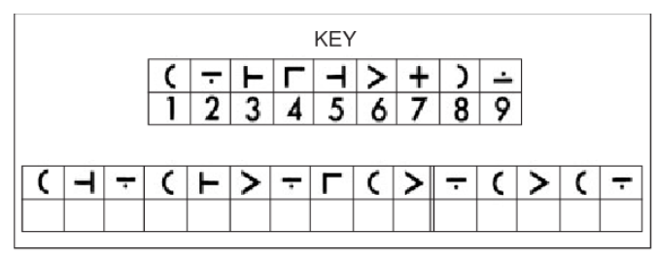
Figure 7: Example of the legend and the first line of the SDMT administration sheet. Image from Nocentini et al (2006).

Digital versions of the SDMT have also been developed. These adaptations have the aim of increasing accessibility for individuals with mobility limitations or those living far from the clinics, ensuring they can complete the test without traveling. Beyond this practical advantage, digital versions of the SDMT provide an effective means for longitudinal assessment, allowing researchers and clinicians to monitor changes in cognitive performance over time in a more comprehensive and flexible way. An example is the electronic SDMT (eSDMT) (Figure 8) that is quick, user-friendly, and demonstrated good-to-excellent validity compared with the oral SDMT performed in clinic (Dini et al., 2025). It can be completed independently at home on a personal computer or laptop, accurately distinguishes pwMS with and without CI, and correlates with global cognitive functioning as measured by the Montreal Cognitive Assessment (MoCA) (Nasreddine et al., 2005).

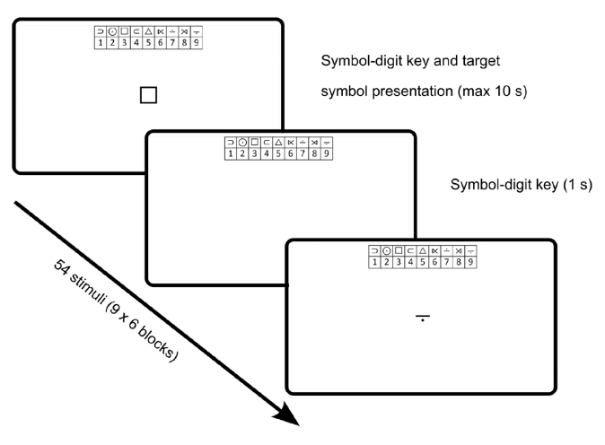
Figure 8: Example of the electronic SDMT. The legend at the top of the screen shows the symbol-digit associations. A target symbol appears in the center of the screen, and participants are required to press the corresponding number on the keyboard. Image from Dini et al. (2025), European Journal of Neurology (CC BY-NC-ND license).

Furthermore, digital versions of the SDMT may be especially useful for participants with severe disability, as motor impairments may otherwise prevent completion or bias performance, leading to an underestimation of true cognitive ability. Chen et al. (2022) developed a brain-computer interface version of the SDMT (BCI-SDMT) that does not require motor or verbal abilities (Figure 9). They demonstrated its feasibility in a sample of stroke patients, showing that participants could understand the instructions, pair numbers with symbols, and send commands using the BCI. Importantly, performance was unaffected by the presence of motor impairments.
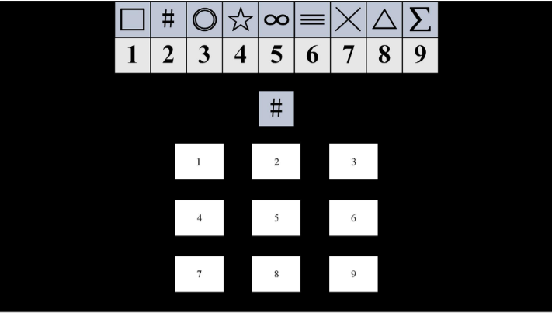Figure 9: Example of the brain computer interface SDMT. The legend at the top of the screen shows the symbol-digit associations. A target symbol appears in the center of the screen, and participants indicate the corresponding number by gazing at it, with each number flashing at a specific frequency. Image from Chen et al. (2022), IEEE Transactions on Neural Systems and Rehabilitation Engineering (CC BY license).

Despite the number of alternative versions developed in recent years, to our knowledge, none have been specifically designed for administration during EEG recordings.
Neuropsychological batteries
A more comprehensive cognitive battery is recommended for individuals who screen positive, as well as for those presenting with subjective complaints of reduced occupational performance, attentional difficulties, or memory problems. Importantly, caregiver-reported concerns may also provide a valuable source of information in this context. The most widely used cognitive batteries validated in the MS population are:
- Brief International Cognitive Assessment for Multiple Sclerosis (BICAMS) (Benedict et al., 2012), it includes the SDMT, the California Verbal Learning Test (CVLT-II) (Delis, 2000), a measure of verbal learning, and the Brief Visuospatial Memory Test (BVMT-R) (Benedict et al., 1996), a measure of visual learning.
- Brief Repeatable Neuropsychological Battery (BRNB) (Rao et al., 1991), composed of the Paced Auditory Serial Addition Test (PASAT) (Gronwall, 1977), SDMT, Selective Reminding Test (SRT) (Buschke, 1973), 10/36 Spatial Recall Test, and Controlled Oral Work Association Test (COWAT).
- Minimal Assessment of Cognitive Function in MS (MACFIMS) (Benedict et al., 2006), including PASAT, SDMT, CVLT-II, BVMT-R, COWAT, Judgment of Line Orientation Test (JLO), and Delis–Kaplan Executive Function System Sorting Test (DKEFS Sorting).
Patient-Reported Outcome Measures
Patient-reported outcome measures (PROMs) are defined as assessments that rely on information provided directly by the patient regarding their health status, without any modification or interpretation by clinicians or external observers. These measures can be administered through self-report questionnaires or structured interviews, provided that the interviewer records the patient’s responses verbatim without influencing or guiding them in any way. PROMs are particularly valuable for evaluating so-called “invisible” symptoms or domains - those that are subjective and perceptible only to the patient - such as fatigue, pain, mood, or cognitive difficulties, which cannot be accurately captured through objective clinical evaluation alone (Brichetto et al., 2020). Examples of PROMs that assess self-reported cognitive difficulties include the Dual-task Impact on Daily-living Activities Questionnaire (DIDA-Q), a measure focused on the motor-cognitive domain. It evaluates individuals perceived challenges in performing dual-task activities in everyday life, where dual tasks usually involve the simultaneous execution of a motor and a cognitive task (Pedullà et al., 2020). Furthermore, the Multiple Sclerosis Neuropsychological Questionnaire (MSNQ) is a screening instrument designed to identify individuals with MS who may be at risk of cognitive dysfunction. It consists of two complementary parts: a self-report version completed by the patient (MSNQ-p) and an informant version (MSNQ-i) completed by a caregiver or close acquaintance (Migliore et al., 2021). In addition, the Modified Fatigue Impact Scale (MFIS) offers a multidimensional evaluation of fatigue, addressing its physical and psychosocial consequences while also incorporating a cognitive subscale that assesses how fatigue interferes with mental efficiency and concentration (Fisk et al., 1994).
1.3.2 Electrophysiological measures
Event-related potentials
Event-related potentials (ERPs) are small changes in the electrical activity of the brain that are recorded from the scalp by means of an electroencephalogram (EEG) (Handy et al., 2005). They are caused by an external or internal sensory, cognitive, or motor event, and appear as a sequence of positive and negative deflections, which are characterized by their polarity and time of occurrence (Woodman 2010). A visual representation is provided in Figure 10. Different ERP components reflect distinct stages of sensory and cognitive processing, with early waves (e.g., P100, N100) indexing perceptual encoding and later ones (e.g., N200, P300) capturing higher-order cognitive processes.

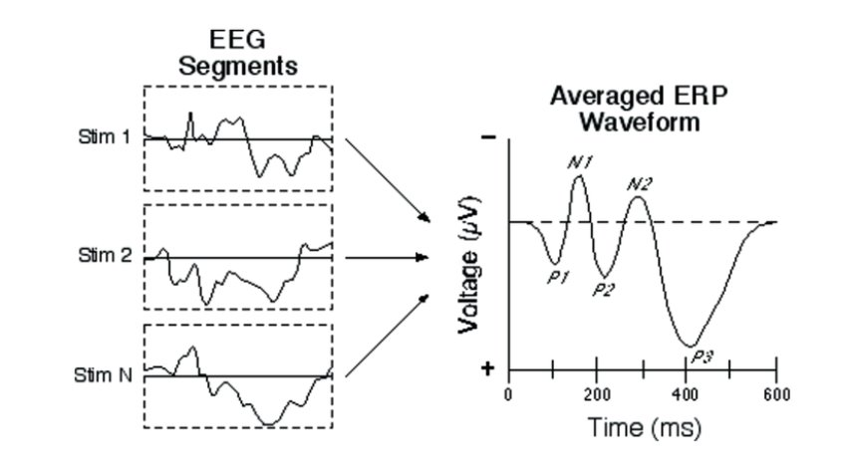
Figure 10: Representation of ERP waveforms elicited in response to a sensory, cognitive or motor event. Early components (P1, N1, and P2) reflect the visual processing of the stimulus, later components (N2 and P3) represent cognitive processes. Image from Léger et al. (2014), Journal of the Association for Information Systems.

ERPs represent a sensitive tool for studying cognitive functions during tasks that engage processing speed, attention, and memory. Specifically, the P300 component has become the most widely investigated, as it can be reliably elicited with simple paradigms such as the oddball task and does not require overt behavioural responses. Its latency is considered a marker of processing speed, while amplitude reductions may signal impaired neural synchronization or reduced cognitive resources (Polich et al., 2000). Specifically, pwMS consistently show prolonged P300 latencies and decreased amplitudes, reflecting disrupted cortical–subcortical communication due to demyelination, thus making this component a promising indicator of cognitive involvement (Magnano et al., 2006). P300 has been shown to be in line with data obtained from neuropsychological tests (Sundgren et al., 2015a; Chinnadurai et al., 2016; Zwecker et al., 2018) and has been correlated with lesions observed on MRI (Piras et al., 2003). Further evidence of the relationship between neurophysiological and neuropsychological data is the significant correlation between PASAT scores and P300 amplitude (Kiiski et al., 2011).
For these reasons, ERPs provide a cost-effective, reliable, and easily administered method for investigating cognitive deficits in individuals with MS (Piras et al., 2003; Leocani et al., 2010). While neuropsychological tests, such as the BICAMS, are relatively quick to administer, their application can be limited in individuals from diverse cultural backgrounds or those with visuomotor impairments. In contrast, ERPs, despite requiring additional time for electrode placement and data acquisition, offer practical advantages in providing an objective and direct measurement of brain activity that does not rely on verbal or motor responses. These advantages include their ability to capture subtle neurophysiological changes that may precede cognitive deficits detectable through standard neuropsychological testing. As a complementary approach, ERPs enable a more holistic evaluation of cognitive functioning in individuals with MS, offering unique insights that can enhance traditional assessments and support clinical decision-making.
Frequency bands
Neural oscillations are rhythmic patterns of electrical activity generated by the coordinated firing of neuronal populations within the CNS. They emerge both spontaneously and in response to external or internal stimuli and represent a fundamental mechanism by which the brain organizes information processing and facilitates communication across distributed neural networks (Buzsáki & Draguhn, 2004).
EEG oscillations are typically divided into distinct frequency bands, each associated with specific cognitive functions and brain states:
- Delta (1–4 Hz): deep sleep and homeostatic processes (Steriade et al., 1993)
- Theta (4–8 Hz): working memory, attention, and relaxed wakefulness (Klimesch, 1999).
- Alpha (8–13 Hz): relaxed alertness, inhibition, and sensory gating (Klimesch, 2012).
- Beta (13–30 Hz): active cognition, attention, and motor control (Engel & Fries, 2010).
- Gamma (>30 Hz): perceptual binding, sensory integration, and higher-order cognition (Fries, 2015).
Overall, EEG frequency band analysis provides valuable insight into the neural mechanisms underlying cognitive and behavioural functions. An overview and visual representation of the frequency bands is provided in Figure 11.
While EEG frequency bands describe the spectral components of neural activity, their functional relevance is often investigated using time-frequency analysis, which allows the examination of how oscillatory power within specific frequency bands dynamically evolves over time, particularly in response to cognitive demands or external stimuli.Recent evidence suggests that alterations in brain oscillatory activity can serve as neurophysiological correlates of cognitive performance and may support diagnostic assessments in neurological disorders (Hardmeier et al., 2012; Van der Meer et al., 2013). For instance, magnetoencephalography (MEG) studies in pwMS have shown a shift in alpha rhythms, characterized by reduced alpha-2 (10-13 Hz) and enhanced alpha-1 power (8-10 Hz), along with a lower alpha peak frequency, which correlates with poorer cognitive performance, particularly slower information processing speed measured by the SDMT (Van der Meer et al., 2013). Similarly, EEG studies have linked increased slow-wave (theta) and decreased fast-wave (beta) power - often expressed as a higher theta/beta ratio, especially in frontal areas to diminished attentional control (Keune et al., 2017). Working memory in pwMS has frequently been examined using the n-back task. In this context, Costers et al. (2020) reported a reduced theta power increase in the right hippocampus, reflecting impairments in stimulus encoding and attentional control. Similarly, Rossi et al. (2024) found that diminished neural activation during the n-back task was linked to lower task accuracy and slower reaction times, further highlighting impaired working memory processing in pwMS.

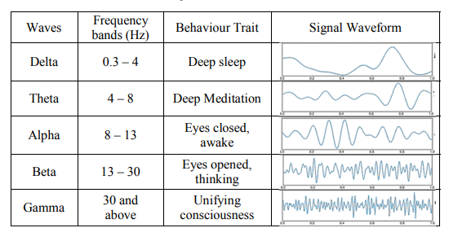
Figure 11: Conventional frequency bands of EEG signals. Image from Oon et al. (2018), ICASSDA. Used with permission from IEEE for thesis purposes.

Connectivity measures
Neurons operate as elements of complex and interconnected networks rather than functioning as independent units. Through continuous excitatory and inhibitory synaptic interactions, these networks generate rhythmic patterns of activation and inhibition (Buzsáki, 2006). Brain regions can display oscillatory activity at multiple frequencies simultaneously, and within synchronized neuronal networks, the phase of these oscillations modulates neuronal excitability. Phase synchronization is a fundamental neural mechanism that supports communication across brain regions, facilitates synaptic plasticity, and underlies a broad range of cognitive functions (Cavanagh et al., 2009). Specifically, research indicates that neural synchronization mechanisms are fundamental to memory, supporting both the temporary maintenance of information in working memory and its consolidation into long-term storage (Fell & Axmacher 2011). An illustration of both synchronized and unsynchronized phase activity is shown in Figure 12.

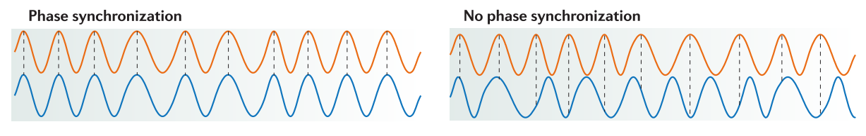

Figure 12: Illustration of neural oscillations with stable phase synchronization (left) and with variable, non-synchronized phases (right). Image from Fell & Axmacher (2011). Reproduced with permission from Springer Nature Limited.

In a recent study conducted by Rossi et al., (2024), pwMS performed a working memory visual-verbal task during MEG recordings. They reported a significant reduction in early theta-band activation within prefrontal networks associated with stimulus encoding and attentional control compared to healthy controls. Furthermore, in another study, Figueroa-Vargas (2020) found that healthy controls exhibited an association between temporo-parietal theta activity and memory load, as well as medial frontal theta activity and successful memory performance. These associations were absent in pwMS, who also failed to exhibit the load-dependent modulation of frontal-to-parietal connectivity observed in controls.
1.3.3 Behavioural measures
Reaction time (RT) is widely used in cognitive psychology as an indicator of processing speed. Evidence shows that both simple and choice RT tasks are sensitive to CI, even when standard neuropsychological tests appear normal (Reicker et al., 2007; Achiron et al., 2007). RT measures demonstrate good reliability and are valuable not only for detecting impairment but also for monitoring recovery over time (Dana et al., 2019). Moreover, the minimal influence of practice effects makes RT tests particularly suitable for repeated assessments. Several computerized tests have been developed and validated in pwMS. Tombaugh and Rees (2008) developed the Computerized Test of Information Processing (CTIP), which includes three computerized tasks of increasing complexity:
1) Simple RT (SRT): a baseline measure of pure processing speed;
2) Choice RT (CRT): requiring selection between two possible stimuli;
3) Semantic RT (SemRT): the most demanding task, involving semantic or lexical decisions before responding.
Furthermore, in a subsequent study, they examined whether the CTIP could identify deficits in processing speed among individuals with MS and compared its sensitivity with that of two variants of the PASAT (the 3.0-second version and the adjusted PASAT). Findings indicate that the CTIP - especially its semantic component - effectively captured the slowing of cognitive processing in pwMS (Tombaugh et al., 2010). Importantly, they accounted for the potential influence of motor impairments on RTs, given that pwMS may experience significant motor difficulties. However, although many studies have used RTs to assess cognitive dysfunction, only one study categorized participants with MS into those with and without CI based on their baseline SDMT z-scores. Specifically, Hsu et al. (2021) administered the Adaptive Cognitive Evaluation (ACE) tablet-based cognitive battery together with the SDMT and PASAT. The ACE included multiple modules designed to assess basic response speed, visual search performance, sustained attention, and visuospatial memory. The findings showed a good association between ACE and SDMT, even after accounting for basic response speed. PwMS with CI displayed slower RTs compared to both pwMS without CI and healthy controls, supporting the potential of the ACE battery as a useful digital tool for evaluating cognitive function in MS. Importantly, this study not only considered basic RTs but also examined the clinical sensitivity of RT measures. Nonetheless, a clearer differentiation between pwMS with and without CI, supported by a comprehensive neuropsychological assessment, is still missing.
OBJECTIVES
The overall objective of the project is to define neurophysiological and behavioural parameters allowing to measure the functional correlates of cognitive function of MS and the effects of neurorehabilitation.
Specifically, our aims are as follows:
- Determine the clinical sensitivity of electrophysiological correlates obtained during the completion of cognitive tasks and compare the accuracy of these measurements.
- To explore the utility of these electrophysiological measures in monitoring and predicting changes associated with cognitive rehabilitation in pwMS.
- Determine the clinical sensitivity of behavioural measures recorded in response to cognitive tasks.
- To explore the use of these behavioural measures as predictors of improvement following cognitive rehabilitation.
METHODOLOGY
3.1 Participants
Participants were recruited between June 2023 and May 2025 from the inpatient's services at the Neurorehabilitation Department of the Casa di Cura Igea in Milan, Italy. Eligibility criteria for pwMS included: (1) age between 18 and 75 years old, (2) diagnosis of MS according to the revised McDonald's criteria (Thompson et al., 2018), (3) no history of major neurological and/or psychiatric disorders (e.g., epilepsy, major depressive disorder, or schizophrenia, as diagnosed by a neurologist or a psychiatrist), and (4) absence of severe visual or motor impairments that could compromise neuropsychological testing (EDSS ≤ 7.5). During hospitalization, participants received a multidisciplinary treatment program - including physiotherapy, occupational therapy, non-invasive brain stimulation, and cognitive rehabilitation - tailored to their individual needs and level of disability. Healthy controls were selected to match pwMS in demographic characteristics and to have no history of neurological or psychiatric disorders. All study procedures followed the principles outlined in the Declaration of Helsinki. Written informed consent was obtained from all participants before their participation in the study, in accordance with the protocols approved by the Institutional Ethics Committee (protocol number: 1162_2022).
3.2 Experimental procedure
Following admission to the clinic, eligible participants were identified and approached in person by the experimenter to explain the study and obtain written informed consent. The experimental procedure is illustrated in Figure 13.
Figure 13: Outline of the experimental procedure completed by pwMS during hospitalization.

3.3 Assessments
3.3.1 Neuropsychological assessment
All participants underwent a neuropsychological evaluation. An experienced neuropsychologist administered the Italian version of the MoCA, a cognitive screening tool for mild CI, and the BICAMS. The BICAMS includes: the oral version of the SDMT, the CVLT-II, measuring verbal learning and memory, and the BVMT-R, measuring visuospatial learning and memory. Lastly, the Stroop Color-Word Test (SCWT) (Stroop, 1935): it is used to measure cognitive control, attention and executive functioning, especially the ability to inhibit automatic responses. For the purposes of the study, pwMS were classified as cognitively impaired if their performance on at least one of these tests fell 1.5 SD below the normative mean, based on published normative data for the Italian population (Goretti et al., 2014). The neuropsychological battery was re-administered at the end of the in-clinic multidisciplinary rehabilitation program, employing alternative test forms when available to minimize practice effects.
3.3.2 Disability measures
Disability was assessed using the Expanded Disability Status Scale (EDSS) (Kurtzke, 1983), a clinical rating scale widely employed in MS research and clinical practice to quantify neurological impairment and disability progression. The EDSS ranges from 0, indicating a normal neurological examination with no disability in any functional system, to 10, corresponding to death due to MS. In the present study, the EDSS evaluation was conducted at two time points: upon admission to the clinic (T0) and again at the conclusion of the multidisciplinary rehabilitation program (T1).
3.3.3 Patient-Reported Outcome Measures
PROMs were collected to assess fatigue, quality of life, mood, and anxiety. These measures were administered at T0 and at T1. Fatigue was evaluated using the MFIS (Strober et al., 2020), and the Fatigue Severity Scale (FSS) (Krupp et al., 1989), two self-report questionnaires measuring the severity of fatigue and its impact on daily functioning. The MFIS includes three subscales - physical, cognitive, and psychosocial - capturing distinct dimensions of fatigue-related impairment. Health-related quality of life was assessed with the shortened version of the Multiple Sclerosis Quality of Life inventory (MSQOL-29) (Rosato et al., 2016), a validated instrument specifically designed for individuals with MS, providing physical and mental health composite scores. Depressive symptoms were measured using the Beck Depression Inventory-II (BDI-II) (Beck et al., 1996), a widely employed 21-item self-report scale. Finally, anxiety was assessed using the State-Trait Anxiety Inventory X-version (STAI-X) (Spielberger, 1983), which differentiates between state anxiety (transient and situation-dependent) and trait anxiety (a more stable predisposition).
3.4 Cognitive rehabilitation
Based on the neuropsychological evaluation, medical history, and PROMs, eligible participants underwent 45-minute cognitive rehabilitation sessions during hospitalization. In line with routine clinical practice, referral to cognitive rehabilitation was primarily based on the presence of a deficit in at least one cognitive domain identified during the neuropsychological assessment. Sessions were conducted individually by a trained neuropsychologist and mainly employed paper-and-pencil materials. Each session included exercises targeting attention, memory, and executive functions, tailored to the patient’s cognitive profile. Tasks were progressively adapted in difficulty to maintain engagement and to stimulate compensatory strategies, while also providing feedback to enhance awareness of cognitive performance. It should be noted that participation in rehabilitation was also influenced by practical and organizational factors of the clinical setting and by patient willingness to engage in treatment. Importantly, for the purposes of this study, the intervention protocol was not modified, in order to preserve the ecological validity of the treatment as routinely delivered in the clinical setting.
3.5 EEG recordings
Participants were asked to sit in a comfortable position in front of a PC screen. Head circumference was measured to ensure the correct positioning of the EEG cap (cap with actiCAP SNAP holders, Brain Vision). Recordings were carried out with a 32-channel EEG system (actiCHamp Plus, Brain Products GmbH, Gilching, Germany), consisting of 29 scalp electrodes organized according to the International 10-20 System. All electrodes were referenced to the linked earlobe channel and offline re-referenced to the opposite earlobe channel. Vertical and horizontal eye movements were recorded through two electrodes situated in the inferior and superior position of the eyes. A sampling rate of 500 Hz was used, and the impedances were kept below 5 kOhms. EEG recordings were performed at both T0 and T1, following cognitive rehabilitation and/or multidisciplinary rehabilitation
3.6 EEG tasks
3.6.1 Resting-State
The procedure involved an 8-minute resting-state recording consisting of two 4-minutes blocks, one with eyes open and one with eyes closed. During the eyes-open condition, participants were instructed to remain relaxed, minimize movements, and direct their gaze toward a fixation cross displayed at the centre of the PC screen, while in the eyes-closed condition they were asked to keep their eyes closed, stay as still as possible, and avoid falling asleep.
3.6.2 Visual Oddball
The visual oddball paradigm consisted of 200 trials in which yellow geometric shapes were presented in random order. Stimuli were displayed for 800 ms, separated by a 1-second inter-stimulus interval. Frequent non-targets (80%) were squares, whereas infrequent targets (20%) were circles. Participants were instructed to mentally count the occurrence of the target stimuli (Kiiski et al., 2011; Kiiski et al., 2018) - the circles - and immediately upon completion of the task, they were asked to report the total number observed.
Figure 14: Example of the visual oddball paradigm.

3.6.3 EEG-SDMT
We developed an EEG-SDMT paradigm suitable for completion during EEG recordings (Figure 15 A). It was delivered through the PC screen displaying a legend with 9 symbols and 9 numbers (1 to 9) at the top. In the centre, a symbol-digit pair was presented for 5 seconds or until a response was given, followed by a 2-second inter-stimulus interval. Stimuli were displayed in white on a fully black background to maximize contrast and readability. Symbol-digit pairs were presented in random order, in two different blocks (90 per block). Participants were instructed to judge, by looking at the legend, if the symbol-digit pair presented was correct or incorrect, and to press the left or right arrow key accordingly. The left/right correspondence was randomly assigned to each participant, with on-screen red and green cues serving as reminders of the response mapping. For everyone, the correspondence used at T0 was reversed at T1 to ensure balanced response conditions across sessions. Instructions were provided both orally by the experimenter and displayed on the screen before the beginning of the training task. The training task featured a shortened version of the EEG-SDMT paradigm (10 symbol-digit pairs), designed to help participants familiarize with the task. Before the EEG-SDMT task, participants performed a simple reaction time task (SRT), which shared the same layout as the EEG-SDMT (Figure 15 B). In this task, they were instructed to press the left or right arrow key as quickly as possible whenever a symbol-digit pair appeared on the screen, regardless of the specific symbol or number presented. Symbol-digit pairs were presented for 2.5 seconds or until a response was given, followed by a 2 ± 1-second inter-stimulus interval (two different blocks, 10 stimuli per block). The SRT served as a baseline reaction task, likely not reliant on higher-order cognitive processes. Key-press RTs (in milliseconds) and number of commission errors were measured for both tasks. Since the key-press RTs measured in the EEG-SDMT paradigm incorporated both motor and cognitive components (complex RTs), the SRT - reflecting the motor component only - was used to isolate the cognitive response time (CogRT). For each participant, CogRT was calculated by subtracting the mean of key-press RTs to the SRT from the mean of those obtained during the EEG-SDMT.
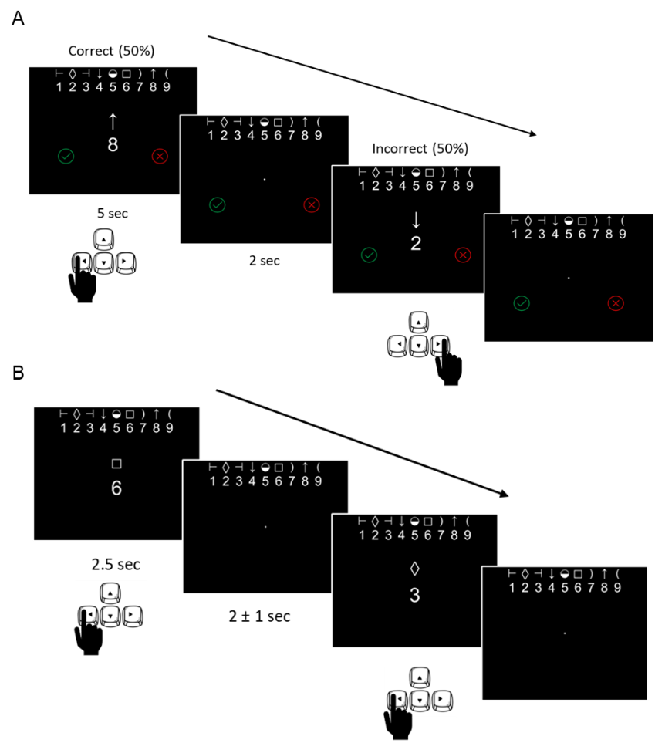Figure 15: (A) Example of the EEG-SDMT; (B) example of the SRT.

3.7 EEG analysis
3.7.1 Preprocessing
Raw EEG signal was preprocessed using Brain Vision Analyzer software (Version 2.2.0, Brain Products GmbH, Gilching, Germany). First, a band-pass filter (0.1 Hz – 40 Hz) was applied, then artifact rejection by visual inspection, and ocular correction were performed (Gratton et al., 1983). Electrooculogram data were only used for artifact rejection in cases of blinks and were not further processed for analysis. Raw EEG-signal preprocessing was the same for all the analysis performed.
3.7.2 Time-Frequency analysis
Time-frequency analysis allows the characterization of neural oscillatory activity in terms of frequency content and its temporal dynamics, providing insight into how brain rhythms evolve over time in response to stimuli or during resting-states. In the present study, time-frequency analysis was conducted on EEG data collected during resting-state (eyes-open and eyes-closed conditions), the visual oddball paradigm, and the EEG-SDMT.
For the resting-state recordings, eyes-open and eyes-closed conditions were analyzed separately using Brain Vision Analyzer. Continuous EEG data were segmented into non-overlapping epochs of 2 seconds. The use of equal-sized, non-overlapping segments is appropriate for stationary signals such as resting-state EEG, as it allows consistent spectral estimation under the assumption of temporal homogeneity. Each segment was transformed into the frequency domain using the Fast Fourier Transform (FFT), and the resulting spectra were averaged across segments for each subject to obtain a stable estimate of the power spectral density. These subject-level spectra were then used to compute power within conventional frequency bands of interest (delta: 1-4 Hz; theta: 4-7 Hz; alpha 8–12 Hz; beta: 13-30 Hz). The gamma frequency band was not included in the present analysis, as scalp EEG is not the most reliable method for assessing high-frequency activity. Gamma oscillations are highly susceptible to contamination from muscle artifacts and other non-neural sources, which can compromise the accuracy and interpretability of the signal (Muthukumaraswamy, 2013).
For the visual oddball and EEG-SDMT recordings, time-frequency decomposition of EEG signals was performed using a continuous wavelet transform (CWT) approach implemented in MATLAB (Version R2022b). For each subject, sensor, and trial, EEG epochs (−200 to 800 ms) were analyzed with a complex Morlet wavelet transform. The frequency range of interest was restricted to 1–30 Hz. For each trial, the complex time–frequency representation was computed, and power was baseline-corrected by subtracting the mean activity in the pre-stimulus interval (−200 to 0 ms) from each frequency bin. Trial-level time–frequency maps were then averaged across trials for each subject and electrode, yielding subject-specific time–frequency representations. Group-level data were subsequently obtained by averaging across participants within each group.
3.7.3 Event-Related Potentials
ERP analysis is a technique used to examine time-locked neural responses to specific sensory, cognitive or motor events. ERPs are derived from the EEG by averaging the electrical brain activity across multiple repetitions of the same type of stimulus, which enhances signal components that are consistently time-locked to the event while minimizing unrelated background activity. ERP waveforms are characterized by a sequence of positive and negative deflections, each associated with specific stages of sensory processing, attention or cognition.
ERP analysis was computed for the visual oddball and EEG-SDMT tasks. EEG traces were segmented into 1-second epochs, time-locked to stimulus presentation (-200 to 800 ms, zero being the onset of the stimuli). The epochs had a corrected baseline starting from 200 ms prior to stimulus onset to the moment of stimulus presentation (from -200 to 0 ms). The averaging procedure of the epochs was performed for each participant using MATLAB. ERP waveforms were obtained from all trials in which the participants gave a correct response. Trials involving errors or missing responses were excluded from the analysis. Electrode selection criteria for ERP measurement were guided by existing literature (Picton, 1992; Johannes et al., 1995; Martinez et al., 2001) and the observed timing and topographic distribution of ERP responses. In particular, centro-parietal sites (e.g., Pz electrode) were considered for cognitive components (e.g., P300), as they best reflected the ERP peak of interest in our dataset, whereas early visual components (P1 and N1) were measured at O1, given the location of the primary visual cortex.
3.7.4 Phase-Locking Values analysis
Functional connectivity between EEG electrodes was assessed using the phase-locking value (PLV), a measure of the consistency of phase differences between pairs of neural signals over time. PLV quantifies the degree of phase synchronization independently of signal amplitude, with values ranging from 0 (no synchronization) to 1 (perfect phase locking).
PLV analysis was performed on EEG data collected during EEG-SDMT task, focusing on the 0-800 ms post-stimulus interval. For each subject, all possible pairs of 29 scalp electrodes were considered, resulting in 406 electrode pairs. EEG signals were filtered in specific frequency bands of interest (delta: 1-4 Hz; theta: 4-7 Hz; alpha 8–12 Hz; beta: 13-30 Hz), and the instantaneous phase of each signal was extracted. For each trial, PLV was computed between each electrode pair, and trial-level values were averaged to obtain a subject-specific PLV matrix. The mean PLV values were computed and compared between pwMS and HCs, and between pwMS with and without CI using non-parametric permutation tests (10,000 iterations per pair). This approach enabled assessment of connectivity differences between groups without distributional assumptions.
3.8 Statistical analysis
Independent samples t-tests were performed to evaluate demographic differences between HCs and pwMS, as well as between pwMS with and without CI. We assessed the assumption of normality using the Shapiro–Wilk test. Behavioural data (i.e., key-press RTs, number of errors) from the EEG-SDMT and SRT tasks, as well as CogRT were analyzed using the Wilcoxon test. Non-parametric tests were chosen because Shapiro-Wilk tests indicated deviations from normality. To control the proportion of false positives in multiple exploratory comparisons, False Discovery Rate (FDR) correction according to the Benjamini-Hochberg procedure was applied, performing pairwise comparisons between groups (HC, pwMS with CI, pwMS without CI). Demographics and behavioural data analyses were carried out in IBM SPSS Statistics (Version 26.0.0.1). Resting-state data were analyzed in Brain Vision Analyzer. Pairwise comparisons were performed using Wilcoxon test to evaluate frequency bands activity differences between HCs and pwMS, as well as between pwMS with and without CI. Time-frequency and ERP data obtained in the visual oddball and EEG-SDMT paradigms were analyzed in MATLAB (Version R2022b). Group differences in time–frequency power, ERP latency, and amplitude were assessed using the Wilcoxon test with FDR correction. Mean PLV group differences were tested using non-parametric permutation tests. Comparisons were performed for each electrode in ERP and time-frequency analyses, and for each electrode pair in PLV analyses. The concurrent validity of the EEG-SDMT and the paper-based SDMT was assessed using Spearman’s rho correlation coefficient. All tests were two-sided, and we set the significance threshold as α = 0.05. Results are reported as mean ± standard deviation (SD) or count (%).
RESULTS
Out of 126 pwMS who met the inclusion criteria, 22 declined participation, and 8 were excluded due to logistical challenges (e.g., short hospitalization or unavailable staff for EEG recordings). Out of the 96 pwMS recruited, 2 voluntarily stopped the EEG recording session (one due to discomfort with EEG gel making contact with their hair, the other for urinary urgency) and 2 could not understand the EEG-SDMT task. Furthermore, 12 pwMS did not perform the EEG recording session at T1: 5 declined participation, 6 were discharged earlier than scheduled, and 1 could not undergo EEG due to a head trauma occurred during hospitalization. On average, patients were hospitalized for 50.29 ± 16.59 days, and the mean interval between the two EEG sessions was 36.44 ± 13.39 days.
4.1 Demographics
Group demographic variables for pwMS and HCs are presented in Table 1. There was no significant age difference between pwMS and HCs, and therefore age was not included as a covariate in the analyses; HCs had more years of education, although this difference was not statistically significant (p = 0.07). When pwMS were divided into cognitively impaired and non-cognitively impaired groups (Table 2), there were no significant differences in age or years of education.

Table 1: Demographic characteristics of the study population.
 | Multiple Sclerosis (n=92) |  | Healthy Controls (n=28) |  | p-value
 | Mean or count(%) | SD | Mean or count(%) | SD | p-value
Age (years) | 53.66 | 9.87 | 50.39 | 12.75 | 0.11
Education (years) | 13.74 | 4.02 | 15.04 | 3.89 | 0.07
Sex (% female) | 59 (64.1%) |  | 20 (71.4%)

Table 2: Demographics and disease characteristics of people with MS, grouped by presence or absence of CI (defined as performance on at least one test falling 1.5 SD below the normative mean).
 | Multiple Sclerosis with CI (n=40) |  |  |  | Multiple Sclerosis without CI (n=52) |  | p-value
 | Mean or count(%) | SD |  | Mean or count(%) |  | SD | p-value
Age (years) | 53.43 |  | 8.89 |  | 53.85 | 10.65 | 0.42
Education (years) | 13.10 |  | 3.80 |  | 14.23 | 4.15 | 0.09
Sex (% female) | 26 (65%) |  |  |  | 33 (63.5%)
MS subtype | SPMS= 29 (72.5%)  PPMS= 7 (17.5%)  RRMS= 1 (2.5%)  MS (n.s)= 3 (7.5%) |  |  |  | SPMS= 35 (67.3%)  PPMS= 14 (26.9%)  RRMS= 0  MS (n.s)= 3 (5.8%)

4.2 Assessments
MoCA, BICAMS, and Stroop test performances were significantly lower in pwMS with CI (all p < 0.001) (Table 3). Since the measured variables were not normally distributed, non-parametric analyses were used. At T1, the overall MS group showed improvement across all tests, with statistically significant gains in the BVMT-R (p < 0.001) and in the Stroop Word (Item: p = 0.015; Time: p = 0.021), Color (Item: p = 0.035; Time: p = 0.015) and Color-Word (Item: p < 0.001; Time: p = 0.004 ) subtests (Table 4).
EDSS scores were significantly higher in pwMS with CI (6.36 ± 0.90) compared to those without CI (5.75 ± 1) (p < 0.01). Across all pwMS, EDSS scores decreased significantly from T0 to T1 (T0: 6.01 ± 1; T1: 5.86 ± 1.03; p = 0.003). Notably, the reduction in EDSS was more pronounced in pwMS with CI (T0: 6.35 ± 0.87; T1: 6.12 ± 0.89; p = 0.002).
PROMs results showed that pwMS with CI had significantly higher scores in the cognitive subscale of MFIS-21 (p = 0.034), BDI-II (p = 0.035) and STAI-X1 (p = 0.046) (Table 5). At T1, the overall MS group showed significant improvements across all administered PROMs (all p < 0.05; Table 6).

Table 3: Neuropsychological assessment of people with MS, grouped by presence or absence of CI (defined as performance on at least one test falling 1.5 SD below the normative mean).
 | Multiple Sclerosis with CI (n=40) |  | Multiple Sclerosis without CI (n=52) |  | p-value
 | Mean | SD | Mean | SD | p-value
MoCA | 24 | 3.97 | 26.85 | 2.34 | < 0.001
SDMT | 31.67 | 10.16 | 50.31 | 12.23 | < 0.001
CVLT-II | 46.26 | 13.70 | 60.54 | 10.82 | < 0.001
BVMT-R | 14.67 | 7.63 | 25.71 | 7.48 | < 0.001
Stroop W-Item | 52.08 | 13.92 | 64.31 | 10.44 | < 0.001
Stroop W-Time | 65.19 | 26.55 | 48.23 | 9.25 | < 0.001
Stroop C-Item | 34.89 | 8.71 | 45.84 | 9.15 | < 0.001
Stroop C-Time | 97.58 | 29.74 | 73.33 | 20.10 | < 0.001
Stroop CW-Item | 17.57 | 6.30 | 26.60 | 11.96 | < 0.001
Stroop CW-Time | 203.33 | 85.70 | 129.64 | 37.15 | < 0.001

Table 4: Neuropsychological assessment of people with MS at T0 and T1.
 | Multiple Sclerosis T0 (n=92) |  | Multiple Sclerosis T1 (n=80) |  | p-value
 | Mean | SD | Mean | SD | p-value
MoCA | 25.63 | 3.43 | 25.67 | 3.04 | 0.842
SDMT | 42.21 | 14.64 | 44.17 | 13.25 | 0.085
CVLT-II | 54.42 | 14.01 | 56.32 | 12.72 | 0.128
BVMT-R | 20.98 | 9.30 | 25.35 | 7.49 | < 0.001
Stroop W-Item | 59.17 | 13.40 | 60.52 | 12.36 | 0.015
Stroop W-Time | 55.36 | 20.29 | 53.10 | 13.59 | 0.021
Stroop C-Item | 41.31 | 10.44 | 43.10 | 10.82 | 0.035
Stroop C-Time | 83.37 | 27.19 | 80.92 | 27.89 | 0.015
Stroop CW-Item | 22.88 | 10.93 | 25.35 | 13.45 | < 0.001
Stroop CW-Time | 160.49 | 71.81 | 150.89 | 83.88 | 0.004

Table 5: Patient-Reported Outcome measures results of people with MS, grouped by presence or absence of CI (defined as performance on at least one test falling 1.5 SD below the normative mean).
 | Multiple Sclerosis with CI (n=40) |  | Multiple Sclerosis without CI (n=52) |  | p-value
 | Mean | SD | Mean | SD | p-value
MFIS-21 | 37.38 | 23.24 | 31.33 | 17.34 | 0.166
MFIS-21 Fisica | 20.08 | 10.76 | 18.94 | 10.50 | 0.620
MFIS-21 Cognitiva | 13.13 | 12.02 | 8.59 | 7.77 | 0.034
MFIS-21 PsicoSociale | 4.16 | 2.73 | 3.78 | 2.32 | 0.486
FSS | 41.86 | 15.81 | 38.55 | 15.60 | 0.330
MSQOL-29 PCS | 42.92 | 8.58 | 43.39 | 8.97 | 0.810
MSQOL-29 MCS | 50.77 | 11.79 | 54.17 | 8.33 | 0.121
BDI-II | 11.84 | 10.53 | 7.78 | 7.19 | 0.035
STAI-X1 | 41.22 | 10.85 | 36.88 | 9.15 | 0.046
STAI X2 | 46.43 | 10.26 | 41.78 | 11.81 | 0.058

Table 6: Patient-Reported Outcome measures result of people with MS at T0 and T1.
 | Multiple Sclerosis T0 (n=92) |  | Multiple Sclerosis T1 (n=80) |  | p-value
 | Mean | SD | Mean | SD | p-value
MFIS-21 | 33.87 | 20.13 | 22.28 | 14.06 | < 0.001
MFIS-21 Fisica | 19.42 | 10.56 | 13.17 | 8.30 | < 0.001
MFIS-21 Cognitiva | 10.50 | 9.98 | 7.02 | 7.87 | < 0.001
MFIS-21 PsicoSociale | 3.94 | 2.49 | 2.46 | 2.29 | < 0.001
FSS | 39.94 | 15.68 | 36.56 | 15.32 | 0.040
MSQOL-29 PCS | 43.20 | 8.76 | 40.20 | 9.51 | 0.048
MSQOL-29 MCS | 52.79 | 9.96 | 55.81 | 8.60 | 0.002
BDI-II | 9.49 | 8.92 | 6.23 | 7.28 | < 0.001
STAI-X1 | 38.70 | 10.07 | 35.84 | 7.40 | 0.005
STAI X2 | 43.74 | 11.36 | 40.32 | 10.27 | < 0.001

Cognitive rehabilitation
Of the 92 pwMS enrolled, 29 underwent rehabilitation, completing on average 9.79 ± 5.75 sessions. This subgroup had a mean age of 53.21 ± 8.25 years and a mean education of 13.52 ± 3.63 years (p = 0.765 and p = 0.721, respectively). The sample included 20 females (69%), with disease types distributed as follows: 21 SPMS (72.4%), 5 PPMS (17.2%), 1 RRMS (3.4%), and 2 cases of undefined MS (7%). Importantly, not all pwMS with CI received cognitive rehabilitation due to time and logistical constraints.
At baseline, pwMS who subsequently underwent the cognitive rehabilitation intervention showed significantly poorer performance across all neuropsychological tests compared with those who did not undergo the intervention (all p < 0.01) (Table 7).
Following the cognitive rehabilitation intervention, pwMS demonstrated significantly improved performance on the SDMT (p = 0.010), BVMT-R (p < 0.001), and two Stroop subtests (Stroop C-Item: p = 0.029; Stroop CW-Item: p = 0.003) (Table 8). PwMS who underwent cognitive rehabilitation improved their SDMT scores by 11.19% compared to baseline, whereas those who did not undergo rehabilitation improved by 2.34%. Furthermore, the disability level significantly decreased at T1 (T0: 6.20 ± 0.98; T1: 5.94 ± 1.01; p = 0.007).
At baseline, PROMs did not differ significantly between pwMS who underwent cognitive rehabilitation and those who did not (Table 9).
Post-intervention PROMs indicated significant improvements in the MFIS-21 total score (p = 0.022), the MFIS-21 physical subscale (p = 0.032), and the MSQOL-29 physical composite (p = 0.008). The reduction in BDI-II scores approached significance (p = 0.050). Although not statistically significant, all other descriptive measures showed improvements in the assessed symptoms (Table 10).

Table 7: Neuropsychological assessment of people with MS grouped by presence or absence of cognitive rehabilitation intervention.
 | Multiple Sclerosis no cognitive rehabilitation (n=63) |  | Multiple Sclerosis cognitive rehabilitation (n=29) |  | p-value
 | Mean | SD | Mean | SD | p-value
MoCA | 26.43 | 2.89 | 23.90 | 3.88 | < 0.001
SDMT | 47.11 | 13.68 | 31.55 | 10.53 | < 0.001
CVLT-II | 58.37 | 12.49 | 45.97 | 13.49 | < 0.001
BVMT-R | 24.23 | 8.30 | 14.03 | 7.40 | < 0.001
Stroop W-Item | 61.72 | 12.67 | 53.41 | 13.46 | 0.009
Stroop W-Time | 52.21 | 19.15 | 62.48 | 21.34 | 0.004
Stroop C-Item | 44.30 | 9.81 | 34.67 | 8.70 | < 0.001
Stroop C-Time | 76.83 | 21.65 | 97.89 | 32.61 | < 0.001
Stroop CW-Item | 25.00 | 11.84 | 18.08 | 6.47 | < 0.001
Stroop CW-Time | 142.69 | 54.67 | 199.37 | 88.91 | < 0.001

Table 8: Neuropsychological assessment of people with MS pre- and post- cognitive rehabilitation intervention (T0, T1).
 | Multiple Sclerosis pre- cognitive rehabilitation T0 (n = 29) |  | Multiple Sclerosis post- cognitive rehabilitation T1 (n = 28) |  | p-value
 | Mean | SD | Mean | SD | p-value
MoCA | 23.90 | 3.88 | 23.86 | 3.18 | 1.000
SDMT | 31.55 | 10.53 | 34.11 | 10.71 | 0.010
CVLT-II | 45.97 | 13.49 | 47.61 | 13.41 | 0.194
BVMT-R | 14.03 | 7.40 | 19.44 | 6.60 | < 0.001
Stroop W-Item | 53.41 | 13.46 | 54.04 | 13.25 | 0.186
Stroop W-Time | 62.48 | 21.34 | 61.04 | 18.17 | 0.102
Stroop C-Item | 34.67 | 8.70 | 38.50 | 11.91 | 0.029
Stroop C-Time | 97.89 | 32.61 | 95.12 | 37.14 | 0.102
Stroop CW-Item | 18.08 | 6.47 | 22.77 | 20.94 | 0.003
Stroop CW-Time | 199.37 | 88.81 | 190.28 | 120.88 | 0.342

Table 9: Patient-Reported Outcome measures result of people with MS grouped by presence of cognitive rehabilitation intervention.
 | Multiple Sclerosis no cognitive rehabilitation (n = 63) |  | Multiple Sclerosis cognitive rehabilitation (n = 29) |  | p-value
 | Mean | SD | Mean | SD | p-value
MFIS-21 | 33.77 | 17.94 | 34.11 | 24.54 | 0.802
MFIS-21 Fisica | 19.98 | 10.29 | 18.21 | 11.22 | 0.516
MFIS-21 Cognitiva | 9.85 | 8.58 | 11.90 | 12.52 | 0.943
MFIS-21 PsicoSociale | 3.92 | 2.26 | 4.00 | 2.97 | 0.821
FSS | 39.48 | 15.03 | 40.93 | 17.24 | 0.653
MSQOL-29 PCS | 43.24 | 8.78 | 43.12 | 8.91 | 0.569
MSQOL-29 MCS | 53.43 | 8.60 | 51.31 | 12.63 | 0.662
BDI-II | 8.90 | 7.41 | 10.69 | 11.46 | 0.965
STAI-X1 | 37.83 | 9.82 | 40.57 | 10.54 | 0.238
STAI X2 | 42.93 | 11.63 | 45.46 | 10.76 | 0.412

Table 10: Patient-Reported Outcome measures result of people with MS pre- and post- cognitive rehabilitation intervention (T0, T1).
 | Multiple Sclerosis pre- cognitive rehabilitation T0 (n = 29) |  | Multiple Sclerosis post- cognitive rehabilitation T1 (n = 28) |  | p-value
 | Mean | SD | Mean | SD | p-value
MFIS-21 | 34.11 | 24.54 | 25.04 | 17.44 | 0.022
MFIS-21 Fisica | 18.21 | 11.22 | 13.29 | 9.47 | 0.032
MFIS-21 Cognitiva | 11.89 | 12.52 | 9.89 | 10.29 | 0.111
MFIS-21 PsicoSociale | 4.00 | 2.97 | 2.96 | 2.78 | 0.061
FSS | 40.93 | 17.24 | 37.89 | 16.79 | 0.341
MSQOL-29 PCS | 43.12 | 8.91 | 38.00 | 9.76 | 0.008
MSQOL-29 MCS | 51.31 | 12.63 | 54.69 | 10.59 | 0.090
BDI-II | 10.69 | 11.46 | 8.48 | 9.97 | 0.050
STAI-X1 | 40.57 | 10.54 | 37.22 | 7.73 | 0.084
STAI X2 | 45.46 | 10.76 | 41.78 | 10.92 | 0.062

4.3 Concurrent validity
Key-press RTs to EEG-SDMT showed a significant negative correlation with paper-based SDMT scores (ρ = -0.756, p < 0.001). Furthermore, the number of errors committed during the completion of the EEG-SDMT also displayed a significant negative correlation with paper-based SDMT scores, albeit of lesser strength (ρ = -0.388, p < 0.001) (Figure 16).
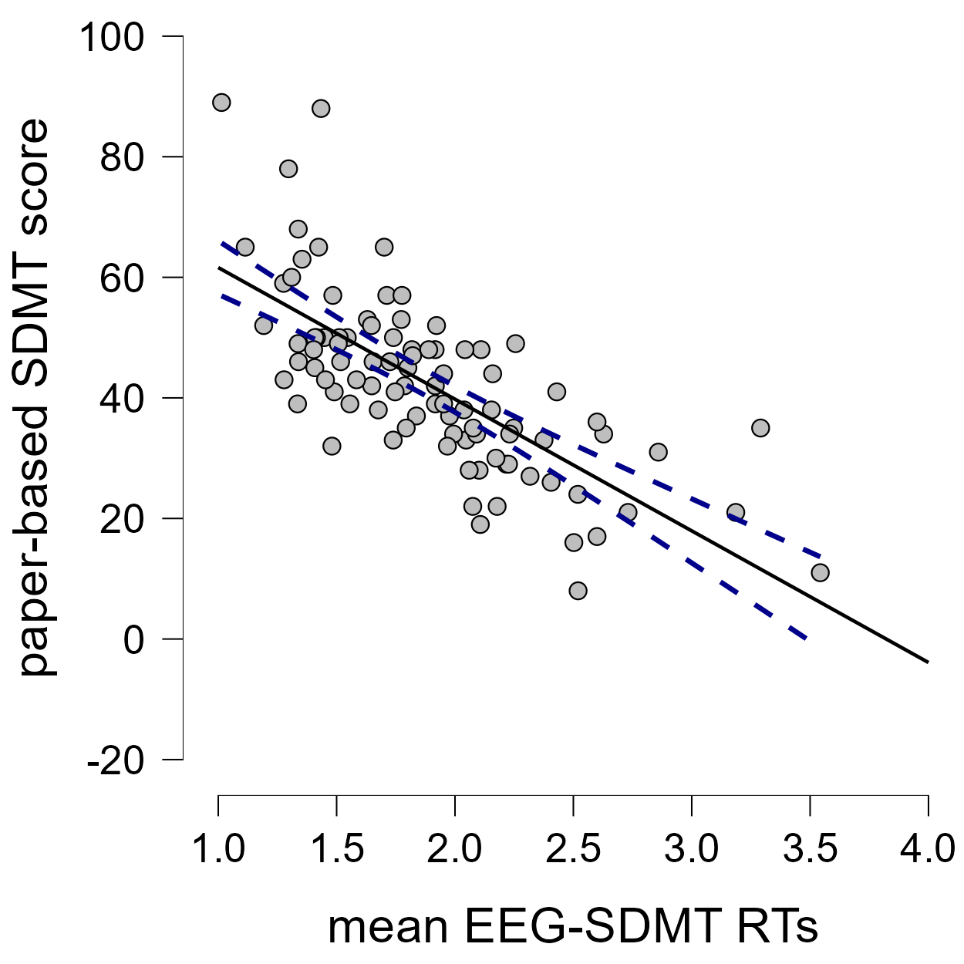
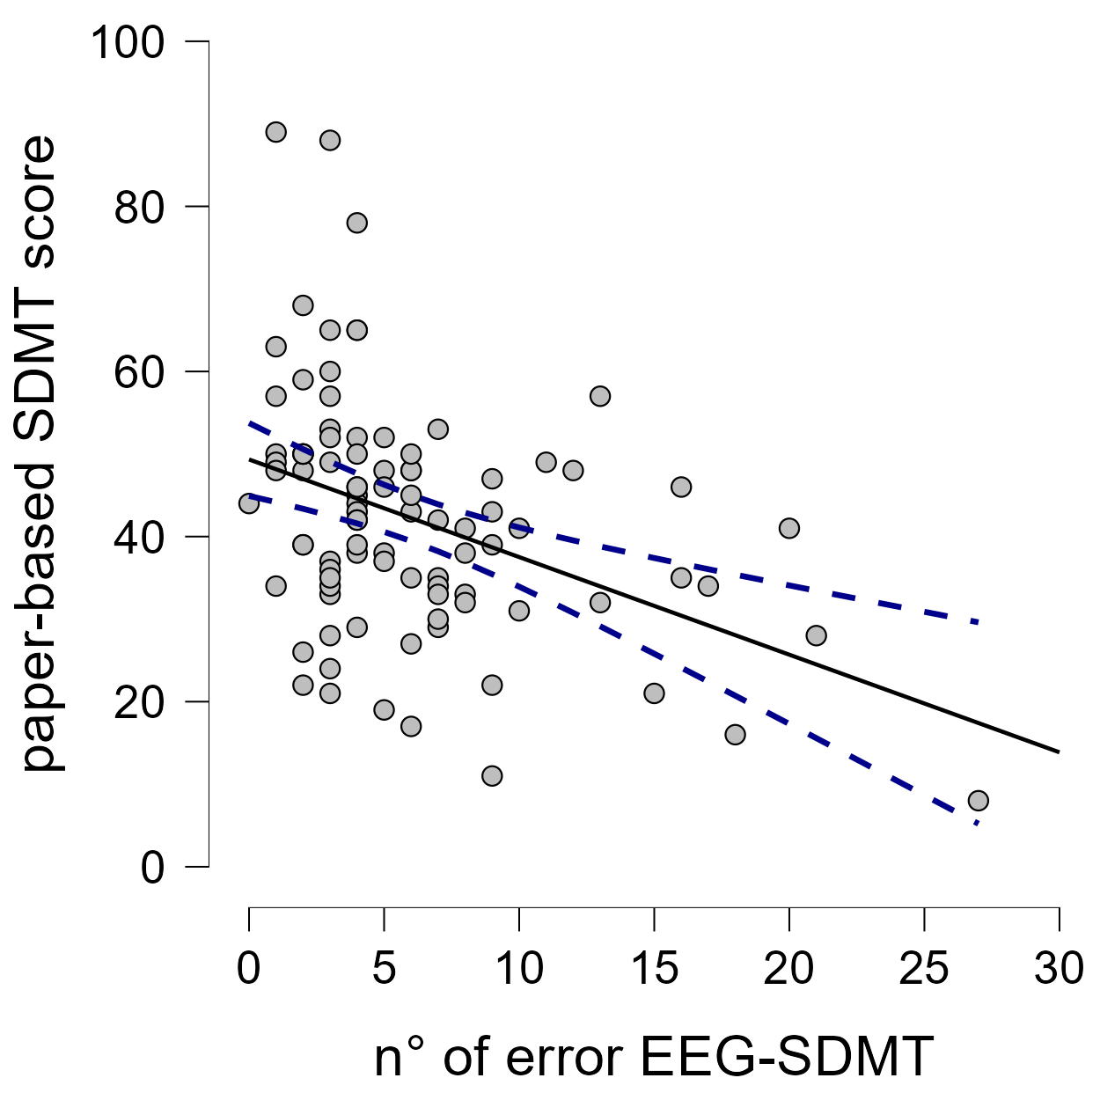
F

Figure 16: Negative correlation between the key-press reaction times to EEG-SDMT (x axis) and paper based SDMT raw scores (y axis) in people with MS (n=92) (left). Negative correlation between the number of errors in the EEG-SDMT (x axis) and paper based SDMT raw scores (y axis) in people with MS (n=92) (right).

4.4 Time-Frequency analysis
4.4.1 Resting-State
PwMS showed significantly higher global alpha activity compared to HC during the eyes-open (EO) condition (p = 0.003) (Figure 17), while no differences were observed during the eyes-closed (EC) condition. A detailed overview of the results can be found in Table 11.

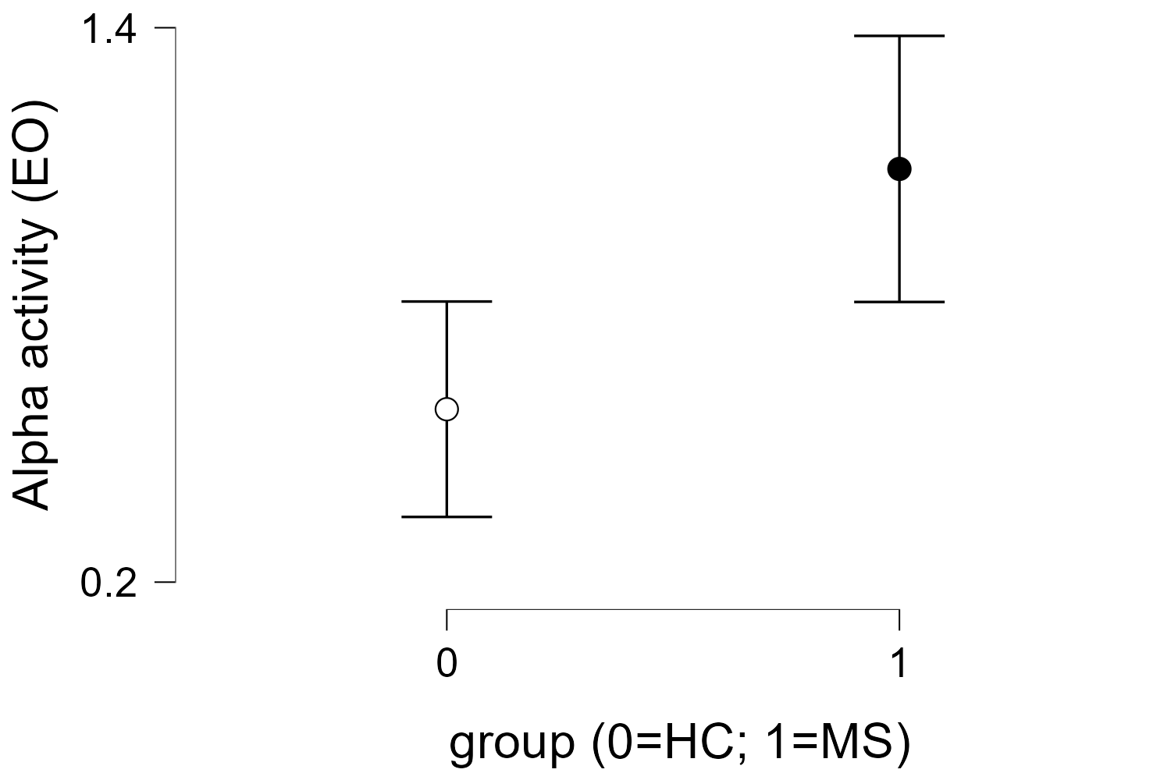
Figure 17: Alpha activity during resting-state with eyes opened in healthy controls and people with MS.
Table 11: Global power during resting-state recordings (eyes-open and eyes-closed conditions) measured in μV².
 | Multiple Sclerosis (n=92) |  | Healthy Controls (n=28)
 | Mean | SD | Mean | SD | p-value
Delta (EO) | 2.43 | 1.65 | 2.63 | 1.92 | 0.884
Delta (EC) | 2.48 | 2.11 | 2.18 | 1.23 | 0.631
Theta (EO) | 0.68 | 0.64 | 0.57 | 0.36 | 0.455
Theta (EC) | 0.78 | 0.72 | 0.58 | 0.26 | 0.322
Alpha (EO) | 1.09 | 1.39 | 0.57 | 0.60 | 0.003
Alpha (EC) | 2.07 | 2.16 | 1.59 | 1.88 | 0.080
Beta (EO) | 0.21 | 0.15 | 0.20 | 0.16 | 0.341
Beta (EC) | 0.23 | 0.17 | 0.25 | 0.19 | 0.322

Additionally, higher delta activity was found both during EO and EC conditions in pwMS with CI (EO: 2.96 ± 1.79 μV²; EC: 2.96 ± 2.70 μV²) compared to pwMS without CI (EO: 2.03 ± 1.42 μV²; EC: 2.12 ± 1.44 μV²) (EO: p < .001; EC: p = 0.027) (Figure 18). No significant differences were found in any of the other frequency bands of interest under either condition.

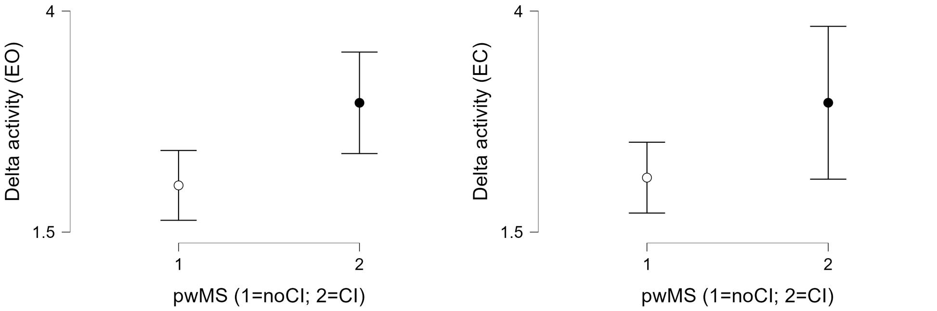
Figure 18: Delta activity during resting-state with eyes opened and eyes closed in people with MS with and without CI.

No significant changes in resting-state global power across the different frequency bands were observed in the MS group at T1 compared to baseline. Similarly, no differences were found in the subgroup that underwent cognitive rehabilitation.
4.4.2 Visual Oddball
An increase in beta-band activity was observed in both the HC and MS groups between 0 and 500 ms following target stimulus onset. This increase did not differ significantly between the groups (Wilcoxon test, FDR-corrected p = n.s.) (Figure 19).
Figure 19: Time–frequency representation of EEG activity during the visual oddball paradigm at electrode Pz. No significant differences between HC and MS are reported.
No statistically significant differences in time–frequency activity were found between pwMS with and without CI (Figure 20).
Figure 20: Time–frequency representation of EEG activity during the visual oddball paradigm at electrode Pz. No significant differences between pwMS with and without CI are reported.
The MS group showed a significantly larger decrease in beta-band activity at T1 compared to T0 throughout the entire analysed time window (p < 0.01) (Figure 21). A similar pattern was observed in the subgroup of pwMS who completed cognitive rehabilitation, with a significant reduction in beta-band activity after treatment (p < 0.01) (Figure 22).
Figure 21: Time–frequency representation of EEG activity during the visual oddball paradigm at electrode Pz. The black contour indicates a statistically significant increase in beta power in the MS group at T1 compared to T0.
Figure 22: Time–frequency representation of EEG activity during the visual oddball paradigm at electrode Pz. The black contour indicates a statistically significant decrease in beta power in the MS group after cognitive rehabilitation treatment.
4.4.3 EEG-SDMT
Compared with HC, pwMS exhibited a reduced alpha-band increase between 200-300 ms (Wilcoxon test, FDR-corrected p < 0.01) and a reduced theta-band increase between 300–600 ms (p < 0.01) following stimulus onset. These differences were observed in centro-parietal regions, as measured at electrode Pz (Figure 23).Figure 23: Time–frequency representation of EEG activity during the SDMT at electrode Pz. The black contour indicates a statistically significant increase in HC compared to MS.
PwMS with and without CI exhibited similar time–frequency activity, with no statistically significant differences between the two groups (Figure 24).
Figure 24: Time–frequency representation of EEG activity during the SDMT at electrode Pz. No significant differences between pwMS with and without CI are reported.
No significant differences were observed in the MS group between baseline and T1, except for a brief time window around 300 ms, where a significant decrease in beta activity was detected at T1 (p < 0.01) (Figure 25).
Figure 25: Time–frequency representation of EEG activity during the SDMT at electrode Pz. The black contour indicates a statistically significant decrease in beta power in the MS group at T1 compared to T0.
No significant differences were observed in pwMS following the cognitive rehabilitation treatment (Figure 26).
Figure 26: Time–frequency representation of EEG activity during the SDMT at electrode Pz. No significant differences between pwMS before and after cognitive rehabilitation treatment.
4.5 Event-Related Potentials
Visual oddball
Grand average ERPs for pwMS and HCs are shown in Figure 27. The P300 component recorded in response to the infrequent stimulus target exhibited a significantly longer latency in pwMS (520.57 ± 99.37 ms) in comparison to HC (447.87 ± 52.51 ms) (Wilcoxon test, FDR corrected p < 0.001). Amplitude was significantly reduced in pwMS (12.47 ± 5.32 μV) vs HC (15.21 ± 4.63 μV) (Wilcoxon test, FDR corrected p < 0.05).

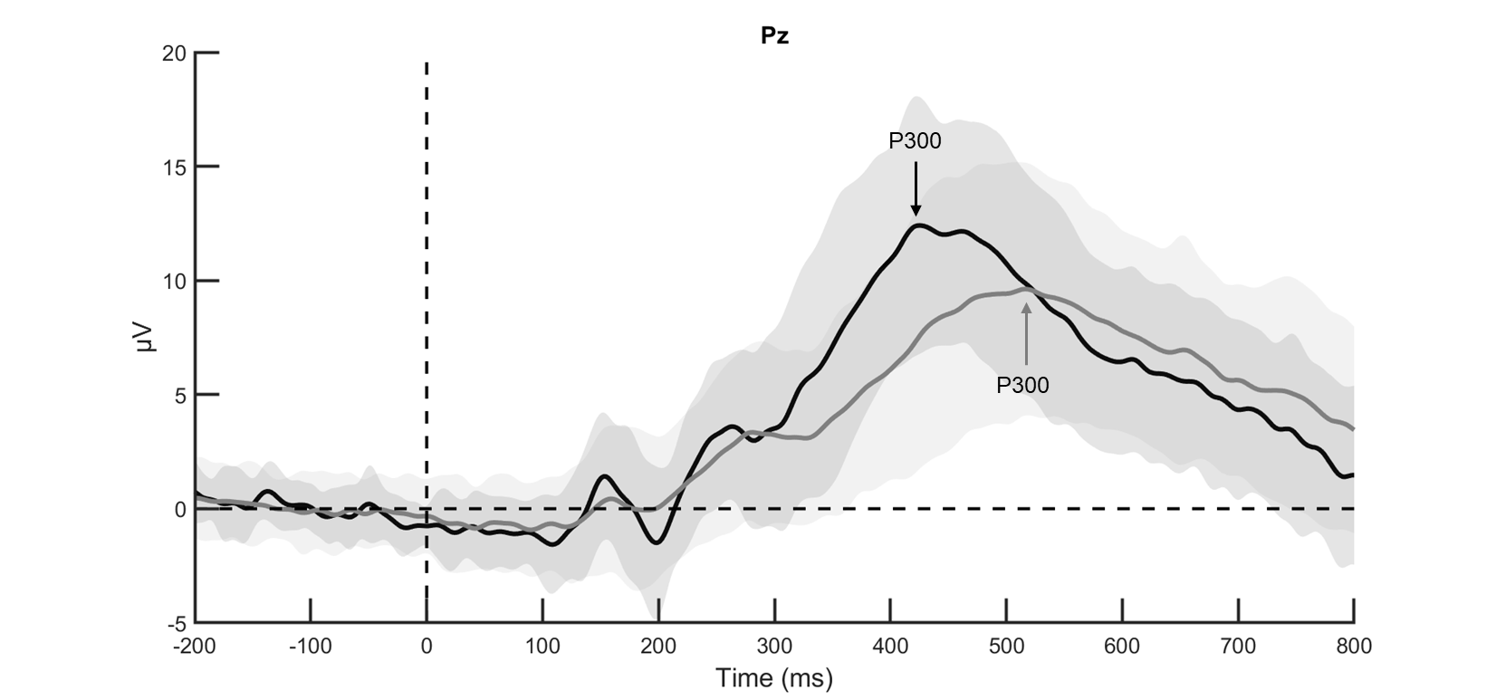Figure 27: Grand average ERPs of healthy controls (in black) and people with MS (in grey). The P300 component to visual oddball paradigm recorded in response to infrequent target onset at electrode Pz. The arrows indicate the average peak latency of each group.

Additionally, P300 latency was significantly longer in pwMS with CI (542.73 ± 100.78 ms) in comparison to pwMS without CI (503.52 ± 95.77 ms) (Wilcoxon test, FDR corrected p < 0.05). Amplitude was lower in pwMS with CI (11.54 ± 5.51 μV) than pwMS without CI (13.18 ± 5.11 μV), although this difference was not statistically significant (Wilcoxon test, FDR corrected p = 0.270). A visual representation is provided in Figure 28.

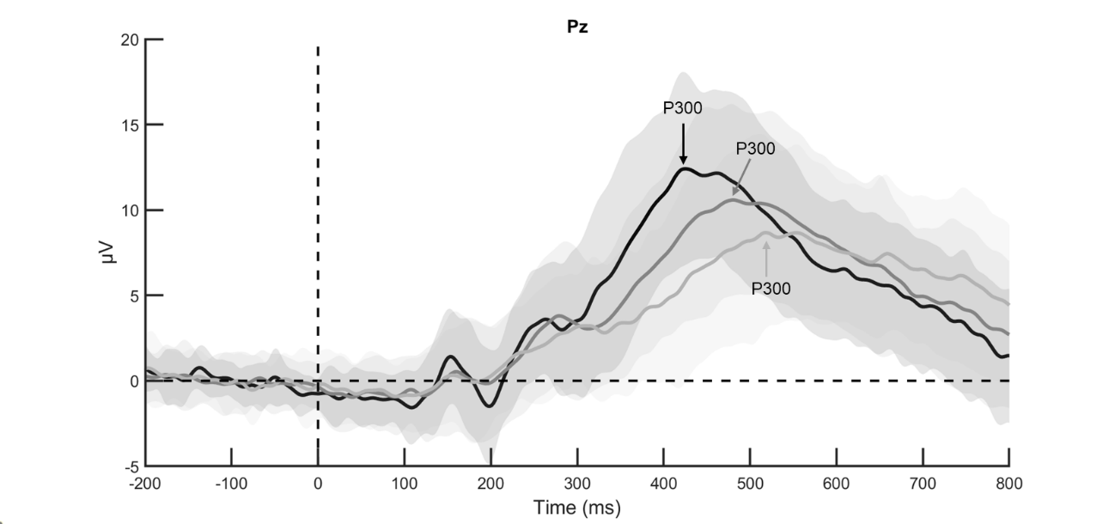Figure 28: Grand average ERPs of healthy controls (in black), people with MS without CI (in dark grey) and people with MS with CI (in light grey). The P300 component to visual oddball paradigm recorded in response to infrequent target onset at electrode Pz. The arrows indicate the average peak latency of each group.

No differences were found in the MS group in either P300 latency or amplitude between baseline and T1 (latency: 525.91 ± 96.82 ms; amplitude: 11.54 ± 4.73 μV) (Wilcoxon test, FDR corrected latency: p = 0.966; amplitude: p = 0.434). A visual representation is provided in Figure 29.

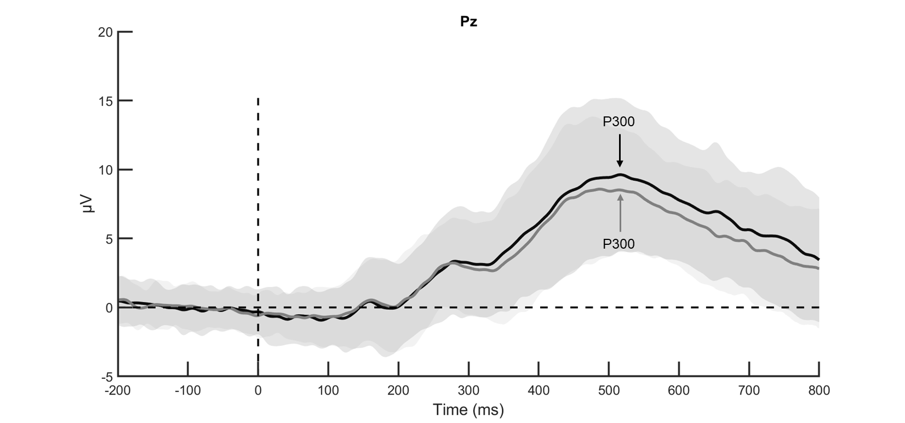Figure 29: Grand average ERPs of MS group at T0 (in black) and at T1 (in grey). The P300 component to visual oddball paradigm recorded in response to infrequent target onset at electrode Pz. The arrows indicate the average peak latency of each group.
Among pwMS who underwent cognitive rehabilitation, no pre–post intervention differences were observed in the P300 component.
EEG-SDMT
Grand average ERPs for pwMS and HCs are shown in Figure 30. After the stimulus onset, a positive peak – designated as the P5 component - with a higher amplitude in HC (13.12 ± 5.64 μV) in comparison to pwMS (10.84 ± 6.41 μV) was elicited over centro-parietal regions (Wilcoxon test, FDR corrected p = 0.067). Latency was significantly longer in pwMS (611.72 ± 122.30 ms) in comparison to HCs (517.29 ± 75.53 ms) (Wilcoxon test, FDR corrected p < 0.01) as in Figure 30 A. No significant differences were found in P5 between pwMS with CI and those without CI (Wilcoxon test, FDR corrected p = 0.940). No significant difference between HC and pwMS were found for the early occipital components (Table 12). After subtracting the visual processing component P1 from the P5 component, a cognitive processing component was identified, exhibiting a significantly longer latency in pwMS (465.68 ± 121.07 ms) compared to HC (376.39 ± 64.42 ms) (Wilcoxon test, FDR corrected p < 0.001).
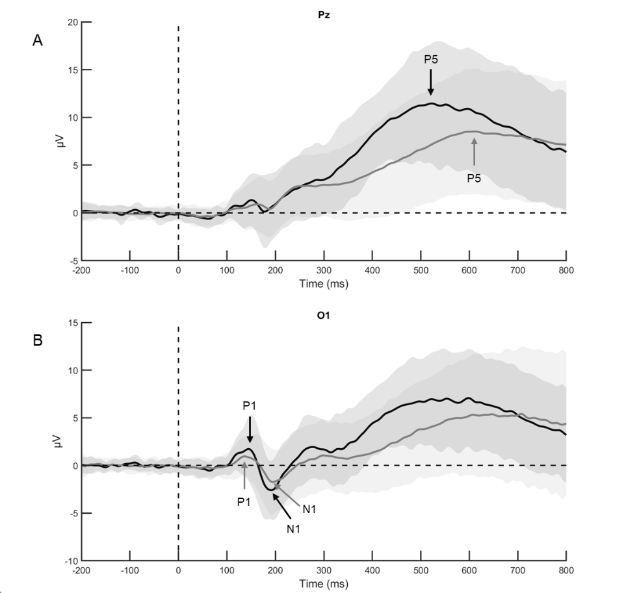
Figure 30: Grand average ERPs of healthy controls (in black) and people with MS (in grey). (A) The P5 component to EEG-SDMT recorded in response to stimulus onset at electrode Pz. The arrows indicate the average peak latency of each group. (B) The visual components P1 and N1 recorded at electrode O1.

Table 12: Early occipital components P1 and N1 recorded at electrode O1.
 | Multiple Sclerosis (n=92) |  | Healthy Controls (n=28)
 | Mean | SD | Mean | SD | p-value
P1 latency | 151.79 | 33.95 | 140.90 | 28.85 | 0.296
P1 amplitude | 2.68 | 1.99 | 3.40 | 2.36 | 0.275
N1 latency | 207.71 | 69.92 | 202.59 | 69.23 | 0.828
N1 amplitude | -3.70 | 3.28 | -3.90 | 2.98 | 0.935

At T1, no significant differences were found either in the P5 latency or amplitude among pwMS (latency: p = 0.799; amplitude: p = 0.308) (Figure 31). Moreover, no significant changes from T0 to T1 were detected in the early occipital components within the pwMS group.

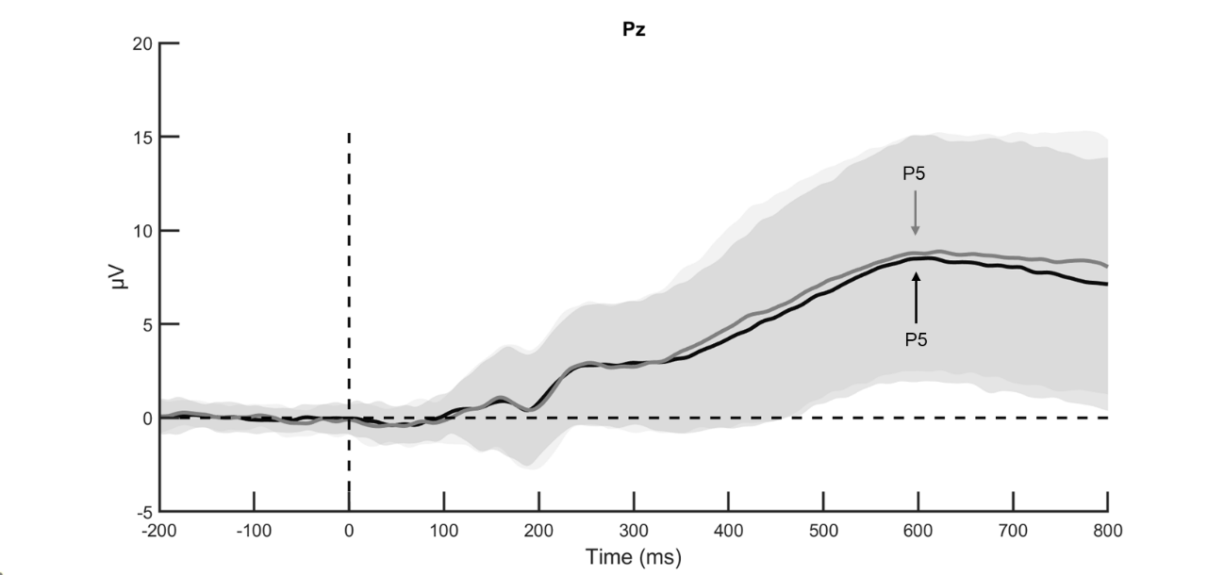Figure 31: Grand average ERPs of MS group at T0 (in black) and at T1 (in grey). The P5 component to EEG-SDMT recorded in response to stimulus onset at electrode Pz. The arrows indicate the average peak latency of each group.

Among pwMS who underwent cognitive rehabilitation, no pre–post intervention differences were observed in the P5, P1, or N1 components.
4.6 Phase-Locking Values analysis
Delta band (1-4 Hz)
PwMS exhibited lower connectivity in the delta frequency band between fronto-temporal, fronto-parietal, and central electrode pairs in comparison to HC. All electrode pairs showing statistically significant differences (p < 0.05) are displayed in Figure 32.

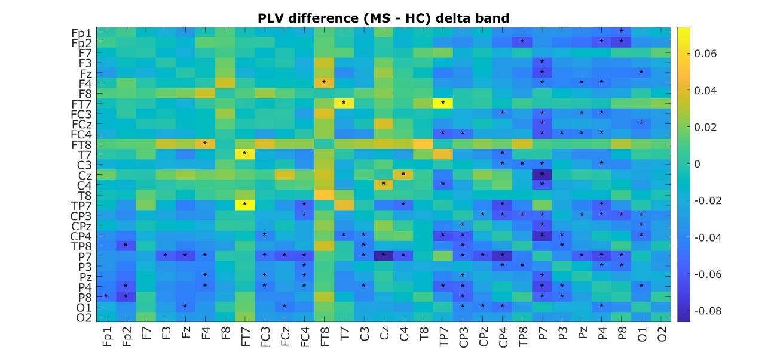Figure 32: The heatmap shows the differences in PLV connectivity in the delta frequency band between MS and HC for all pairs of electrodes considered. Colors indicate the magnitude and direction of the difference: positive values represent higher PLV in MS compared to HC; negative values represent lower PLV. Asterisks indicate electrode pairs for which the difference is statistically significant (p < 0.05), highlighting reliable changes in connectivity between groups.

Stratification of the MS sample by cognitive status revealed that the cognitively impaired group showed lower delta-band connectivity between parietal, temporo-parietal, and temporo-occipital electrode pairs in comparison to cognitively preserved MS (all p < 0.05) (Figure 33).
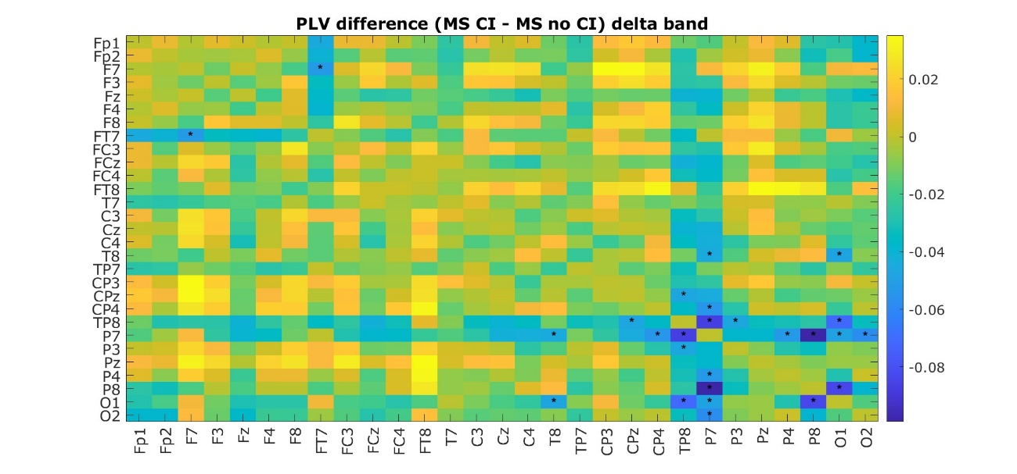Figure 33: The heatmap shows the differences in PLV connectivity in the delta frequency band between MS with and without CI for all pairs of electrodes considered. Colors indicate the magnitude and direction of the difference: positive values represent higher PLV in MS without CI compared to MS with CI; negative values represent lower PLV. Asterisks indicate electrode pairs for which the difference is statistically significant (p < 0.05), highlighting reliable changes in connectivity between groups.

A limited number of electrode pairs exhibited significant changes in the group of MS at T1 in delta-band connectivity. Higher fronto-temporal and temporo-central connectivity were recorded at T1 compared to T0. The significant electrode pairs are displayed in Figure 34 (all p < 0.05).

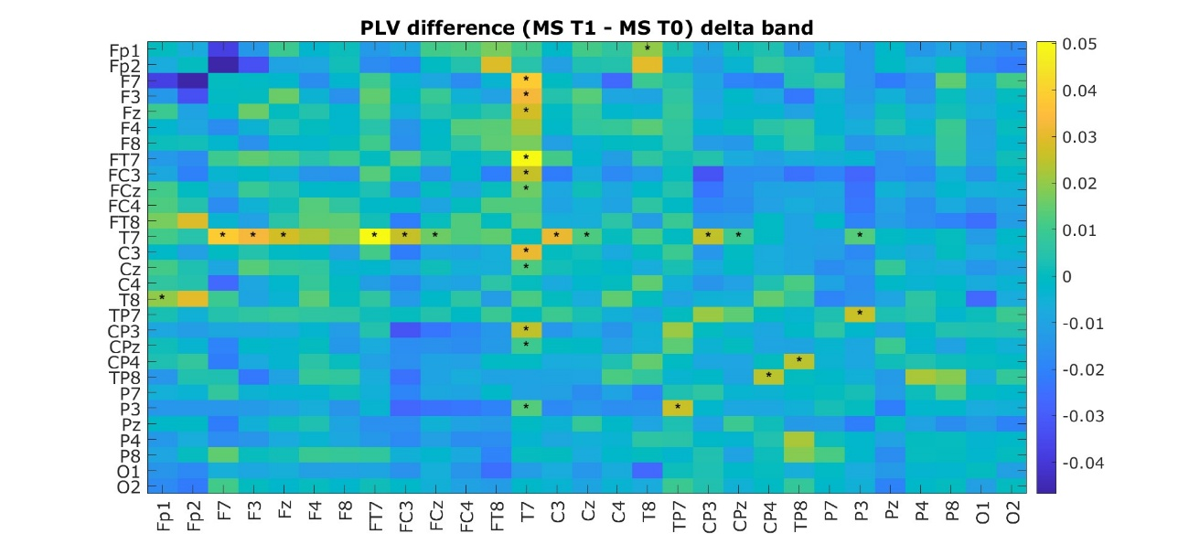Figure 34: The heatmap shows the differences in PLV connectivity in the delta frequency band between baseline and T1 in MS for all pairs of electrodes considered. Colors indicate the magnitude and direction of the difference: positive values represent higher PLV at T1 compared to T0; negative values represent lower PLV. Asterisks indicate electrode pairs for which the difference is statistically significant (p < 0.05), highlighting reliable changes in connectivity between groups.

The MS group that underwent cognitive rehabilitation showed increased delta band connectivity following the intervention, particularly between fronto-temporal and fronto-parietal regions. Additionally, enhanced delta connectivity was observed across interhemispheric frontal electrode pairs. All significant electrode pairs are displayed in the Figure 35 (all p < 0.05).

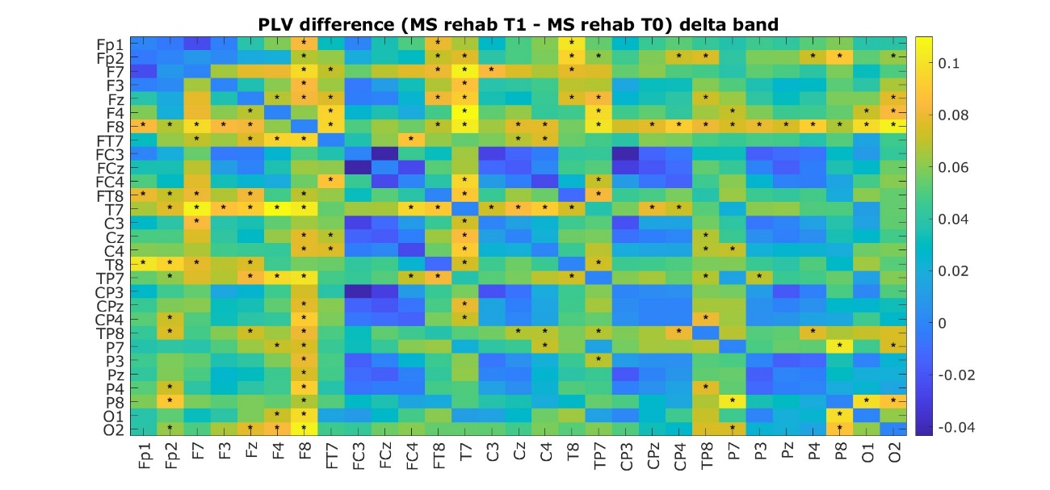Figure 35: The heatmap shows the differences in PLV connectivity in the delta frequency band between pre- and post- cognitive rehabilitation in MS for all pairs of electrodes considered. Colors indicate the magnitude and direction of the difference: positive values represent higher PLV at T1 after cognitive rehabilitation compared to T0; negative values represent lower PLV. Asterisks indicate electrode pairs for which the difference is statistically significant (p < 0.05), highlighting reliable changes in connectivity between groups

Theta band (4-7 Hz)
Higher theta-band connectivity was observed in fronto-temporal and fronto-parietal electrode pairs in the MS group compared with the HC group. Lower connectivity was reported in MS between interhemispheric central electrode pairs. All electrode pairs for which the difference is statistically significant (p < 0.05) are represented in Figure 36.

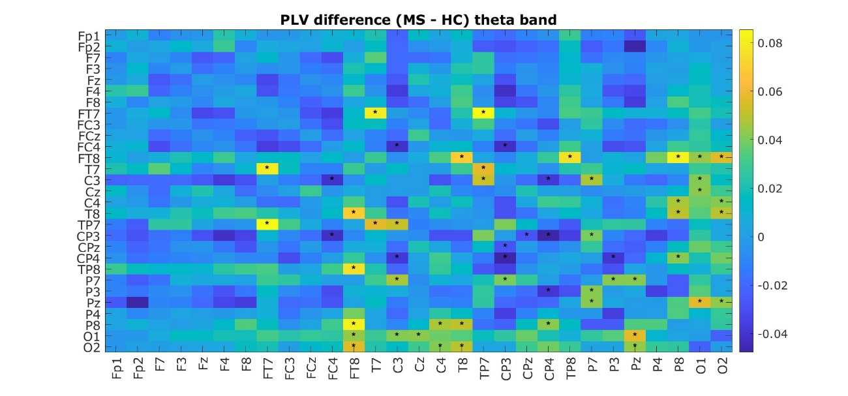Figure 36: The heatmap shows the differences in PLV connectivity in the theta frequency band between MS and HC for all pairs of electrodes considered. Colors indicate the magnitude and direction of the difference: positive values represent higher PLV in MS compared to HC; negative values represent lower PLV. Asterisks indicate electrode pairs for which the difference is statistically significant (p < 0.05), highlighting reliable changes in connectivity between groups.

When the MS sample was stratified based on cognitive status, the cognitively impaired group showed higher theta-band PLV connectivity between fronto-central and fronto-parietal electrode pairs compared with the cognitively preserved group. Conversely, the cognitively impaired group exhibited lower theta-band connectivity between centro-parietal and interhemispheric parietal electrode pairs. All electrode pairs for which the difference is statistically significant (p < 0.05) are represented in Figure 37.

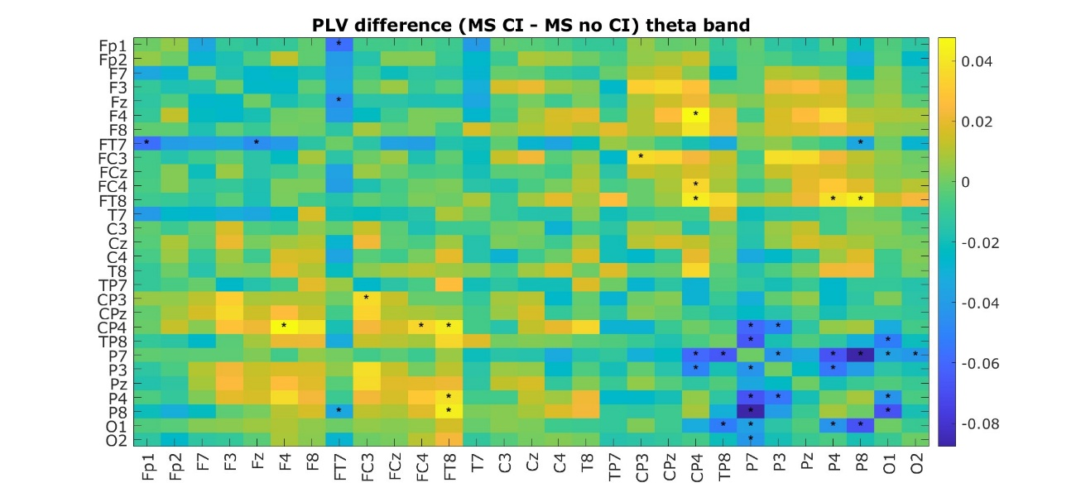Figure 37: The heatmap shows the differences in PLV connectivity in the theta frequency band between MS with and without CI for all pairs of electrodes considered. Colors indicate the magnitude and direction of the difference: positive values represent higher PLV in MS without CI compared to MS with CI; negative values represent lower PLV. Asterisks indicate electrode pairs for which the difference is statistically significant (p < 0.05), highlighting reliable changes in connectivity between groups.

No significant differences were observed between T0 and T1 in the MS group. Only a limited number of electrode pairs exhibited significant changes in theta-band connectivity, characterized by higher frontal and fronto-central connectivity at T0 compared to T1, and reduced fronto-temporal connectivity at T0. The significant electrode pairs are displayed in Figure 38 (all p < 0.05).

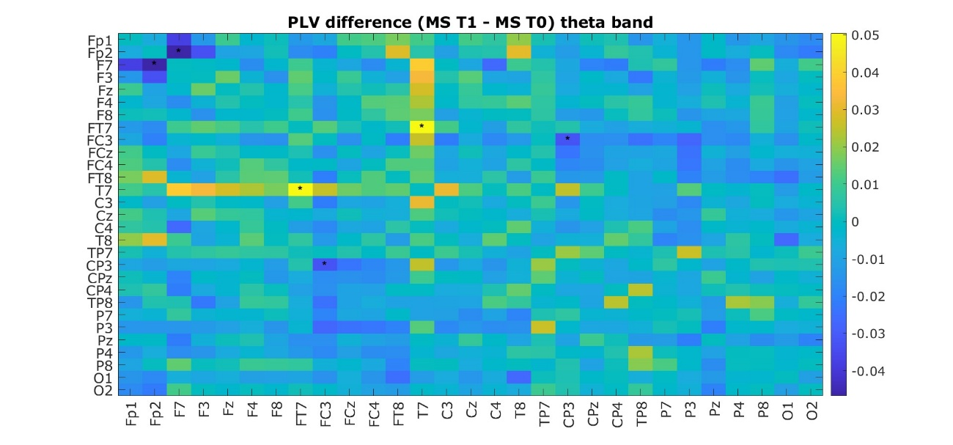Figure 38: The heatmap shows the differences in PLV connectivity in the theta frequency band between baseline and T1 in MS for all pairs of electrodes considered. Colors indicate the magnitude and direction of the difference: positive values represent higher PLV at T1 compared to T0; negative values represent lower PLV. Asterisks indicate electrode pairs for which the difference is statistically significant (p < 0.05), highlighting reliable changes in connectivity between groups.

The MS group that underwent cognitive rehabilitation showed increased theta band connectivity following the intervention, particularly between fronto-temporal, fronto-central, and fronto-parietal regions. Additionally, enhanced theta connectivity was observed between temporo-parietal areas and across interhemispheric parietal electrode pairs. All significant electrode pairs are displayed in Figure 39 (all p < 0.05).

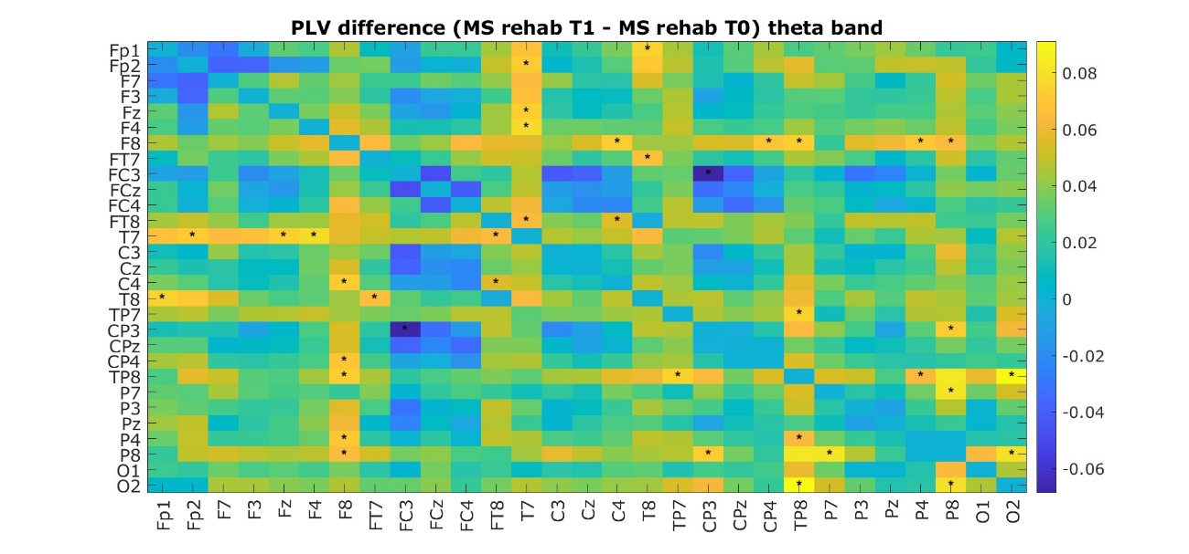Figure 39: The heatmap shows the differences in PLV connectivity in the theta frequency band between pre- and post- cognitive rehabilitation in MS for all pairs of electrodes considered. Colors indicate the magnitude and direction of the difference: positive values represent higher PLV at T1 after cognitive rehabilitation compared to T0; negative values represent lower PLV. Asterisks indicate electrode pairs for which the difference is statistically significant (p < 0.05), highlighting reliable changes in connectivity between groups.

Alpha band (8-12 Hz)
The MS group exhibited higher connectivity in the alpha frequency band between fronto-temporal and temporal electrode pairs compared to HC, while showing lower connectivity between interhemispheric central and parietal electrode pairs (all p < 0.05) (Figure 40).

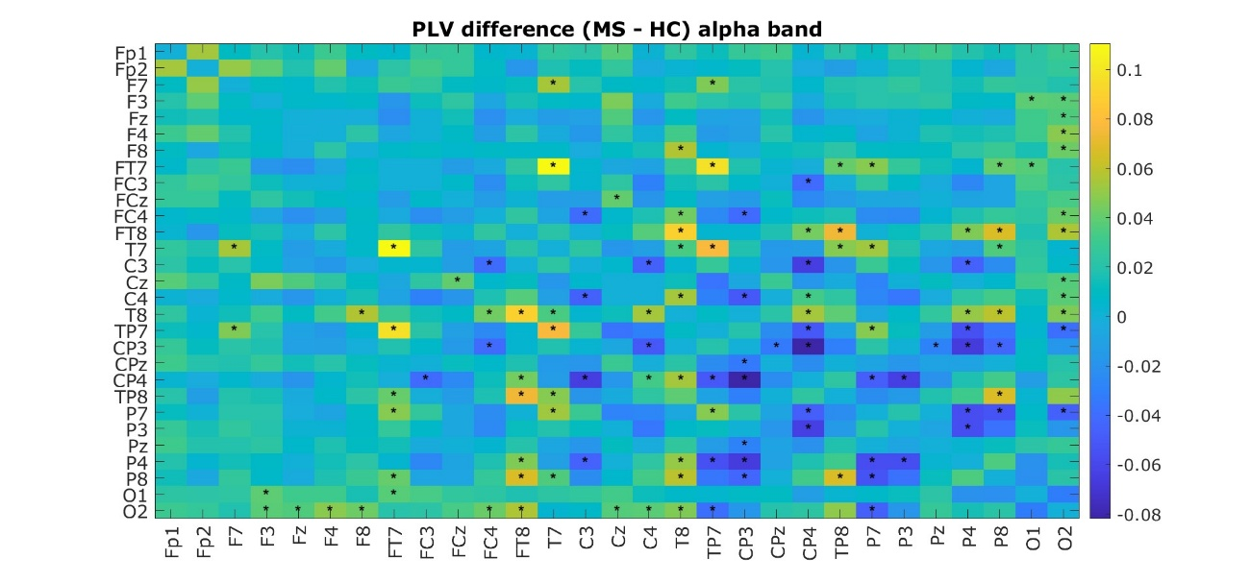Figure 40: The heatmap shows the differences in PLV connectivity in the alpha frequency band between MS and HC for all pairs of electrodes considered. Colors indicate the magnitude and direction of the difference: positive values represent higher PLV in MS compared to HC; negative values represent lower PLV. Asterisks indicate electrode pairs for which the difference is statistically significant (p < 0.05), highlighting reliable changes in connectivity between groups.

Cognitively impaired pwMS reported higher connectivity in the alpha frequency band between frontal and fronto-central electrode pairs compared to cognitively preserved pwMS. Conversely, they showed lower connectivity between parietal electrode pairs compared to pwMS without CI (all p < 0.05) (Figure 41).

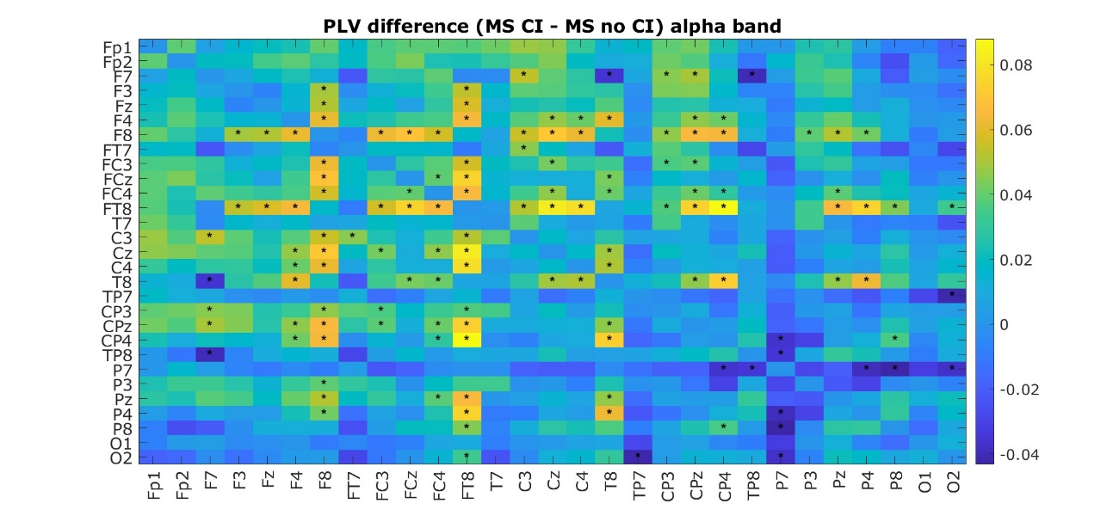Figure 41: The heatmap shows the differences in PLV connectivity in the alpha frequency band between pwMS with and without CI for all pairs of electrodes considered. Colors indicate the magnitude and direction of the difference: positive values represent higher PLV in pwMS without CI compared to pwMS with CI; negative values represent lower PLV. Asterisks indicate electrode pairs for which the difference is statistically significant (p < 0.05), highlighting reliable changes in connectivity between groups.

No significant differences were observed between T0 and T1 in the MS group. Only a few electrode pairs showed significant changes in alpha-band connectivity, with higher frontal connectivity at T0 compared to T1, and lower fronto-temporal connectivity at T0. The significant electrode pairs are shown in Figure 42 (all p < 0.05).

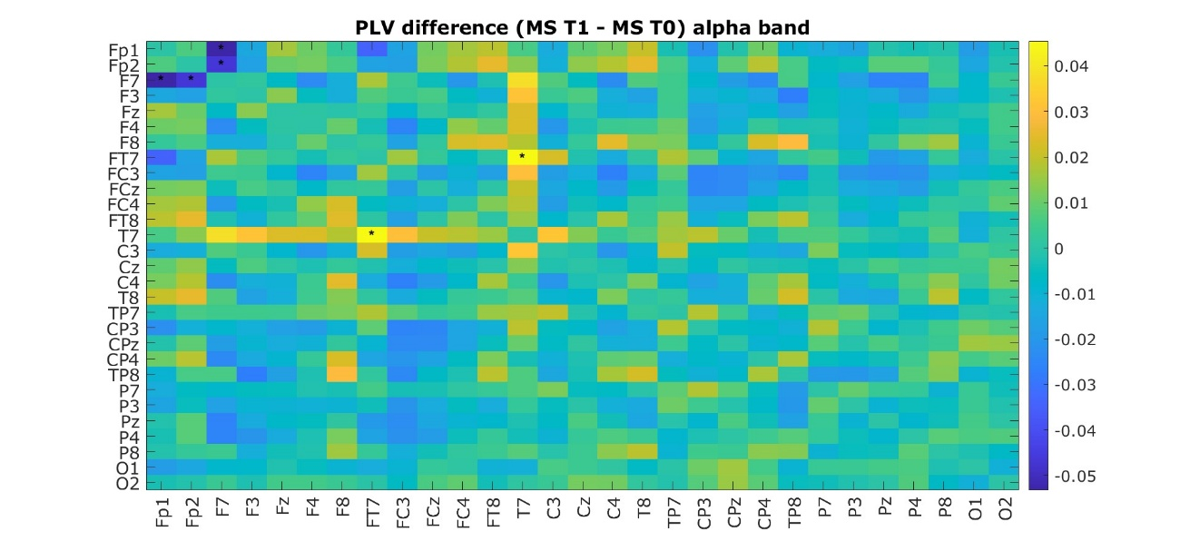Figure 42: The heatmap shows the differences in PLV connectivity in the alpha frequency band between baseline and T1 in MS for all pairs of electrodes considered. Colors indicate the magnitude and direction of the difference: positive values represent higher PLV T1 compared to T0; negative values represent lower PLV. Asterisks indicate electrode pairs for which the difference is statistically significant (p < 0.05), highlighting reliable changes in connectivity between groups.

An increase in alpha-band connectivity was observed between fronto-central and fronto-parietal electrode pairs in pwMS following cognitive rehabilitation. All significant electrode pairs are shown in Figure 43 (all p < 0.05).

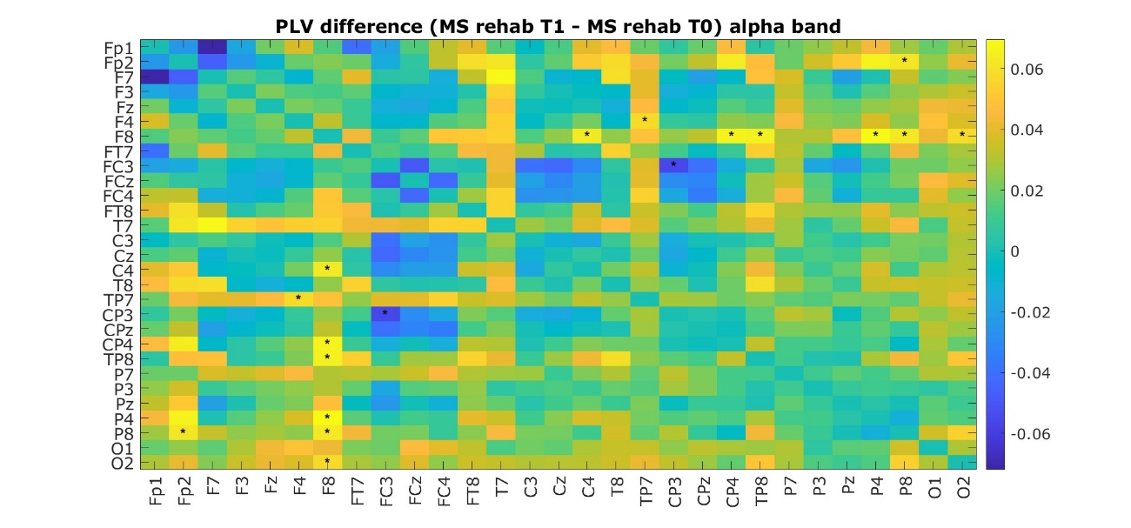Figure 43: The heatmap shows the differences in PLV connectivity in the alpha frequency band between pre- and post- cognitive rehabilitation in MS for all pairs of electrodes considered. Colors indicate the magnitude and direction of the difference: positive values represent higher PLV at T1 after cognitive rehabilitation compared to T0; negative values represent lower PLV. Asterisks indicate electrode pairs for which the difference is statistically significant (p < 0.05), highlighting reliable changes in connectivity between groups.

Beta band (13-30 Hz)
Higher connectivity in the beta frequency band was observed between frontal and fronto-temporal electrode pairs in MS in comparison to HC. Figure 44 displays all electrode pairs with significant connectivity differences.

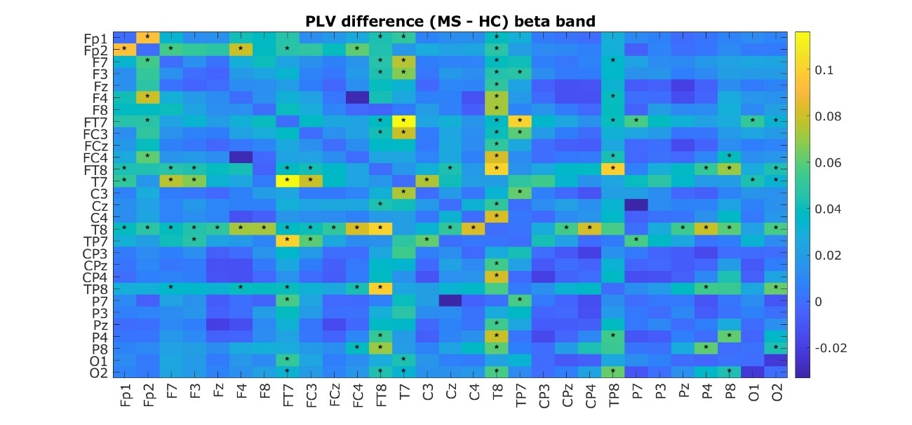
Figure 44: The heatmap shows the differences in PLV connectivity in the beta frequency band between MS and HC for all pairs of electrodes considered. Colors indicate the magnitude and direction of the difference: positive values represent higher PLV in MS compared to HC; negative values represent lower PLV. Asterisks indicate electrode pairs for which the difference is statistically significant (p < 0.05), highlighting reliable changes in connectivity between groups.

Higher beta-band connectivity was reported between fronto-central and fronto-parietal electrode pairs in pwMS with CI in comparison to pwMS without CI (all p < 0.05) (Figure 45).

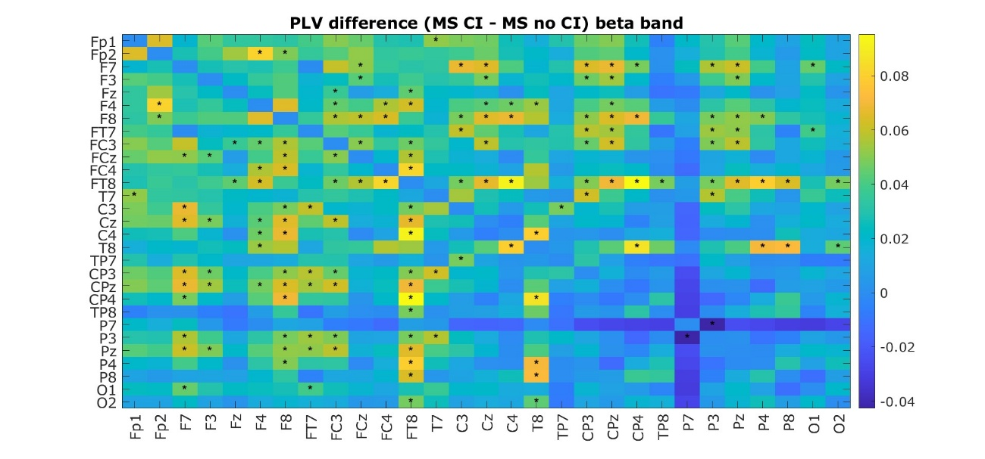Figure 45: The heatmap shows the differences in PLV connectivity in the beta frequency band between pwMS with and without CI for all pairs of electrodes considered. Colors indicate the magnitude and direction of the difference: positive values represent higher PLV in pwMS without CI compared to pwMS with CI; negative values represent lower PLV. Asterisks indicate electrode pairs for which the difference is statistically significant (p < 0.05), highlighting reliable changes in connectivity between groups.

No significant differences were observed between T0 and T1 in the MS group. Only a few electrode pairs showed significant changes in beta-band connectivity, with higher frontal and fronto-central connectivity at T0 compared to T1. The significant electrode pairs are shown in Figure 46 (all p < 0.05).

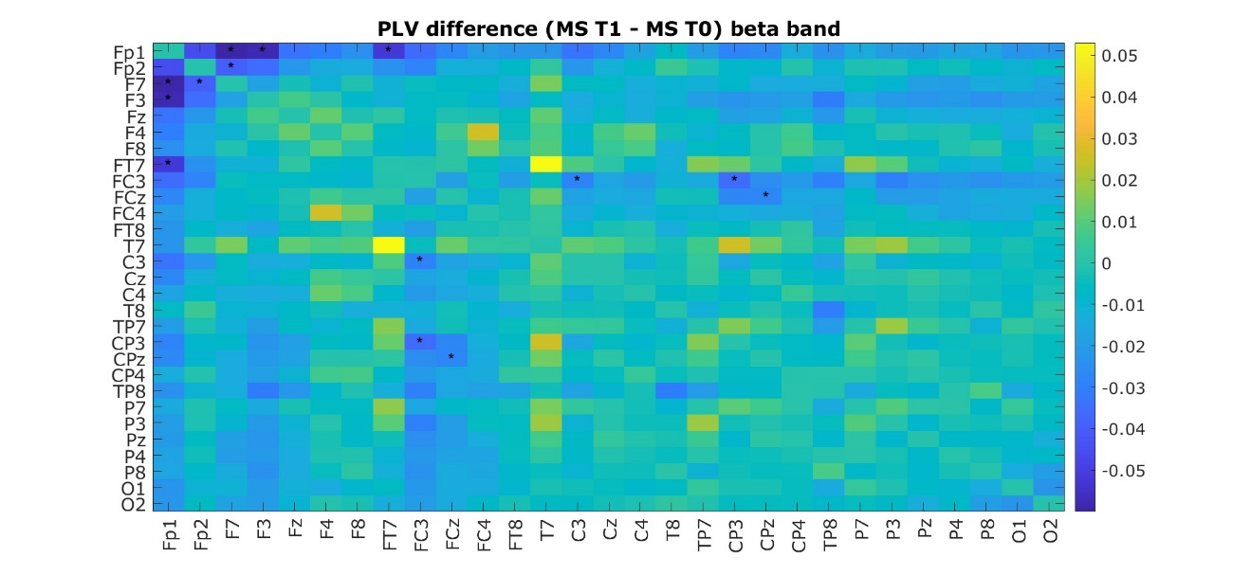Figure 46: The heatmap shows the differences in PLV connectivity in the beta frequency band between baseline and T1 in MS for all pairs of electrodes considered. Colors indicate the magnitude and direction of the difference: positive values represent higher PLV at T1 compared to T0; negative values represent lower PLV. Asterisks indicate electrode pairs for which the difference is statistically significant (p < 0.05), highlighting reliable changes in connectivity between groups.

No significant differences were observed after cognitive rehabilitation in the MS group. A limited number of electrode pairs exhibited significant changes in beta-band connectivity, characterized by higher fronto-central connectivity at T0 compared to T1, and reduced fronto-temporal connectivity at T0. The significant electrode pairs are displayed in Figure 47 (all p < 0.05).

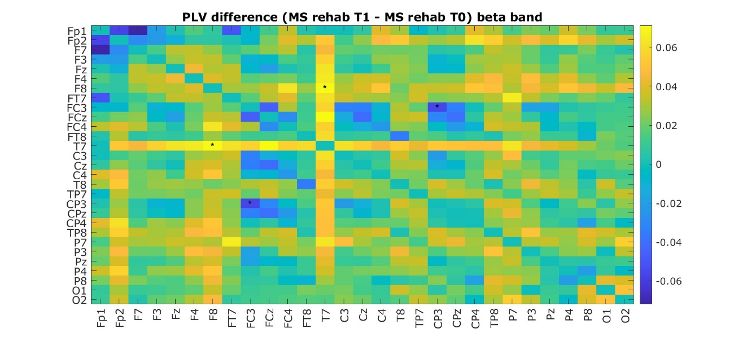Figure 47: The heatmap shows the differences in PLV connectivity in the beta frequency band between pre- and post- cognitive rehabilitation in MS for all pairs of electrodes considered. Colors indicate the magnitude and direction of the difference: positive values represent higher PLV at T1 after cognitive rehabilitation compared to T0; negative values represent lower PLV. Asterisks indicate electrode pairs for which the difference is statistically significant (p < 0.05), highlighting reliable changes in connectivity between groups.

4.7 Behavioural measures
4.7.1 EEG-SDMT
Pairwise comparisons found a significant difference in key-press RTs among the groups (HC, pwMS without CI, pwMS with CI). The number of errors also varied significantly between HC and pwMS with CI, and between pwMS with and without CI (Table 13). At T1, the MS group exhibited significantly faster RTs (Table 14). Considering the subgroup of pwMS who underwent cognitive rehabilitation, no differences were found pre- and post- intervention (Table 15). However, pwMS who received cognitive rehabilitation improved their RTs by an average of 3.57% relative to baseline, while those who did not undergo rehabilitation showed an average improvement of 2.07% (p = 0.528).
4.7.2 SRT
Among the 92 pwMS and 28 HC, only 62 pwMS and 13 HCs completed the simple RT task as this measure was implemented after the start of the study and was not included in the initial protocol. Significant differences in RTs were found between HC and pwMS without CI, and HC and pwMS with CI (Table 13). At T1, the MS group did not show any significant differences (Table 14). Considering the subgroup of pwMS who underwent cognitive rehabilitation, no differences were found pre- and post- intervention (Table 15).
4.7.3 CogRT
Pairwise comparisons showed significant differences across groups (Table 13). At T1, the MS group did not show any significant differences (Table 14). Considering the subgroup of pwMS who underwent cognitive rehabilitation, no differences were found pre- and post- intervention (Table 15).
The CogRT demonstrated significant correlations with MoCA and BICAMS scores. Specifically, CogRT recorded at T0 was negatively correlated with MoCA (ρ = -0.486, p < 0.001), paper-based SDMT scores (ρ = -0.775, p < 0.001), CVLT-II scores (ρ = -0.578, p < 0.001), and BVMT-R scores (ρ = -0.614, p < 0.001) administered at baseline (Figure 48). Furthermore, CogRT recorded at T1 was negatively correlated with MoCA (ρ = -0.724, p < 0.001), paper-based SDMT scores (ρ = -0.585, p < 0.001), CVLT-II scores (ρ = -0.511, p < 0.001), and BVMT-R scores (ρ = -0.565, p < 0.001) administered at T1. CogRT recorded at T0 showed also a good correlation with MoCA (ρ = -0.644, p < 0.001) and BICAMS scores obtained at T1 (SDMT: ρ = -0.678, p < 0.001; CVLT-II: ρ = -0.479, p < 0.001; BVMT-R: ρ = -0.527, p < 0.001).

Table 13: Wilcoxon Test with FDR correction results - comparisons of key-press RTs and n° of errors during EEG-SDMT, SRT and CogRT among HC, pwMS without CI (MS no CI) and pwMS with CI (MS CI).

Task | Group | Mean | SD | Comparison | p-value
EEG-SDMT RT | HC | 1.32 | 0.22 | HC vs. MS no CI | 0.0012
 | MS no CI | 1.65 | 0.38 | HC vs. MS CI | 0.0012
 | MS CI | 2.20 | 0.43 | MS no CI vs. MS CI | 0.0012
N° of errors EEG-SDMT | HC | 4.29 | 3.96 | HC vs. MS no CI | 0.522
 | MS no CI | 4.98 | 4.15 | HC vs. MS CI | 0.03
 | MS CI | 7.40 | 0.89 | MS no CI vs. MS CI | 0.032
SRT | HC | 0.30 | 0.03 | HC vs. MS no CI | 0.0012
 | MS no CI | 0.39 | 0.08 | HC vs. MS CI | 0.0012
 | MS CI | 0.41 | 0.09 | MS no CI vs. MS CI | 0.32
CogRT | HC | 1.02 | 0.17 | HC vs. MS no CI | 0.032
 | MS no CI | 1.27 | 0.35 | HC vs. MS CI | 0.0012
 | MS CI | 1.82 | 0.35 | MS no CI vs. MS CI | 0.0012

Table 14: Wilcoxon Test with FDR correction results - comparison of key-press RTs and n° of errors during EEG-SDMT, SRT and CogRT at T0 and T1 in pwMS.
 | Multiple Sclerosis T0 |  | Multiple Sclerosis T1
 | Mean | SD | Mean | SD | p-value
EEG-SDMT RT | 1.89 | 0.48 | 1.81 | 0.44 | .004
N° of errors EEG-SDMT | 6.03 | 4.96 | 6.90 | 7.02 | .226
SRT | 0.39 | 0.09 | 0.39 | 0.08 | .940
CogRT | 1.50 | 0.44 | 1.43 | 0.39 | .145

Table 15: Wilcoxon Test with FDR correction results - comparison of key-press RTs and n° of errors during EEG-SDMT, SRT and CogRT pre- and post- cognitive rehabilitation.
 | Multiple Sclerosis pre- cognitive rehabilitation T0 |  | Multiple Sclerosis post- cognitive rehabilitation T1
 | Mean | SD | Mean | SD | p-value
EEG-SDMT RT | 2.21 | 0.36 | 2.12 | 0.39 | .115
N° of errors EEG-SDMT | 7.65 | 6.10 | 9.85 | 10.63 | .354
SRT | 0.39 | 0.08 | 0.42 | 0.09 | .669
CogRT | 1.79 | 0.27 | 1.72 | 0.36 | .231

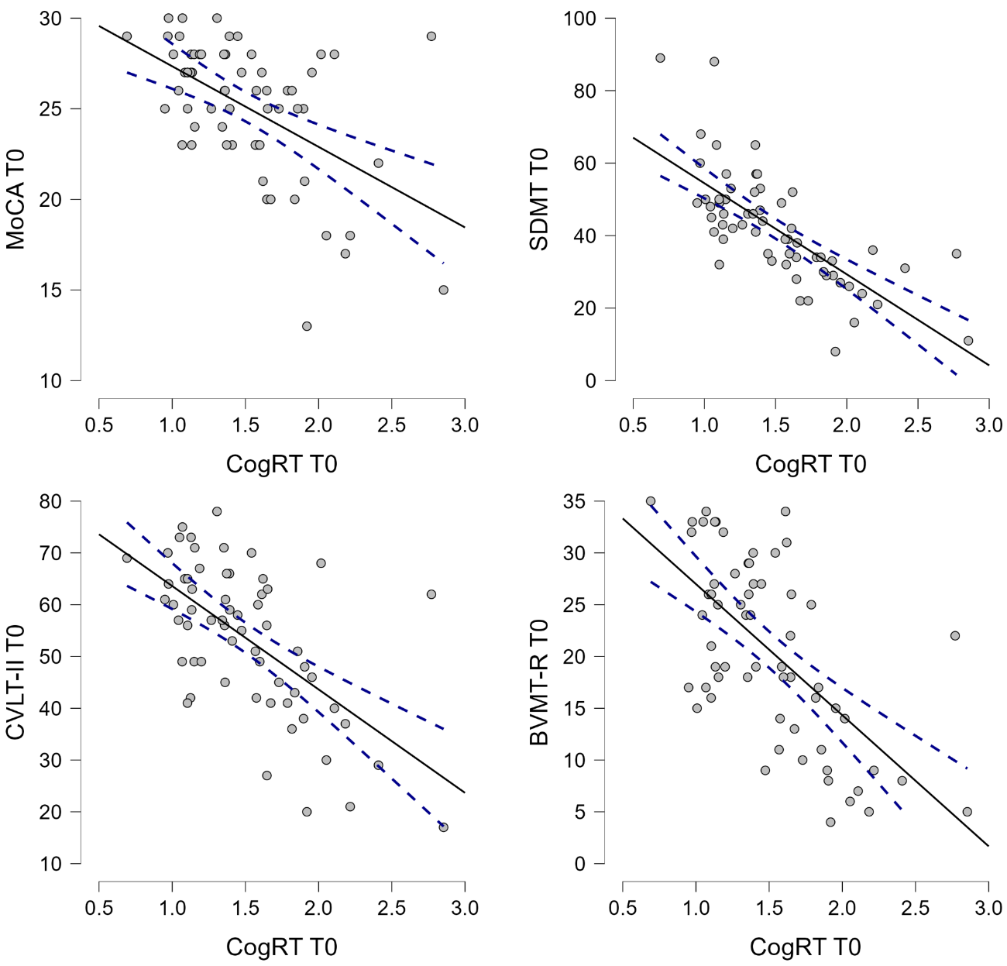
Figure 48: Negative correlation between MoCA, three sub-tests of the BICAMS (SDMT; CVLT-II; BVMT-R) (x axis) and the cognitive response time (y axis) in people with MS (n= 62).

4.8 Correlational analysis
4.8.1 Time-Frequency analysis
A positive correlation was found between global alpha power during eyes-open resting-state condition and P5 latency recorded during EEG-SDMT (ρ = 0.226, p = 0.013). Additionally, global theta power during both eyes-open and eyes-closed was positively associated with P5 latency (EO: ρ = 0.201, p = 0.027; EC: ρ = 0.251, p = 0.006) and P5 amplitude (EO: ρ = 0.197, p = 0.031; EC: ρ = 0.219, p = 0.016). Global theta power during eyes-open significantly correlated also with P3 amplitude recorded during oddball paradigm (ρ = 0.229, p = 0.012).
4.8.2 Event-Related Potentials
P300 component to visual oddball paradigm
A significant correlation between P300 latency and EDSS score at T0 was reported (ρ = -0.241, p = 0.022), whereas no association emerged between these variables at T1.
Furthermore, at baseline, P300 latency showed positive correlations with the number of errors (ρ = 0.190, p = 0.037) and RTs (ρ = 0.509, p < 0.001) in the EEG-SDMT, as well as with RTs recorded during the SRT (ρ = 0.374, p < 0.001) and CogRT tasks (ρ = 0.560, p < 0.001). Conversely, P300 amplitude at baseline was negatively correlated with RTs in the EEG-SDMT (ρ = –0.348, p < 0.001), SRT (ρ = –0.277, p = 0.016), and CogRT (ρ = –0.388, p < 0.001). All these measures were collected at baseline. At T1, P300 latency was positively correlated with RTs in the EEG-SDMT (ρ = 0.527, p < 0.001), SRT (ρ = 0.299, p = 0.031), and CogRT (ρ = 0.501, p < 0.001), whereas P300 amplitude showed no significant associations. Lastly, P300 latency at T0 was associated with the number of errors (ρ = 0.260, p = 0.020) and RTs (ρ = 0.305, p = 0.006) in the EEG-SDMT, as well as with RTs recorded during the SRT (ρ = 0.377, p = 0.005) and CogRT tasks (ρ = 0.286, p = 0.038) obtained at T1.
P300 latency at baseline was also negatively correlated with MoCA (ρ = -0.303, p = 0.004), SDMT (ρ = -0.448, p < 0.001), CVLT-II (ρ = -0.302, p = 0.004), BVMT-R (ρ = -0.250, p = 0.017), PASAT 3 (ρ = -0.353, p = 0.001), and PASAT 2 (ρ = -0.351, p = 0.004). These associations were maintained also at T1, where P300 latency correlated with MoCA (ρ = -0.344, p = 0.003), SDMT (ρ = -0.450, p < 0.001), CVLT-II (ρ = -0.327, p = 0.005), BVMT-R (ρ = -0.350, p = 0.002), and PASAT 3 (ρ = -0.307, p = 0.010). P300 amplitude at T1 was positively correlated with CVLT-II (ρ = 0.367, p = 0.001), BVMT-R (ρ = 0.296, p = 0.011), and PASAT 3 (ρ = 0.247, p = 0.040). Finally, P300 latency at baseline was negatively correlated with MoCA (ρ = -0.289, p = 0.008), SDMT (ρ = -0.412, p < 0.001), CVLT-II (ρ = -0.342, p = 0.002), BVMT-R (ρ = -0.303, p = 0.006), PASAT 3 (ρ = -0.343, p = 0.002), and PASAT 2 (ρ = -0.349, p = 0.005) administered at T1.

P5 component to EEG-SDMT
A significant association was found between baseline P5 amplitude and the EDSS score at T0 (ρ = -0.244, p=0.021), whereas no association emerged between these variables at T1.
Interestingly, there was a significant positive correlation between P5 latency and the number of errors (ρ = 0.190, p = 0.037) and RTs (ρ = 0.356, p < 0.001) in the EEG-SDMT, RTs recorded in response to SRT (ρ = 0.361, p = 0.001), and CogRT (ρ = 0.372, p = 0.001) at baseline. On the other hand, P5 amplitude was significantly correlated with paper-based SDMT score administered at T0 (ρ = 0.227, p = 0.029) (Figure 49).

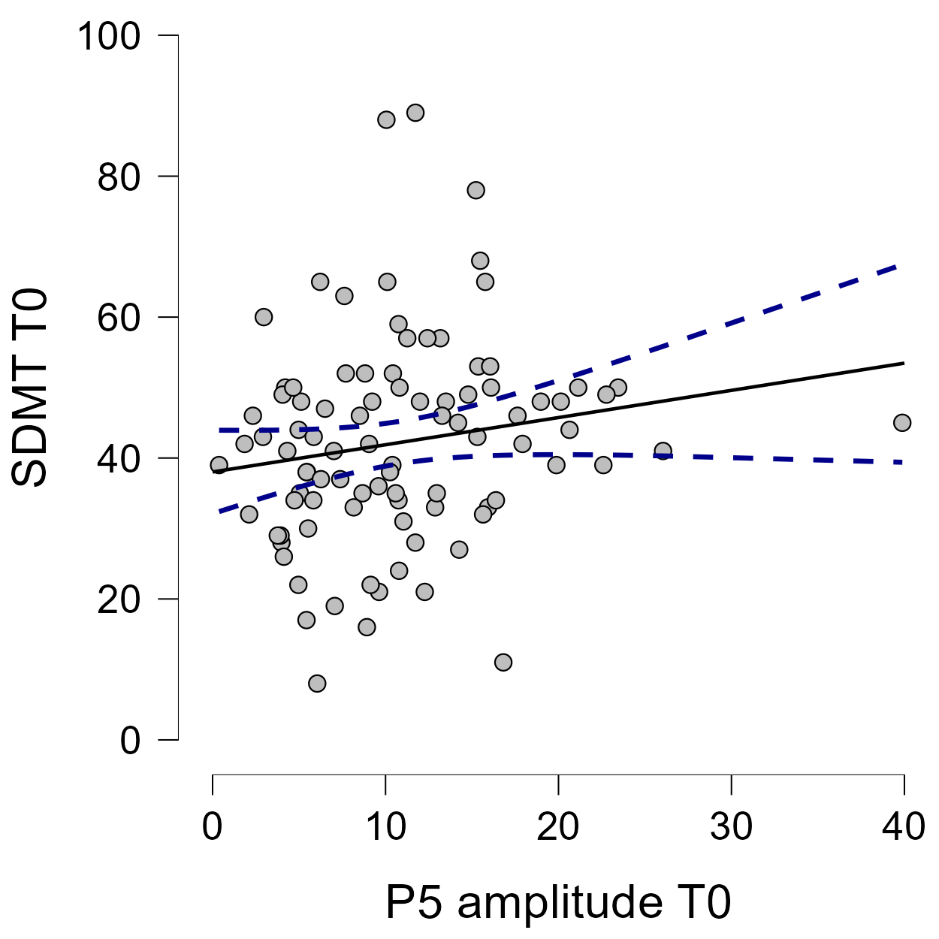
Figure 49: Positive correlation between SDMT and the amplitude of the P5 component as recorded from the EEG-SDMT task (n= 92).

The latency of the P5 component recorded at T1 was significantly associated with the RTs in response to EEG-SDMT (ρ = 0.273, p = 0.014) and SRT (ρ = 0.278, p = 0.044) performed at the end of the hospitalization period. Furthermore, P5 latency significantly correlated with SDMT score at T1 (ρ = -0.266, p = 0.021) (Figure 50).

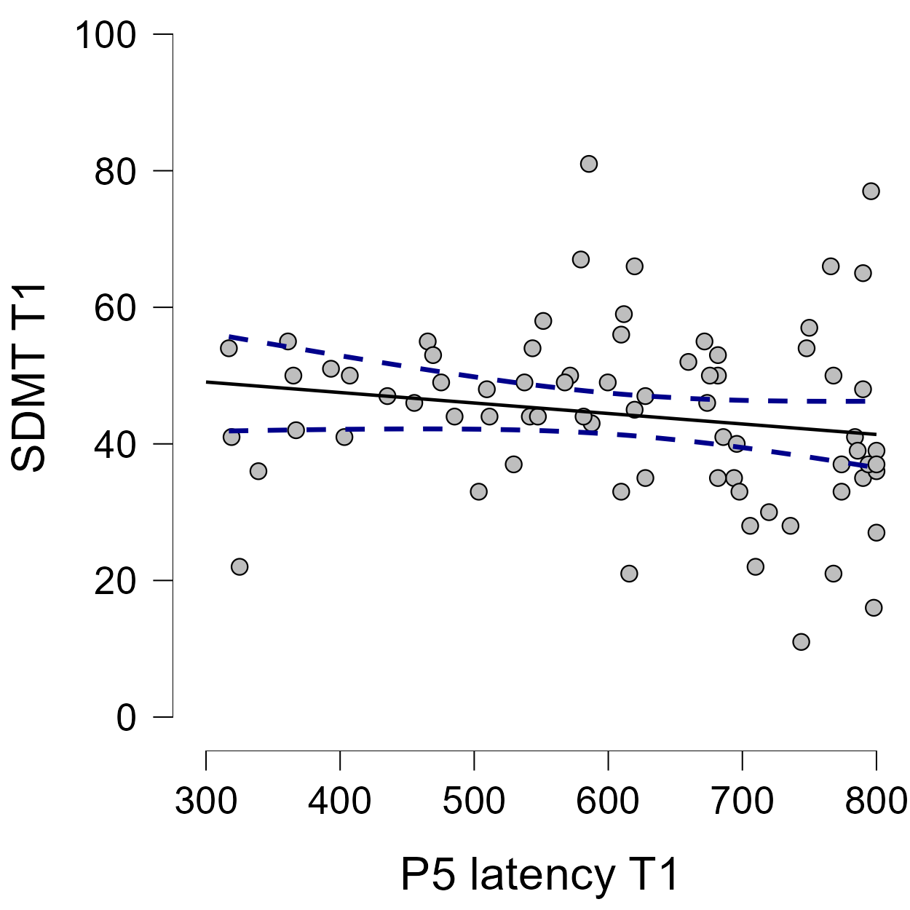
Figure 50: Negative correlation between SDMT and the latency of the P5 component as recorded from the EEG-SDMT task. Both measures are recorded at T1 (n=80).

Lastly, the P5 latency at baseline was negatively correlated with the SDMT score obtained at T1 (ρ = -0.224, p = 0.043) (Figure 51).

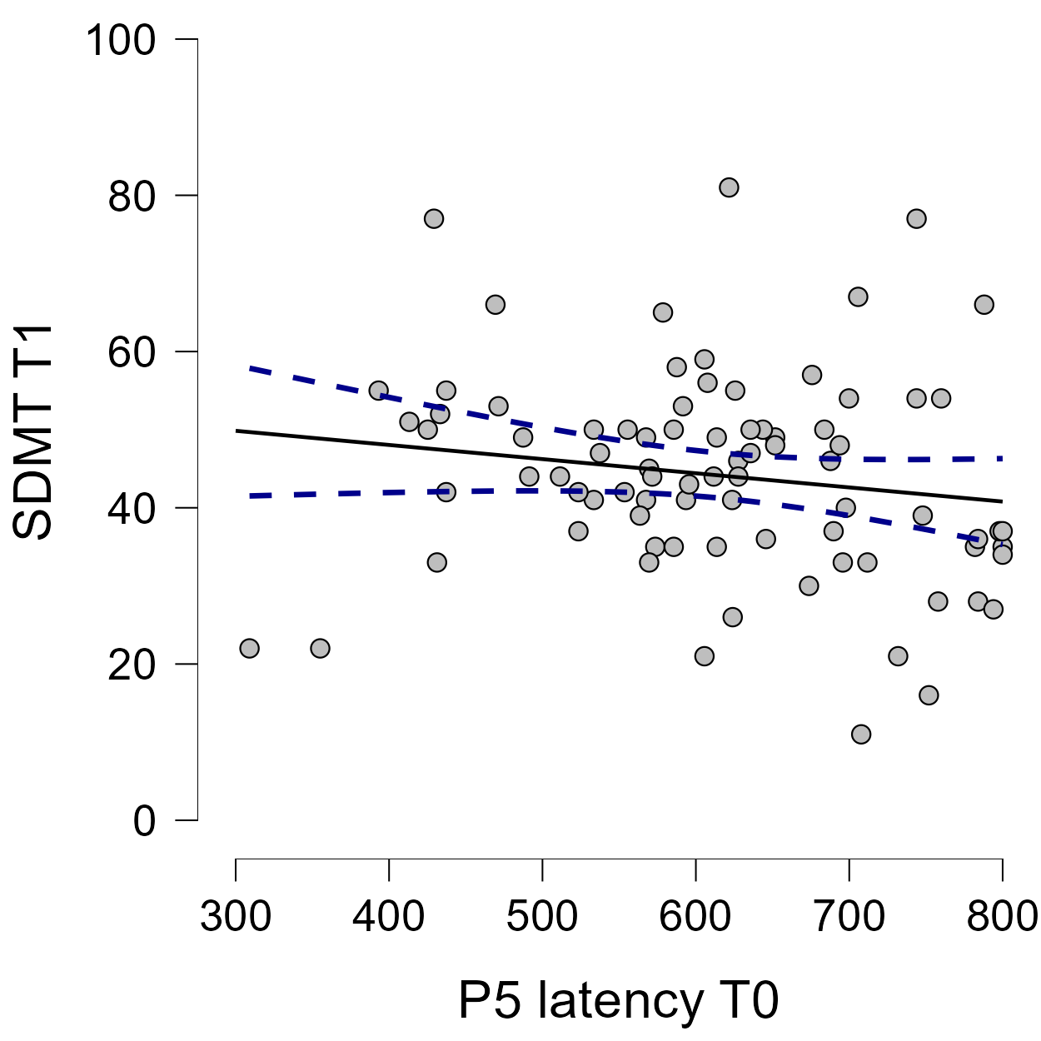
Figure 51: Negative correlation between SDMT administered at T1 and the latency of the P5 component as recorded from the EEG-SDMT task at T0.

DISCUSSION
Our aim was to identify electrophysiological correlates of cognitive functioning in pwMS. To this end, we investigated the potential of a resting-state EEG paradigm, an oddball task, and an EEG-compatible version of the SDMT. Given the widespread use of the SDMT as a screening tool for cognitive dysfunction in MS, we specifically sought to extract electrophysiological and behavioural markers sensitive to CI. In addition, we compared the clinical sensitivity of the markers obtained across paradigms, both for distinguishing preserved from impaired cognition and for monitoring longitudinal changes pre- and post-cognitive rehabilitation, while acknowledging that any observed improvements cannot be attributed solely to the intervention, as they may also reflect natural recovery or the effects of concomitant treatments.
5.1 Concurrent validity of the EEG-SDMT
We developed an EEG-compatible version of the SDMT. To reduce potential artifacts, we minimized eye movements and replaced the oral response modality - known to introduce interference in EEG traces (Fargier et al., 2018) - with a simple keypress response requiring minimal hand movement. While this adaptation differs slightly from the standardized paper-based SDMT, it engages the same cognitive functions.
This similarity is supported by the strong correlation observed between RTs in the EEG-SDMT and scores from the paper-based SDMT. A weaker association of errors with the clinical SDMT score is expected, since the paper-based version is scored by the number of correct responses in 90 seconds. Errors may only indirectly affect performance by reducing the total number of correct responses, whereas RTs more directly reflect the scoring principle of the test. These findings suggest that the EEG-SDMT may capture similar cognitive domains as the traditional version while being tailored for neurophysiological research. Although alternative versions of the SDMT have been adapted for use on smartphones, tablets, and computers, these tools are primarily designed for practical usability in clinical or everyday contexts. To the best of our knowledge, the EEG-SDMT is the first version developed for EEG research, enabling the simultaneous collection of both neural and behavioural data.
5.2 Time-Frequency analysis
Resting-State
The higher global alpha activity during open eyes resting-state condition recorded in pwMS is consistent with previous literature, which have associated higher slow-wave activity with overall poorer cognition and reduced information processing speed (Van der Meer et al., 2013; Keune et al., 2017). In our study, we also found a significant association between global alpha power and P5 latency during the EEG-SDMT, indicating that individuals with higher resting-state alpha activity also exhibited slower cortical responses during task execution.
Furthemore, higher global delta activity was present during eyes-open and eyes-closed conditions in cognitively impaired pwMS. A similar pattern was reported by Babiloni et al. (2016), who found an increased delta cortical activity in pwMS compared to HC. This activity was more pronounced in central, parietal, and limbic regions and was higher in secondary-progressive than in relapsing–remitting MS, suggesting that excessive slow-wave synchronization reflects more severe and widespread cortical dysfunction. More recently, Baldini et al. (2024) demonstrated that increased delta activity over visual network areas was associated with higher levels of cognitive fatigue, further supporting the link between increased slow-wave activity and cognitive inefficiency in MS.
In our data, no significant differences in theta or beta power were observed between pwMS and HC. Nevertheless, previous studies have frequently reported alterations in these frequency bands, including an increased frontal theta/beta ratio associated with poorer SDMT performance (Keune et al., 2017) and elevated theta power over frontal regions in cognitively impaired pwMS (Comi et al., 1998).
While resting-state EEG activity holds promise as an early biomarker of cognitive dysfunction, there is still a critical need to develop standardized protocols and consistent methodological approaches to ensure the reliability, reproducibility, and comparability of findings across different research settings (Perez et al., 2024).
Visual oddball paradigm
An increase in beta-band activity following target stimulus onset was observed in both HC and MS groups. These findings are in line with those reported by Vázquez-Marrufo et al. (2008) in an auditory oddball paradigm, where individuals with MS showed increased power in the beta and gamma bands. The authors noted that this enhancement did not differ between frontal and parietal regions, which they interpreted as indicative of fronto-cortical atrophy associated with partial white matter disconnection. Nonetheless, other studies have reported heterogeneous results. For instance, Kiiski et al. (2012) reported that pwMS exhibited reduced task-related theta power and a greater posterior decrease in alpha activity compared to controls in both visual and auditory oddball paradigms. The attenuation of theta power was interpreted as reflecting neural disruption potentially linked to demyelination, whereas the enhanced posterior alpha decrease in MS was considered indicative of a compensatory process. Conversely, Sarrias-Arrabal et al. (2021) found an increase in alpha activity in both HC and MS groups during a visual oddball paradigm. They observed group differences in the latency of maximal alpha synchronization, with HC reaching peak alpha activity faster than pwMS, likely reflecting the effects of demyelination on neural conduction. The variability reported across studies likely reflects differences in disease stage, lesion load, cognitive status, and methodological approaches to EEG preprocessing and time–frequency analysis. Nevertheless, despite these discrepancies, the findings collectively support the notion that alterations in oscillatory dynamics reflect a dynamic interplay between functional impairment and compensatory reorganization.
The decrease in beta-band activity observed in the oddball task at T1 - found both after multidisciplinary rehabilitation and after cognitive rehabilitation - may reflect a potential improvement in attentional efficiency and executive control following treatment. This stronger beta desynchronization could also indicate a modulation of compensatory mechanisms and functional connectivity. While the precise neural mechanisms remain uncertain, these changes are consistent with the possibility of treatment-related neural plasticity in pwMS. To our knowledge, no previous studies have specifically reported similar beta-band changes following rehabilitation in this population.
EEG-SDMT
The smaller increase observed in alpha and theta power in parietal areas may indicate reduced attentional control in pwMS. Notably, the attenuation of theta activity occurred between 300 and 600 ms – the same temporal window in which the P5 component was elicited. This reduced theta enhancement may reflect impaired engagement of attentional and executive networks during task performance, consistent with the delayed and less efficient cortical processing observed through the P5 latency. In line with our results, previous MEG studies also reported a smaller theta band increase in pwMS during cognitively demanding tasks. For instance, Costers et al. (2021) observed a reduced theta power increase in the right hippocampus between 0 and 400 ms during a visual-verbal n-back paradigm, suggesting impaired recruitment of memory-related regions. Similarly, Rossi et al. (2024) described a diminished activation of a prefrontal theta network associated with stimulus encoding and attentional control. Together, these findings reinforce the interpretation that altered theta dynamics in pwMS reflect a disruption in the neural mechanisms supporting efficient cognitive processing. The pattern observed for alpha oscillations appears to be more complex and open to interpretation. In our study, pwMS exhibited a reduced increase in alpha power, a finding that may seem counterintuitive given that alpha activity is commonly linked to cortical inhibition during working memory and attentional processes (Riddle et al., 2020). In particular, alpha amplitudes have been shown to increase in the parietal regions during the maintenance and manipulation phases of visual working memory (Kawasaki et al., 2010), reflecting the active suppression of irrelevant information. Therefore, the attenuated alpha enhancement - or equivalently, a stronger alpha desynchronization - observed in pwMS may not necessarily indicate dysfunction but rather reflect a compensatory mechanism. This pattern could represent greater cortical recruitment and increased neural effort to sustain performance in the presence of reduced neural efficiency. However, it is also possible that the reduced alpha modulation reflects a failure to adequately maintain attentional focus or to inhibit irrelevant external stimuli, a mechanism that may underlie the poorer behavioural performance observed during task. Such impaired behavioural outcomes were evident not only in our findings but have also been consistently reported in previous studies (Costers et al., 2021).
5.3 Event-Related Potentials
The longer latency of the P300 component in response to the visual oddball paradigm observed in pwMS aligns with previous findings, supporting the notion that the P300 serves as a simple, objective, and non-specific marker of central nervous system dysfunction in MS. In addition, the reduced P300 amplitude found in pwMS further corroborates earlier reports describing attenuated amplitude as a common feature in this population (Polich et al., 2004; Magnano et al., 2006; Vasquez-Marrufo et al., 2008). Our analysis revealed significant effects in parietal areas; however, other studies have also reported the involvement of frontal regions, showing either longer P300 latencies (Zwecker et al., 2018) or higher amplitudes interpreted as compensatory mechanisms (Sundgren et al., 2015b). Importantly, we also observed a longer P300 latency in cognitively impaired pwMS. Only a few studies have clearly differentiated between pwMS with and without CI (Zwecker et al., 2018), whereas most have instead focused on correlations between P300 parameters and neuropsychological performance (Kiiski et al., 2011; Chinnadurai et al., 2016). The present finding of a significant difference in P300 latency between cognitively preserved and impaired pwMS therefore supports the potential utility of this measure as an electrophysiological correlate of cognitive dysfunction, which - if validated at the individual level - could aid in the identification of cognitive deficits in MS. However, in our results, P300 latency did not show any significant change either following multidisciplinary rehabilitation alone or after the addition of a specific cognitive rehabilitation program. This lack of modulation may be attributable to the relatively short interval between T0 and T1, as well as the limited number of cognitive rehabilitation sessions completed. Notably, Covey et al. (2018) reported improvements in P300 latency only after a more intensive regimen of 20 n-back training sessions delivered over four weeks, which specifically targeted working memory, suggesting that both session number and task specificity are critical for eliciting measurable electrophysiological changes.
The P5 component identified in response to EEG-SDMT task can be interpreted as a P300 with prolonged latency when compared to the P300 typically elicited in traditional visual oddball or working memory paradigms (Polich et al., 1997; Covey et al., 2018). This difference is likely due to the number of items that must be processed before determining the correctness of the presented stimulus. Consistent with previous findings, greater task demands – reflected in the number of items to process – are associated with increased P300 latency (Speer & Soldan 2015). We observed a longer peak latency in pwMS in comparison to controls over centro-parietal areas. As previous studies have consistently reported prolonged P300 latency in pwMS relative to controls in response to oddball paradigm (Magnano et al., 2006; Zwecker et al., 2018), the P5 may similarly serve as a potential neurophysiological marker of the slowdown in cognitive processing speed inherent to the pathology. Early afferent components did not differ between HC and pwMS, suggesting that the longer latency of the P5 component in pwMS is likely due to higher-order cognitive processes. This is supported by the hypothesis that information processes stages unfold sequentially in the brain (Imani et al., 2021). Therefore, the similar latencies observed in the early sensory components in pwMS and HC support the notion that the group disparities stem from cognitive processing mechanisms. This hypothesis is further sustained by the longer latency of the cognitive processing component, calculated by subtracting P1 latency from P5 latency. However, the P5 component is not able to robustly differentiate pwMS with and without CI. In contrast, the P300 component elicited during the visual oddball paradigm did show significant differences between cognitively impaired and preserved pwMS, supporting its sensitivity to cognitive dysfunction. This greater sensitivity, compared to the P5 component, may partly reflect the nature of the task itself. The oddball paradigm is relatively simple and places lower demands on information processing than the EEG-SDMT, which may have allowed the ERP to more clearly distinguish between cognitively impaired and preserved pwMS. Further supporting this interpretation, the P300 component showed stronger correlations with performance on neuropsychological tests, suggesting that it may serve as a more direct electrophysiological correlate of cognitive functioning in pwMS. These findings are consistent with previous research reporting significant associations between P300 latency and amplitude and performance on the BICAMS battery (Amato et al., 2016; Artemiadis et al., 2018).
However, neither component was sensitive enough to detect longitudinal changes following either the multidisciplinary or the specific cognitive rehabilitation intervention, suggesting that ERP measures may capture relatively stable aspects of cognitive processing rather than short-term training-related plasticity. ERP analysis, by definition, captures neural responses that are time-locked to external events and averages out trial-by-trial variability, thereby minimizing both intra- and inter- subject variability. While this provides insights into synchronized cognitive events, it may lack the sensitivity needed to detect more complex, variable patterns of CI in MS. Therefore, although both the P300 and P5 components may represent valuable electrophysiological correlates of cognitive slowing or dysfunction, their utility would be maximized when integrated with comprehensive neuropsychological assessment. This combined approach could enhance the accuracy of cognitive profiling and may be particularly advantageous in clinical contexts where physical disability limits the feasibility of traditional testing.
5.4 Phase-Locking Values analysis
Higher fronto-temporal (theta, alpha, and beta bands) and fronto-parietal (theta band) connectivity were observed in pwMS. Moreover, a distinct connectivity pattern emerged in cognitively impaired pwMS, who exhibited enhanced fronto-central (theta, alpha, and beta bands) and fronto-parietal (theta and beta bands) connectivity compared to cognitively preserved pwMS. These findings contrast with Figueroa-Vargas (2020), who reported a lack of fronto-parietal connectivity modulation in pwMS. However, other studies have reported increased functional connectivity within the default mode and fronto-parietal networks in association with cognitive dysfunction in MS, interpreted as reflecting compensatory neural effort in response to structural damage (Hawellek et al., 2011; Schoonheim et al., 2015; Meijer et al., 2017). In particular, Meijer et al. (2017) demonstrated that the fronto-parietal network showed increased interconnections with other brain regions, suggesting that grey and white matter damage may reduce the capacity for efficient local information processing, thereby shifting the processing load toward more centrally located hubs. Importantly, in cognitively impaired pwMS, the increased connectivity may not necessarily reflect efficient or goal-directed processing. Instead, it could represent a more diffuse, unspecific increase in neural activity - an inefficient use of resources that fails to support task-relevant computations, possibly reflecting a maladaptive response to structural damage. Despite the controversial results, these findings may indicate that any alteration in functional connectivity - whether reflecting compensatory or maladaptive mechanisms - is closely linked to cognitive dysfunction in MS. Furthermore, we observed decreased connectivity in the centro-parietal and parietal regions within the theta and alpha frequency bands in cognitively impaired pwMS. This finding contrasts with previous reports describing increased parietal connectivity in the theta band and reduced temporal connectivity, which were interpreted as indicative of a compensatory shift from temporal to parietal regions, albeit reflecting a less efficient processing strategy (Hardmeier et al., 2012). Taken together, these results seem to contradict the functional reorganization hypothesis, according to which greater structural damage in pwMS would be expected to lead to a decrease in functional connectivity (Schoonheim et al., 2015). Although reduced inhibitory activity has been proposed as a possible explanation for altered connectivity patterns in MS, this mechanism alone may not fully account for the observed changes. Since excitatory neurons are also likely affected by demyelination and neurodegeneration, the resulting imbalance between excitation and inhibition could lead to complex, region-dependent alterations in functional connectivity, rather than a uniform increase or decrease (Dutta et al., 200; Denève et al., 2016).
At T1, the overall group of individuals with MS did not exhibit significant differences in connectivity across any frequency band, except for a few isolated electrode pairs. However, following the cognitive rehabilitation intervention, clear connectivity changes were observed, with increased fronto-temporal and fronto-parietal connectivity in the delta, theta, and alpha frequency bands. Additionally, greater theta-band connectivity was detected between parietal electrode pairs. These findings may reflect functional reorganization processes induced by cognitive rehabilitation. The observed enhancement in fronto-parietal and fronto-temporal connectivity suggests improved coordination among large-scale neural networks subserving key cognitive domains, such as attention, working memory, and executive control - functions that are often compromised in pwMS. This interpretation is further supported by the improvement in cognitive performance observed after the cognitive rehabilitation intervention. The fronto-parietal network, in particular, plays a central role in the dynamic allocation of attentional resources, top-down modulation of sensory processing, and the maintenance and manipulation of information in working memory (Scolari et al., 2015; Marek & Dosenbach 2018). Stronger connectivity within this circuit may therefore indicate a more efficient recruitment of neural resources during cognitive tasks, possibly compensating for structural and functional disconnection caused by demyelination and axonal loss. Enhanced theta and alpha connectivity likely reflect improved synchronization between distant cortical regions involved in these cognitive operations. Theta oscillations are known to support cognitive control, task engagement, and memory updating, whereas alpha activity has been associated with inhibitory control and the selective suppression of irrelevant information, facilitating efficient information processing (Klimesch 1999; Basar et al., 2001). The observed increase in parietal theta connectivity may further indicate strengthened integration within posterior associative regions, which are crucial for visuo-spatial attention and the coordination of sensory information with higher-order executive processes.
Other studies have reported connectivity changes following cognitive rehabilitation or domain-specific cognitive training. For instance, Bonavita et al. (2015) observed increased functional connectivity within the default mode network - particularly in the posterior cingulate and bilateral parietal cortices - following an eight-week computer-based cognitive rehabilitation program conducted twice per week. These neural changes were accompanied by improved performance on the SDMT, PASAT-3, and PASAT-2, indicating a beneficial effect on information processing speed and working memory. Moreover, Aguirre et al. (2021) reported increased behavioural performance associated with an enhanced functional connectivity within the fronto-parietal network following an adaptive n-back training program administered for 60 minutes per day over four consecutive days. Taken together, these results support the hypothesis that cognitive rehabilitation can stimulate brain plasticity and promote functional reorganization in MS. The observed strengthening of fronto-parietal and parietal connectivity may reflect compensatory network-level reorganization that helps preserve cognitive efficiency despite ongoing structural damage. Importantly, these connectivity changes should be interpreted as associative markers of such reorganization, potentially mediated by the multidisciplinary treatment, rather than as direct causal mechanisms. Overall, these findings underscore the potential of targeted cognitive training to modulate large-scale neural networks and sustain cognitive functioning in pwMS.
5.5 Behavioural measures
Cognitively impaired pwMS had significantly longer EEG-SDMT RTs and committed more errors compared with both pwMS without CI and HCs. SRT did not significantly differ between pwMS with and without CI. Slower RTs and reduced response accuracy in pwMS have also been reported in other studies employing computerized visual-manual tasks (Dana et al., 2019). Notably, Reicker et al. (2007) demonstrated that pwMS exhibit significantly slower RTs compared to HCs in computerized information processing tasks (Reicker et al., 2007). Moreover, increasing the difficulty of the test further amplified the RT differences between the two groups. Importantly, their analysis accounted for potential generalized motor slowing by normalizing task performance relative to a baseline SRT. They concluded that the prolonged RTs observed in pwMS are associated with reduced information processing speed, consistent with our findings. However, that study lacked a comparison between cognitively impaired and preserved pwMS. To our knowledge, only one study has shown RTs from a tablet-based test to be sensitive to cognitive dysfunction in pwMS (Hsu et al., 2021).
The CogRT, obtained as a measure of cognition independent of the motor component, demonstrated its ability to discriminate between pwMS with and without CI, with the cognitively impaired group showing significantly longer CogRT values. This finding is particularly important as it highlights the sensitivity of CogRT in capturing subtle variations in cognitive function that might be overlooked in traditional "pen-and-paper" tests, which cannot incorporate RTs as a parameter. Furthermore, the significant correlations observed between CogRT, MoCA and all three tests of the BICAMS underline its utility in reflecting cognitive performance across multiple domains, such as processing speed, verbal learning, and visual memory. This relationship strengthens the case for integrating the calculation of CogRT into cognitive assessments, as it provides a quantitative and objective measure of processing efficiency, which traditional neuropsychological tools may not directly capture. This finding is aligned with a previous study that have identified a strong association between RTs (simple and complex) and cognitive functions as measured through the SDMT (Hsu et al., 2021). Additionally, the independence of CogRT from the motor component allows for a more accurate evaluation of cognitive abilities, free from the confounding effects of motor impairments often observed in pwMS.
Taken together, our findings suggest that the slower performance observed in the cognitively impaired group was attributable to reduced cognitive efficiency rather than motor slowing, or visual dysfunction (as no differences were found in the visual ERP components). This interpretation is further reflected in their poorer performance on the MoCA and BICAMS compared to cognitively preserved pwMS.
However, in our results, only RTs during the EEG-SDMT task were faster in the MS group at T1, following multidisciplinary rehabilitation. In contrast, SRT and CogRT did not show any significant differences. This selective improvement in RTs during the EEG-SDMT likely reflects a task-specific enhancement of cognitive performance rather than a generalized increase in motor or perceptual speed. Although the CogRT provides a motor-independent measure of cognitive efficiency, it assesses processing speed in a decontextualized manner and may therefore be less sensitive to the integrated cognitive demands of the EEG-SDMT. Practice effects may have contributed to the observed improvement in EEG-SDMT RTs, however the greater percentage gain in RTs among pwMS who underwent cognitive rehabilitation suggests that the intervention itself added benefits beyond simple repetition, while smaller improvements in pwMS who did not participate in cognitive rehabilitation likely reflects practice effect alone. Overall, these findings suggest that the observed improvements are task-specific and do not reflect a generalized facilitation of motor or perceptual processes.
Conclusions
The present work aimed to investigate the neurophysiological correlates of cognitive functioning in pwMS through the use of an EEG-compatible version of the SDMT. This new paradigm made it possible to collect, simultaneously, behavioural and electrophysiological data during the performance of a task widely used in clinical settings for the screening of cognitive impairment. Overall, the results confirmed the presence of a general slowing of cognitive processing in pwMS compared to healthy controls. ERP analyses showed that both the P300 and P5 components were delayed in individuals with MS, reflecting reduced neural efficiency. Importantly, the P300 component was able to distinguish between MS with and without cognitive impairment, confirming its role as a sensitive marker of cognitive dysfunction. The P5 component did not show such differentiation, possibly due to the higher cognitive load and greater complexity of the EEG-SDMT task, which provides a more general, rather than domain-specific, measure of cognitive functioning. Time-frequency analyses offered further insights, showing altered theta and alpha oscillations in parietal regions, suggesting impaired engagement of attentional networks. Resting-state EEG revealed increased global slow-wave activity in pwMS, consistent with widespread cortical slowing. Functional connectivity analyses highlighted compensatory patterns at baseline, with increased fronto-temporal and fronto-parietal synchronization, and post-rehabilitation enhancements in these networks, reflecting adaptive neural plasticity. From a behavioural perspective, cognitively impaired pwMS displayed slower RTs and reduced accuracy compared to preserved patients and healthy controls, indicating lower cognitive efficiency rather than purely visuomotor slowing. The inclusion of RT-based measures, such as CogRT, proved particularly informative, offering a quantitative and sensitive measure of processing speed that correlated with traditional neuropsychological assessments. Taken together, these findings suggest that while ERPs remain valuable for identifying generalized cognitive slowing, connectivity-based metrics and behavioural measures provide a more dynamic and sensitive means to capture both cognitive impairment and rehabilitation-induced changes. The EEG-SDMT paradigm thus seems to be a promising tool for investigating the interplay between cognitive performance and neural activity in pwMS. By integrating behavioural outcomes with neurophysiological measures, it opens new perspectives for the identification of cognitive status and for monitoring the efficacy of rehabilitation interventions.
Limitations
Participants were recruited during hospitalization in a rehabilitation clinic, which may not fully represent the broader MS population, although the EEG procedures used are feasible in outpatient settings. Moreover, the lack of a control group receiving a pseudo-intervention limits the ability to disentangle the specific effects of cognitive rehabilitation from non-specific factors such as spontaneous recovery or test-retest improvements.
Another limitation concerns the smaller number of HC (n=28) compared to pwMS (n=92), which may have reduced statistical power, and the overrepresentation of progressive forms and moderate disability within the MS cohort, making the results less generalizable to RRMS. In addition, the SRT task was administered only to a subset of participants, limiting conclusions from this measure.
EEG time-frequency analyses were conducted using fixed frequency bands. This approach does not account for inter-individual variability in oscillatory dynamics. Consequently, subtle frequency-specific effects may not have been fully captured. Additionally, EEG analyses did not include a topographic region-of-interest (ROI) approach, which could have reduced the number of statistical comparisons and the associated risk of false-positive findings. Connectivity was assessed using PLV at the sensor level, a measure that is sensitive to volume conduction effects. As a result, inferences regarding the underlying cortical sources should be interpreted with caution.
Furthermore, the variability in both the multidisciplinary and cognitive rehabilitation programs, differences in the number of sessions completed, and the relatively short interval between the two EEG recordings may have limited the ability to capture more consistent or pronounced neurophysiological changes.
Future work
Future studies could consider recording EEG during tasks that engage distinct or more specific cognitive domains (e.g., attention, working memory). Moreover, future research should move beyond the binary classification of pwMS as cognitively preserved or impaired and adopt an approach based on cognitive phenotypes. This framework would promote a more personalized approach to cognitive rehabilitation, allowing interventions to be tailored to the specific cognitive profiles of each individual. Importantly, different cognitive phenotypes may be associated with distinct neurophysiological markers, suggesting that each phenotype could exhibit unique patterns of brain network alterations and potentially respond differently to rehabilitation interventions.
Implementing a standardized cognitive rehabilitation protocol with both an experimental and a control group is crucial to accurately assess whether improvements in electrophysiological measures are specifically attributable to the intervention. Such a design would enhance the interpretability and reproducibility of the findings. Future studies should also aim to expand the sample size and to adopt predictive modeling approaches to identify neurophysiological markers associated with rehabilitation outcomes. In addition, increasing the number of rehabilitation sessions may be necessary to induce measurable neurophysiological changes, as longer or more intensive training could be required to elicit plasticity at the cortical level. Finally, future studies should incorporate more advanced EEG analyses - such as source-level functional connectivity measures - to capture the directionality and integration of neural activity across brain regions. These approaches would offer a more comprehensive understanding of how large-scale brain networks are altered in cognitive impairment and how they may reorganize in response to cognitive rehabilitation.

References
Achiron, A., Doniger, G. M., Harel, Y., Appleboim‐Gavish, N., Lavie, M., & Simon, E. S. (2007). Prolonged response times characterize cognitive performance in multiple sclerosis. European Journal of Neurology, 14(10), 1102-1108.
Aguirre, N., Cruz-Gómez, Á. J., Esbrí, S. F., Miró-Padilla, A., Bueichekú, E., Broseta-Torres, R., ... & Forn, C. (2021). Enhanced frontoparietal connectivity in multiple sclerosis patients and healthy controls in response to an intensive computerized training focused on working memory. Multiple Sclerosis and Related Disorders, 52, 102976.
Amato, M. P., Hakiki, B., Goretti, B., Rossi, F., Stromillo, M. L., Giorgio, A., ... & De Stefano, N. (2012). Association of MRI metrics and cognitive impairment in radiologically isolated syndromes. Neurology, 78(5), 309-314.
Amato, M. P., Langdon, D., Montalban, X., Benedict, R. H., DeLuca, J., Krupp, L. B., ... & Comi, G. (2013). Treatment of cognitive impairment in multiple sclerosis: position paper. Journal of neurology, 260(6), 1452-1468.
Amato, M. P., Morra, V. B., Falautano, M., Ghezzi, A., Goretti, B., Patti, F., ... & Mattioli, F. (2018). Cognitive assessment in multiple sclerosis—an Italian consensus. Neurological Sciences, 39(8), 1317-1324.
Amato, N., Cursi, M., Rodegher, M., Moiola, L., Colombo, B., Falautano, M., ... & Leocani, L. (2016). Stroop event-related potentials as a bioelectrical correlate of frontal lobe dysfunction in multiple sclerosis. Multiple Sclerosis and Demyelinating Disorders, 1(1), 8.
Artemiadis, A. K., Anagnostouli, M. C., Zalonis, I. G., Chairopoulos, K. G., & Triantafyllou, N. I. (2018). Structural MRI correlates of cognitive event-related potentials in multiple sclerosis. Journal of Clinical Neurophysiology, 35(5), 399-407.
Babiloni, C., Del Percio, C., Capotosto, P., Noce, G., Infarinato, F., Muratori, C., ... & Lupattelli, T. (2016). Cortical sources of resting state electroencephalographic rhythms differ in relapsing–remitting and secondary progressive multiple sclerosis. Clinical Neurophysiology, 127(1), 581-590.
Baldini, S., Sartori, A., Rossi, L., Favero, A., Pasquin, F., Dinoto, A., ... & Manganotti, P. (2024). Fatigue in multiple sclerosis: A resting-state EEG microstate study. Brain topography, 37(6), 1203-1216.
Başar, E., Başar-Eroglu, C., Karakaş, S., & Schürmann, M. (2001). Gamma, alpha, delta, and theta oscillations govern cognitive processes. International journal of psychophysiology, 39(2-3), 241-248.
Beck, A. T., Steer, R. A., & Brown, G. (1996). Beck depression inventory–II. Psychological assessment.
Benedict, R. H., Wahlig, E., Bakshi, R., Fishman, I., Munschauer, F., Zivadinov, R., & Weinstock-Guttman, B. (2005). Predicting quality of life in multiple sclerosis: accounting for physical disability, fatigue, cognition, mood disorder, personality, and behavior change. Journal of the neurological sciences, 231(1-2), 29-34.
Benedict, R. H., Cookfair, D., Gavett, R., Gunther, M., Munschauer, F., Garg, N., & Weinstock-Guttman, B. (2006). Validity of the minimal assessment of cognitive function in multiple sclerosis (MACFIMS). Journal of the International Neuropsychological Society, 12(4), 549-558.
Benedict, R. H., Amato, M. P., Boringa, J., Brochet, B., Foley, F., Fredrikson, S., ... & Langdon, D. (2012). Brief International Cognitive Assessment for MS (BICAMS): international standards for validation. BMC neurology, 12(1), 55.
Bonavita, S., Sacco, R., Della Corte, M., Esposito, S., Sparaco, M., d’Ambrosio, A., ... & Tedeschi, G. (2015). Computer-aided cognitive rehabilitation improves cognitive performances and induces brain functional connectivity changes in relapsing remitting multiple sclerosis patients: an exploratory study. Journal of neurology, 262(1), 91-100.
Boschetti, A., Maida, E., Dini, M., Tacchini, M., Gamberini, G., Comi, G., & Leocani, L. (2024). A review on the feasibility and efficacy of home-based cognitive remediation in people with multiple sclerosis. Journal of Clinical Medicine, 13(7), 1916.
Brichetto, G., & Zaratin, P. (2020). Measuring outcomes that matter most to people with multiple sclerosis: the role of patient-reported outcomes. Current opinion in neurology, 33(3), 295-299.
Burschka, J. M., Keune, P. M., Menge, U., Oy, U. H. V., Oschmann, P., & Hoos, O. (2012). An exploration of impaired walking dynamics and fatigue in multiple sclerosis. BMC neurology, 12(1), 1-8.
Buschke, H. (1973). Selective reminding for analysis of memory and learning. Journal of Verbal Learning and Verbal Behavior, 12(5), 543-550.
Buzsaki, G., & Draguhn, A. (2004). Neuronal oscillations in cortical networks. science, 304(5679), 1926-1929.
Buzsáki, G. (2006). Rhythms of the Brain. Oxford university press.
Cavanagh, J. F., Cohen, M. X., & Allen, J. J. (2009). Prelude to and resolution of an error: EEG phase synchrony reveals cognitive control dynamics during action monitoring. Journal of Neuroscience, 29(1), 98-105.
Chen, X., Hu, N., & Gao, X. (2022). Development of a brain-computer interface-based symbol digit modalities test and validation in healthy elderly volunteers and stroke patients. IEEE Transactions on Neural Systems and Rehabilitation Engineering, 30, 1433-1440.
Chiaravalloti, N. D., & DeLuca, J. (2008). Cognitive impairment in multiple sclerosis. The Lancet Neurology, 7(12), 1139-1151.
Chinnadurai, S. A., Venkatesan, S. A., Shankar, G., Samivel, B., & Ranganathan, L. N. (2016). A study of cognitive fatigue in Multiple Sclerosis with novel clinical and electrophysiological parameters utilizing the event-related potential P300. Multiple Sclerosis and Related Disorders, 10, 1-6.
Comi, G., Martinelli, V., Locatelli, T., Leocani, L., & Medaglini, S. (1998). Neurophysiological and cognitive markers of disease evolution in multiple sclerosis. Multiple Sclerosis Journal, 4(3), 260-265.
Costers, L., Van Schependom, J., Laton, J., Baijot, J., Sjøgård, M., Wens, V., ... & Nagels, G. (2020). Spatiotemporal and spectral dynamics of multi‐item working memory as revealed by the n‐back task using MEG. Human Brain Mapping, 41(9), 2431-2446.
Costers, L., Van Schependom, J., Laton, J., Baijot, J., Sjøgård, M., Wens, V., ... & Nagels, G. (2021). The role of hippocampal theta oscillations in working memory impairment in multiple sclerosis. Human brain mapping, 42(5), 1376-1390.
Covey, T. J., Shucard, J. L., Benedict, R. H., Weinstock-Guttman, B., & Shucard, D. W. (2018). Improved cognitive performance and event-related potential changes following working memory training in patients with multiple sclerosis. Multiple Sclerosis Journal–Experimental, Translational and Clinical, 4(1), 2055217317747626.
Dana, A., Rafiee, S., & Gholami, A. (2019). Motor reaction time and accuracy in patients with multiple sclerosis: effects of an active computerized training program. Neurological Sciences, 40(9), 1849-1854.
De Meo, E., Portaccio, E., Giorgio, A., Ruano, L., Goretti, B., Niccolai, C., ... & Amato, M. P. (2021). Identifying the distinct cognitive phenotypes in multiple sclerosis. JAMA neurology, 78(4), 414-425.
Delis, D. C., Kramer, J. H., Kaplan, E., & Ober, B. A. (2000). California verbal learning test--. Assessment.
Deloire, M., Ruet, A., Hamel, D., Bonnet, M., & Brochet, B. (2010). Early cognitive impairment in multiple sclerosis predicts disability outcome several years later. Multiple Sclerosis Journal, 16(5), 581-587.
Denève, S., & Machens, C. K. (2016). Efficient codes and balanced networks. Nature neuroscience, 19(3), 375-382.
Dini, M., Gamberini, G., Tacchini, M., Boschetti, A., Gradassi, A., Chiveri, L., ... & Leocani, L. (2025). Development and validation of an electronic Symbol‐Digit Modalities Test for remote monitoring of people with multiple sclerosis. European journal of neurology, 32(1), e16454.
Dutta, R., McDonough, J., Yin, X., Peterson, J., Chang, A., Torres, T., ... & Trapp, B. D. (2006). Mitochondrial dysfunction as a cause of axonal degeneration in multiple sclerosis patients. Annals of neurology, 59(3), 478-489.
Engl, C., Tiemann, L., Grahl, S., Bussas, M., Schmidt, P., Pongratz, V., ... & Mühlau, M. (2020). Cognitive impairment in early MS: contribution of white matter lesions, deep grey matter atrophy, and cortical atrophy. Journal of neurology, 267(8), 2307-2318.
Fargier, R., Buerki, A., Pinet, S., Alario, F. X., & Laganaro, M. (2018). Word onset phonetic properties and motor artifacts in speech production EEG recordings. Psychophysiology, 55(2), e12982.
Fell, J., & Axmacher, N. (2011). The role of phase synchronization in memory processes. Nature reviews neuroscience, 12(2), 105-118.
Figueroa-Vargas, A., Cárcamo, C., Henríquez-Ch, R., Zamorano, F., Ciampi, E., Uribe-San-Martin, R., ... & Billeke, P. (2020). Frontoparietal connectivity correlates with working memory performance in multiple sclerosis. Scientific Reports, 10(1), 9310.
Fisk, J. D., Ritvo, P. G., Ross, L., Haase, D. A., Marrie, T. J., & Schlech, W. F. (1994). Measuring the functional impact of fatigue: initial validation of the fatigue impact scale. Clinical Infectious Diseases, 18(Supplement_1), S79-S83.
Fries, P. (2015). Rhythms for cognition: communication through coherence. Neuron, 88(1), 220-235.
Gerhardsson, L., Hou, L., & Pettersson, K. (2021). Work-related exposure to organic solvents and the risk for multiple sclerosis—a systematic review. International Archives of Occupational and Environmental Health, 94(2), 221-229.
Goretti, B., Niccolai, C., Hakiki, B., Sturchio, A., Falautano, M., Minacapelli, E., ... & Amato, M. P. (2014). The brief international cognitive assessment for multiple sclerosis (BICAMS): normative values with gender, age and education corrections in the Italian population. BMC neurology, 14(1), 171.
Goverover, Y., Chiaravalloti, N., & DeLuca, J. (2008). Self-generation to improve learning and memory of functional activities in persons with multiple sclerosis: Meal preparation and managing finances. Archives of Physical Medicine and Rehabilitation, 89(8), 1514-1521.
Granziera, C., Wuerfel, J., Barkhof, F., Calabrese, M., De Stefano, N., Enzinger, C., ... & MAGNIMS Study Group Barkhof F de Stefano N Sastre-Garriga J Ciccarelli O Enzinger C Filippi M Gasperini Claudio Kappos L Palace J Vrenken H Rovira À Rocca MA Yousry T. (2021). Quantitative magnetic resonance imaging towards clinical application in multiple sclerosis. Brain, 144(5), 1296-1311.
Gratton, G., Coles, M. G., & Donchin, E. (1983). A new method for off-line removal of ocular artifact. Electroencephalography and clinical neurophysiology, 55(4), 468-484.
Gronwall, D. M. A. (1977). Paced auditory serial-addition task: a measure of recovery from concussion. Perceptual and motor skills, 44(2), 367-373.
Grut, V., Biström, M., Salzer, J., Stridh, P., Jons, D., Gustafsson, R., ... & Sundström, P. (2021). Cytomegalovirus seropositivity is associated with reduced risk of multiple sclerosis—a presymptomatic case–control study. European journal of neurology, 28(9), 3072-3079.
Handy, T. C. (Ed.). (2005). Event-related potentials: A methods handbook. MIT press.
Hardmeier, M., Schoonheim, M. M., Geurts, J. J., Hillebrand, A., Polman, C. H., Barkhof, F., & Stam, C. J. (2012). Cognitive dysfunction in early multiple sclerosis: altered centrality derived from resting-state functional connectivity using magneto-encephalography.
Hartung, H. P., Cree, B. A. C., Barnett, M., Meuth, S. G., Bar-Or, A., & Steinman, L. (2023). Bioavailable central nervous system disease-modifying therapies for multiple sclerosis. Frontiers in immunology, 14, 1290666. Az<
Hauser, S. L., & Oksenberg, J. R. (2006). The neurobiology of multiple sclerosis: genes, inflammation, and neurodegeneration. Neuron, 52(1), 61-76.
Hawellek, D. J., Hipp, J. F., Lewis, C. M., Corbetta, M., & Engel, A. K. (2011). Increased functional connectivity indicates the severity of cognitive impairment in multiple sclerosis. Proceedings of the National Academy of Sciences, 108(47), 19066-19071.
Hedström, A. K., Lima Bomfim, I., Barcellos, L., Gianfrancesco, M., Schaefer, C., Kockum, I., ... & Alfredsson, L. (2014). Interaction between adolescent obesity and HLA risk genes in the etiology of multiple sclerosis. Neurology, 82(10), 865-872.
Hedström, A. K., Åkerstedt, T., Olsson, T., & Alfredsson, L. (2015). Shift work influences multiple sclerosis risk. Multiple Sclerosis Journal, 21(9), 1195-1199.
Hedström, A. K., Mowry, E. M., Gianfrancesco, M. A., Shao, X., Schaefer, C. A., Shen, L., ... & Alfredsson, L. (2016). High consumption of coffee is associated with decreased multiple sclerosis risk; results from two independent studies. Journal of Neurology, Neurosurgery & Psychiatry, 87(5), 454-460.
Hsu, W. Y., Rowles, W., Anguera, J. A., Anderson, A., Younger, J. W., Friedman, S., ... & Bove, R. (2021). Assessing cognitive function in multiple sclerosis with digital tools: observational study. Journal of Medical Internet Research, 23(12), e25748.
Imani, E., Harati, A., Pourreza, H., & Goudarzi, M. M. (2021). Brain-behavior relationships in the perceptual decision-making process through cognitive processing stages. Neuropsychologia, 155, 107821.
Johannes, S., Münte, T. F., Heinze, H. J., & Mangun, G. R. (1995). Luminance and spatial attention effects on early visual processing. Cognitive Brain Research, 2(3), 189-205.
Kalb, R., Beier, M., Benedict, R. H., Charvet, L., Costello, K., Feinstein, A., ... & DeLuca, J. (2018). Recommendations for cognitive screening and management in multiple sclerosis care. Multiple Sclerosis Journal, 24(13), 1665-1680.
Kawasaki, M., Kitajo, K., & Yamaguchi, Y. (2010). Dynamic links between theta executive functions and alpha storage buffers in auditory and visual working memory. European Journal of Neuroscience, 31(9), 1683-1689.
Keune, P. M., Cocks, A. J., Young, W. R., Burschka, J. M., Hansen, S., Hofstadt-van Oy, U., ... & Muenssinger, J. (2015). Dynamic walking features and improved walking performance in multiple sclerosis patients treated with fampridine (4-aminopyridine). BMC neurology, 15(1), 171.
Keune, P. M., Hansen, S., Weber, E., Zapf, F., Habich, J., Muenssinger, J., ... & Oschmann, P. (2017). Exploring resting-state EEG brain oscillatory activity in relation to cognitive functioning in multiple sclerosis. Clinical Neurophysiology, 128(9), 1746-1754.
Kiiski, H., Reilly, R. B., Lonergan, R., Kelly, S., O'Brien, M., Kinsella, K., ... & Whelan, R. (2011). Change in PASAT performance correlates with change in P3 ERP amplitude over a 12-month period in multiple sclerosis patients. Journal of the neurological sciences, 305(1-2), 45-52.
Kiiski, H., Reilly, R. B., Lonergan, R., Kelly, S., O'Brien, M. C., Kinsella, K., ... & Whelan, R. (2012). Only low frequency event-related EEG activity is compromised in multiple sclerosis: insights from an independent component clustering analysis.
Kiiski, H., Jollans, L., Donnchadha, S. Ó., Nolan, H., Lonergan, R., Kelly, S., ... & Whelan, R. (2018). Machine learning EEG to predict cognitive functioning and processing speed over a 2-year period in multiple sclerosis patients and controls. Brain topography, 31(3), 346-363.
King 3rd, R. (2020). Atlas of MS 3rd edition: mapping multiple sclerosis around the world. Multiple Sclerosis International Federation.
Klimesch, W. (1999). EEG alpha and theta oscillations reflect cognitive and memory performance: a review and analysis. Brain research reviews, 29(2-3), 169-195.
Klimesch, W. (2012). Alpha-band oscillations, attention, and controlled access to stored information. Trends in cognitive sciences, 16(12), 606-617.
Koch-Henriksen, N., & Magyari, M. (2021). Apparent changes in the epidemiology and severity of multiple sclerosis. Nature Reviews Neurology, 17(11), 676-688.
Kolb, H., Al-Louzi, O., Beck, E. S., Sati, P., Absinta, M., & Reich, D. S. (2022). From pathology to MRI and back: Clinically relevant biomarkers of multiple sclerosis lesions. NeuroImage: Clinical, 36, 103194.
Krupp, L. B., LaRocca, N. G., Muir-Nash, J., & Steinberg, A. D. (1989). The fatigue severity scale: application to patients with multiple sclerosis and systemic lupus erythematosus. Archives of neurology, 46(10), 1121-1123.
Kurtzke, J. F. (1983). Rating neurologic impairment in multiple sclerosis: an expanded disability status scale (EDSS). Neurology, 33(11), 1444-1444.
Langdon, D. W. (2011). Cognition in multiple sclerosis. Current opinion in neurology, 24(3), 244-249.
Lazeron, R. H., Boringa, J. B., Schouten, M., Uitdehaag, B. M., Bergers, E., Lindeboom, J., ... & Polman, C. H. (2005). Brain atrophy and lesion load as explaining parameters for cognitive impairment in multiple sclerosis. Multiple Sclerosis Journal, 11(5), 524-531.
Lebrun‐Frenay, C., Kantarci, O., Siva, A., Sormani, M. P., Pelletier, D., Okuda, D. T., ... & Zeydan, B. (2020). Radiologically isolated syndrome: 10‐year risk estimate of a clinical event. Annals of neurology, 88(2), 407-417.
Léger, P. M., Sénecal, S., Courtemanche, F., de Guinea, A. O., Titah, R., Fredette, M., & Labonte-LeMoyne, E. (2014, October). Precision is in the eye of the beholder: Application of eye fixation-related potentials to information systems research. Association for Information Systems.
Leocani, L., Gonzalez-Rosa, J. J., & Comi, G. (2010). Neurophysiological correlates of cognitive disturbances in multiple sclerosis. Neurological Sciences, 31(Suppl 2), 249-253.
Lucassen, E. B., Turel, A., Knehans, A., Huang, X., & Eslinger, P. (2016). Olfactory dysfunction in multiple sclerosis: a scoping review of the literature. Multiple sclerosis and related disorders, 6, 1-9.
Magnano, I., Aiello, I., & Piras, M. R. (2006). Cognitive impairment and neurophysiological correlates in MS. Journal of the neurological sciences, 245(1-2), 117-122.
Marek, S., & Dosenbach, N. U. (2018). The frontoparietal network: function, electrophysiology, and importance of individual precision mapping. Dialogues in clinical neuroscience, 20(2), 133-140.
Martınez, A., Di Russo, F., Anllo-Vento, L., & Hillyard, S. A. (2001). Electrophysiological analysis of cortical mechanisms of selective attention to high and low spatial frequencies. Clinical Neurophysiology, 112(11), 1980-1998.
Meijer, K. A., Eijlers, A. J., Douw, L., Uitdehaag, B. M., Barkhof, F., Geurts, J. J., & Schoonheim, M. M. (2017). Increased connectivity of hub networks and cognitive impairment in multiple sclerosis. Neurology, 88(22), 2107-2114.
Migliore, S., Landi, D., Proietti, F., D’Aurizio, G., Squitieri, F., Mataluni, G., ... & Marfia, G. A. (2021). Validity of the Italian multiple sclerosis neuropsychological screening questionnaire. Neurological Sciences, 42(11), 4583-4589.
Moccia, M., Lanzillo, R., Palladino, R., Chang, K. C. M., Costabile, T., Russo, C., ... & Brescia Morra, V. (2016). Cognitive impairment at diagnosis predicts 10-year multiple sclerosis progression. Multiple Sclerosis Journal, 22(5), 659-667.
Montalban, X., Lebrun-Frénay, C., Oh, J., Arrambide, G., Moccia, M., Amato, M. P., ... & Thompson, A. J. (2025). Diagnosis of multiple sclerosis: 2024 revisions of the McDonald criteria. The Lancet Neurology, 24(10), 850-865.
Muthukumaraswamy, S. D. (2013). High-frequency brain activity and muscle artifacts in MEG/EEG: A review and recommendations. Frontiers in Human Neuroscience, 7, 138. https://doi.org/10.3389/fnhum.2013.00138
Nabizadeh, F., Pirahesh, K., Azami, M., Moradkhani, A., Sardaripour, A., & Ramezannezhad, E. (2024). T1 and T2 weighted lesions and cognition in multiple Sclerosis: A systematic review and meta-analysis. Journal of Clinical Neuroscience, 119, 1-7.
Nasreddine, Z. S., Phillips, N. A., Bédirian, V., Charbonneau, S., Whitehead, V., Collin, I., ... & Chertkow, H. (2005). The Montreal Cognitive Assessment, MoCA: a brief screening tool for mild cognitive impairment. Journal of the American Geriatrics Society, 53(4), 695-699.
Nocentini, U., Giordano, A., Vincenzo, S.D., Panella, M., & Pasqualetti, P. (2006). The Symbol Digit Modalities Test - Oral version: Italian normative data. Functional neurology, 21 2, 93-6 .
Olsson, T., Barcellos, L. F., & Alfredsson, L. (2017). Interactions between genetic, lifestyle and environmental risk factors for multiple sclerosis. Nature Reviews Neurology, 13(1), 25-36.
Oon, H.N., Saidatul, A., & Ibrahim, Z. (2018). Analysis on Non-Linear Features of Electroencephalogram (EEG) Signal for Neuromarketing Application. 2018 International Conference on Computational Approach in Smart Systems Design and Applications (ICASSDA), 1-8.
Pedullà, L., Tacchino, A., Podda, J., Bragadin, M. M., Bonzano, L., Battaglia, M. A., ... & Ponzio, M. (2020). The patients’ perspective on the perceived difficulties of dual-tasking: Development and validation of the Dual-task Impact on Daily-living Activities Questionnaire (DIDA-Q). Multiple sclerosis and related disorders, 46, 102601.
Perez, V., Duque, A., Hidalgo, V., & Salvador, A. (2024). EEG frequency bands in subjective cognitive decline: A systematic review of resting state studies. Biological Psychology, 191, 108823.
Picton, T. W. (1992). The P300 wave of the human event-related potential. Journal of clinical neurophysiology, 9, 456-456.
Pierrot-Deseilligny, C., & Souberbielle, J. C. (2017). Vitamin D and multiple sclerosis: An update. Multiple sclerosis and related disorders, 14, 35-45.
Piras, M. R., Magnano, I., Canu, E. D. G., Paulus, K. S., Satta, W. M., Soddu, A., ... & Aiello, I. (2003). Longitudinal study of cognitive dysfunction in multiple sclerosis: neuropsychological, neuroradiological, and neurophysiological findings. Journal of Neurology, Neurosurgery & Psychiatry, 74(7), 878-885.
Polich, J., & Margala, C. (1997). P300 and probability: comparison of oddball and single-stimulus paradigms. International Journal of Psychophysiology, 25(2), 169-176.
Polich, J., & Herbst, K. L. (2000). P300 as a clinical assay: rationale, evaluation, and findings. International Journal of Psychophysiology, 38(1), 3-19.
Polich, J. (2004). Clinical application of the P300 event-related brain potential. Physical Medicine and Rehabilitation Clinics, 15(1), 133-161.
Pravatà, E., Rocca, M. A., Valsasina, P., Riccitelli, G. C., Gobbi, C., Comi, G., ... & Filippi, M. (2017). Gray matter trophism, cognitive impairment, and depression in patients with multiple sclerosis. Multiple Sclerosis Journal, 23(14), 1864-1874.
Racosta, J. M., & Kimpinski, K. (2016). Autonomic dysfunction, immune regulation, and multiple sclerosis. Clinical Autonomic Research, 26(1), 23-31.
Rao, S. M., Leo, G. J., Bernardin, L., & Unverzagt, F. (1991). Cognitive impairment in multiple sclerosis. I. Frequency, patterns, and prediction. Neurology, 41(5), 685–691. https://doi.org/10.1212/WNL.41.5.685
Reich, D. S., Lucchinetti, C. F., & Calabresi, P. A. (2018). Multiple Sclerosis. The New England journal of medicine, 378(2), 169–180. https://doi.org/10.1056/NEJMra1401483
Reicker, L. I., Tombaugh, T. N., Walker, L., & Freedman, M. S. (2007). Reaction time: An alternative method for assessing the effects of multiple sclerosis on information processing speed. Archives of clinical neuropsychology, 22(5), 655-664.
Riccitelli, G., Rocca, M. A., Pagani, E., Rodegher, M. E., Rossi, P., Falini, A., ... & Filippi, M. (2011). Cognitive impairment in multiple sclerosis is associated to different patterns of gray matter atrophy according to clinical phenotype. Human brain mapping, 32(10), 1535-1543.
Riddle, J., Scimeca, J. M., Cellier, D., Dhanani, S., & D’Esposito, M. (2020). Causal evidence for a role of theta and alpha oscillations in the control of working memory. Current Biology, 30(9), 1748-1754.
Rocca, M. A., Amato, M. P., De Stefano, N., Enzinger, C., Geurts, J. J., Penner, I. K., ... & Filippi, M. (2015). Clinical and imaging assessment of cognitive dysfunction in multiple sclerosis. The Lancet Neurology, 14(3), 302-317.
Rosato, R., Testa, S., Bertolotto, A., Confalonieri, P., Patti, F., Lugaresi, A., ... & Solari, A. (2016). Development of a short version of MSQOL-54 using factor analysis and item response theory. PLoS One, 11(4), e0153466.
Rossi, C., Vidaurre, D., Costers, L., D’hooghe, M. B., Akbarian, F., D’haeseleer, M., ... & Van Schependom, J. (2024). Disrupted working memory event-related network dynamics in multiple sclerosis. Communications Biology, 7(1), 1592.
Rosso, M., & Chitnis, T. (2020). Association between cigarette smoking and multiple sclerosis: a review. JAMA neurology, 77(2), 245-253.
Rosti-Otajärvi, E., & Hämäläinen, P. (2013). Behavioural symptoms and impairments in multiple sclerosis: a systematic review and meta-analysis. Multiple Sclerosis Journal, 19(1), 31-45.
Rottoli, M., La Gioia, S., Frigeni, B., & Barcella, V. (2017). Pathophysiology, assessment and management of multiple sclerosis fatigue: an update. Expert review of neurotherapeutics, 17(4), 373-379.
Roy, S., Benedict, R. H., Drake, A. S., & Weinstock-Guttman, B. (2016). Impact of pharmacotherapy on cognitive dysfunction in patients with multiple sclerosis. CNS drugs, 30(3), 209-225.
Sandry, J., Simonet, D. V., Brandstadter, R., Krieger, S., Sand, I. K., Graney, R. A., ... & Sumowski, J. F. (2021). The Symbol Digit Modalities Test (SDMT) is sensitive but non-specific in MS: Lexical access speed, memory, and information processing speed independently contribute to SDMT performance. Multiple sclerosis and related disorders, 51, 102950.
Sarrias-Arrabal, E., Eichau, S., Galvao-Carmona, A., Domínguez, E., Izquierdo, G., & Vázquez-Marrufo, M. (2021). Deficits in early sensory and cognitive processing are related to phase and nonphase EEG activity in Multiple Sclerosis patients. Brain sciences, 11(5), 629.
Schoonheim, M. M., Hulst, H. E., Brandt, R. B., Strik, M., Wink, A. M., Uitdehaag, B. M., ... & Geurts, J. J. (2015). Thalamus structure and function determine severity of cognitive impairment in multiple sclerosis. Neurology, 84(8), 776-783.
Scolari, M., Seidl-Rathkopf, K. N., & Kastner, S. (2015). Functions of the human frontoparietal attention network: Evidence from neuroimaging. Current opinion in behavioural sciences, 1, 32-39.
Simon, K. C., Munger, K. L., Yang, X., & Ascherio, A. (2010). Polymorphisms in vitamin D metabolism related genes and risk of multiple sclerosis. Multiple Sclerosis Journal, 16(2), 133-138.
Smith, A. (1973). Symbol digit modalities test. The clinical neuropsychologist.
Soldan, S. S., & Lieberman, P. M. (2023). Epstein–Barr virus and multiple sclerosis. Nature Reviews Microbiology, 21(1), 51-64.
Speer, M. E., & Soldan, A. (2015). Cognitive reserve modulates ERPs associated with verbal working memory in healthy younger and older adults. Neurobiology of aging, 36(3), 1424-1434.
Spielberger, C. D. (1983). State-trait anxiety inventory for adults.
Steriade, M., McCormick, D. A., & Sejnowski, T. J. (1993). Thalamocortical oscillations in the sleeping and aroused brain. Science, 262(5134), 679-685.
Strober, L. B., Bruce, J. M., Arnett, P. A., Alschuler, K. N., DeLuca, J., Chiaravalloti, N., ... & Román, C. A. F. (2020). Tired of not knowing what that fatigue score means? Normative data of the Modified Fatigue Impact Scale (MFIS). Multiple sclerosis and related disorders, 46, 102576.
Stroop, J. R. (1935). Studies of interference in serial verbal reactions. Journal of experimental psychology, 18(6), 643.
Sundgren, M., Nikulin, V. V., Maurex, L., Wahlin, Å., Piehl, F., & Brismar, T. (2015a). P300 amplitude and response speed relate to preserved cognitive function in relapsing–remitting multiple sclerosis. Clinical Neurophysiology, 126(4), 689-697.
Sundgren, M., Wahlin, Å., Maurex, L., & Brismar, T. (2015b). Event related potential and response time give evidence for a physiological reserve in cognitive functioning in relapsing–remitting multiple sclerosis. Journal of the Neurological Sciences, 356(1-2), 107-112.
Sundqvist, E., Sundström, P., Lindén, M., Hedström, A. K., Aloisi, F., Hillert, J., ... & Olsson, T. (2012). Epstein-Barr virus and multiple sclerosis: interaction with HLA. Genes & Immunity, 13(1), 14-20.
Thompson, A. J., Banwell, B. L., Barkhof, F., Carroll, W. M., Coetzee, T., Comi, G., ... & Cohen, J. A. (2018). Diagnosis of multiple sclerosis: 2017 revisions of the McDonald criteria. The Lancet Neurology, 17(2), 162-173.
Tombaugh, T. N., & Rees, L. (2008). Computerized Test of Information Processing (CTIP). Toronto, Ontario, Canada: Multi-Health Systems Inc.
Tombaugh, T. N., Berrigan, L. I., Walker, L. A., & Freedman, M. S. (2010). The Computerized Test of Information Processing (CTIP) offers an alternative to the PASAT for assessing cognitive processing speed in individuals with multiple sclerosis. Cognitive and Behavioural Neurology, 23(3), 192-198.
Van der Meer, M. L., Tewarie, P., Schoonheim, M. M., Douw, L., Barkhof, F., Polman, C. H., ... & Hillebrand, A. (2013). Cognition in MS correlates with resting-state oscillatory brain activity: An explorative MEG source-space study. NeuroImage: Clinical, 2, 727-734.
Vázquez-Marrufo M., González-Rosa J. J., Vaquero E., Duque P., Borges M., Izquierdo G., Gómez C. M. (2008). Abnormal ERPs and high-frequency band power in multiple sclerosis. International Journal of Neuroscience, 118(1), 27-38. doi:10.1080/00207450601041906.
Walton, C., King, R., Rechtman, L., Kaye, W., Leray, E., Marrie, R. A., ... & Baneke, P. (2020). Rising prevalence of multiple sclerosis worldwide: Insights from the Atlas of MS. Multiple Sclerosis Journal, 26(14), 1816-1821.
Woodman, G. F. (2010). A brief introduction to the use of event-related potentials in studies of perception and attention. Attention, Perception, & Psychophysics, 72(8), 2031-2046.
Wu, J., Olsson, T., Hillert, J., Alfredsson, L., & Hedström, A. K. (2023). Influence of oral tobacco versus smoking on multiple sclerosis disease activity and progression. Journal of neurology, neurosurgery, and psychiatry, 94(8), 589–596. https://doi.org/10.1136/jnnp-2022-330848
Yozbatıran, N., Baskurt, F., Baskurt, Z., Ozakbas, S., & Idiman, E. (2006). Motor assessment of upper extremity function and its relation with fatigue, cognitive function and quality of life in multiple sclerosis patients. Journal of the neurological sciences, 246(1-2), 117-122.
Zwecker, M., Sarova, I., Lavie, M., Zeilig, G., & Achiron, A. (2018). Detection of cognitive impairment in multiple sclerosis based on P300 event-related potential. Int. J. Phys. Med. Rehabil, 6(04).

