UNIVERSITA’ VITA-SALUTE SAN RAFFAELE

CORSO DI DOTTORATO DI RICERCA INTERNAZIONALE IN MEDICINA MOLECOLARE

Curriculum in Neuroscienze e Neurologia Sperimentale


TRANSIENT TELOMERASE INDUCTION IN MYOGENIC PROGENITOR CELLS TO OVERCOME STEM CELL EXHAUSTION IN DUCHENNE MUSCULAR DYSTROPHY
Supervisore: Prof. Giulio Cossu

Co-supervisore: Prof.ssa Graziella Messina
Tesi di DOTTORATO di RICERCA di Luigi Barone
Matricola: 021611
Ciclo di dottorato XXXVIII
SSD: BIO/11
Anno Accademico 2024/2025

CONSULTAZIONE TESI DI DOTTORATO DI RICERCA

Il/la sottoscritto | Luigi Barone
Matricola | 021611
nato a | Napoli (NA)
il | 22/07/1994

Autore della Tesi di Dottorato di Ricerca dal titolo: “Transient telomerase induction in myogenic progenitor cells to overcome stem cell exhaustion in Duchenne muscular dystrophy”
- AUTORIZZA la Consultazione della Tesi
È fatto divieto di riprodurre, in tutto o in parte, quanto in essa contenuto

Data 24/11/2025 Firma …….................................

DECLARATION

This thesis has been:
- composed by myself and has not been used in any previous application for a degree. Throughout the text I use both ‘I’ and ‘We’ interchangeably.
- has been written according to the editing guidelines approved by the University.

For the following image/s from 1 to 15, it was not possible to obtain permission and is/are therefore included in thesis under the “fair use” exception (Italian legislative Decree no. 68/2003).

All the results presented here were obtained by myself, except for:

Karyotype analysis (Results, chapter 4, figure 12), were performed in collaboration with OSR Cytogenetic Lab, Milan, Italy.

All sources of information are acknowledged by means of reference.

ABSTRACT
Duchenne muscular dystrophy (DMD) is an X-linked disease marked by progressive muscle wasting, failed regeneration, and eventual cardiac or respiratory failure. Loss of dystrophin causes repeated cycles of degeneration and regeneration driven by membrane fragility and calcium overload. Over time, satellite cells—the main muscle stem cell population—lose their regenerative capacity, leading to fibrosis and fat infiltration that further impair muscle function. Although muscle can robustly regenerate after acute injury, the mechanisms behind the gradual exhaustion of satellite cells in DMD remain unclear. One proposed contributor is excessive telomere attrition caused by the high proliferative demand imposed by chronic degeneration. Telomere erosion, strongly linked to cellular aging, is reflected in vitro as well: DMD myogenic cells show a markedly reduced lifespan in culture. As current diagnostics no longer require muscle biopsy, patient-derived DMD cells are scarce and further limited by their restricted proliferative capacity.
This project addresses these limitations by exploring, for the first time in DMD cells, transient non-integrating mRNA delivery of the telomerase catalytic subunit hTERT to delay proliferative senescence through telomere restoration. The goal is to uncover mechanisms of replicative senescence and potential rejuvenation in myogenic progenitors, following hTERT mRNA transfection.
hTERT mRNA treatment increased telomere length in DMD myogenic progenitors, improving their survival in vitro, and leading to the significantly enhanced proliferation. Notably, healthy cells did not exhibit similar benefits, indicating a disease-specific responsiveness.
In conclusion, extending the proliferative capacity of DMD cells may provide a powerful tool to study telomere biology, muscle stem cell exhaustion, and their impact on dystrophic pathology, ultimately supporting the development of new regenerative approaches.

RIASSUNTO
La distrofia muscolare di Duchenne (DMD) è una patologia genetica legata al cromosoma X caratterizzata da progressivo deterioramento muscolare, mancanza di rigenerazione, con esito fatale causato da insufficienza cardiaca e respiratoria. L’assenza di distrofina causa ripetuti cicli di degenerazione e rigenerazione provocati dalla fragilità intrinseca di membrana e surplus di calcio. Nel tempo, le cellule satelliti, cellule staminali residenti nel muscolo, perdono la loro capacità rigenerativa portando a deposizione di tessuto fibrotico e adiposo alterando l’architettura muscolare. Sebbene il muscolo possegga un alto potenziale rigenerativo, il meccanismo che spieghi l’esaurimento delle cellule satelliti rimane non chiaro. Una probabile concausa è l’eccessivo accorciamento telomerico dovuto all’elevata richiesta proliferativa. L’erosione dei telomeri, un meccanismo fortemente legato all’invecchiamento, è visibile anche in vitro: le cellule miogeniche DMD mostrano una marcata riduzione proliferativa. Siccome le moderne pratiche di diagnosi non richiedono più la necessità di una biopsia, la disponibilità di cellule DMD è bassa, limitata anche dalla loro scarsa attività proliferativa.
Per questo progetto si è cercato di superare questo limite utilizzando, per la prima volta su un modello DMD, un mRNA transiente e non integrativo codificante la subunità catalitica di hTERT per ritardare la senescenza proliferativa attraverso il ripristino dei telomeri. L’obiettivo è indagare il meccanismo dell’invecchiamento e il potenziale ringiovanimento dei progenitori miogenici dopo la trasfezione dell’mRNA di hTERT. Il trattamento ha significativamente aumentato la proliferazione, raddoppiando la resa di cellule ottenute rispetto ai controlli, e incrementato la lunghezza dei telomeri nei progenitori miogenici DMD, migliorando la loro sopravvivenza in vitro. Si noti che le cellule sane non hanno ottenuto gli stessi benefici, suggerendo una risposta specifica per le popolazioni distrofiche. In conclusione, aumentare la capacità proliferativa delle cellule DMD potrebbe fornire uno strumento utile per lo studio dei telomeri, dell’esaurimento della nicchia staminale del muscolo e del loro impatto sulla distrofia, supportando lo sviluppo di nuovi approcci rigenerativi.

Index
1 ABSTRACT
1 RIASSUNTO
2 Introduction 4
2.1 Muscular Dystrophies 4
2.1.1 Clinical Epidemiology 4
2.1.2 DMD: Genetic basis and pathological mechanisms 6
2.1.3 Muscle loss and impaired regeneration 9
2.1.4 Satellite cells exhaustion 10
2.1.5 Telomere attrition under chronic regeneration in human and animal model 12
2.2 Telomeres and telomerase 14
2.2.1 Telomeres 14
2.2.2 Consequences of telomere attrition and senescence 16
2.2.3 Tissue specificity and physiological variation 17
2.2.4 Mechanisms accelerating telomere shortening 19
2.2.5 Telomerase 20
2.2.6 Telomerase biogenesis, recruitment and subcellular trafficking 21
2.2.7 Telomerase regulation under stress and ageing 23
2.3 Advances in therapies for DMD. 28
2.3.1 Cell-based therapies 29
2.3.2 Alternative myogenic progenitors 29
2.3.3 Stem cell–derived myogenic cells and gene editing 31
2.3.4 Gene therapy approaches 32
2.3.5 RNA-based therapeutic approaches 33
2.3.6 mRNA-based therapeutics 35
2.3.7 mRNA encoding hTERT as a regenerative cofactor 38
3 Aim of the study 41
4 Results 42
4.1 Isolation and characterization of myogenic populations from Healthy and DMD donor 42
4.2 Proliferative potential of myogenic cells 44
4.3 Morphological changes in aging cells 46
4.4 Differentiation capacity of myogenic cells 46
4.5 SA-Bgal Staining 47
4.6 Ki-67 evaluation for proliferative assessment 49
4.7 Telomerase activity in aging cells 51
4.8 Average telomere length quantification in aging cells 52
4.9 hTERT encoding mRNA transfection 55
4.9.1 mRNA synthesis and cell treatment 55
4.10 Cells proliferative evaluation after hTERT mRNA transfection 58
4.11 Ki-67 expression after hTERT mRNA transfection 61
4.12 Karyotype Analysis 63
4.13 Transient expression of exogenous hTERT declines after two passages in culture 64
4.14 Treatment effect on myogenic differentiation after hTERT transfection 66
4.15 Average telomere length quantification in DMD cells after transfection 67
4.16 Relative Telomere elongation evaluated in single-cell resolution with Telo-qFISH 68
4.17 RNA sequencing 71
5 Discussion 76
6 Materials and methods 83
6.1 Cell culture and proliferation curves 83
6.2 Human TERT mRNA template generation and synthesis 84
6.3 Magnetic Beads Separation 84
6.4 Flow Cytometry 85
6.5 Cell treatment 86
6.6 Telomerase activity Measurement 86
6.7 Average Telomere Length quantification by qPCR 86
6.8 Immunofluorescence 87
6.9 RNA extraction and sequencing 87
6.10 Beta-Galactosidase assay 88
6.11 In Vitro Myogenic Differentiation Assay 88
6.12 Telomeres Fluorescence in situ hybridization (FISH) 89
6.13 FISH images acquisition and quantification 89
6.14 Karyotype analysis 90
6.15 Statistical analysis 90
7 References 91

Introduction

Muscular Dystrophies

Clinical Epidemiology
Muscular dystrophies (MDs) are genetic diseases affecting primarily skeletal and often cardiac muscle; they are caused by mutations in more than 40 genes (Ozisik et al, 2024). These pathologies share common features such as muscles wasting and progressive loss of ambulation implying molecular changes in the extracellular and membrane proteins environment organization. Despite different molecular mechanism, MDs result in loss of muscle mass with subsequent deposition of fibrotic scars and fat tissue even though they differ widely in severity, groups of muscles involved and age of onset (Chulanova et al, 2025).
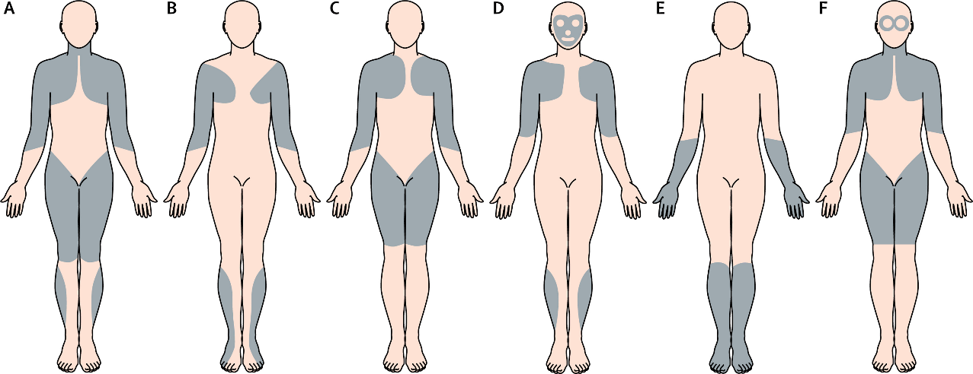
Due to their heterogeneity, one of the classification of these diseases is based on the anatomical distribution of muscle degeneration: Limb-Girdle (heterogeneous group, proximal shoulder/pelvic girdle), Emery-Dreifuss (Proximal upper extremity and distal lower extremities), Oculopharyngeal (Eyelids, throat), Duchenne and Becker (hips, legs, shoulders, spine) and many other variants (Lovering et al, 2005) (Fig. 1). Duchenne muscular dystrophy (DMD) is the most common and one of the most severe MDs.
DMD/BMD
Emery-Dreifuss MD
Limb-Girdle MD
FSHD MD
Distal MD
Oculopharyngeal MD
Figure 1) Distribution of affected muscles in different forms of MDs. Adapted from Emery, 2002.

DMD is an inherited, x-linked progressive muscle-wasting disorder caused by mutations in dystrophin (Dp427m), the largest gene in our genome, whose absence leads to membrane instability. It has a prevalence of 1 out 5-6000 males born, with extremely rare case in females. Clinically, the disease manifests in early childhood (around 2–3 years of age) with delayed motor milestones and progressive muscle weakness. Patients typically become wheelchair-dependent in their early teens, and by the age of ~20 assisted ventilation is usually required. Even with optimal physiotherapy and corticosteroid treatment, life expectancy rarely exceeds 40 years, with respiratory or cardiac failure as the primary cause of death (Duan et al, 2021). The absence of dystrophin, a protein linking the extracellular matrix with actin cytoskeleton, causes destabilization of the Dystrophin associated Glycoprotein Complex (DGC) and cause muscle fragility (Fig. 2). This fragility results in Ca⁺⁺ leakage into the cytoplasm and fiber death. This starts repeated cycles of degeneration and regeneration in myofibers. Among muscular dystrophies, Duchenne muscular dystrophy (DMD) represents the most severe and frequent form, offering a model to study the mechanisms underlying muscle degeneration and regenerative failure.

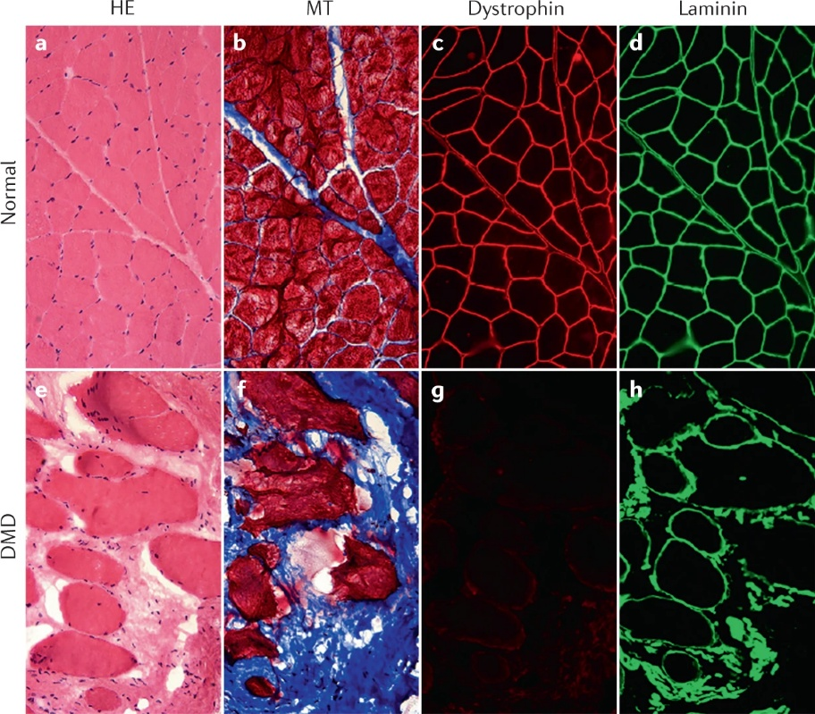
Figure 2) Staining of different sections of healthy muscle (a-d) and a DMD patient (e-h). In order: Haematoxylin and eosin staining (HE) shows inflammation, nuclear fibers distribution, connective tissue deposits and variable fiber size (a and e); Masson’s Trichrome (MT) shows increased fibrosis in blue (b and f); Dystrophin and Laminin staining shows lack of dystrophin expression in DMD patient and altered Laminin⁺ fiber size. Taken from Duan et al., 2021.

DMD: Genetic basis and pathological mechanisms
Being the largest gene in the human genome, the DMD locus is particularly prone to mutations, and thousands of different variants have been described so far. Most mutations in DMD are deletions (60–70%), with a smaller proportion consisting of duplications, point mutations, or small insertions and deletions (Aartsma-Rus et al, 2006)
The DMD gene, located on chromosome Xp21, encodes for dystrophin, a 427 kDa cytoskeletal protein. Mutations in this large locus, which spans 2.4 Mb and 79 exons, frequently result in an alteration of the protein reading frame leading to complete loss of dystrophin expression, causing Duchenne muscular dystrophy (DMD). The absence of dystrophin disrupts the connection between the cytoskeleton and the extracellular matrix, leading to sarcolemmal fragility, fiber damage and death, accompanied by chronic inflammation. Mutations or exon deletions that do not alter the reading frame produce truncated yet partially functional proteins, resulting in a milder phenotype known as Becker muscular dystrophy (BMD) (England et al, 1990). In BMD the truncation of the protein is caused mainly by deletion of internal exons (45-55) and not at its termini. (Fig. 3)

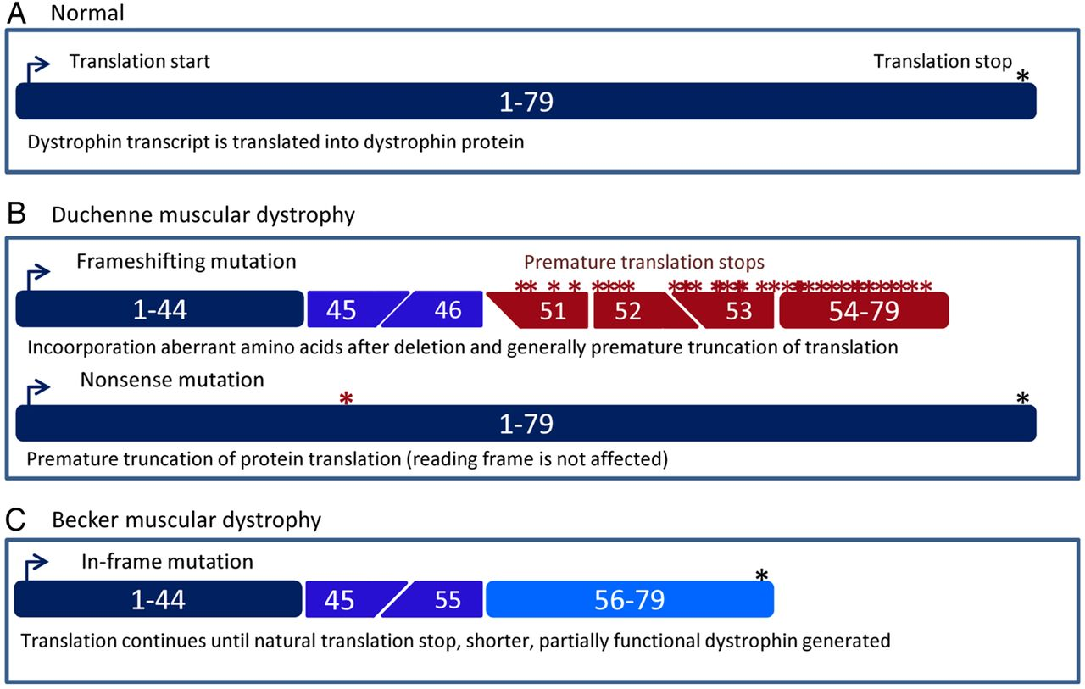
Figure 3) Schematic representation of dystrophin transcripts in healthy individuals and in patients with Duchenne (DMD) and Becker (BMD) muscular dystrophies. In the normal condition (A), the dystrophin mRNA includes 79 exons that are translated into the full-length dystrophin protein until stop codon (blue asterisk). In Duchenne muscular dystrophy (B), mutations (red asterisks, premature stop codons) often disrupt the open reading frame, leading to premature termination of translation and complete absence of functional dystrophin. These frame-shifting mutations can result from exon deletions, insertions, or nonsense mutations introducing an early stop codon. In Becker muscular dystrophy (C), instead, mutations typically preserve the reading frame. Therefore, translation proceeds to the natural stop codon, producing a shorter but partially functional dystrophin protein. This molecular distinction explains the milder clinical phenotype observed in BMD compared with DMD. Dark blue represents translated exons; in blue exons skipped during translation; in light blue exons not affected in BMD; in red possible sites of premature translation stops in DMD. Image adapted from Aartsma-Rus et al., 2015.

Loss of dystrophin disorganizes the dystrophin-associated glycoprotein complex (DGC), whose components become under expressed and mislocalized on the plasma membrane (e.g., sarcoglycans) (Fig. 4). This phenomenon, also recurrent in limb-girdle muscular dystrophies, highlights the essential structural role of these proteins in maintaining membrane integrity (Roberts et al, 2015). Moreover, sarcolemmal instability causes increased Ca²⁺ influx, triggering cytotoxic cascades and enhancing oxidative stress already generated by contraction-induced mechanical strain, ultimately leading to myonecrosis. The resulting necrosis and oxidative stress sustain a chronic inflammatory environment that further exacerbates muscle damage (Consalvi et al, 2011).
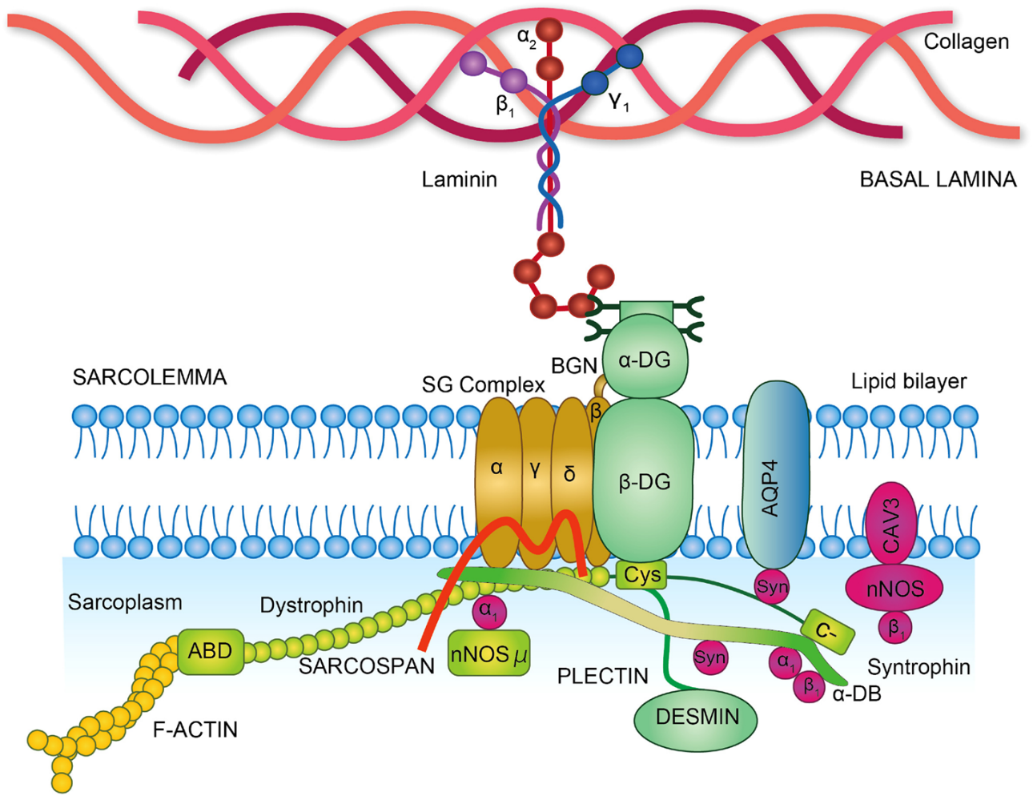
Figure 4) Schematic representation of the organization of the dystrophin-associated glycoprotein complex (DGC). Dystrophin anchors the intracellular actin cytoskeleton (F-actin) to the sarcolemma through its actin-binding domain (ABD) and interactions with β-dystroglycan. The dystroglycan complex, composed of α- and β-dystroglycan, links the cytoskeleton to the extracellular matrix by binding laminin in the basal lamina. The sarcoglycan complex (α, β, γ, and δ sarcoglycans) and sarcospan are embedded in the lipid bilayer and contribute to membrane stability. On the cytoplasmic side, dystrophin associates with adaptor and signaling proteins including syntrophins, dystrobrevin (α-DB), neuronal nitric oxide synthase (nNOS), and plectin, which in turn connects the DGC to the intermediate filament network (desmin). Additional membrane-associated proteins such as aquaporin-4 (AQP4) and caveolin-3 (CAV3) are shown. Together, the DGC provides structural support to muscle fibers and acts as a signaling hub; disruption of its components leads to sarcolemmal fragility and muscular dystrophies. Image taken from Tsoumpra et al., 2019.

Muscle loss and impaired regeneration
Following injury, in healthy muscle, muscle stem cells (satellite cells) are activated to proliferate, differentiate into myoblasts that fuse together to replace dead fibers. Quiescent satellite cells reside between the basal lamina and the muscle fiber membrane (Fig. 5). Upon activation they undergo self-amplification to establish a myogenic progenitor pool (Giordani et al, 2018). Although they represent a small fraction of the total muscle mass, satellite cells possess a strong proliferative potential capable of maintaining muscle regeneration under homeostatic conditions. Moreover, it has been shown that in different conditions and models, other types of cells may contribute to muscle regeneration, for example mesoangioblasts (Minasi et al, 2002), a pericyte-like cell population; CD133+ (Torrente et al, 2004), cells deriving from peripheral blood; different populations of pluripotent stem cells (PSC), embryonic pluripotent stem cells (ePSC) including induced pluripotent stem cells (iPSC) (Takahashi & Yamanaka, 2006).
However, studies across multiple experimental models have consistently shown that satellite cells harbour the principal regenerative potential in skeletal muscle (Zammit et al, 2004; Lepper et al, 2009). Notably, genetic ablation of satellite cells via Pax7-driven diphtheria toxin expression abolished muscle regeneration after injury, indicating that alternative progenitor populations, although reported to exhibit myogenic potential under certain conditions, cannot fully restore muscle tissue in the absence of satellite cells (Lepper et al, 2011; Sambasivan et al, 2011; Relaix & Zammit, 2012). Importantly, these findings do not exclude the presence of other myogenic or progenitor populations in muscle tissue but indicate that their contribution to regeneration is negligible when satellite cells are absent.

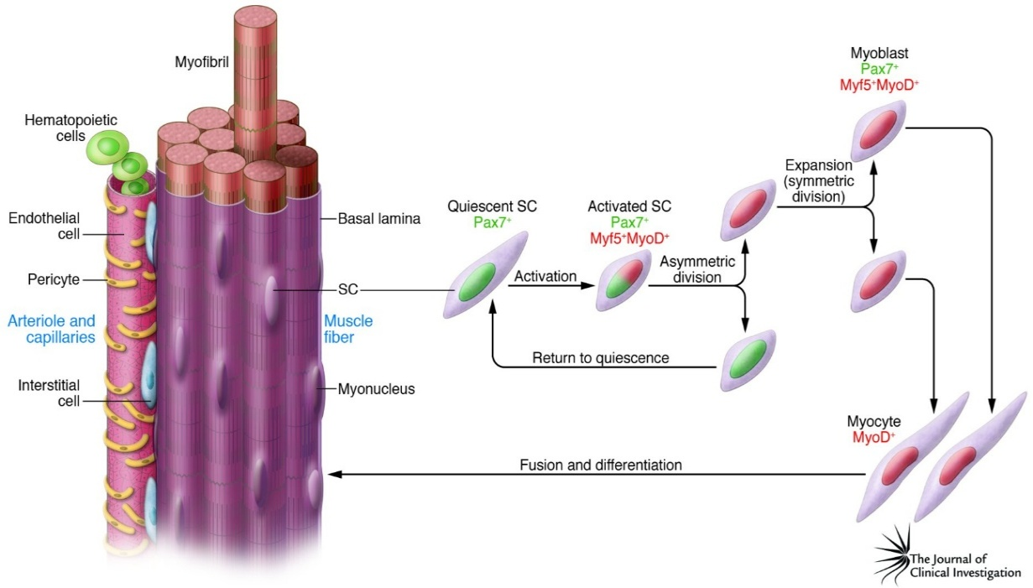In DMD, however, muscular progenitors harbour reduced proliferative potential (Blau et al, 1983; Webster et al, 1986) and the repeated cycles of degeneration and regeneration progressively shift them toward senescence. The depletion of functional progenitors leads to increased collagen deposition by FAPS/fibroblasts and expansion of adipose tissue, which further reduces the available space for myogenic regeneration. Despite remarkable technical advancements, the mechanisms underlying the progressive decline in muscle regeneration remains elusive. Among the proposed explanations, the hypothesis of excessive telomere shortening may account for the reduced proliferative capacity of satellite cells.
Figure 5) Schematic representation of the skeletal muscle stem cell (satellite cell) hierarchy. Quiescent satellite cells (Pax7⁺) residing beneath the basal lamina become activated upon injury, giving rise to Pax7⁺/MyoD⁺ progenitors that either self-renew through asymmetric division or expand through symmetric division to generate myoblasts (MyoD⁺). Myoblasts subsequently differentiate and fuse to form multinucleated myofibers, contributing to muscle growth and regeneration. From Tedesco et al., 2010.

Satellite cells exhaustion

Role of satellite cells in regeneration and evidence of reduced proliferative potential

In healthy muscle, regeneration relies mostly on satellite cells, which divide asymmetrically to replenish the stem cell pool and generate myoblasts that repair damaged fibers. In DMD, dystrophin deficiency may impair this asymmetric division, as dystrophin participates in cell polarity and orientation (Chang et al, 2018). Nevertheless, loss of polarity alone cannot explain the progressive regenerative failure, which likely results from a multifactorial impairment of stem cell maintenance and activation.
Several studies have reported that dystrophic muscle progenitors exhibit reduced proliferative potential and enter a premature senescent state, limiting the available stem cell pool for regeneration (Blau et al, 1983; Esper et al, 2024; Mouly et al, 2005; Sugihara et al, 2020).
The concept of a finite proliferative lifespan was first introduced by Leonard Hayflick, who demonstrated that normal human fibroblasts undergo only a limited number of divisions before entering replicative senescence (Hayflick & Moorhead, 1961).
Subsequent discoveries—ranging from the identification of telomeres as chromosomal end structures (McClintock, 1938) to the description of the end-replication problem (Olovnikov, 1971) and the discovery of telomerase (Greider & Blackburn, 1985)—linked this proliferative limit to progressive telomere shortening. Subsequent studies correlated the telomere length as “mitotic sensor” (Mouly et al, 2005) and their dysfunction might affect cells’ proliferative potency (Campisi & d’Adda di Fagagna, 2007).

Telomere attrition under chronic regeneration in human and animal model
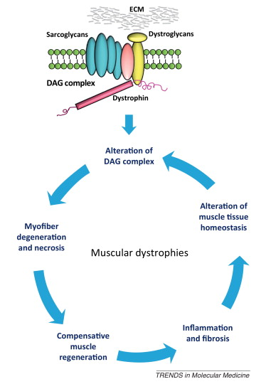
In DMD, the continuous regenerative cycles impose sustained proliferation on satellite cells and their myogenic progeny (Fig. 6). This continuous activation may increase replication-associated stress and metabolic demand, leading to oxidative damage that may further accelerates telomere erosion.
Figure 6) Alterations in the DAG complex trigger progressive necrotic degeneration of skeletal muscle, followed by repeated cycles of regeneration. Over time, this depletes the satellite cell pool and impairs regenerative capacity. Dystrophic muscles also exhibit chronic inflammation, predominantly macrophage infiltration, and develop fibrotic and adipose tissue. These changes contribute to muscle weakness and exacerbate clinical outcomes. Adapted from Fanzani et al., 2012.

Although muscle stem cells retain some telomerase activity (Wright et al., 1996), the repeated requirement to divide may prevent effective telomere elongation. Post-translational modifications or repression of hTERT expression could also contribute to insufficient enzymatic function (Daniel et al, 2012). Additional evidence suggests that telomeric oxidative lesions, particularly 8-oxoG, may interfere with telomerase activity and contribute to neotelomere formation, as recently demonstrated (Kinzig et al, 2024). Extra-telomeric effects of hTERT have been discovered as mitochondrial transcription factor for antioxidative enzyme expression (Marinaccio et al, 2023). As a result, dystrophic progenitors progressively lose proliferative capacity and become unable to reach complete myotube fusion (Webster et al, 1986), thereby reducing the regenerative output of the tissue.
Early evidence of this phenomenon came from studies on muscle biopsies of DMD patients, which revealed markedly shorter telomeres compared with age-matched controls (Decary et al, 2000). Interestingly, while telomere length remained relatively stable among healthy individuals of different ages (Decary et al, 1997), cells from dystrophic patients showed premature attrition even in children, supporting the idea that excessive regenerative turnover contributes to accelerated telomere loss in vivo. These data provided the first direct link between chronic muscle degeneration and a molecular hallmark of cellular aging.
Further confirmation came from the development of the mdx/mTR double-mutant mouse model, which combines the dystrophin deficiency of the mdx background with deletion of the telomerase RNA component (mTR).
While mdx mice alone exhibit only mild symptoms—minimal fibrosis, limited muscle wasting and normal lifespan (Bulfield et al, 1984; DiMario et al, 1991; Straub et al, 1997)—the addition of shortened telomeres dramatically exacerbated the phenotype.
The double mutant recapitulates several hallmarks of human DMD, including extensive fibrosis, calcium accumulation in muscle fibers, elevated serum creatine kinase, decreased muscle strength, and poor treadmill performance (Sacco et al, 2010). Although several DMD models are available, including dogs, non-human primates, pigs and rabbits, an emerging DMD rat model has recently been developed and shown to reproduce key pathological features of the disease, while offering practical advantages in terms of size, handling and experimental scalability (Relaix et al, 2025).
However, findings in these models therefore provides compelling evidence that telomere attrition and telomerase deficiency may be key determinants of the severe regenerative failure observed in DMD.
Altogether, these findings strongly support the concept that dystrophic muscle degeneration is accompanied by progressive telomere shortening and replicative senescence, aligning DMD with the broader framework of cellular aging and paving the way for telomerase-based interventions.

Telomeres and telomerase
Given the strong evidence that telomere dysfunction may contribute to muscle stem cell exhaustion in DMD, it is essential to understand the molecular structure and biology of telomeres and telomerase.
The existence of a mechanism controlling cell division was already postulated in 1881 by August Weismann, who proposed that “a worn-out tissue has a limited capacity to renew itself,” anticipating the later discovery that telomeres might be involved in such regulation.

Telomeres
Telomeres are non-coding tandem repeated hexamers (TTAGGG), located at both ends of each chromosome, serving as protective caps to prevent loss of coding DNA and chromosomal end-to-end fusion (Chakravarti et al, 2021). These DNA repeats are embedded in a specialized protein complex known as Shelterin, composed of six core proteins: telomeric repeat–binding factor 1 (TRF1), telomeric repeat–binding factor 2 (TRF2), TRF2-interacting protein (RAP1), TRF1-interacting nuclear factor 2 (TIN2), adrenocortical dysplasia protein homolog (TPP1), and protection of telomeres 1 (POT1). Among them, TRF1 and TRF2 specifically associate with double-stranded telomeric DNA, whereas POT1 binds to the single-stranded 3′ overhang, collectively ensuring telomere protection and length regulation.
Telomeres also adopt a higher-order configuration called the T-loop, where the 3′ single-stranded overhang (approximately 300 bases) invades the double-stranded telomeric region, forming a lasso-like structure. This configuration, stabilized by Shelterin components, prevents telomere ends from being recognized as double-strand breaks (DSBs) by the DNA repair machinery, thereby avoiding unwanted activation of repair pathways (Shay & Wright, 2011). (Fig. 7)
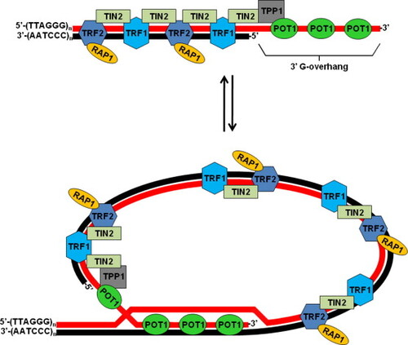
Figure 7) Structure of telomere T-loop and Shelterin complex. A model of telomere structure where 3’ G-overhang invade the distal region in duplex conformation forming the lasso-like structure, aided by the shelterin complex. Taken from Lamarche et al., 2010.
During each S phase of the cell cycle, telomeres shorten by approximately 50–150 base pairs, mainly due to the inability of DNA polymerase to fully replicate the lagging strand, a phenomenon known as the end-replication problem (Griffith et al, 1999). Progressive telomere shortening occurs in all dividing somatic cells as a consequence of incomplete lagging-strand synthesis, oxidative stress, and other DNA-damaging events. This shortening process acts as a protective barrier against uncontrolled cell proliferation and tumorigenesis.

Consequences of telomere attrition and senescence

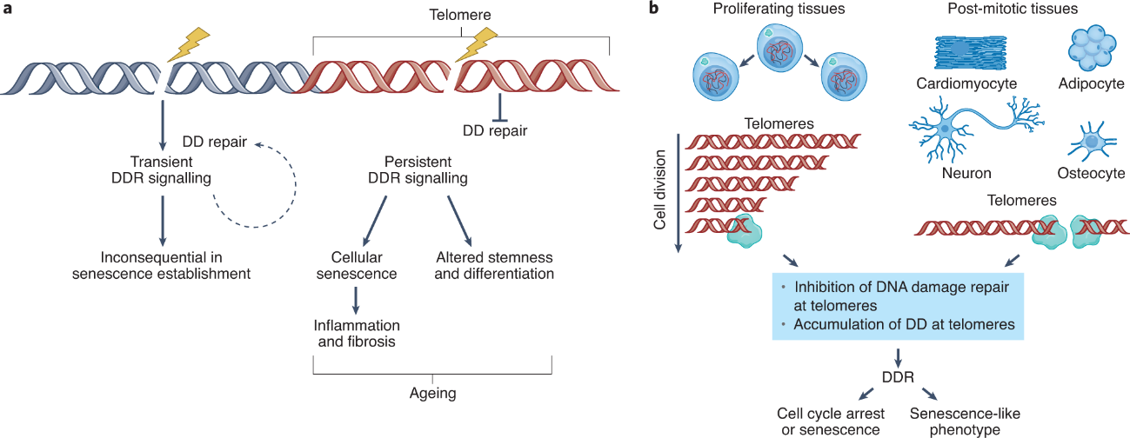
Functionally, telomeres act as molecular buffers preserving genome stability. When telomere length falls below a critical threshold, the protective Shelterin complex can no longer mask chromosome ends, which are then recognized as sites of DNA damage. This series of events may lead to an arrest of the cell cycle, switching from an “active” state to the “senescent” state. Senescence has been identified as a physiological response to numerous stressors such as starvation, hypoxia, genotoxic agents, mitochondrial dysfunction and oncogene activation (Fig. 8). Nonetheless, there is no consensus on what the definition of a senescent cell and which markers could be used to identify this state (Gorgoulis et al, 2019). Indeed, cells undergo senescence regardless of organismal age, an example is the “programmed” senescence detected even in embryogenesis, contributing to tissue development.
Figure 8) Genomic DNA damage (DD) initially triggers a transient DNA damage response (DDR). This transient signaling is often insufficient to establish the permanent state of senescence. However, irreparable, persistent DNA damage, particularly when localized at telomeres, causes a protracted DDR. In Proliferating Tissues (e.g., stem cell niches, muscle progenitors): Telomeres are shortened with each cell cycle division. When telomeres reach a critically short length, they trigger the persistent DDR, signalling damage and initiating the senescent phenotype. In Non-Proliferating, Post-Mitotic Tissues (e.g., cardiomyocytes) telomere dysfunction can be driven by irreparable DNA damage that occurs directly within the telomeric structures due to oxidative stress or other insults, independent of cell division. Taken from Rossiello et al., 2022

Uncapped telomeres activate a DNA damage response (DDR), primarily mediated by the ATM/ATR–p53–p21 pathways, resulting in either transient growth arrest, apoptosis, or entry into replicative senescence (d’Adda di Fagagna et al, 2003).
However, the DDR at dysfunctional telomeres triggers phosphorylation of histone H2AX (γH2AX) and accumulation of 53BP1 and MDC1, forming telomere dysfunction–induced foci (TIFs) that maintain chronic signalling (Takai et al, 2003). Persistent activation of p53/p21^CIP1 and p16^INK4a–Rb pathways enforces irreversible growth arrest and contributes to the senescence-associated secretory phenotype (SASP), characterized by the release of pro-inflammatory cytokines and altered metabolism (Coppé et al, 2008; Rodier et al, 2009).
Importantly, while telomere attrition represents a major driver of replicative senescence, similar DDR activation can be induced by oxidative or mechanical stress independently of telomere length, a phenomenon known as stress-induced premature senescence (Gorgoulis et al, 2019). Moreover, not all telomeres shorten at same rate/time, and already in 2001, Hemann et al. demonstrated that it is not the average telomere length but rather the presence of a critically short telomere that triggers chromosome instability and senescence (Hemann et al, 2001). More recent work has expanded this model by including telomere uncapping, TIFs, and persistent DDR rather than mere attrition.
Thus, telomere dysfunction acts as both a mitotic clock and a chronic stress sensor that limits cell proliferation and tissue renewal. In highly regenerative tissues such as skeletal muscle, excessive telomere shortening can exhaust the proliferative capacity of satellite cells, contributing to degenerative processes like those observed in DMD.

Tissue specificity and physiological variation

Telomere length and maintenance differ widely among cell types and tissues, reflecting their proliferative history, metabolic activity, and telomerase expression. Rapidly renewing compartments such as epithelia and hematopoietic progenitors display shorter telomeres and higher turnover, whereas long-lived, postmitotic tissues such as neurons and cardiomyocytes maintain more stable telomere length over time (Daniali et al, 2013; Demanelis et al, 2020). These differences may mirror the balance between cell division–driven telomere erosion and compensatory mechanisms such as telomerase activity or DNA repair.
Inherited defects in telomere maintenance further illustrate the tissue-specific consequences of telomere dysfunction. Mutations in telomerase components (TERT, TERC, DKC1) or Shelterin proteins (TINF2, POT1) underlie a spectrum of human disorders collectively known as telomere biology disorders, including dyskeratosis congenita, aplastic anemia, idiopathic pulmonary fibrosis, and Hoyeraal–Hreidarsson syndrome. These pathologies primarily affect highly proliferative tissues—bone marrow, skin, and lung epithelia—where continuous turnover renders cells particularly sensitive to telomere shortening (Armanios & Blackburn, 2012; Stanley & Armanios, 2015).
Although neurons and cardiomyocytes are largely postmitotic, growing evidence indicates that telomere dysfunction also contributes to degenerative processes, such as DMD, in these tissues through non-canonical mechanisms (Mourkioti et al, 2013; Saretzki, 2023). Persistent DNA damage signalling, mitochondrial impairment, and increased oxidative stress can activate a telomere-associated DNA damage response (TA-DDR) independently of cell division, promoting functional decline (Liu et al, 2023; Yeh et al, 2019). Such “replication-independent” telomere damage links chronic oxidative stress to age-related diseases of the nervous and cardiovascular systems.
In skeletal muscle, telomere length is relatively stable in quiescent fibers but progressively shortens in satellite cells during repeated regenerative cycles. Telomere erosion in these progenitors has been associated with the age-related decline in muscle regenerative potential (Decary et al, 1997; Renault et al, 2000). In pathological conditions such as Duchenne muscular dystrophy (DMD), where continuous fiber degeneration imposes sustained proliferation on satellite cells, telomere shortening is markedly accelerated. Studies in DMD patients have shown that telomeres in both skeletal and cardiac muscle are significantly shorter than in age-matched controls (Decary et al, 2000), and experiments in the mdx/mTR mouse model confirmed that telomerase deficiency aggravates fibrosis, inflammation, and muscle weakness (Sacco et al, 2010; Tichy et al, 2021).
Altogether, these observations underscore that telomere dynamics are shaped by both intrinsic proliferative demand and extrinsic stress conditions, which together dictate tissue-specific rates of telomere attrition. The interplay between these factors becomes especially relevant in chronic degenerative diseases such as DMD, where excessive regeneration, inflammation, and oxidative stress converge to accelerate telomere loss.

Mechanisms accelerating telomere shortening

In addition to the end-replication problem, several environmental and metabolic stressors can accelerate telomere erosion. Reactive oxygen species (ROS), chronic inflammation, and replication stress are among the major contributors, as telomeric DNA—being guanine-rich—is highly susceptible to oxidative damage. Oxidation of guanine residues to 8-oxo-guanine hampers proper replication fork progression, promotes single-strand breaks, and accelerates telomere loss (Hewitt et al, 2012; von Zglinicki, 2002).
Persistent telomere dysfunction also triggers a chronic DNA damage response (DDR), leading to activation of p53–p21 and NF-κB signaling cascades. These pathways reinforce cellular senescence and promote a senescence-associated secretory phenotype (SASP), characterized by the secretion of pro-inflammatory cytokines such as IL-6 and TNF-α, further amplifying oxidative stress and telomere attrition in neighboring cells (Kane & Sinclair, 2019).
Emerging evidence suggests that telomere shortening may also alter local chromatin architecture, reducing the telomere position effect (TPE) and leading to derepression of subtelomeric genes with potential pro-inflammatory or stress-related functions (Robin et al, 2014; Suda et al, 2021). Although the extent of this mechanism in human tissues remains under investigation, it may represent an additional layer linking telomere dysfunction to chronic inflammation and tissue degeneration.
In the context of muscular dystrophies such as DMD, persistent oxidative stress, mitochondrial dysfunction, and NF-κB activation are hallmarks of disease pathology and may exacerbate telomere erosion beyond the expected rate from replication alone. This cumulative telomere dysfunction enhances senescence of muscle progenitors and further limits regenerative capacity, contributing to disease progression.

Telomerase

Complex structure, assembly and telomere interaction

To counteract telomere loss, certain cell types express telomerase (TERT), an enzyme that elongates chromosome ends by synthesizing new telomeric repeats using its intrinsic RNA component as a template.
The holoenzyme telomerase is a ribonucleoprotein complex consisting of a reverse transcription catalytic subunit (TERT), a non-coding RNA component acting as template (TERC) and different cofactors (Fig. 9). Many of these cofactors have been identified throughout the years and can be divided into stably associated to the complex and transiently associated. Notably, co-expression of TERT and TERC is able to exert their function in a context of cell extract or in vitro (Mitchell & Collins, 2000; Tesmer et al, 1999).
The interaction between TERT and TERC is highly influenced by RNA secondary structures in TERC through specific domains. TERT sequence contains an N-terminal domain (TEN), the reverse transcriptase catalytic core (RT), an RNA binding domain (TRBD) and a C-terminal extension (CTE). It has been shown that TERT binds to the Pseudoknot template (PK/T) and CR4/5 domains of TERC, “invading” the catalytic component. Both factors are necessary to reach fully active telomerase (Chen et al, 2002; Robart & Collins, 2010). Cryo-EM and biochemical studies elucidated TERT structure as canonical compared to other reverse transcriptases, that is a “ring” structure arranging a central channel that accommodates the hybrid template substrate of DNA-RNA allowing the exit of newly synthesized telomeric DNA (Jiang et al, 2018; Nguyen et al, 2018). On the other side, TERC RNA is scaffolding diverse accessory proteins such as TCAB1 (telomerase Cajal Body protein 1, for Cajal Body association and telomerase trafficking into the nucleus) and the Diskerin complex (comprising Diskerin protein, NOP10 and NHP2) (Roake & Artandi, 2020). Hence, the RNA template region (3′-CAAUCCCAAUC-5′) binds 3’-end of telomeric single strand, and the telomerase is associated with TPP1-POT1, and indirectly with TRF1/2 and RAP1, member of the Shelterin complex, through TEN domain, stabilizing the holoenzyme (Wang & Meier, 2004). The assembly of the catalytically competent telomerase complex occurs in the nucleus, yet its recruitment to telomeres and subsequent activation depend on a finely tuned network of chaperones and trafficking proteins. Among these, Hsp90, p23, and the Cajal body–associated factor TCAB1 play essential roles in TERT stabilization and nuclear import.
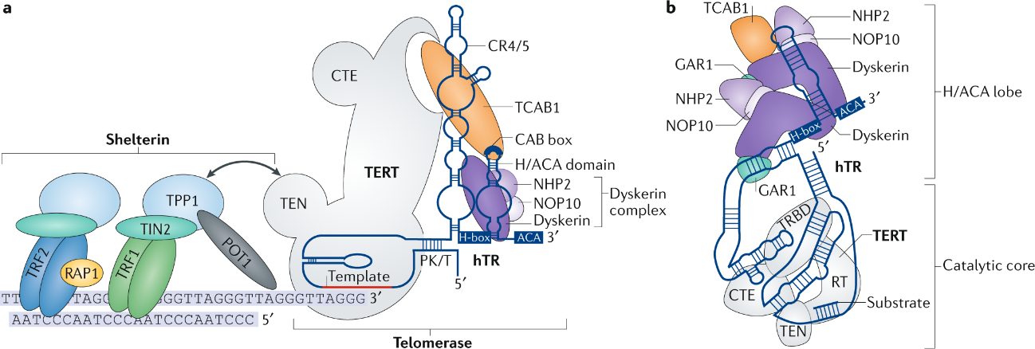
Figure 9) Shelterin, telomerase and their association with telomeres. A) The functional telomerase complex is an RNP composed of TERT (catalytic enzyme) and hTR (RNA scaffold). hTR's H/ACA domain is bound by the dyskerin complex, while its template region is used by TERT (via TRBD) to synthesize telomeric repeats. The telomere end is capped by the Shelterin complex, which includes TRF1, TRF2, RAP1, TIN2, and POT1. The critical recruitment of telomerase to the telomere is mediated by TPP1 (part of Shelterin), which interacts directly with the TEN domain of TERT. B) The telomerase complex adopts a flexible, RNA-tethered two-lobed structure. The first lobe comprises the hTR H/ACA domain, bound by two sets of the dyskerin complex (including Dyskerin, NHP2, NOP10, and GAR1) and TCAB1. The second lobe contains the catalytic core, where TERT and hTR encircle the telomere substrate. The two lobes are connected by the CR4/5 domain of hTR. Adapted from Nguyen et al., 2018

Telomerase biogenesis, recruitment and subcellular trafficking
In most somatic cells, telomerase expression is repressed at the end of embryonic development, leading to progressive telomere shortening throughout life (Yang et al, 2002). While hTERC is widely and ubiquitously expressed in human adult cells, expression of hTERT is restricted to specific cell types, such as germ cells, epithelial and intestinal stem cells, and activated lymphocytes (Wright et al, 1996) and to different developmental stages, reaching its transcriptional suppression in most tissues (Bodnar et al, 1998).
For instance, numerous studies have demonstrated that primary human fibroblasts lack detectable hTERT expression and telomerase activity, resulting in progressive telomere shortening (Cao et al, 2011; Razdan et al, 2018; Zhou et al, 2009). Interestingly, iPSC reprogrammed fibroblast re-express telomerase, reinforcing its role in development and commitment, indicating that epigenetic silencing is driven by promoter methylation (Agarwal et al, 2010; Zhong et al, 2012).
The hTERT gene is approximately 40 kb, comprising of 16 exons and 15 introns on chromosome 5. It has different binding sites for numerous transcription factors as Myc Klf-1 and SP1, despite having a single promoter. Re-expression of these transcription factors does not entirely rescue hTERT expression in somatic cells (Oh et al, 2001; Wong et al, 2010).
Recently, studies have proposed mechanisms explaining the lack of hTERT expression in somatic cells by exon 2 skipping in mRNA transcript in differentiated cells while stem cells were still expressing it (Penev et al, 2021; Withers et al, 2012).
Telomerase recruitment to telomeres is based on cell cycle. As a very conserved mechanism, telomerase recruitment at telomeres during S phase is similarly shared among different species, as humans and budding yeasts (Jády et al, 2006; Nandakumar & Cech, 2013; Tomlinson et al, 2008). The recruitment is driven by TERT-TPP1 interaction, that is linked to other telomere proteins as TIN2, TRF1/2 and POT1 which link the single-strand telomere overhang (Baumann & Cech, 2001). Loss of TIN2 or TPP1 impairs telomerase recruitment at telomeres as TPP1 interacts with TERT with a “patch” of amino acids called “TEL patch” (Xin et al, 2007; Zhong et al, 2012). Mutations in the binding sites of the TEL patch led to decreased telomerase processivity and excessive telomere shortening, leading to clinical manifestations as Dyskeratosis congenita, a pathology characterized by very short telomeres (Schmidt et al, 2016).
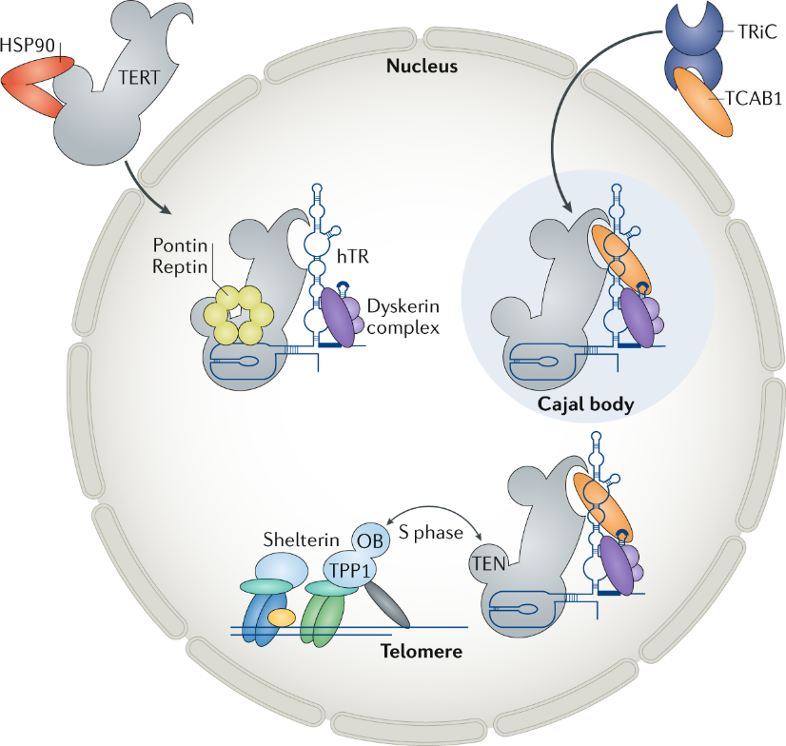
Although TERT exerts its function on DNA, its localization has a very dynamic pattern: as other small Cajal body-specific ribonucleoproteins (scaRNPs) TERT resides in Cajal Bodies within the nucleus. After translation, TERT is folded and transported in the nucleus by chaperon Heat Shock Protein 90 (HSP90), then bounded with Reptin and Pontin to complex with Dyskerin complex. In the Cajal Bodies, TCAB1 is added to the assembly complex (Roake & Artandi, 2020) (Fig. 10).
Figure 10) The functional telomerase ribonucleoprotein (RNP) is assembled through highly regulated steps. The catalytic protein TERT requires maturation by the chaperone HSP90. The hTR scaffold is bound co-transcriptionally by the Dyskerin complex (including Dyskerin, NOP10, NHP2, and NAF1). Pontin and Reptin promote the final holoenzyme assembly. Nuclear transport is mediated by TCAB1 (assisted by TRiC), which correctly targets the complex to Cajal bodies; TCAB1 absence leads to mislocalization (e.g., to the nucleolus). Final telomere recruitment occurs during S phase via a key interaction between the N-terminal domain (TEN) of TERT and the TEL patch on the telomeric capping protein TPP1. Image taken from Roarke and Artandi, 2020.
Recent live-cell single-molecule imaging has revealed that human telomerase uses three-dimensional nuclear diffusion to probe telomeres thousands of times during S-phase, yet only rarely forms a long-lived association capable of elongation; this dynamic behaviour underscores that telomerase is not permanently bound to chromosome ends but instead engages in a highly regulated, transient recruitment process (Schmidt et al., 2016).
Nonetheless, telomerase is best known for its canonical role in elongating telomeres, but growing evidence indicates that hTERT also exerts several non-canonical functions beyond the nucleus, particularly under stress or ageing conditions.

Telomerase regulation under stress and ageing
As previously mentioned, telomerase is tightly associated with stemness, even after iPSC reprogramming. Its expression virtually allows infinite replicative lifespan in stem cells. Moreover, overexpression of the enzyme is sufficient to immortalize cells in most cases (Shitova et al, 2024). Interestingly, in the specific case of myogenic progenitors, telomerase itself is unable to induce prolonged replicative potency, but this was overcome by bypassing cell-cycle checkpoints protein (Cdk-4, Bm-1), leading to proliferative increase (Benedetti et al, 2018; Zhu et al, 2007)
Notwithstanding its fundamental role in maintaining cellular homeostasis, telomerase reactivation occurs in more than 80% of human cancers, enabling limitless replicative potential (Hanahan & Weinberg, 2011). While telomerase is the primary mechanism for telomere elongation, a minority of tumors rely instead on alternative lengthening of telomeres (ALT) via recombination (Yuan et al, 2019)
In contrast, normal somatic cells progressively age, undergoing telomere erosion and replicative senescence, whereas stem and cancer cells evade this limitation by maintaining or reactivating telomerase. Beyond its canonical function in sustaining replicative potential, telomerase is deeply linked with the cellular response to aging and stress. Its regulation in these contexts reveals how environmental and metabolic challenges can reshape both telomere dynamics and hTERT localization
Aging, broadly defined as the progressive functional decline of biological systems, remains one of the least understood processes in biology. The scientific debate revolves around whether aging represents a programmed process encoded in our genome—a form of evolutionary selected termination of development, or rather a stochastic accumulation of molecular damage over time. In this context, telomerase could counteract aging by reducing telomere attrition, but its expression in adult is restricted to only high proliferative cell types. However, cells and tissue under chronic stress and/or inflammation undergo premature aging for ROS accumulation, accelerate telomere shortening, DSBs, epigenetic alteration and impaired autophagy (López-Otín et al, 2023). Among the various sources of chronic stress contributing to accelerated telomere attrition, inflammation plays a particularly central role. Persistent inflammatory signalling not only promotes oxidative damage but also interferes directly with telomerase regulation.
Inflammation is a complex mechanism part of natural response following physical, chemical and biological stimuli (Germolec et al, 2018) (Fig. 11), activating different pathways with pro-inflammatory tumor necrosis factor-alpha (TNF-α), interleukin (IL)-6, IL-8, IL-1β, IL-12, IL-23, interferon families, and others- and anti-inflammatory factors synthesis such as IL-4, IL-10, IL-13, IL-11. Upstream cytokines production, the activation of Nuclear Factor kappa B (NF-kB), one of the most important transcription factors initiating the cascade signalling, is a key step to start the pathway (Liu et al, 2023). Usually, inflammation acts as acute response to bring back homeostasis balance within the tissues. However, in certain contexts, the resolution phase fails, leading to chronic, self-sustaining inflammation.
Chronic inflammation is a risk factor for several disorders, comprising chronic respiratory diseases, autoimmune diseases, cancers and neurodegenerative diseases (Cildir et al, 2017; Shirazi et al, 2017). It has been shown that chronic inflammation exacerbates telomere disfunction in NF-κB1−/− mouse, a model with low inflammation levels (Jurk et al, 2014). Remarkably, in pathologies with persistent NF-kB activation, such as DMD, there is an increased telomere shortening in muscle satellite cells (Tichy et al., 2021)
Altogether, TNF-alfa and p38 MAPK signalling pathway can impact on telomere/telomerase system through NF-kB pathway (Tokunaga et al., 2013). After a stress, TNF-alfa can activate Activating Transcription Factor 7 (ATF7) phosphorylated by p38 causing ATF7 release and detachment of telomerase from telomeres. For example, p38 MAPK is strongly activated after acute exercise, reducing TRF1 expression, a Shelterin component regulating telomere length impacting on mouse skeletal muscle cells (Ludlow et al, 2012). In addition to transcriptional repression under chronic inflammation, telomerase is also regulated post-translationally. Stress signalling pathways can alter hTERT localization, driving its transient export from the nucleus to the cytoplasm and even mitochondria.
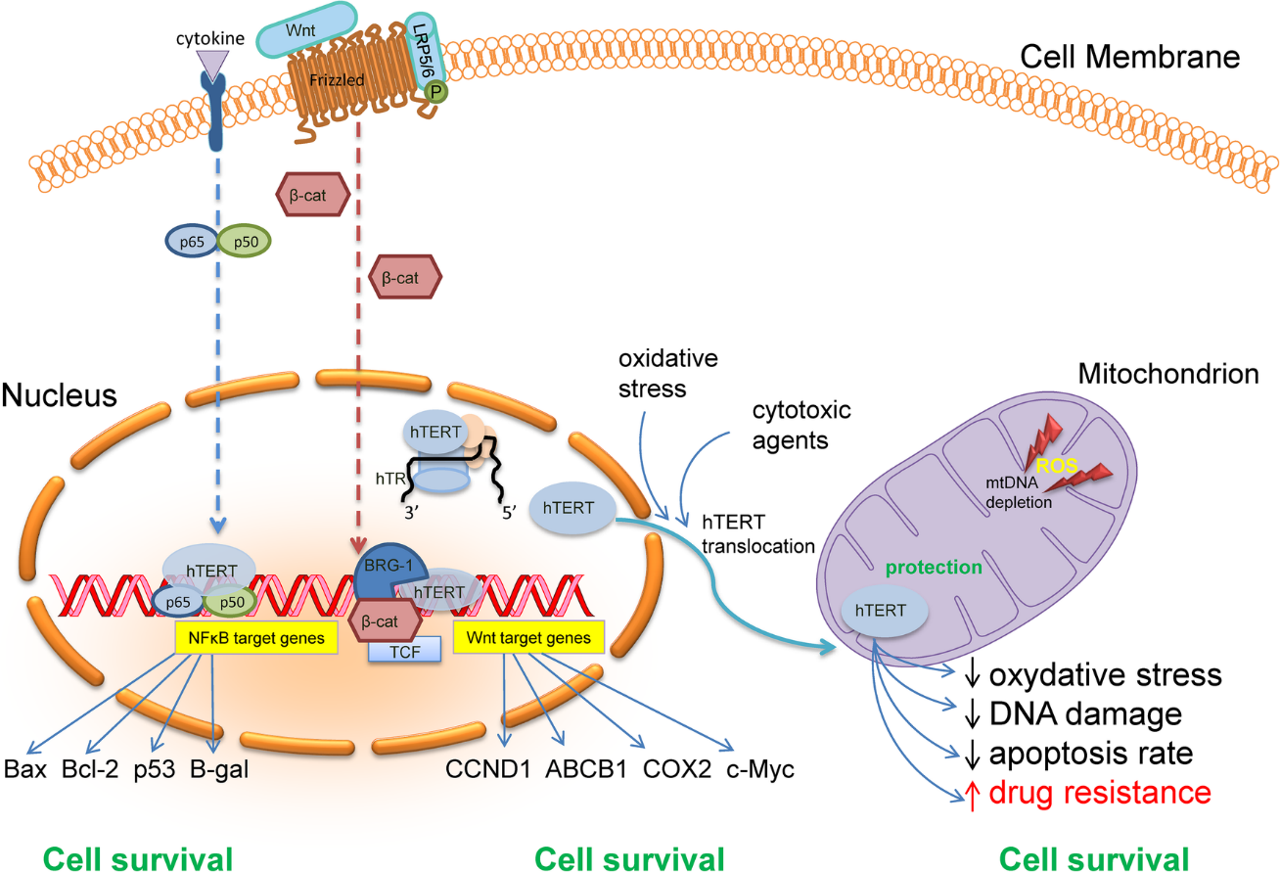
Figure 11) Schematic overview of the extra-telomeric functions of hTERT. Under oxidative or cytotoxic stress, hTERT can translocate from the nucleus to mitochondria, where it mitigates ROS accumulation, mtDNA damage, and apoptosis. In the nucleus, hTERT interacts with transcriptional regulators such as NF-κB and β-catenin/TCF, modulating target genes involved in cell survival, proliferation, and stress response. Adapted from Romaniuk et al., 2018.
Once translated, TERT can undergo different modification causing its shuttling from the nucleus to the cytoplasm. The most frequent modification is phosphorylation by AKT, PKC and SRC kinases. Especially SRC kinase, with Tyr⁷⁰⁷ phosphorylation under oxidative stress conditions, and AKT cause the translocation of TERT from nucleus to cytoplasm (Haendeler et al, 2003; Jeong et al, 2015). On the other hand, dephosphorylation by ShP2 reverses this effect (Jakob et al, 2008) (Fig. 12).
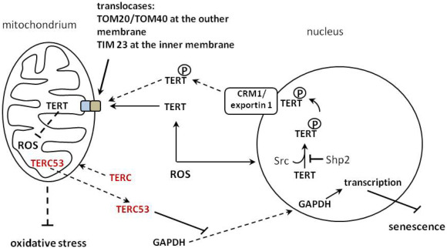
Figure 12) Model of hTERT subcellular shuttling and mitochondrial protection under oxidative stress. Upon oxidative stimuli, phosphorylated hTERT translocates from the nucleus to mitochondria through the TOM/TIM complex, where it reduces ROS accumulation and mtDNA damage. Image taken from Boniewska-Bernacka et al., 2020.
Additionally, TERT translocation can lead the enzyme towards mitochondria. It has been shown that in the telomerase sequence there is 20 amino acids motif that allows its translocation in mitochondria (Santos et al, 2004). In conditions of mild stress, ectopically expressed telomerase cannot counteract telomere shortening, but is able to reduce mitochondrial DNA damage (Ahmed et al, 2008).
Altogether, these findings highlight the dual nature of telomerase: while its constitutive activation promotes cellular immortality and oncogenic transformation, its absence predisposes cells to premature senescence and impaired regenerative capacity. In this view, the ability to finely modulate telomerase expression and activity becomes a therapeutic opportunity rather than a risk. Indeed, controlled and transient expression of hTERT could counteract telomere attrition and oxidative damage in chronic degenerative settings—such as muscular dystrophies—without inducing uncontrolled proliferation.

Advances in therapies for DMD.
The first official medical description of Duchenne muscular dystrophy (DMD) dates back to 1868, when Duchenne de Boulogne provided a detailed account of this progressive muscle wasting condition. More than a century and a half later, despite remarkable advances in molecular biology and genetics, no definitive cure has yet been developed.
Since the pioneering study in 1989, in which transplantation of normal myoblasts into mdx mice restored dystrophin expression in host fibers (Partridge et al, 1989), cell therapy has been extensively explored as a potential treatment for dystrophinopathies. However, subsequent preclinical and clinical trials revealed several critical limitations related to myoblast transplantation, including poor survival, limited migration, and the need for repeated local injections. These drawbacks prompted the investigation of alternative cell types with greater regenerative and engraftment potential for muscle repair.
More recently, gene therapy approaches have emerged, including adeno-associated viral (AAV) vectors delivering micro- or mini-dystrophins, CRISPR/Cas9-based genome editing, and antisense oligonucleotide (ASO) therapies for exon skipping (Shimizu-Motohashi et al., 2025). Although these strategies have produced encouraging results in preclinical models, clinical outcomes have so far shown limited efficacy, and long-term safety remains critical, after the death of several DMD patients in clinical trials by Pfizer, Sarepta and others (Table 1).
Table 1) Current therapeutic approaches for Duchenne muscular dystrophy. Overview of the main therapeutic strategies currently pursued in Duchenne muscular dystrophy, including standard-of-care and experimental approaches. (Jolly et al, 2025)
Therapeutic strategy | Mechanism of action | Target level | Clinical status | Main limitations
Corticosteroid treatment | Anti-inflammatory and immunomodulatory effects to slow muscle degeneration | Muscle environment | Standard of care | Does not restore dystrophin; long-term side effects
Exon-skipping therapies | Modulation of dystrophin pre-mRNA splicing to restore the reading frame | Gene expression | Approved for selected mutations | Mutation-specific; low dystrophin expression levels
Gene replacement therapy (AAV-based) | Delivery of micro- or mini-dystrophin constructs | Gene / protein | Advanced clinical trials | Immune responses; vector size and dose limitations
Genome editing approaches | Permanent correction of dystrophin mutations (e.g. CRISPR/Cas9) | Genome | Preclinical / early clinical | Delivery efficiency; safety and off-target concerns
Cell-based therapies | Transplantation of myogenic progenitors to promote regeneration | Cellular regeneration | Clinical trials | Limited engraftment; scalability and persistence
Supportive and metabolic therapies | Improvement of muscle stability and metabolic function | Tissue function | Clinical trials | Symptomatic; non-curative

At present, DMD management mainly relies on symptomatic treatment. Corticosteroids remain the standard of care to slow disease progression, despite their well-documented adverse effects with long-term administration. Drugs to support cardiac function have also extended lifespan and quality of life. Supportive physiotherapy and assisted ventilation are also routinely used to improve quality of life and delay loss of function (Verhaart & Aartsma-Rus, 2019).

Cell-based therapies

Myoblast transplantation
From the beginning of cell therapy, myoblast seemed the ideal candidate for a possible cure. As mentioned before, the first demonstration that this hypothesis could work came from successful myoblast transplantation in mdx mice (Partridge et al., 1989). However, subsequent preclinical and clinical trials revealed several major limitations, including extensive myoblast death shortly after transplantation (Fan et al, 1996), limited migratory capacity that required multiple local injections to achieve measurable engraftment (Skuk et al, 1999), and poor myoblast survival under cyclosporine-based immunosuppression (Hong et al, 2002). After these trials, three major issues were confirmed by several research: majority of myoblasts die in the first 3 days after intra-muscular transplantation; low migration from injection site; inadequate immunosuppression leads to cell rejection (Mouly et al, 2005). Subsequent trials showed greater myoblast local engraftment and dystrophin production with a “high-density protocol” and multiple injections per cm², but these were the best results so far (Skuk et al, 2007, 2006, 2004).
These challenges prompted the exploration of alternative sources of cells able to be successfully transplanted and regenerate muscles.

Alternative myogenic progenitors
In parallel with the initial attempts to transplant myoblasts, new studies began to identify additional cell populations with potential myogenic capacity. In the late 1990s, several mesodermal progenitors were characterized that shared key features with muscle precursors. Among them were the cells termed mesoangioblasts—so named because of their mixed phenotype of mesoderm progenitors (meso) and vessel-derived angioblasts (Minasi et al, 2002) (Fig. 13).
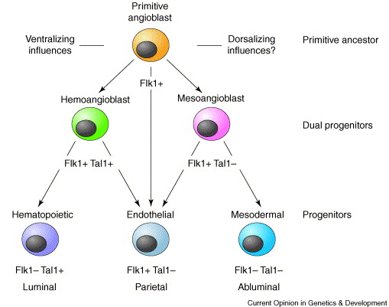
Figure 13) Hypothetical model of mesoangioblast origin. Schematic representation of the proposed developmental relationships between primitive angioblasts and their downstream lineages. According to this model, mesoangioblasts originate from Flk1⁺ precursors with dual endothelial–mesodermal potential, diverging from hemoangioblasts that give rise to hematopoietic and endothelial cells. Taken from Cossu and Bianco, 2003.
Their discovery stemmed from the isolation of dorsal aorta–derived cells from mouse embryos, which expressed both pericyte and early endothelial markers and exhibited strong proliferative potential in vitro as well as multilineage differentiation capacity within the mesodermal lineages (De Angelis et al, 1999).
These progenitors were subsequently isolated from other species, including rat, dog, and human. While embryonic cells display both endothelial and pericyte traits, postnatal mesoangioblasts more closely resemble pericytes yet retain high proliferation and myogenic (smooth and skeletal) differentiation potential.
Notably, mesoangioblasts can cross the endothelial barrier, which allows systemic delivery via the circulation, migrate under the basal lamina, and fuse with regenerating fibers, contributing to myosin heavy chain (MHC) and dystrophin expression (Galvez et al, 2006).
Furthermore, allogenic mesoangioblasts transplanted via intra-arterial delivery led to functional improvement and preserved ambulation in dystrophic dogs (Sampaolesi et al, 2006) under a regime of immune suppression and phenotype amelioration in α-sarcoglycan–null mice (Sampaolesi et al, 2003).
Following these promising results, a first-in-human clinical trial was conducted to evaluate the safety and efficacy of intra-arterial mesoangioblast delivery (Cossu et al, 2015). The study involved five DMD patients who received four consecutive intra-femoral arterial infusions of HLA-matched donor mesoangioblasts derived from a sibling. The treatment proved to be safe and well tolerated, yet its clinical efficacy remained limited. Donor-derived dystrophin expression was detected only in the youngest patient, at levels comparable to those achieved in exon-skipping trials (Goemans et al, 2016).
The modest outcome was attributed to several factors, including the advanced age of enrolled patients (selected for safety reasons), chronic corticosteroid therapy that impairs mesoangioblast adhesion to the endothelium, suboptimal cell dosage, and species-specific anatomical and biomechanical differences limiting efficient muscle targeting.
Despite these limitations, this trial provided important insights into the challenges of translating cell therapy from animal models to human patients and underscored the need for strategies enhancing cell survival, migration, and engraftment efficiency.

Stem cell–derived myogenic cells and gene editing
The advent of induced pluripotent stem cell (iPSC) technology (Takahashi and Yamanaka, 2006) was a game changing event in advanced regenerative medicine. It opened new perspectives for drug screening, disease modelling, autologous cell therapy (Cerneckis et al, 2024), as well as in DMD, allowing the generation of patient-specific myogenic progenitors that could, in principle, restore dystrophin expression without immune rejection (Darabi et al, 2012; Shoji et al, 2015).
iPSC-derived myogenic progenitors can be obtained through transgene-mediated reprogramming followed by directed myogenic differentiation. Various strategies have been developed to induce myogenic differentiation from iPSCs, including forced expression of key transcription factors such as PAX7 or MyoD, and stepwise modulation of signalling pathways (Wnt, FGF, BMP) to mimic embryonic myogenesis (Chal et al, 2015; Darabi et al, 2012; Shelton et al, 2014). Despite these advances, iPSC-derived myogenic progenitors often display variable differentiation efficiency and heterogeneous phenotypes, posing challenges for reproducibility and scalability (Young et al, 2016). Incomplete differentiation can result in residual pluripotent cells and chromosomal instability, increasing the risk of teratoma formation upon transplantation (Kim et al, 2013). Furthermore, the reprogramming and genetic correction processes—commonly relying on integrative viral vectors, PiggyBac transposons, or CRISPR/Cas9—may introduce genomic instability or off-target modifications (Pacesa et al, 2024). In addition to intrinsic risks, large-scale production and functional maturation of iPSC-derived myogenic progenitors remain major bottlenecks for clinical translation (Piga et al, 2019; Shelton et al, 2014).
Although iPSC-derived myogenic cells and organoids represent a powerful platform for disease modelling and potential autologous therapies, their clinical translation is still hindered by technical and safety constraints (Yang et al, 2025). Consequently, therapeutic research has increasingly shifted toward gene-based approaches that aim to restore dystrophin expression directly in patients’ muscle fibers, minimizing the need for extensive cell manipulation.

Gene therapy approaches

AAV-mediated micro- and mini-dystrophin delivery
In vivo gene therapy aims to correct genetic diseases at their molecular origin by restoring, replacing, or editing defective genes. Unlike cell-based therapies, which rely on the transplantation of exogenous cells, gene therapy directly targets patient tissues to re-establish proper protein expression.
Over the past two decades, rapid advances in vector design and delivery technologies have enabled several successful clinical applications, particularly for monogenic disorders affecting the retina and spinal motoneurons in the nervous system (Naso et al, 2017). Among the various platforms developed, adeno-associated viruses (AAVs) have emerged as the most commonly used vectors for in vivo gene delivery due to their ability to transduce non-dividing cells, their relatively stable episomal persistence, and their relatively low immunogenic profile. This has made them the main vehicle for micro- and mini-dystrophin replacement strategies in Duchenne muscular dystrophy (DMD).
For DMD, the major limitation arises from the gene’s exceptional size (2.4 Mb, with a coding sequence exceeding 14 kb), which vastly surpasses the ~4.7 kb packaging capacity of AAV vectors. To overcome this, several truncated constructs — known as micro- and mini-dystrophins — have been engineered to retain key functional domains (the actin-binding N-terminus, central rod domain repeats, and C-terminal dystroglycan-binding site) while fitting into the AAV genome (Duan et al, 2021).
The first human trial testing AAV-mediated micro-dystrophin delivery was initiated in 2023 by Sarepta Therapeutics using delandistrogene moxeparvovec-rokl (Elevidys, formerly SRP-9001) in ambulatory DMD children. The AAV vector, AAVrh74, is a serotype showing high tropism for skeletal muscle, originally isolated from rhesus macaque (Macaca mulatta) tissues (Chicoine et al, 2014). Initial phases showed partly encouraging results, with increased motor scores (North Star Ambulatory Assessment, NSAA) and correct dystrophin localization, but severe immune-mediated adverse events such as myositis and myocarditis were later reported (Zaidman et al, 2023).
Moreover, during the Phase III ENVISION trial (NCT05881408), two non-ambulatory DMD patients experienced acute liver failure resulting in fatalities, leading to temporary suspension of the study. Other reports have described adverse effects such as acute kidney injury and thrombocytopenia (Chwalenia et al, 2025).
Despite these challenges, immune responses to viral capsid proteins (that prevents a second administration when expression begins to be reduced, after few years) and transgene products, as well as dose-related toxicities, remain the primary limitations of AAV-based therapy (Wang et al, 2024). Additionally, large-scale vector manufacturing and cost of production pose further hurdles to clinical translation.
Nonetheless, AAV-mediated micro-dystrophin therapy remains one of the most advanced and clinically relevant experimental approaches for DMD, paving the way for safer and more durable gene delivery strategies.

RNA-based therapeutic approaches
In parallel with the development of gene therapy approaches aimed at achieving permanent correction at the DNA level, RNA-based strategies have been investigated as safer and more versatile alternatives. These tools act downstream of the genome, modulating gene expression without altering DNA sequences.
The COVID-19 pandemic has further accelerated the adoption of this technology, as many of the vaccines developed were based on mRNA platforms. While mRNA is primarily exploited for transient protein or epitope synthesis, antisense oligonucleotides (ASOs) enable targeted regulation of RNA expression through exon skipping, translational inhibition, or transcript degradation. Among these, antisense oligonucleotide–based exon skipping has reached the most advanced clinical development for DMD, representing the first RNA-based therapeutic class approved for this disease.

Antisense oligonucleotides (ASOs) and exon skipping
ASOs are short single-stranded nucleic acid sequences (typically 25–30 nucleotides) designed to bind complementary regions of a target pre-mRNA to modulate its post-transcriptional processing. By promoting exon skipping or transcript degradation, ASOs enable precise control over gene expression (Chwalenia et al., 2025).
In the context of DMD, where numerous mutations disrupt the dystrophin reading frame, exon-skipping approaches initially emerged as a promising therapeutic strategy. The rationale is to bypass the mutated exon to restore the open reading frame, thereby converting a severe DMD phenotype into a milder Becker-like one (Aartsma-Rus et al, 2009; Roberts et al, 2020), resulting in an internally deleted but still functional dystrophin protein. Moreover, this ASO-mediated exon-skipping approach can be tailored to specific mutation genotypes, potentially covering the majority of DMD-causing variants (Bladen et al, 2015).
Despite their theoretical versatility, ASO efficacy is limited by several intrinsic factors: DNA- and RNA-based ASOs are prone to nuclease degradation, exhibit modest binding affinity, and show poor tissue and cellular penetration (Roberts et al., 2020). Chemically modified ASOs, such as phosphorodiamidate morpholino oligomers (PMOs), feature a neutral phosphorodiamidate backbone analogous to DNA phosphodiester bonds. This confers remarkable resistance to nucleases and increased molecular stability in biological fluids (Amantana & Iversen, 2005; Summerton & Weller, 1997), making PMOs a preferrable platform for clinical exon-skipping applications.
After preclinical assessment of safety profile (3 g/kg, (Wu et al, 2010), four PMO ASOs have been approved by the FDA for DMD treatment: eteplirsen, golodirsen, casimersen (Sarepta), and viltolarsen (NS Pharma) (Chwalenia et al., 2025). Some severe adverse events were reported (Haque et al., 2024) and therapeutic benefit remained limited, with only modest dystrophin restoration—approximately 5.9% after 25 weeks of viltolarsen treatment (Clemens et al, 2020). Notably, none of these ASOs have yet been approved by the European Medicines Agency (EMA).
To address these limitations, alternative RNA-based strategies have been explored. One notable approach involves the use of modified small nuclear RNAs (snRNAs), such as U7 snRNA, engineered to induce exon skipping within muscle fibers. This is indeed a cell-mediated exon-skipping since cells are transduced with a lentivector expressing the U7 snRNA, engineered to skip the acceptor and donor slice site of exon 51. Recent studies demonstrated that U7-mediated exon skipping can restore dystrophin expression not only in transduced nuclei but also in adjacent ones within multinucleated myofibers, suggesting a potential cross-correction effect (Galli et al, 2024). A proof of principle clinical trial using this strategy showed robust dystrophin expression (>40%) in the few areas spared by fibrosis in a compromised muscle of a patient at a very advanced stage of disease (manuscript in preparation). Although still at an experimental stage, these findings open the possibility for a more efficient and durable exon-skipping strategy through stable expression of therapeutic snRNAs.
In parallel with these RNA-splicing–based approaches, a distinct class of RNA therapeutics has emerged—synthetic messenger RNAs (mRNAs)—capable of transiently expressing virtually any protein of interest. Unlike viral vectors or ASOs, mRNA delivery offers a versatile and safer platform for controlled, short-term protein production, paving the way for novel regenerative applications.

mRNA-based therapeutics
As previously anticipated, mRNA became popular even outside of the scientific community after the COVID-19 pandemic, even though seminal studies were starting in the 1980s. Indeed, the first successful use of an mRNA, specifically an in vitro transcribed (IVT) RNA, was in 1990, when the mRNA of a reporter gene was administered in animals and the encoded protein was subsequently detected (Wolff et al, 1990).
Differently from drugs based on DNA, mRNAs possess unique features: high transfection efficacy and low intrinsic toxicity, as they are translated in the cytosol and remain outside the nucleus; no risk of genomic integration or mutagenesis, and the ability to produce virtually any protein or peptide through endogenous translation machinery. Their transient nature ensures a high safety profile, as they are degraded by physiological RNA decay pathways (Qin et al, 2022).
However, mRNAs can still trigger innate immune responses through recognition by endosomal and cytosolic RNA sensors such as Toll-like receptors (TLR3, TLR7, TLR8) and RIG-I–like receptors. This limitation was overcome by introducing chemically modified nucleosides—such as pseudouridine and N1-methylpseudouridine—which reduce immunogenicity while increasing translation efficiency (Karikó et al, 2008; Pardi et al, 2015)
On the other hand, the poor stability, low efficacy, and excessive immunostimulation initially halted the development of mRNA-based therapeutics (Chaudhary et al, 2021). In fact, mRNA is highly susceptible to RNase-mediated degradation and carries a strong negative charge, limiting its uptake.
To overcome these obstacles, modern IVT mRNA manufacturing follows a defined pipeline: a linearized DNA template containing a bacteriophage promoter (T7, SP6, or T3) is transcribed in vitro, followed by 5′ capping, 3′ polyadenylation, purification, and formulation into lipid nanoparticles (LNPs) for delivery (Hou et al, 2021).
Encapsulation in LNPs—composed of ionizable lipids, cholesterol, phospholipids, and PEG-lipids—protects mRNA from enzymatic degradation, facilitates cellular uptake, and enables efficient cytosolic release (Samaridou et al, 2025).

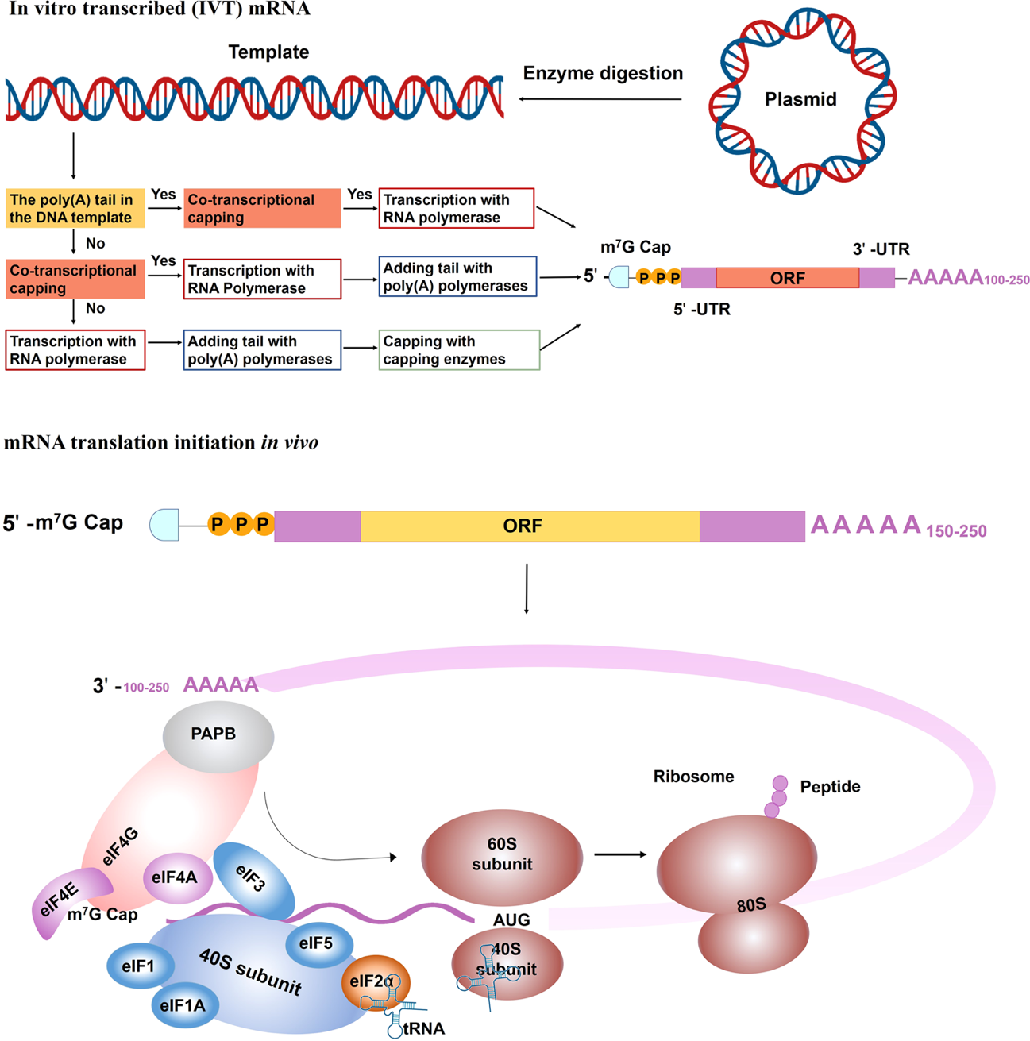
Generally, mRNAs are composed of a 5′ cap, 5′ and 3′ untranslated regions (UTRs), an open reading frame (ORF, devoid of introns), and a poly(A) tail (Fig. 14)
Figure 14) Pipeline for In Vitro Transcribed (IVT) mRNA Production and Final Architecture. This schematic illustrates the manufacturing process of functional mRNA and its essential structural components. A) The process begins with a linearized DNA Template derived from a Plasmid (via enzyme digestion) containing the gene of interest (ORF) and regulatory sequences. The diagram details three main pathways for generating the mature mRNA, involving Transcription with RNA Polymerase and the sequential addition of the two crucial elements: the 5' cap and the 3' Poly(A) tail (100–250 nucleotides). Capping can be performed either co-transcriptionally or enzymatically using capping enzymes, resulting in the protective m⁷G Cap (7-methylguanosine) at the 5' end. B) The final optimized IVT mRNA molecule comprises the 5'-m$^7$G Cap, the 5' and 3' Untranslated Regions (UTRs), the Open Reading Frame (ORF, encoding the protein), and the Poly(A) tail (150–250 nucleotides). This structure is essential for mRNA translation initiation in vivo in the cytosol, facilitating ribosome recognition and stabilizing the transcript against degradation. Adapted from Qin et al., 2022

The 5′ cap is essential for ribosome recognition and translation initiation, typically consisting of a 7-methylguanosine (m7G) linked through a triphosphate bridge to the first nucleotide. Various cap analogues (Cap 0, Cap 1, Cap 2) with distinct methylation states are used to improve stability and reduce immunogenicity. Non-capped mRNAs are rapidly degraded, as they are recognized as foreign.
The UTRs, located at both termini, do not encode proteins but modulate mRNA translation and stability. The 5′ UTR contributes to ribosome recruitment and translation initiation, whereas the 3′ UTR regulates transcript stability and decay rate (Pardi et al., 2018).
The poly(A) tail, typically 100–250 nucleotides long, interacts with poly(A)-binding proteins (PABPs) and translation initiation factors (eIF4G, eIF4E) to promote a “closed-loop” structure, enhancing translation efficiency and mRNA stability. Although tail length influences translation, this relationship is not always linear.
Finally, once translated, IVT mRNAs are naturally degraded through canonical cellular decay pathways involving decapping enzymes (DCP1/2), deadenylation complexes, and 5′–3′ or 3′–5′ exonucleases such as XRN1 and the exosome complex (Garneau et al, 2007). This ensures transient expression, high biosafety, and reversibility—features that make mRNA an attractive therapeutic platform.
The optimization of these molecular and delivery features has enabled the clinical implementation of mRNA-based therapies, first in vaccination and now extending to regenerative and genetic disease contexts (Pardi et al., 2018; Hou et al., 2021). Given its high biosafety profile, transient expression, and transfection efficacy, mRNA emerges as an ideal platform to address the secondary complications and regenerative limitations inherent to Duchenne Muscular Dystrophy (DMD).
Specifically, a major challenge in DMD is the functional exhaustion and replicative senescence of satellite cells, which ultimately compromises chronic muscle repair. Consequently, the transient expression of the key telomerase component, hTERT, via mRNA delivery, has been explored as a targeted strategy to potentially restore the proliferative and self-renewal capacity of dystrophic myogenic progenitors.

mRNA encoding hTERT as a regenerative cofactor
mRNA technology has recently emerged as a versatile and safe platform not only for antigen delivery or protein replacement, but also for the transient modulation of complex cellular pathways. Unlike viral vectors or DNA-based approaches, synthetic mRNAs provide controllable, non-integrative, and short-lived expression, offering a promising strategy to transiently boost regenerative capacity or counteract stress-induced dysfunctions. Within this framework, the catalytic subunit of telomerase (hTERT) has gained renewed attention as a regenerative cofactor capable of preserving proliferative competence and genomic stability under conditions of cellular stress and ageing.
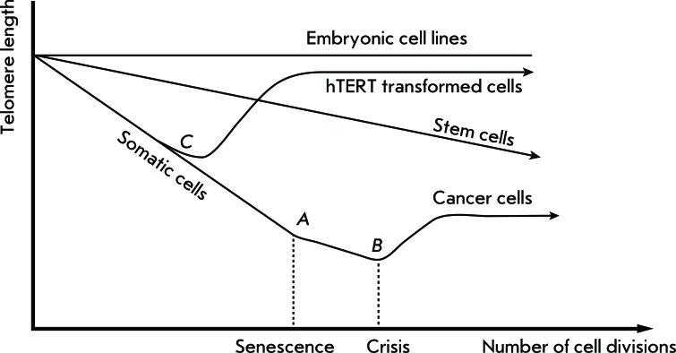
Telomerase has long been associated with the maintenance of stemness and replicative potential (Fig. 15). Early work showed that ectopic hTERT expression was, most of the times, sufficient to bypass replicative senescence and immortalize multiple primary cell types, including fibroblasts, endothelial cells (Bodnar et al, 1998; Jiang et al, 1999; Liu et al, 1999), but not myoblasts (Zhu et al., 2007). These findings provided the conceptual basis for exploiting telomerase in regenerative medicine.
Figure 15) Schematic telomere maintenance. Depending on telomerase expression, telomere length my vary during cells lifespan. In embryonic cells telomerase is constitutively expressed keeping telomeres length stable, while in adult stem cells decrease and normal cells cease definitively ultimately reaching the Hayflick limit (A) and the crisis (B). Cells surviving and overcoming the crisis are cancer cells. In somatic cells, senescence can be overcome by hTERT overexpression reaching immortalization. Skvortsov et al., 2011
However, constitutive overexpression raised substantial oncogenic and safety concerns, limiting translational applications.
A key turning point came with the demonstration that transient expression of in vitro–transcribed (IVT) hTERT mRNA could extend telomeres without inducing uncontrolled proliferation. Ramunas et al. (2015) first showed that a single pulse of modified hTERT mRNA rapidly elongated telomeres in fibroblasts and myoblasts, maintaining normal karyotype, proliferation limits. Subsequent studies confirmed that this transient activation delays senescence, improves mitochondrial function, and enhances resistance to oxidative and metabolic stress, especially in premature aging-related pathology as Hutchinson-Gilford (Li et al, 2019; Qin et al, 2025) in vitro and in vivo (Mojiri et al, 2021). In mouse models and human cell systems, mRNA-mediated telomerase expression has been associated with improved tissue regeneration and cells engraftment (Chang et al, 2024), DNA repair, enhanced CAR-T cells activity (Bai et al, 2016), and reduced inflammatory signatures, particularly in contexts of chronic or stress-induced telomere attrition (Mojiri et al., 2021).
Interestingly, several of these stress-related mechanisms parallel the pathological features of Duchenne muscular dystrophy (DMD). In dystrophic muscle, persistent inflammation, elevated ROS, and continuous regeneration cycles accelerate telomere erosion and satellite cell exhaustion (Sacco et al., 2010). In this scenario, transient hTERT expression may provide a physiological advantage—counteracting premature senescence and supporting the proliferative capacity of myogenic progenitors—without the oncogenic risks associated with permanent activation. Chang et al., although performed in skin rather than muscle, these results support the idea that transient telomerase activation might similarly benefit myogenic progenitors in DMD, which face persistent proliferative demand and replicative decline. This concept has also been reinforced by early clinical trials exploring telomerase-based interventions in degenerative or immune-related conditions (NCT02327468; NCT04133454; NCT00834665), highlighting a favorable safety profile for transient telomerase modulation.
Altogether, transient delivery of hTERT mRNA represents a promising therapeutic avenue to enhance regenerative responses and cellular resilience in conditions characterized by chronic stress, telomere dysfunction, or premature ageing—features that are particularly relevant to DMD pathology.

Aim of the study

Duchenne muscular dystrophy (DMD) is characterised by progressive muscle degeneration and impaired regenerative capacity, which are increasingly recognised to involve intrinsic proliferative limitations of muscle progenitor cells. In this context, the overall aim of this PhD project was to investigate the cellular and molecular determinants underlying the proliferative gap between healthy and dystrophic human myogenic progenitors, with a particular focus on telomere dynamics and telomerase activity as central regulators of replicative capacity.
To this end, the project first aimed to establish and characterise in vitro models of healthy and DMD-derived myogenic progenitor cells, analysing their proliferative behaviour in relation to telomere length and telomerase activity across extended culture. By integrating proliferation assays with molecular assessment of telomere maintenance, the study sought to define whether altered telomere homeostasis represents a key mechanism contributing to the premature proliferative exhaustion observed in dystrophic cells.
Building on this framework, a second major objective of the project was to explore a targeted strategy to modulate telomere dynamics in dystrophic myogenic progenitors. Specifically, the study aimed to produce and deliver transient, non-integrating mRNA encoding the telomerase catalytic subunit hTERT, and to evaluate its impact on telomere maintenance, proliferative behaviour and replicative lifespan of DMD-derived cells. Through this approach, the project sought to assess whether transient telomerase reactivation could partially mitigate intrinsic proliferative limitations of dystrophic myogenic progenitors, providing mechanistic insight into telomere-dependent regulation of muscle stem cell function in DMD.

Results

Isolation and characterization of myogenic populations from Healthy and DMD donor
To evaluate the proliferative potential of myogenic population in vitro, cells were isolated from muscle biopsies from two different donors. First biopsy was obtained from Donor#1 (vastus medialis, healthy, CTRL 9-years old male), who underwent orthopaedic surgery for non-muscle related conditions (lower limb bone fracture). A second muscle biopsy was obtained from Donor #2 (extensor digitorum brevis; Duchenne muscular dystrophy; 17-year-old male) prior to transplantation. The patient was enrolled in a clinical trial involving intramuscular injections of genetically corrected autologous mesoangioblasts (auto-MABs) and was followed for one year after injection. At the time of study entry, the patient was non-ambulant and receiving steroid treatment. The diagnosis of DMD was molecularly confirmed, with a documented mutation in the dystrophin gene amenable to exon 51 skipping. Disease severity was limited to an intermediate stage, with no more than a 50% reduction in muscle mass, as assessed by quantitative magnetic resonance imaging (MRI), corresponding to grade 2 according to the classification proposed by Kinali et al. (2011). Written informed consent was obtained from the patient’s caregivers, and the patient provided assent in accordance with ethical guidelines. The heterogeneous biopsy-derived populations were kept in culture to expand them to create early-passages backups and in substantial number to undergo magnetic beads separation to reduce as much as possible physical stress. The populations were separated with magnetic beads loaded with antibodies against CD56+ (nCAM), a marker for neural, immune system and muscle cells. Cells were kept separated throughout the proliferation assays. The identity of the separated population was then confirmed through flow cytometer analysis (Flow-cytometry analysis in Fig.16)
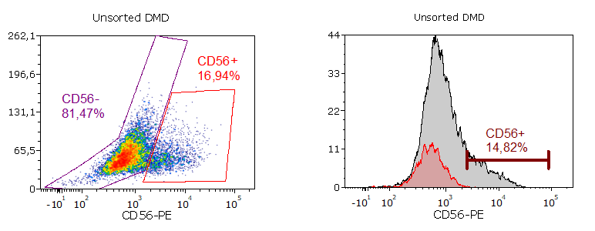
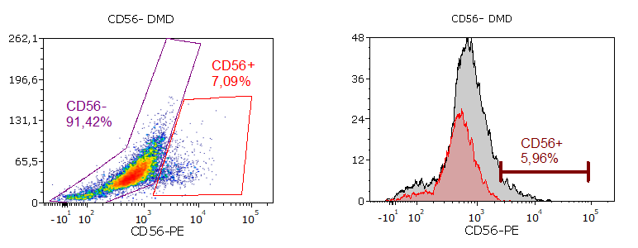
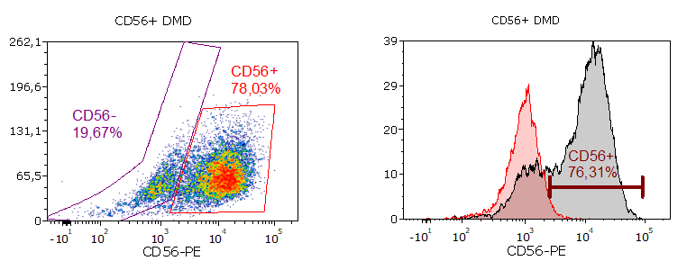
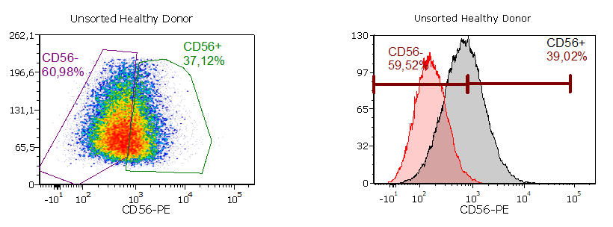
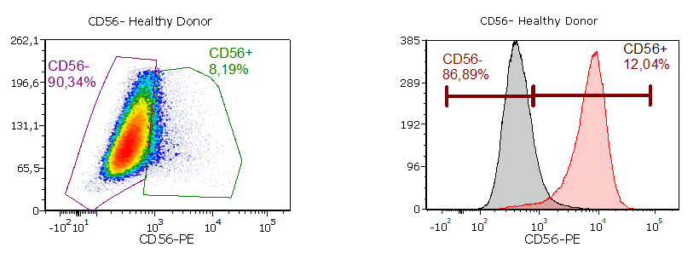
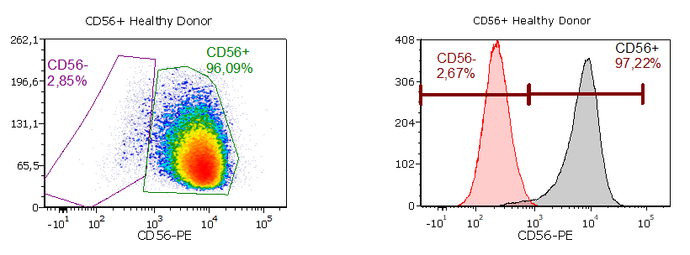
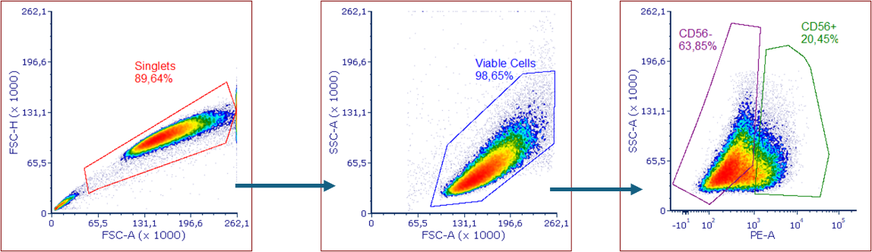
Both experiments underwent the same gating strategy (Fig.16-A): 1° and 2° gate for physical parameters (FSC-H vs FSC-A; SSC-A vs FSC-A), the 3° on the CD56-PE (SSC-A vs PE). Healthy donor cells and DMD cells were first analyzed for their initial composition. Healthy donor: CD56⁺ 37.12%, CD56⁻ 60.98%; DMD donor: CD56⁺ 16.94%, CD56⁻ 81.47%, showing a reduced CD56⁺ population in the DMD sample. After magnetic bead separation in a depletive fashion, the CD56⁺ fraction reached 96.09% purity in the Healthy donor and 78.03% in the DMD donor. The CD56- fraction was 90.34% negative in Healthy donor and 91.42% in DMD donor, indicating only minor contamination from the opposite population.
Figure 16) Flow Cytometer analysis of myogenic cells. A) Representative example of gating strategy for cells discrimination. Cells were analyzed for their physical parameters (FSC-H, FSC-A, SSC-A) to obtain suitable fraction for fluorochrome-conjugated identification of CD56⁺ and CD56⁻ populations. B) Analysis of healthy (left) and DMD (right) cells extracted from biopsies: first lane represents original cells composition (Unsorted) after few passages in culture. Second and third lane represent cells composition after magnetic beads separation. Data were acquired in two different experiments.
A
B

Proliferative potential of myogenic cells
To investigate differences in proliferative behavior among the cell populations, population doublings (PD) were calculated as ln(N°harvested/N°seeded)/ln(2). PD reflect the number of cell divisions required to generate the observed increase in cell number, enabling direct comparison of proliferative capacity across passages and experimental conditions independently of seeding density. The curves were made in double and the cells were seeded always in the same number until replicative senescence.
In a first evaluation, both populations (CD56⁺ and CD56-) of healthy donor were kept in two different media for comparison: one has been developed inhouse with a known composition (See Materials and Methods) from now and on referred as “MIX”, the other is called Myocult SF (Catalog # 05980, StemCell Technology) especially designed for myoblasts expansion. The complete proliferation profile of the two media shows similar performances although differentiation of myogenic progenitors could have been achieved only in the MIX medium (Fig. 17).
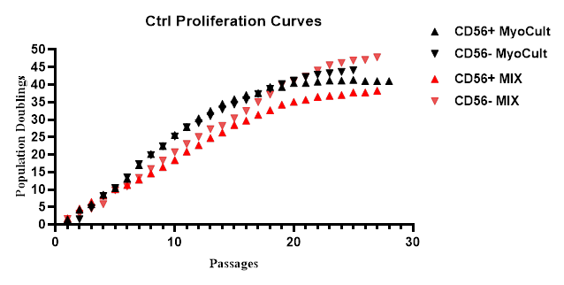
Figure 17) Proliferation profile of myogenic cells from a healthy donor in two different media (MyoCult and MIX). Cells were kept in the same condition and approximately the same time in culture. Despite minor differences in doubling time, all populations reached a sustained proliferation rate as indicate in the table above.

Population doubling (PD) analysis was performed for CD56+ and CD56- cells under two media conditions (MyoCult and MIX). CD56+ cells reached slightly higher PD in MYO compared to MIX, while CD56- cells showed robust proliferation in both conditions, with MIX giving the highest theoretical cell yield. These results indicate that CD56- populations expand more extensively than CD56+ populations, independent of medium, and that MyoCult supports CD56+ proliferation slightly better than MIX. MyoCult proliferation shows a faster kinetics while MIX tends to have a steady pace. The assay ended when cells harvested were fewer than the plated, for two consecutive times.
Once assessed that our medium was able to meet high standards in terms of proliferation and keeping functional activities in both populations, the following experiments were conducted with the latter.
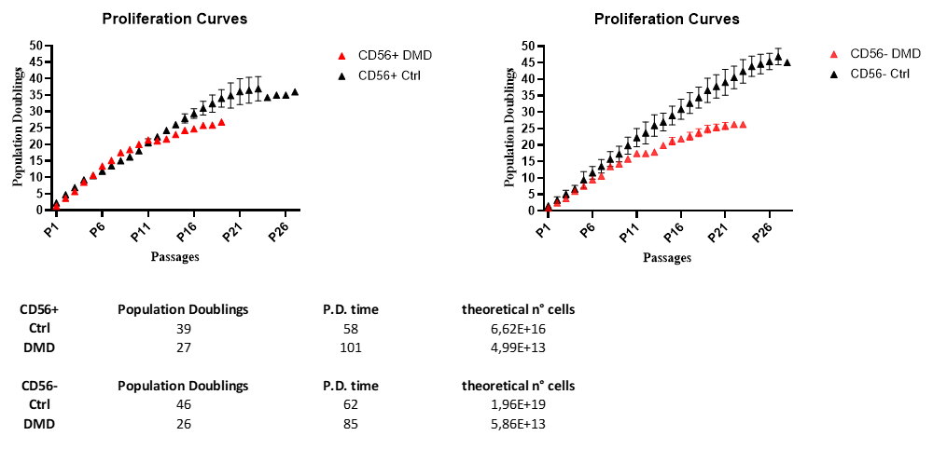
A comparison between Healthy and DMD donors was performed (Fig. 18). CD56+ cells from the healthy donor reached 35 population doublings (PD), compared to 25 PD for the DMD donor. In the CD56- population, the difference was more pronounced, with healthy cells achieving 45 PD versus 26 PD in DMD cells, indicating a substantially higher proliferative capacity in healthy populations.
Figure 18) Proliferation curves of myogenic progenitor cells derived from a healthy (in black) and DMD donor (in red). On X axis are indicated the passages in culture and cells were plated always in the same number to calculate population doublings. The curves are meant to be in duplicate. Data are shown as mean ± SEM

Morphological changes in aging cells
Aging cells underwent noticeable morphological changes common to both genotypes. Initially, cells displayed a round or spindle-like shape, with some floating cells corresponding to actively dividing cells. Over time, cells became more elongated and thinner, indicative of stress, and eventually showed signs of vacuolization and soma enlargement (Fig. 19).
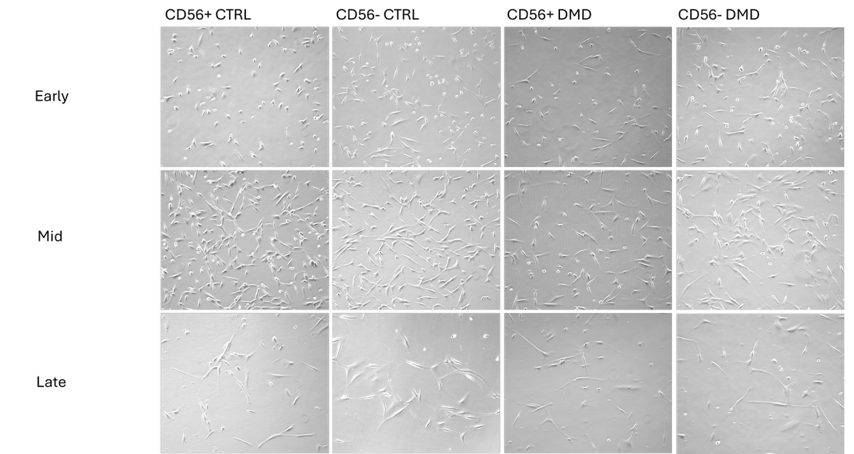
Figure 19) Brightfield images of different aging stages in culture. Representation of (in order): CD56⁺ and CD56⁻ (CTRL), CD56⁺ and CD56⁻ (DMD). The populations are divided in different stages: early (approx. Passage 13), mid (approx. Passage 21) and late (approx. Passage 30). Images taken at 10x magnification.

Differentiation capacity of myogenic cells
Healthy donor myoblasts (CD56⁺) displayed a robust differentiation capacity at early passages, forming multinucleated myotubes efficiently. This ability was gradually lost with increasing passages, although differentiation could still be observed until near senescence compared with DMD cells. Interestingly, pericyte-like (CD56⁻) cells from the healthy donor, which are reported (Dellavalle, 2007) to undergo myogenic differentiation in certain conditions, were also able to form myotube expressing myosin, although with a lower efficiency and only in the early phase.
In contrast, DMD donor cells showed a markedly reduced differentiation potential. Myoblasts exhibited a low myotube formation potency, while pericyte-like cells did not display any detectable differentiation under the same conditions (Fig. 20).
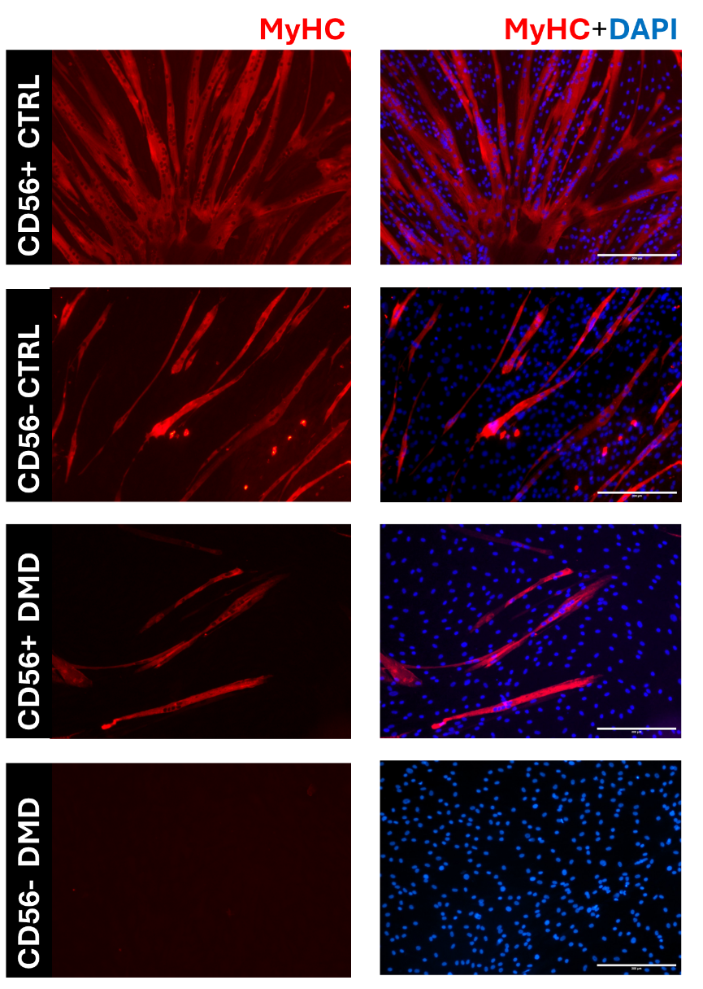
Figure 20) Differentiation ability of myogenic cells. Representative images of immunostaining for MyHC (MF20 in red) to assess cell’s differentiation in CD56⁺ and CD56⁻ populations of dystrophic and healthy donor cells age-matched. Dystrophic CD56- were unable to differentiate. Images were taken at 10x magnification. Scale bar 300µm.

SA-Bgal Staining
Cells were kept in culture approximately for three months. Morphological transition to a more senescent-state revealed to come in stages and not in linear fashion as expected. It was noted that around passage 23, in our system cells would start to behave differently in proliferation and physical appearance.
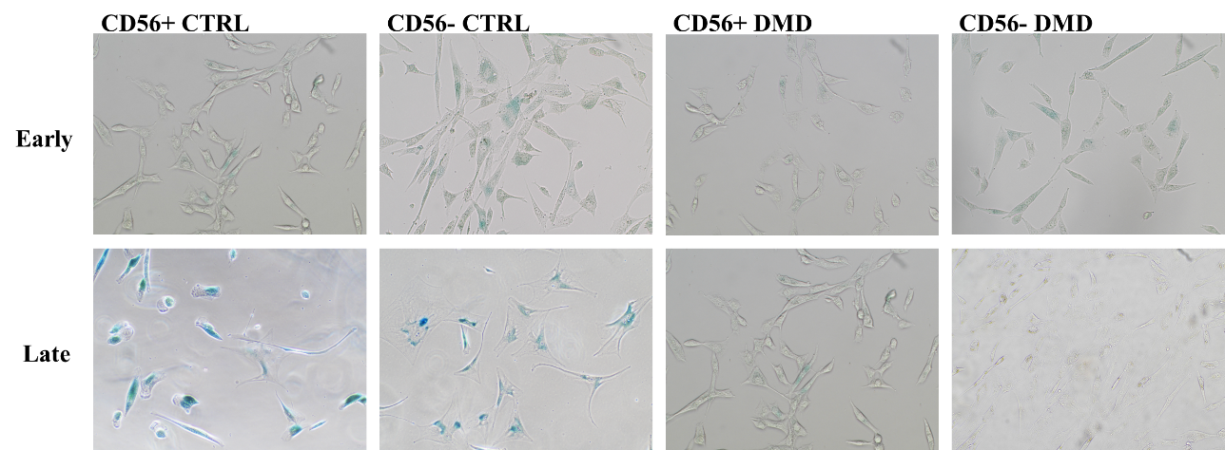
Although not clearly indicating a full senescence stage, cells were tested for X-Gal assay (Fig. 21), a colorimetric staining indicating presence of B-Galactosidase (marker of increased autophagy in lysosomes), giving a blue staining.
Figure 21) X-gal staining of healthy and DMD myogenic progenitors at late passages.
Representative bright-field images showing β-galactosidase–positive (senescent) cells in CD56⁺ and CD56⁻ populations from healthy and DMD donors. Blue staining indicates increased senescence burden, which is absent in DMD-derived cultures. Images taken at 10x magnification.
Healthy cells were tested for a qualitative analysis given the nature of the assay. Both populations CD56⁺ and CD56⁻ showed minor signs of β-Galactosidase activity and low percentage of positive cells, while this markedly increased during their late stage both in intensity and percentage of positive cells. Interestingly, DMD populations didn’t show signs of positivity for the assay. There was no difference between stages.

Ki-67 evaluation for proliferative assessment
To visualize proliferative status of the cultures at different timepoints, cells were immunostained for Ki-67 (Fig. 22-A). In Fig.21 B-C cells were compared at early (10-13 passages) and late (27-30 passages) stage. Results are expressed as the ratio of positive to total cells (ranging from 0 to 1).
With one donor per condition, these data will be described without statistics.
In 22-B, healthy CD56⁻ population showed minor changes of Ki-67 positive nuclei (CD56⁻ 0.55 vs 0.38). Healthy CD56⁺ population had a significant decline (CD56⁺ 0.80 vs 0.30).
In the DMD donor (Fig. 21-C), both and populations (CD56⁻ 0,40 vs 0,07; CD56⁺ 0,55 vs 0,10) showed a strong decline in Ki-67 positivity from early to late passages, confirming their reduced proliferative potential and the onset of replicative senescence. These data are in line with the proliferation profiles illustrated previously.
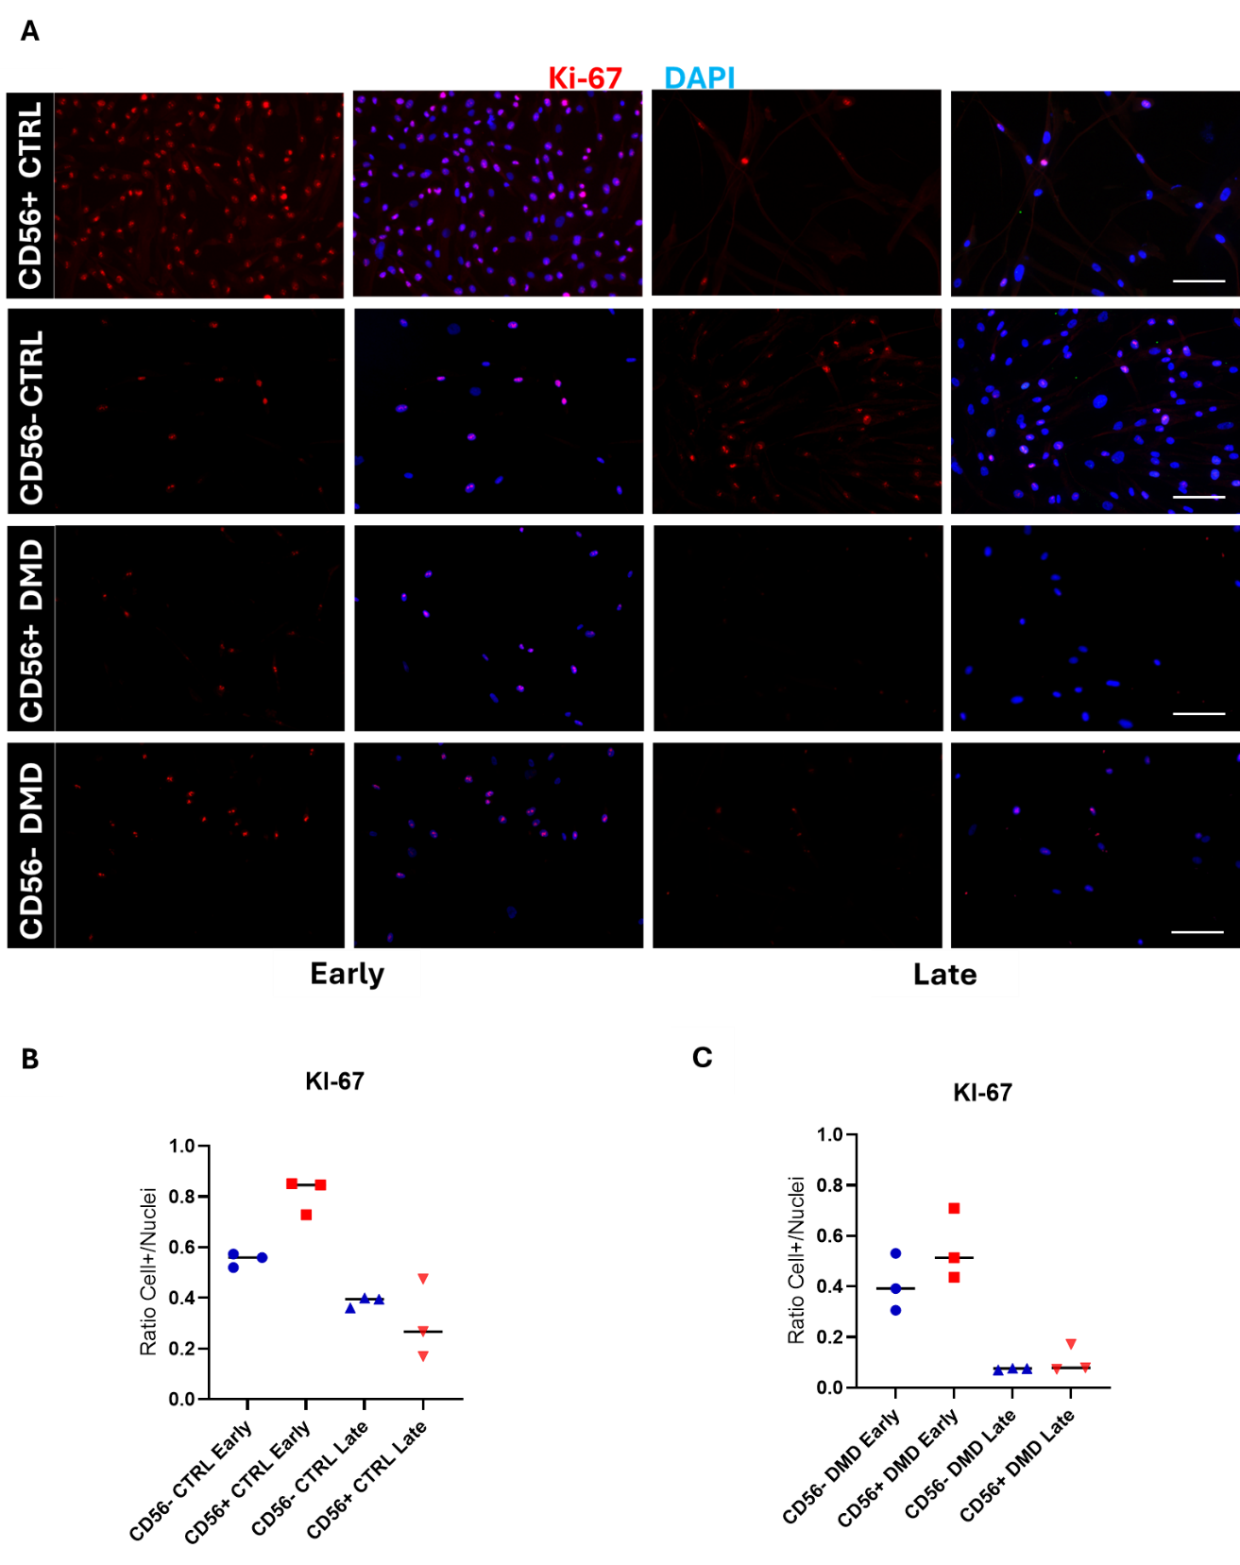
Figure 22) Evaluation of proliferative cells at different aging stages. A) Immunofluorescence staining for Ki-67 to evaluate cells in active division at different stages in different genotypes (B-Healthy donor; C-DMD donor). Passages of the cells were matched as closely as possible based on their aging stage among populations. Calculation was made by counting positive cells on total number of nuclei. Data represent mean ± SEM of three technical replicates from a single donor. No statistical test applied due to n=1. Scale Bar 100µm

Telomerase activity in aging cells
To establish whether myogenic precursors retain telomerase activity, cells were tested using a TRAP assay (Fig. 23). This qPCR-based assay quantitatively measures enzymatic activity by providing a telomeric substrate for hTERT and amplifying the extended products (as detailed in Materials and Methods). Telomerase activity was normalized to protein content and heat-inactivated controls and expressed as relative amplification units per microgram of protein. Positive controls in the assay are HEK 293T (telomerase overexpressing cell line) and a cellular extract of telomerase-positive cells provided in the kit (cells’ identity not specified). In CTRL populations, a downward trend in telomerase activity was observed in aging CD56⁺ cells (Early vs. Late, p = 0.0387) and when comparing early CD56⁺ to CD56⁻ cells at the same stage (Early CD56⁺ vs. CD56⁻, p = 0.0354), after Two-way repeated-measures ANOVA, whereas no statistically significant changes were observed in CD56⁻ cells. This suggests that the temporal decline in telomerase activity is more pronounced in CD56⁺ myoblasts. On average, telomerase activity decreased by approximately 5-fold from early to late passages in CD56⁺ cells, whereas CD56⁻ cells still retained a modest activity.
In DMD-derived cells, telomerase activity was measured at three passages. The inclusion of an intermediate timepoint was included to monitor the shift trend of proliferation during. Two-way repeated-measures ANOVA showed no significant changes throughout the groups. Although CD56⁺ cells displaying higher but not statistically significant values compared to CD56⁻ counterparts at early stage, both populations exhibit a dramatic decline in mid stage, and rise again in the late stage. Despite the late-stage increase in telomerase activity, cells nevertheless did not resume proliferation.

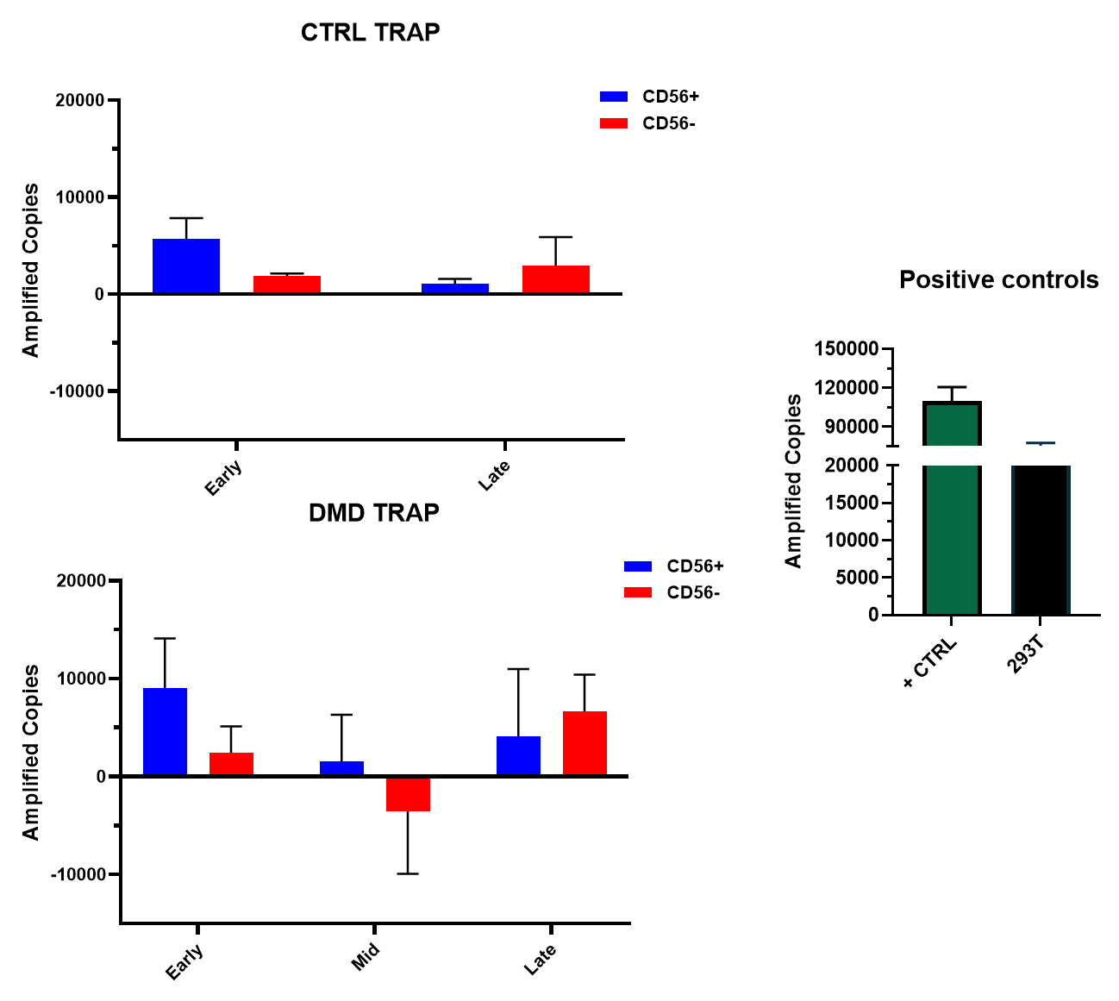
Figure 23) Telomerase activity quantification at different timepoints. Both population (CD56⁺ in blue, CD56⁻ in red) of healthy (CTRL, A) and DMD-derived (B) cellular extract were tested for TRAP assay, in presence of internal and external positive control (C). Data are displayed as mean result of amplified copies normalized on background and µg of protein (Amplified Copies-Heat treated/µg of proteins). Data were analyzed with Two-way repeated-measures ANOVA and Tukey's multiple comparisons test as post-hoc analysis. Error bars indicate data ± SEM.
A
B
C

Average telomere length quantification in aging cells
Telomeres are non-coding hexameric DNA repeats located at the ends of chromosomes, protecting coding regions from degradation. Their length correlates with the proliferative status of the cell.
To determine the average telomere length, a qPCR-based assay was employed (Fig. 24) as described by Cawthorn (Cawthon, 2002). HEK293T cells (a telomerase-overexpressing cell line) and immortalized myoblasts (CD56⁺ human myoblasts transduced with hTERT and Cdk4, obtained from Prof. V. Mouly previously described in Zhu et al., 2007) with telomerase overexpression, were used as technical positive controls.
In healthy donor cells, both populations showed a progressive decrease in telomere length across passages (CD56⁺ CTRL: early 7.53 kb, mid 6.08 kb, late 4.93 kb, very late 5.43 kb; CD56⁻ CTRL: early 9.20 kb, mid 7.83 kb, late 4.96 kb, very late 4.20 kb; early vs. late ***p = 0.0004; early vs. very late ***p < 0.0001). Although CD56⁻ cells displayed longer telomeres at the early stage, their overall shortening was slightly greater than that observed in CD56⁺ cells.
DMD-derived cells exhibited a similar but more pronounced declining trend (CD56⁺ DMD: early 7.00 kb, mid 4.06 kb, late 2.70 kb, very late 4.93 kb; early vs. mid *p = 0.046; early vs. late **p = 0.0048; CD56⁻ DMD: early 6.66 kb, mid 5.43 kb, late 3.66 kb, very late 4.93 kb; early vs. late *p = 0.041), with a deflection at the late stage in both populations, consistent with the trend observed in the TRAP assay.
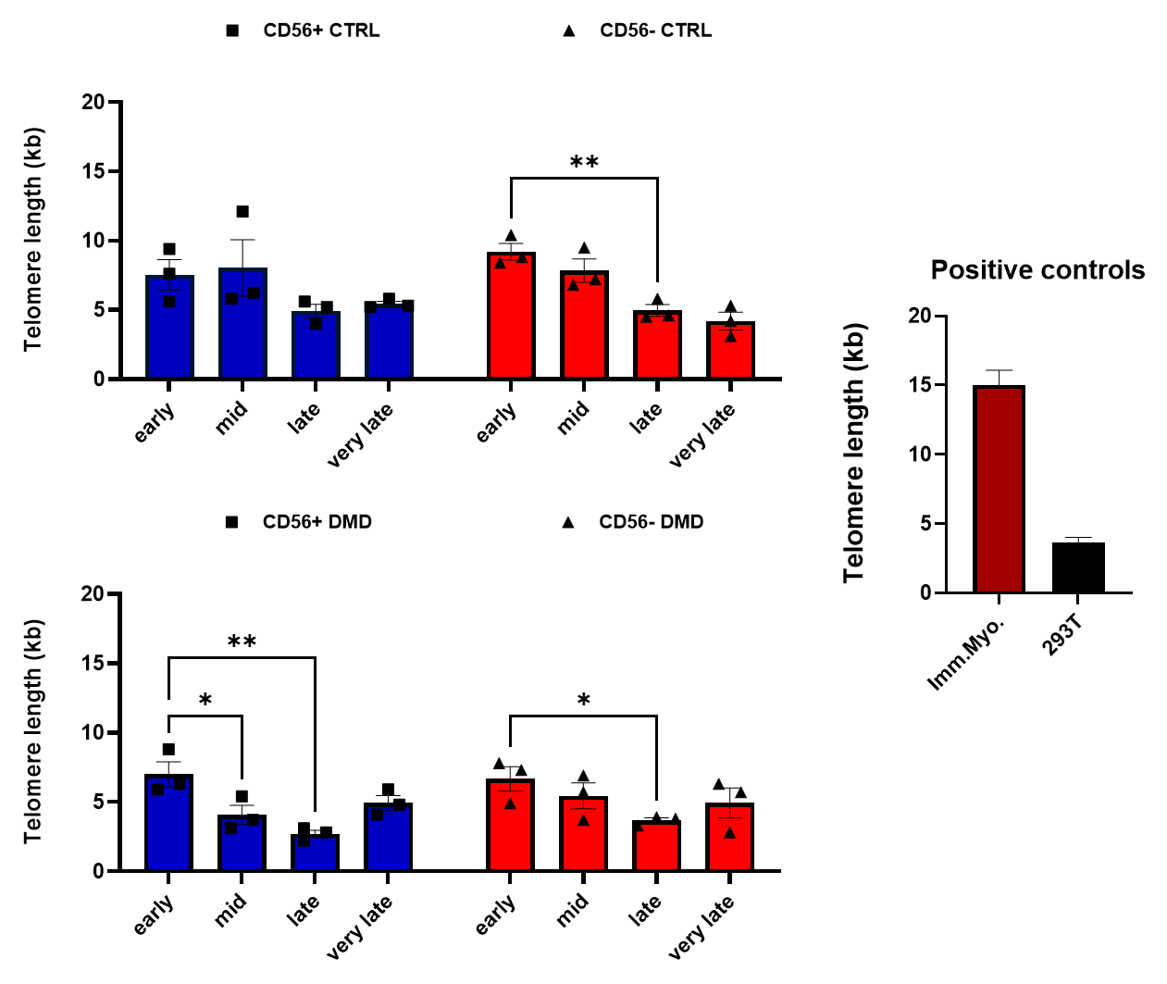
Figure 24) Telomere length dynamics in CTRL and DMD myogenic populations. Average telomere length was measured by qPCR in CD56⁺ and CD56⁻ cells from healthy donors (blue) and DMD donors (red) across serial passages (Early, Mid, Late, Very Late). HEK293T and immortalized myoblasts (hTERT/Cdk4) were included as positive controls. Bars represent mean ± SEM of technical replicates (n = 3). Statistical analysis was performed by two-way repeated-measures ANOVA followed by Dunnett’s post hoc test. *p < 0.05, **p < 0.01, ***p < 0.001.

hTERT encoding mRNA transfection

mRNA synthesis and cell treatment

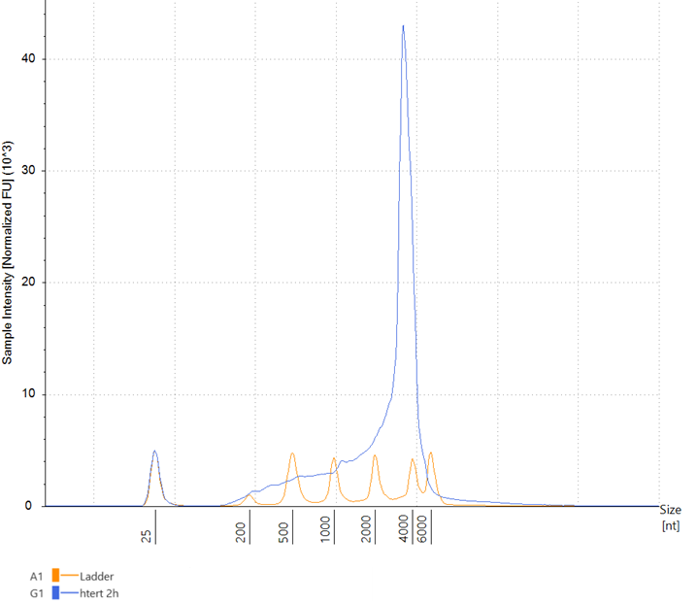
The hTERT mRNA was synthesized and quality checked as discussed in Materials and Methods. Agarose gel electrophoresis confirmed the expected size of DNA sequence (~3450 bp), and Tapestation (Agilent) analysis showed a single peak corresponding to the expected mRNA transcript (Fig. 25).
Figure 24) hTERT mRNA profile and schematic representation of its sequence. A) Electrophoretic profile of hTERT mRNA (in blue) and reference ladder (in orange) produced by Tapestation’s analysis software. B) hTERT sequence and its components schematically displayed. Exact sequence of components, except hTERT coding sequence (NM_198253.2), is under patent.
A
B

Once assessed the baseline situation of parameters described previously, the cells were then treated with a mRNA encoding hTERT. Cells were transfected at the mid passages stage (P20–23) with 1 µg/ml of hTERT mRNA using a lipid-based reagent. Immunofluorescence for hTERT was performed 48 h post-transfection on 5000 cells seeded on Matrigel-coated slides, with three groups: untreated (UT), mock-transfected (Mock), and hTERT mRNA (Treatment) (Fig. 26).
In the CD56⁺ population, hTERT immunofluorescence intensity increased significantly compared to UT and Mock groups (2.35-fold increase, p = 0.0330 vs UT; p = 0.0395 vs Mock) (Fig. 26). In contrast, CD56– cells showed only a non-significant increase in fluorescence, both in the Treated group (1.49-fold vs UT) and in the Mock group (1.64-fold vs UT), suggesting possible response due to population heterogeneity. Moreover, in DMD-derived cells, the CD56⁺ population showed significant increase in hTERT intensity compared to UT and Mock groups (3.32-fold increase, ****p<0.0001 vs UT and Mock). In contrast, CD56⁻ population despite the significative intensity of both Treatment (2.34-fold increase, *p=0.03 vs UT) and Mock (2.83-fold increase, *p<0.01 vs UT), the data trend of both populations reflects what has been reported for the healthy population.

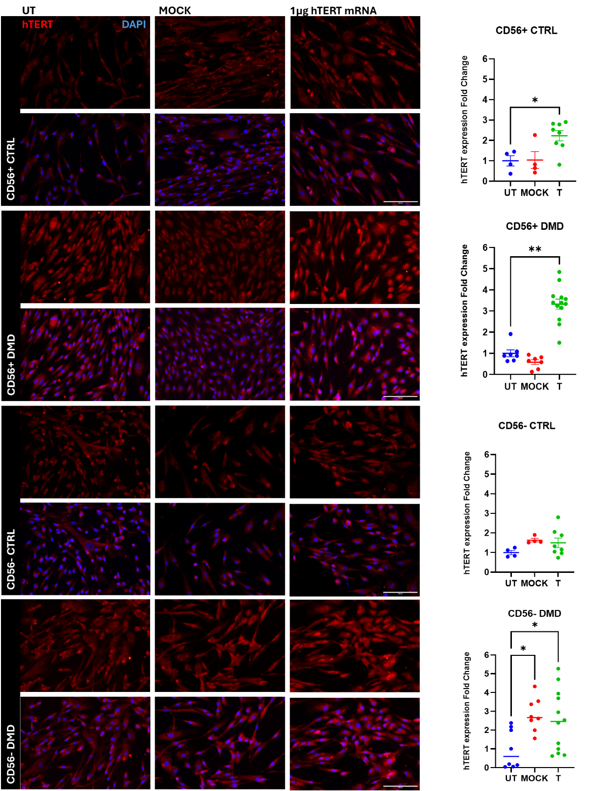
Figure 26) hTERT expression after hTERT mRNA transfection (1µg/ml) 48h later. Immunofluorescence for hTERT (red) and nuclei (DAPI, blue) in CD56⁺ and CD56⁻ muscle progenitors from healthy (CTRL) and DMD donors. Columns correspond to untreated (UT), mock-transfected (MOCK), and hTERT mRNA-transfected samples. Rows represent CD56⁺ CTRL, CD56⁺ DMD, CD56⁻ CTRL, and CD56⁻ DMD populations. Cells were fixed 48 h post-transfection. Stronger nuclear and cytoplasmic hTERT staining is observed in transfected cells, especially in DMD-derived progenitors. Quantification of fluorescence intensity was performed and statistically analyzed with One-way ANOVA and a Dunn’s comparison test as post-hoc analysis on at least 5 independent fields per condition. Scale bar: 300 µm *p < 0.05, **p < 0.01.

Cells proliferative evaluation after hTERT mRNA transfection
To investigate whether the exogenous telomerase had a functional impact on cells, proliferation curves after transfection were evaluated.
Proliferation of CD56⁺ and CD56⁻ DMD cells was assessed after hTERT mRNA transfection with two incubation times (4 h and 16 h) (Fig. 27). Linear regression analysis of cumulative PD profiles revealed a significantly increased proliferation rate in CD56⁺ cells compared to untreated (UT) and mock conditions at both incubation times (One-Way ANOVA on regression slopes, 4h p< 0.0001; 16h p<0.0001). CD56⁻ cells also showed a similar increase only at 4h with a slightly reduction at 16h (ANOVA on regression slopes 4h p=0.0011; 16h p=0.0098). Consistently, transfected CD56⁺ cells at 4h reached up to 13.6 PD, confronted with 5.4 in UT and 6.1 in Mock while at 16h achieved up to 11.3 PD, compared with 5.4 and 6.7 PD in UT and Mock, respectively, resulting in approximately a three-fold higher theoretical cell yield at 4h (1.12 × 10⁹ vs. 3.30 × 10⁶ cells) and 2-fold increase at 16h (2.05 × 10⁸ vs. 3.40×10⁶). A similar trend was observed in CD56⁻ cells, with transfected samples reaching up to 10.3 PD at 4h (vs. 6.0 UT, 5.1 Mock) and 9.9 PD (vs. 6.9 UT, 5.1 Mock) at 16h, corresponding to a ~2-fold increase in theoretical cell yield (7.45 × 10⁷ vs. 9.32 × 10⁶). Notably, incubation time (4 h vs. 16 h) did not substantially affect the proliferation of CD56⁺, while it did with CD56⁻ population.
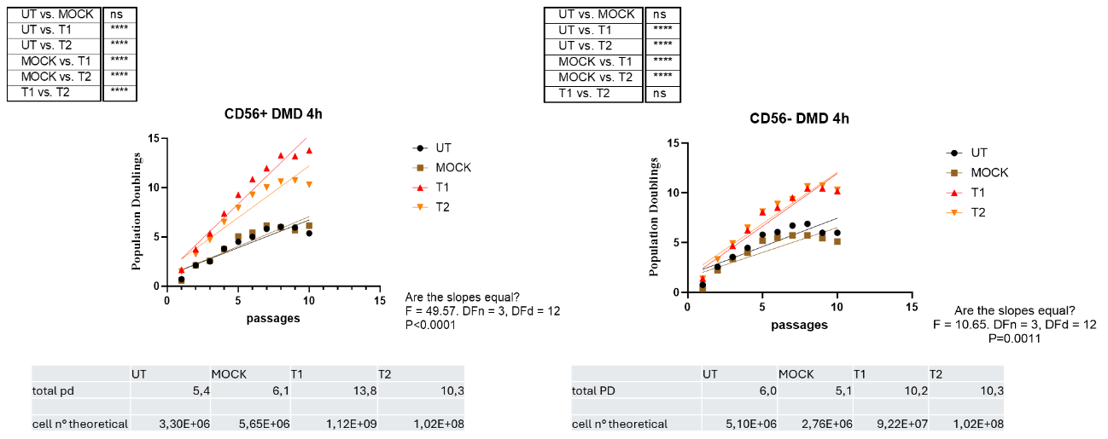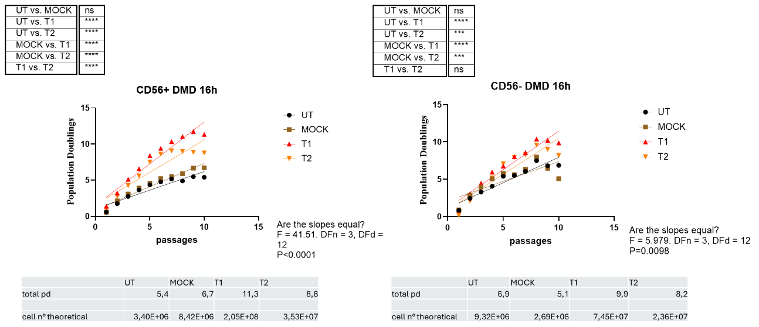
Figure 27) Evaluation of proliferation after hTERT mRNA transfection (1 µg/ml) in DMD muscle progenitors. (A, B) CD56⁺ population incubated for 4 h (A) or 16 h (B). (C, D) CD56⁻ population incubated for 4 h (C) or 16 h (D). Untreated (UT, black) and mock-transfected (MOCK, brown) cells served as controls, while treated samples (T1, red; T2, orange) represent replicates. Cells were seeded at equal density (80,000) at each passage to calculate population doublings (PD). Growth curves were fitted by linear regression to derive slopes, which were then compared by One-Way ANOVA. Tables below the graphs report calculated PD values and the corresponding theoretical cell numbers (seeded cells × 2^PD). ***p < 0.001, ****p<0.0001.
A
B
C
D
Healthy donor-derived cells underwent hTERT transfection to test replicability of results obtained from DMD cells (Fig. 28). Linear regression analysis on cumulative PD profiles revealed a statistical increase in CD56⁺ Treated population (T1, T2) compared to untreated (UT) and mock (Mock) (Anova on regression slopes, T1 vs UT ****p<0.0001; T1 vs Mock) reaching a modest increase in terms of proliferation for T1 and T2 (6.2 and 5.5 PD) compared to UT and Mock (4.8 and 4.8). Theoretical cell yield was slightly higher in treated groups (T1 5,85 × 10⁶, T2 3.66 × 10⁶) compared to UT and Mock (2.26 × 10⁶ and 2.19 × 10⁶).
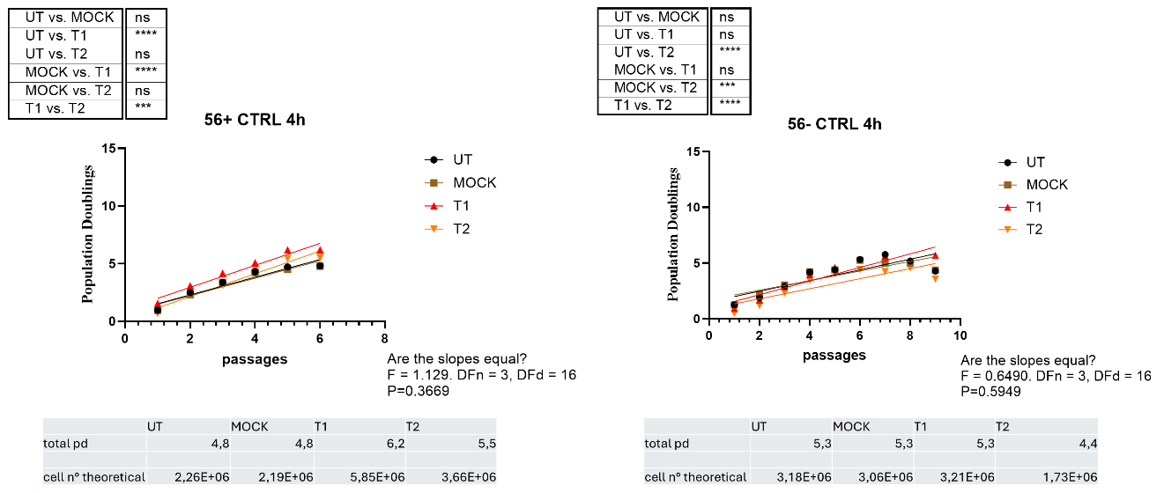
Figure 28) Evaluation of proliferation after hTERT mRNA transfection (1 µg/ml) in healthy (CTRL) muscle progenitors. A) CD56⁺ population incubated for 4 h. B) CD56⁻ population incubated for 4 h. Untreated (UT, black) and mock-transfected (MOCK, brown) cells served as controls, while treated samples (T1, red; T2, orange) represent replicates. Cells were seeded at equal density (80,000) at each passage to calculate population doublings (PD). Growth curves were fitted by linear regression to derive slopes, which were then compared by One-Way ANOVA. Tables below the graphs report calculated PD values and the corresponding theoretical cell numbers (seeded cells × 2^PD). ****p<0.0001.

Ki-67 expression after hTERT mRNA transfection
Since hTERT mRNA transfection resulted in an increased proliferative potential in both DMD-derived populations, but not in CTRL cells, proliferation markers were re-evaluated one passage after mRNA delivery (Fig. 29).
Results are expressed as the ratio of positive to total cells (ranging from 0 to 1).
In CTRL cells, both CD56⁺ and CD56⁻ populations showed a decreasing trend, although statistically significant differences were observed only in CD56⁺ (CD56⁺: UT = 0.40, Mock = 0.32, T = 0.28, UT vs T *p=0.049; CD56⁻: UT = 0.26, Mock = 0.28, T = 0.21).
In DMD-derived cells, no statistically significant differences were detected between treated and control conditions (p > 0.05 for all comparisons) (CD56⁺: UT = 0.15, Mock = 0.16, T = 0.18; CD56⁻: UT = 0.24, Mock = 0.24, T = 0.31).
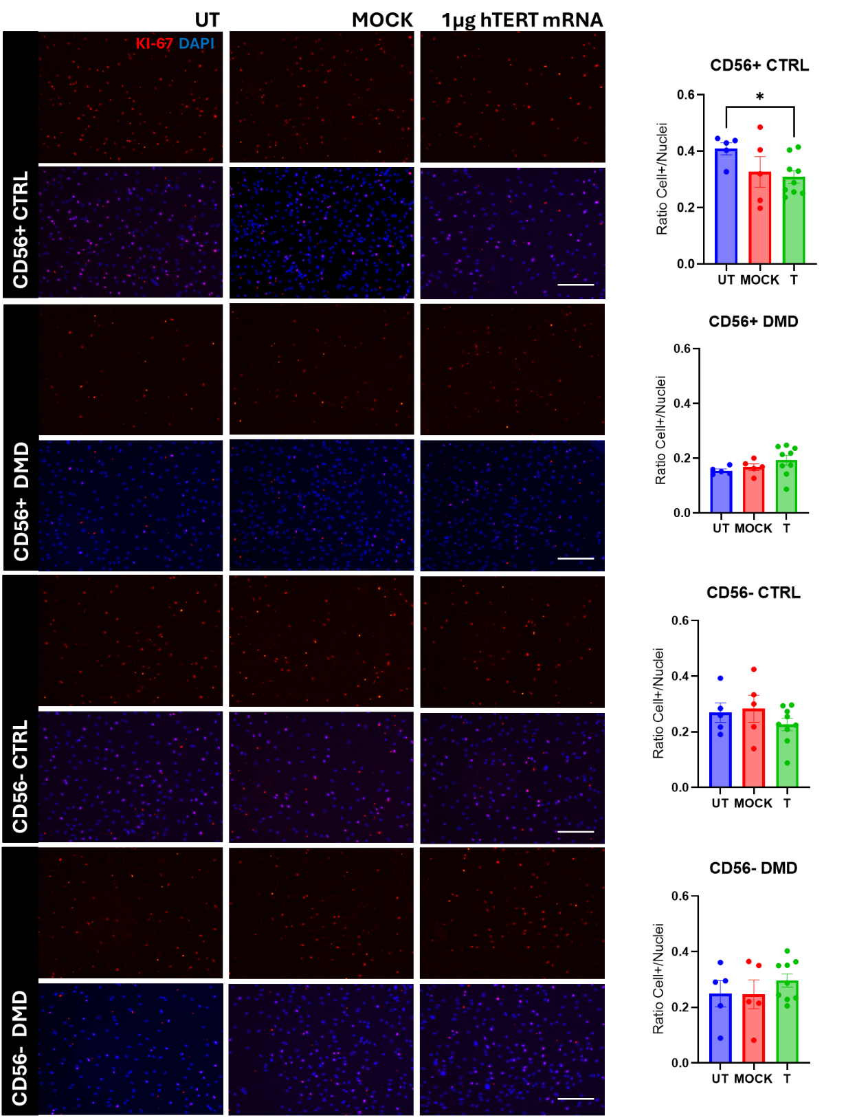
Figure 29) Proliferative marker evaluation after hTERT mRNA transfection. Representative images of Ki-67 (red) and DAPI (blue) staining in CD56⁺ and CD56⁻ myogenic cells from CTRL and DMD donors at one passage after transfection. Quantification of Ki-67⁺ cells was performed by counting positive nuclei over the total number of nuclei (values ranging from 0 to 1). At least 5 fields per condition were acquired. Data were tested with ANOVA Mixed Model, followed by Dunnet’s multiple comparison test. Scale Bar 300µm. *p<0.05.

Karyotype Analysis
Finally, to ensure that aging and hTERT transfection do not hamper chromosomal stability, a karyotype analysis was performed by HSR Cytogenetic laboratory (Fig. 30). The report demonstrated that healthy-derived cells were no subjected to chromosomal alteration. Accordingly, DMD cells were tested after some passages after the transfection, concomitant to their proliferative boost, resulting in a normal karyotype, highlighting safety of hTERT transient expression.

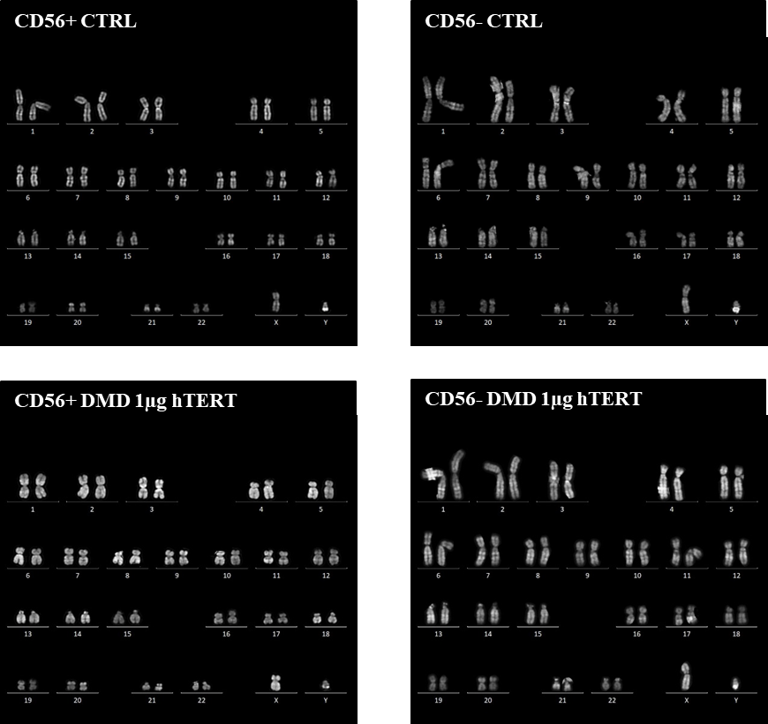
Figure 30) Chromosomal spread analysis. Cells were induced in metaphase and spread onto slides. DNA was stained with Quinacrine (QFQ) and analyzed with a resolution of 400 bands.

Transient expression of exogenous hTERT declines after two passages in culture
To confirm that exogenous hTERT expression is transient, cells were immunostained for hTERT 2 passages (approximately 1 week) after hTERT transfection (Fig. 31). In CD56⁺ and CD56⁻ population of both genotype, fluorescent intensity of treated and untreated group showed no significant differences, except CD56⁺ samples whereas treated levels were lower than Untreated and Mock (UT vs. MOCK **p= 0,0067; UT vs. T ***p= 0,0006) consistently in healthy and DMD groups. These data confirm short-term expression of hTERT.

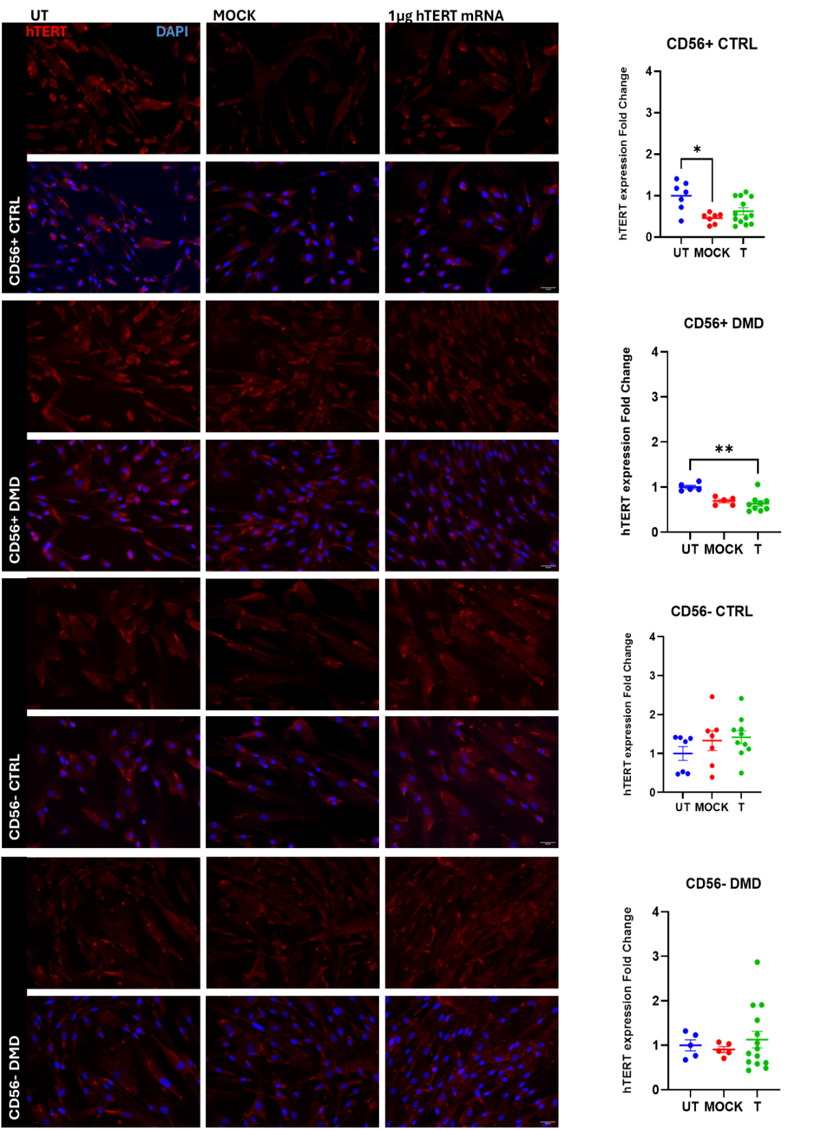
Figure 31) hTERT expression two passages after hTERT mRNA transfection (1µg/ml). Immunofluorescence for hTERT (red) and nuclei (DAPI, blue) in CD56⁺ and CD56⁻ muscle progenitors from healthy (CTRL) and DMD donors. Columns correspond to untreated (UT), mock-transfected (MOCK), and hTERT mRNA-transfected samples. Rows represent CD56⁺ CTRL, CD56⁺ DMD, CD56⁻ CTRL, and CD56⁻ DMD populations. Cells were fixed after 2 passages post-transfection. Fluorescence intensity quantification of hTERT expression indicates no differences or a reduction (CD56⁺ of both genotypes) compared to untreated. Results were statistically analyzed with Kruskal-Wallis on at least 5 independent fields per condition. Scale bar: 300 µm. *p < 0.05, **p < 0.01.

Treatment effect on myogenic differentiation after hTERT transfection
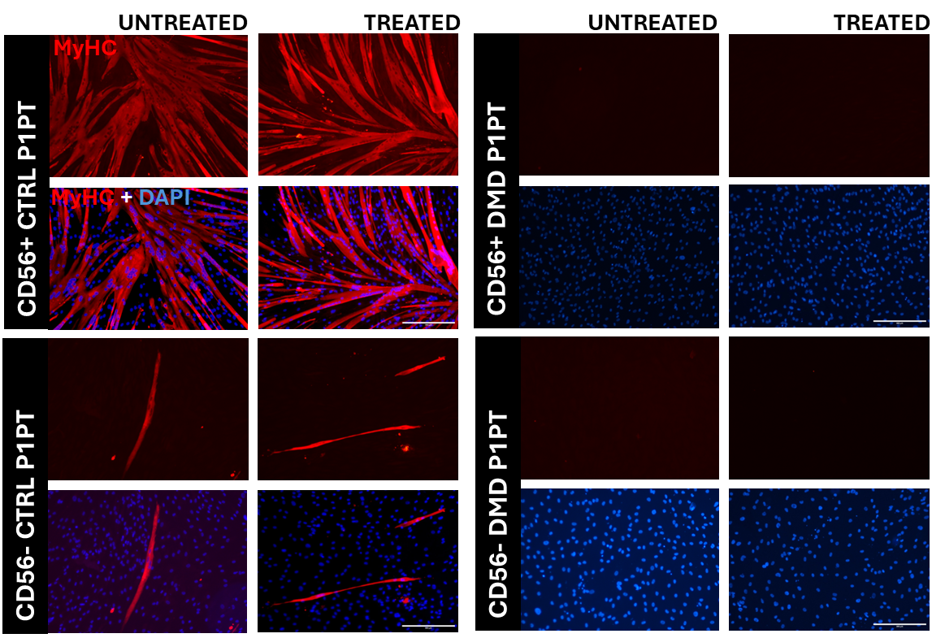
Given the role of hTERT in sustaining proliferation, it was examined whether its transient expression interferes with the myogenic differentiation program (Fig. 32). Cells were treated with hTERT mRNA (1 µg/ml) for 4 h, allowed to recover and proliferate for a few days, and then plated on Matrigel-coated dishes and induced to differentiate.
In control (CTRL) cells, both populations expressed MyHC to a comparable extent, with no significant differences compared to their matched untreated counterparts. In contrast, DMD-derived cells displayed a severely impaired differentiation potential, with no detectable formation of mature myotubes, indicating that transient hTERT expression was not sufficient to restore myogenic competence in a system already characterized by an intrinsically compromised differentiation program.
Figure 32) Immunostaining for MyHC to assess cell’s differentiation in CD56+ and CD56- populations of dystrophic and healthy donor cells after h-TERT transfection. One passage after transfection, cells were shifted in differentiation medium for approximately 12 days. Differentiation potency was not affected by hTERT transfection in CTRL cells, while dystrophic cells were unable to differentiate independently of the treatment. Scale Bar 300µm.

Average telomere length quantification in DMD cells after transfection
To determine whether exogenous hTERT was able to remodel telomere infrastructures, the qPCR was repeated initially on both CD56⁺ and CD56⁻ DMD samples (Fig. 33).
After hTERT mRNA transfection, DNA was collected at different timepoints (1, 3 and 6 passages). The average telomere length was compared within the CD56⁺ and CD56⁻ populations. No statistical differences in telomere length were observed regardless of the analyzed timepoints and cell populations. Moreover, the high variability among the technical replicates was observed. Due to lack of expected outcomes and technical challenges of using qPCR method to quantify telomere length, a more sensitive approach was implemented (described in section 4.16).
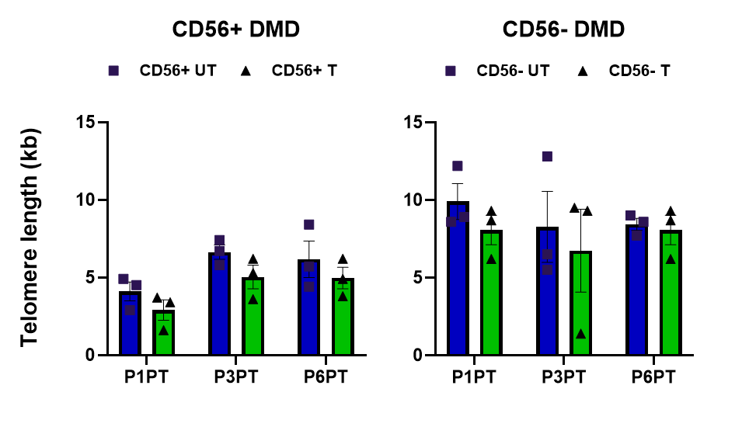
Figure 33) Telomere length evaluation in DMD myogenic populations after mRNA transfection. Average telomere length was measured by qPCR in CD56⁺ and CD56⁻ cells of Untreated (Blue) and Treated (green) conditions at 1, 3 and 6 passages after hTERT mRNA transfection. Bars represent mean ± SEM of technical replicates (n = 3). Statistical analysis was performed by two-way repeated-measures ANOVA followed by Dunnett’s post hoc test.

  - Relative Telomere elongation evaluated in single-cell resolution with Telo-qFISH
Quantitative Fluorescence In Situ Hybridization (Q-FISH) analysis was performed on CD56⁺ and CD56⁻ myogenic cells derived from healthy controls (CTRL) and Duchenne muscular dystrophy (DMD) patients to assess relative telomere length distribution. Telomeric foci were detected using a Cy3-labeled (CCCTAA)₃ probe (red), while nuclei were counterstained with DAPI (blue). Representative images for each condition are shown in Fig. 34.
Quantification was carried out on at least n = 50 nuclei per condition. The mean telomere fluorescence intensity (arbitrary units, A.U.) was calculated using Telometer (see Materials and Methods) and normalized to the DAPI signal.
A first analysis of pooled nuclei (Fig. 33), expressed as fold change relative to untreated controls, revealed that both DMD populations showed a significant increase in telomere fluorescence intensity (CD56⁺ Treated, 1.125-fold, *p < 0.05; CD56⁻ Treated, 1.150-fold, **p < 0.01) compared n CTRL samples, an increase in fluorescence signal was observed in CD56⁻ cells (Mock, 1.185-fold, ***p < 0.001; Treated, 1.211-fold, ****p < 0.0001) compared to untreated controls, whereas CD56⁺ Treated cells showed a significant reduction of telomeric signal (0.295-fold, ****p < 0.0001) relative to their matched controls.
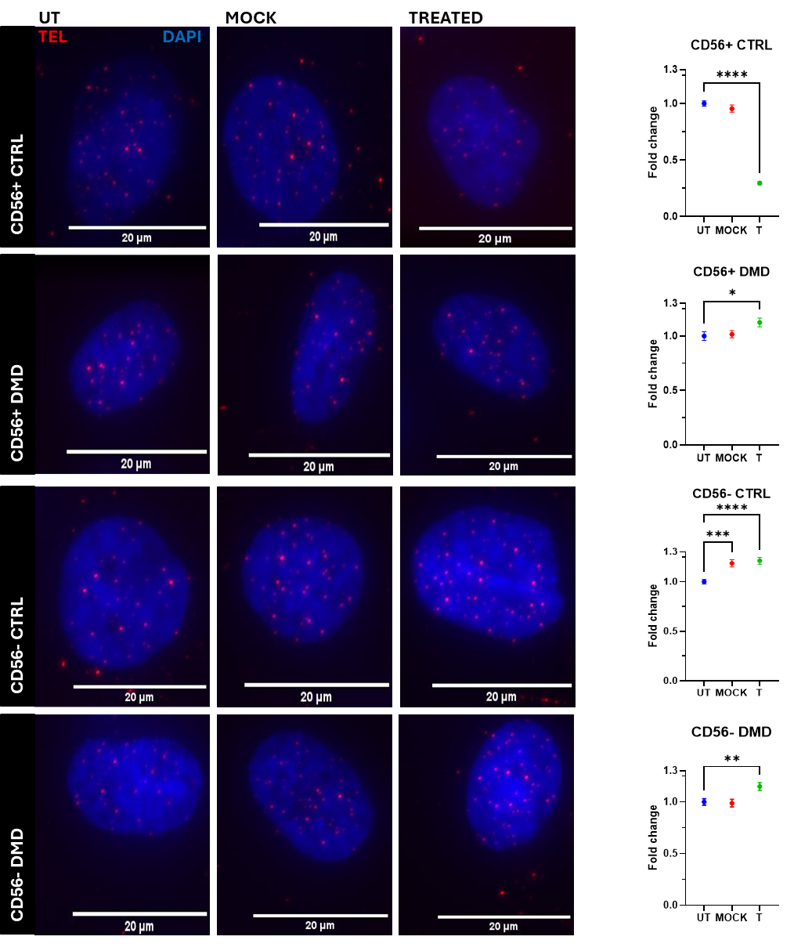
Furthermore, individual nuclei data were plotted as frequency distributions using automatically defined bin intervals (Fig. 35). The overall distribution of telomere intensities indicated a broader and right-skewed pattern in DMD-derived cells and in CD56⁻ CTRL samples, in contrast to the narrower, left-shifted distribution observed in CD56⁺ CTRL. to Mock and Untreated cells.
Figure 34) Representative nuclei images of Q-FISH staining and their relative quantification (on the side). Statistical significance was assessed by one-way ANOVA followed by Dunnett’s multiple comparisons test. Data are presented as mean ± SEM for ANOVA comparisons. Scale bar: 20 µm. *p < 0.05, **p < 0.01, ***p < 0.001, ****p<0.0001.

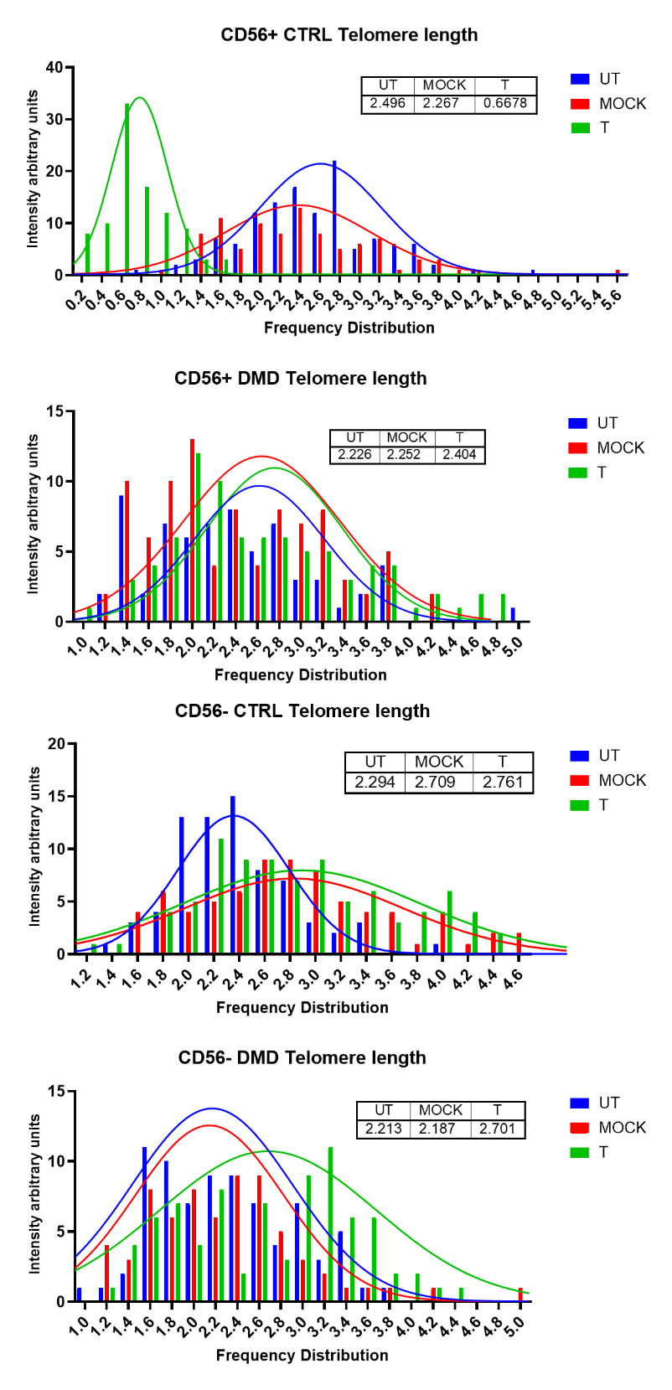
Figure 35) Frequency distribution of telomere fluorescence intensities in CD56⁺ and CD56⁻ myogenic cells from control (CTRL) and Duchenne muscular dystrophy (DMD) donors. Histograms represent individual nuclear measurements (bins defined automatically) of UT (blue), Mock (red) and T (green), overlaid with Gaussian-fit curves and mean fluorescence values (see inset tables). DMD populations and CD56⁻ CTRL cells display broader, right-skewed distributions, whereas CD56⁺ CTRL cells show a narrower, left-shifted profile.

RNA sequencing
To preliminary explore the global transcriptional organization of the experimental conditions, total RNA was extracted from the cells and sequenced two passages after transfection. Since it is well established that myoblasts (CD56⁺) and pericyte-like cells (CD56⁻) differ in several biological aspects — including proliferation potential, differentiation capacity, and extracellular matrix interactions — the two populations were analyzed separately, as consistently done throughout this project, given that such differences could be further amplified in the context of Duchenne muscular dystrophy (DMD).
The ectopic expression of hTERT was expected to reshape the transcriptional landscape, reflecting both direct and downstream effects of telomerase reactivation. The resulting gene expression profiles thus provide an overview of how hTERT may influence cellular programs relevant to proliferation, stress response, and differentiation potential, which will be further explored through functional ontology analyses.
Hierarchical clustering was performed on the log₂ fold-change values of the 300 most variable genes across all pairwise comparisons. This subset was selected to minimize background noise and to focus the analysis on the most informative transcriptional differences driving sample segregation, in line with commonly adopted practices for exploratory RNA-seq analyses. Gene-wise z-score normalization was applied, and clustering was based on correlation distance and average linkage method. In CD56⁺ cells, the heatmap showed a clear grouping of the four experimental contrasts into two main clusters corresponding to the treatment status. In CD56⁻ cells, clustering appeared less defined, with a more heterogeneous distribution of expression changes across comparisons (Fig. 36).
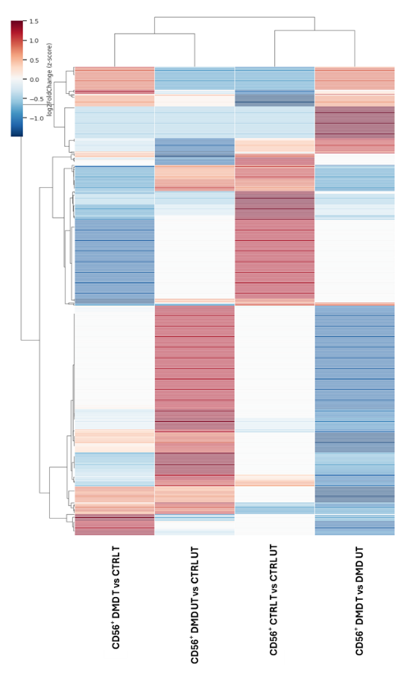
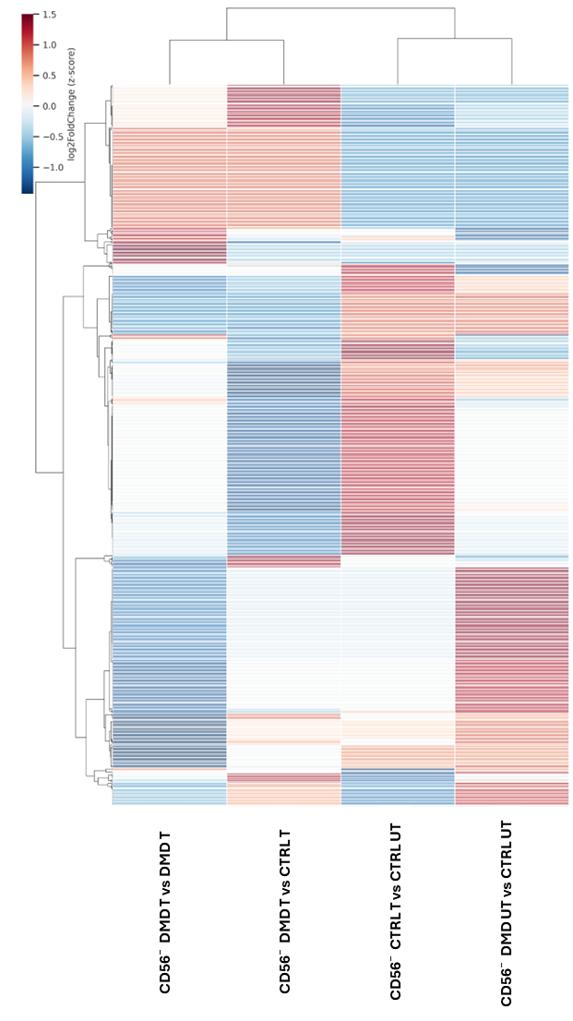
Differential expression analysis confirmed these trends. In CD56⁺ myoblasts, 2518 genes were differentially expressed between untreated DMD and control samples (1758 upregulated and 760 downregulated). After hTERT transfection, the number of differentially expressed genes between DMD and control decreased to 1103 (740 upregulated and 363 downregulated). The direct comparison between treated and untreated DMD myoblasts identified only 59 differentially expressed genes (7 upregulated and 52 downregulated). Consistently, Gene Ontology analysis showed that several processes enriched in the untreated DMD condition — including extracellular matrix organization, inflammatory response, and stress-related pathways — were less represented after treatment, suggesting a partial normalization of the transcriptomic profile (Fig. 37).
Figure 36) Hierarchical clustering of the 300 most variable genes across experimental conditions in CD56⁺ (left) and CD56⁻(right) myogenic cells. Heatmaps represent z-score–normalized expression values of the 300 genes showing the highest variance among groups. Samples include control (CTRL) and Duchenne muscular dystrophy (DMD) cells, either untreated (UT) or treated (T) with hTERT mRNA. Each column corresponds to a comparison, and each row represents a gene. Clustering was performed using correlation distance and average linkage. The resulting dendrograms illustrate the global transcriptional organization within each cell population, highlighting distinct expression profiles between genotypes and partial convergence upon hTERT expression.
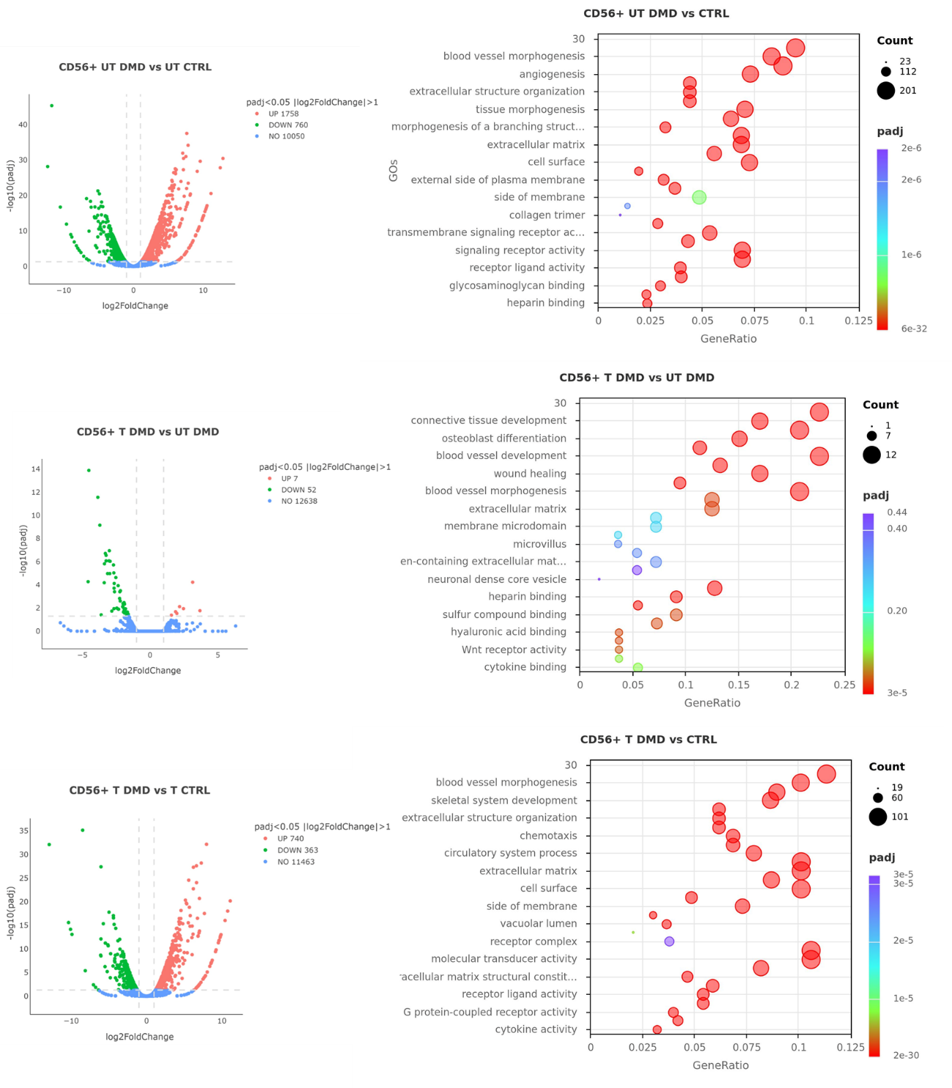
Figure 37) Differential gene expression and Gene Ontology (GO) enrichment analyses in CD56⁺ myogenic cells from control (CTRL) and Duchenne muscular dystrophy (DMD) donors. Volcano plots (left) show the distribution of differentially expressed genes (DEGs) between untreated (UT) and treated (T) conditions for each comparison, highlighting upregulated (red) and downregulated (green) transcripts (padj < 0.05, |log₂FoldChange| > 1). Bubble plots (right) represent the top enriched GO terms among DEGs (Biological Process and Molecular Function categories). In untreated DMD versus CTRL cells, 2500 genes were significantly modulated, mainly related to extracellular matrix organization, morphogenesis, and angiogenesis. Following hTERT treatment, the transcriptional divergence between DMD and CTRL was reduced to ~1000 DEGs, with enrichment in tissue development and cell surface–associated processes, suggesting a partial normalization of gene expression programs.
In CD56⁻ cells, the untreated DMD vs. control comparison showed 2,262 differentially expressed genes (1,420 upregulated and 842 downregulated). Following hTERT transfection, the number of differentially expressed genes between DMD and control decreased to 1,024 (621 upregulated and 403 downregulated), while the direct comparison between treated and untreated DMD samples revealed 76 differentially expressed genes (10 upregulated and 66 downregulated). After hTERT treatment, the total count of DEG further decreased, together with a reduction in the number and significance of enriched Gene Ontology terms. The same functional categories observed in myoblasts were generally represented, including extracellular matrix organization, cell adhesion, and stress response, but with lower enrichment scores and gene counts. (Fig. 38).

Overall, hTERT expression attenuated the transcriptional alterations observed in DMD cells, leading to fewer differentially expressed genes and reduced enrichment of stress- and fibrosis-related pathways. This pattern suggests a partial rescue of the transcriptomic profile toward a more physiological state.
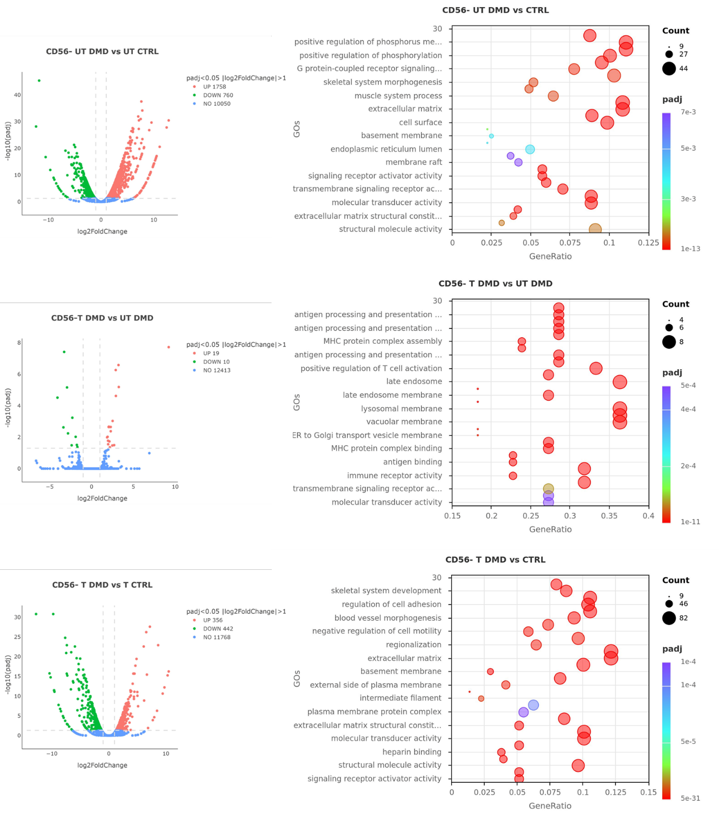
Figure 38) Differential gene expression and Gene Ontology (GO) enrichment analyses in CD56⁺ myogenic cells from control (CTRL) and Duchenne muscular dystrophy (DMD) donors. Volcano plots (left) show the distribution of differentially expressed genes (DEGs) between untreated (UT) and treated (T) conditions for each comparison, highlighting upregulated (red) and downregulated (green) transcripts (padj < 0.05, |log₂FoldChange| > 1). Bubble plots (right) represent the top enriched GO terms among DEGs (Biological Process and Molecular Function categories). In CD56⁻ cells, the number of differentially expressed genes and enriched ontologies was lower, and the transcriptional response to treatment appeared more heterogeneous, reflecting the higher intrinsic plasticity of this population.

Discussion
Duchenne muscular dystrophy (DMD) is the most common and one of the most severe forms of muscular dystrophy, all of which are characterized by a progressive decline in the regenerative capacity of skeletal muscle. In DMD, the phenotype is particularly dramatic due to the continuous and excessive demand placed on muscle progenitors, which must repeatedly activate to sustain cycles of degeneration and attempted regeneration. Despite decades of research, the mechanisms underlying this regenerative failure remain incompletely understood, and multiple hypotheses have been proposed. What is well established is that, over time, the balance between degeneration and regeneration shifts irreversibly: functional muscle fibers are progressively lost and replaced by fibrotic or adipose tissue.
Following the discovery of telomeres and telomerase, and their essential roles in cell-cycle control and proliferative lifespan, seminal work by Helen Blau and colleagues (Blau et al., 1983) revealed differences in telomere biology between muscle cells from healthy and DMD individuals. These observations were particularly striking given that skeletal muscle is largely post-mitotic in its mature form, suggesting that telomere dynamics might only influence the proliferative competence of muscle progenitor cells. This idea laid the conceptual foundation for linking telomere attrition to impaired regenerative capacity in DMD. To support this, a mouse model mdx/TR was later introduced to better recapitulate the disease (reduced lifespan, fibrosis, inflammation), showing comparable discrepancies with their matched controls in telomere length (Sacco et al., 2010; Tichy et al., 2021) as shown previously.
Although telomere shortening and impaired regenerative capacity have been associated in DMD, the specific contribution of telomerase activity and telomere dynamics to the proliferative decline of human myogenic precursors remains unclear. Moreover, no study has compared and characterized culture conditions, proliferation, telomere length and telomerase activity in myogenic progenitors CD56⁺ (identifying myoblasts) and CD56⁻ (a heterogeneous population comprising pericyte-like cells) during ex-vivo aging. Importantly, no study has yet tested whether a non-integrative and transient telomerase-based approach—such as hTERT mRNA delivery—can enhance the proliferative capacity of dystrophic muscle progenitors. Whether such an intervention can boost expansion while preserving their differentiation potential and genomic stability remains largely unexplored. This decline in proliferative competence is particularly critical for therapeutic strategies based on cell transplantation, where the inability to obtain sufficient numbers of viable and functional autologous or allogeneic muscle progenitors represents a major bottleneck in cell manufacturing (Maffioletti et al, 2014). Based on these considerations, this PhD project aimed to explore a novel approach to counteract the intrinsic low-rate proliferation in dystrophic myogenic cells.
The proliferation profiles obtained with the commercial medium and the custom-made (MIX) medium were broadly comparable; however, MIX uniquely preserved the differentiation capacity of the cells. This suggests that the strong mitogenic cues provided by the commercial formulation may impair the ability of myogenic progenitors to exit the cell cycle and engage their differentiation program. Notably, the MIX medium supported prolonged expansion and yielded high cell numbers, consistent with only a few reports achieving similar long-term expansion (Stadler et al, 2011) and superior to outcomes commonly described in the literature (Gros et al, 2022; Jarocha et al, 2014). This makes MIX particularly suitable for large-scale expansion of primary human myogenic cells.
Following medium optimization, both progenitor populations were characterized in healthy and DMD backgrounds. As reported in previous studies (Blau et al., 1983; Webster et al., 1990; Mouly et al., 2005), DMD-derived (17-year-old male donor) CD56⁺ and CD56⁻ cells displayed markedly impaired proliferative capacity, as confirmed by reduced Ki-67 expression both at early passages and at the end of the growth curves. These cells also exhibited a reduced or absent differentiation capacity compared with healthy counterparts (9-year-old male donor). The differences observed between genotypes are consistent with their biological context: in healthy cultures, reduced proliferative output can be influenced by donor age (Decary et al., 1997; Mouly et al., 2005), and the behaviour of the healthy donor used here aligns with these findings. Conversely, the impaired proliferation of DMD-derived cells reflects the premature cellular ageing characteristic of dystrophic muscle, where continuous cycles of degeneration and regeneration impose persistent proliferative pressure on muscle progenitors.
In line with this, healthy-derived CD56⁺ cells—and to a lesser extent CD56⁻ cells—retained a consistent myogenic differentiation program, whereas DMD-derived progenitors exhibited profound defects: CD56⁺ cells differentiated poorly even at early passages and rapidly lost this capacity, while CD56⁻ cells failed to differentiate entirely. An additional factor that may have contributed to the reduced differentiation capacity of DMD-derived cells is their prior handling in a GMP-compliant clinical trial setting, where cells were expanded in MyoCult SF medium. Notably, our group has observed a marked reduction in myogenic differentiation following prolonged culture in this medium, suggesting that culture conditions may influence differentiation outcomes independently of the genetic background.
Given that such proliferative defects may arise from impaired telomere maintenance, the mean telomere length of both populations was assessed using qPCR, revealing shorter telomeres in DMD cells already at early stages of culture. Although studies from Rudnicki's group and others indicate that satellite cell abundance is not necessarily reduced in dystrophic muscle—and instead highlight defects in asymmetric division and lineage entry (Chang et al, 2016; Dumont et al, 2015)—a substantial body of evidence links telomere shortening to regenerative failure in DMD skeletal muscle (Sacco et al., 2010; Tichy et al., 2021) and in the cardiac context (Mourkioti et al., 2013). These findings provide a mechanistic rationale for the intrinsic proliferative limitations observed here and reinforce the concept that telomere erosion contributes directly to the exhaustion of dystrophic muscle progenitors.
Emerging evidence indicates that dystrophic muscle and satellite cells display features associated with proliferative impairment and regenerative decline early during disease progression, independently of patient age (Cardone et al., 2023; Sugihara et al., 2020). In this context, the telomere alterations and proliferative behaviour observed in DMD-derived progenitor cells in this study are consistent with an emerging view of Duchenne muscular dystrophy as a condition characterised by premature stem cell exhaustion rather than chronological ageing alone.
Telomerase activity assays further showed that DMD cells may retain relatively higher telomerase activity than healthy cells possibly due to high proliferative demand, although this did not translate into improved proliferative capacity. Telomeres, on the other hand, followed a decreasing trend during in vitro aging as expected. Interestingly, although generally shorter compared to controls, DMD cells in mid-passage (around passage 20) displayed a marked increase in telomere shortening accompanied by a drop in telomerase activity. However, cells that subsequently re-expressed/re-activated telomerase and partially restored telomere length eventually still underwent replicative senescence. This behaviour may reflect clonal selection occurring after a crisis associated with hTERT downregulation or inactivation, where only subclones with higher fitness and residual telomerase activity survived.
In line with this complexity, the identification of senescence in dystrophic cells remains methodologically challenging. Interestingly, while it’s widely accepted the SA-βGalactosidase as marker for senescent cells (Cai et al, 2020; Debacq-Chainiaux et al, 2009), long-term cultured DMD cells resulted several times at several stages negative for the assay, contrary to healthy ones. This is not completely unexpected as several studies highlighted the unreliability of this assay due to different pathways activation, suggesting more involved markers as p16INK4a and p21 (Debacq-Chainiaux et al, 2009; Sousa-Victor et al, 2014) and may be implemented in the future.
After establishing an in vitro model capturing the proliferative potential, telomere/telomerase dynamics, and differentiation capacity of healthy- and DMD-derived myogenic progenitors, the next step was to evaluate whether transient hTERT reintroduction could mitigate the intrinsic proliferative limitations of DMD cells. To this aim, a modified hTERT mRNA was designed to ensure increased stability, reduced immunogenicity, and suitability for cell-based applications, and was synthesised through in vitro transcription (IVT) (see Materials and Methods). This approach allowed a strictly transient expression of telomerase—without genomic integration—providing a controlled system to assess its contribution to the replicative defects observed in DMD progenitors. Cells were treated at the mid-stage of their lifespan (around passage 20 for both genotypes), corresponding to the point at which DMD proliferation begins to decline while still avoiding overt senescence. Protein translation was confirmed 48 h post-transfection by immunostaining. Both genotypes expressed hTERT, although the increase was more modest in healthy samples. Within subpopulations, CD56⁺ cells from both genotypes showed clear induction of hTERT, with a higher magnitude in DMD cells, suggesting greater permissiveness to mRNA delivery or translation. CD56⁻ cells exhibited broader variability, reflecting their intrinsic heterogeneity, and displayed a slight signal even in mock conditions, more evident in DMD cultures. A follow-up analysis two passages later (approximately one week) showed a complete disappearance of hTERT signal—or even a reduction relative to baseline in both CD56⁺ subsets—confirming the expected transient nature of the treatment and suggesting a possible refractory or negative-feedback mechanism limiting sustained telomerase expression.
To assess whether hTERT delivery influenced cell-cycle dynamics, Ki-67 expression was measured one passage after treatment. Although no statistically significant differences emerged, a clear trend was observed: healthy cells showed a slight decrease in Ki-67 positivity following treatment, whereas DMD samples displayed the opposite tendency, indicating a mild stimulation of proliferation.
To investigate whether hTERT delivery affected telomere maintenance, telomere length was evaluated one passage after transfection. qPCR-based measurements were too variable (data not shown), so analysis was shifted to telomere qFISH, allowing single-cell resolution. Across ≥50 nuclei per condition, qFISH revealed a clear increase in telomere signal in all treated DMD samples and in healthy CD56⁻ cells, with distributions skewed toward higher fluorescence values, consistent with elongation. Conversely, healthy CD56⁺ cells showed a reduction in telomere intensity, suggesting a distinct response to telomerase re-expression. Preferential elongation of critically short telomeres could explain these shifts, as previously observed in Cre/Lox-mediated TERT reactivation in BJ fibroblasts (Steinert et al, 2000) and in Hutchinson-Gilford progeria syndrome (Li et al, 2019).
These trends aligned with proliferation assays. In both DMD timepoints (4 h, 16 h), hTERT-treated CD56⁺ and CD56⁻ cultures showed increased population doublings compared to controls, in some cases doubling total PDs, resulting in a substantial theoretical increase in yield. In contrast, healthy cells showed minimal effects in CD56⁺ cultures and none in CD56⁻ cells, matching their limited hTERT induction and telomere dynamics. Ramunas et al. similarly reported that transient telomerase mRNA elongates telomeres in fibroblasts and myoblasts, although only fibroblasts achieved sustained lifespan extension under repeated treatments; myoblasts remained constrained by p16-mediated arrest, consistent with earlier hTERT-based immortalisation attempts (Zhu et al, 2007; Ramirez et al, 2001). This parallels the present results: healthy myoblasts showed no proliferative gain and even reduced qFISH signal, though this requires confirmation via p16 or additional senescence markers. The heterogeneous CD56⁻ population behaved similarly, reflecting its mixed progenitor/fibroblast composition.
The effects of transient telomerase re-expression on differentiation were evaluated by inducing myotube formation after hTERT mRNA delivery. In healthy CD56⁺ and CD56⁻ cultures, hTERT did not alter fusion capacity, in agreement with prior data showing that telomerase reintroduction does not impair myogenesis, as telomerase activity is normally silenced during fusion (O’Connor et al, 2009; Di Donna et al, 2003). This is consistent with evidence that fully immortalised myoblasts and mesoangioblasts preserve differentiation competence without acquiring tumorigenic potential (Zhu et al., 2007; Benedetti et al., 2017). In contrast, DMD-derived cells failed to fuse regardless of treatment, confirming that their intrinsic differentiation block cannot be corrected by telomerase alone (Kodippili & Rudnicki, 2023).
To explore the molecular basis of this differential sensitivity, an exploratory bulk RNA-seq was performed. Healthy and DMD samples segregated clearly, and CD56⁺ and CD56⁻ lineages retained distinct transcriptional identities. Analysis of the 300 most variable genes revealed a more pronounced response to hTERT in CD56⁺ cells. Importantly, treated DMD samples became transcriptionally closer to treated healthy controls, supporting a partial rescue effect. Differential expression analysis confirmed this: only a limited number of genes changed upon treatment within DMD samples, yet the number of DEGs between treated DMD and treated healthy cells decreased by ~2.5-fold in CD56⁺ and ~2.7-fold in CD56⁻ populations. GO analysis indicated that pathways typically dysregulated in DMD—fibrosis, ECM remodelling, inflammation, and muscle development—were partially normalized after treatment, especially in CD56⁺ cells. This aligns with emerging evidence that telomerase can mitigate impaired cellular pathways beyond telomere biology, such as DNA repair (Li et al, 2025).
Finally, karyotype analysis of long-expanded healthy and hTERT-treated DMD cells showed no chromosomal abnormalities, supporting the safety of transient telomerase expression.
In spite of the new findings obtained in this project, several limitations should be considered when interpreting the results. First, all the experiments were conducted in a traditional 2D culture system, which intrinsically exposes cells to multiple stressors, including atmospheric oxygen, light, repeated manipulation, and the structural constraints of a monolayer environment. These conditions do not reproduce the architecture, mechanical stimuli, or niche complexity of skeletal muscle tissue, and therefore limit the physiological relevance of the observations.
Another important limitation concerns donor availability. The study was performed using cells derived from a single donor for each genotype. This is partly due to the progressively reduced access to DMD biopsies, as current diagnostic protocols no longer require invasive muscle sampling. Although the results remain internally consistent, expanding the number of donors or moving toward 3D models—such as organoids or engineered muscle tissue—would strengthen reproducibility and generalizability. The use of genetically engineered iPSCs could also overcome the scarcity of primary tissue; however, this approach would not fully recapitulate the epigenetic landscape and cumulative stress that patient-derived cells have experienced in vivo.
Methodological constraints also influence the interpretation of the molecular data. The qPCR-based assays used to measure telomere length and telomerase activity rely on commercial kits that allow minimal optimization and display significant inter-experimental variability. Furthermore, qPCR measurements of telomeres provide only an average telomere length, without resolving chromosomal heterogeneity, while the TRAP assay cannot discriminate between total hTERT protein and the fraction that is enzymatically active. The qFISH approach employed in this project offers high sensitivity and relative quantification but does not provide absolute telomere length; thus, applying qFISH on metaphase chromosome spreads would be necessary to overcome this limitation.
The evaluation of mRNA-based hTERT expression represents another area in need of further exploration. The present work tested a single mRNA formulation and exposure regimen, yet many refinements could improve both stability and potency, such as transitioning from Cap0 to Cap1, optimizing UTRs, or examining emerging platforms like circular or self-amplifying mRNAs. Future studies should also test multiple dosages, repeated administrations, and application during myogenic differentiation to determine whether hTERT expression can preserve or enhance the myogenic program. Moreover, a deeper characterization of hTERT homeostasis in DMD myogenic cells—including nuclear residency time, post-translational modifications, and potential mitochondrial roles—remains an open and important question.
Finally, the in vitro nature of this study limits the ability to predict how treated cells would behave in vivo. Engraftment potential, proliferative persistence, and long-term stability within muscle tissue are essential parameters that can only be evaluated through transplantation assays or appropriate animal models.
In the future, another donor’s biopsy will be studied to confirm whether the effects observed in this work—particularly the enhanced responsiveness of DMD cells to transient hTERT expression—are reproducible across individuals. For this second donor, the full experimental workflow will be repeated, including proliferation curves, qFISH-based telomere measurements, and Ki-67 analysis, together with the implementation of additional senescence markers such as p16^INK4a or p21 to refine the characterisation of proliferative decline. To improve telomere analysis, qFISH will also be extended to metaphase chromosome spreads, enabling the detection of critically short telomeres and telomere-free ends with higher resolution. In parallel, selected transcriptional changes identified by RNA-seq will be validated by qPCR on key driver genes linked to proliferation, telomere maintenance, or cellular stress pathways, strengthening the mechanistic interpretation of the transcriptomic dataset. Finally, high-resolution imaging will be used to examine hTERT localisation after mRNA delivery, with particular attention to nuclear import and potential mitochondrial retention, to clarify whether differences in hTERT trafficking contribute to the divergent responses between healthy and DMD progenitors. Together, these experiments will consolidate the robustness of the findings and refine the understanding of telomerase reactivation in dystrophic myogenic cells.
In conclusion, the data generated in this project reveal a coherent and biologically meaningful correspondence between the in vitro model used and key hallmarks of Duchenne muscular dystrophy. The combination of impaired proliferation, progressive loss of myogenic competence, shortened telomeres despite detectable telomerase activity, elevated cellular stress, and marked transcriptomic dysregulation reproduces fundamental aspects of the dystrophic phenotype. These findings reinforce the idea that telomere erosion and dysfunctional telomerase regulation constitute central contributors to the proliferative decline of DMD myogenic progenitors.

Within this framework, the introduction of transient, non-integrative hTERT expression produces a striking genotype-dependent effect. While healthy-derived myogenic cells show minimal or even adverse responses, DMD-derived progenitors exhibit a robust enhancement of proliferative performance. This selective responsiveness likely reflects the cumulative epigenetic and environmental pressures to which dystrophic cells are exposed in vivo, rendering them more permissive to telomerase reactivation. The observation that short-lived hTERT expression can partially restore the expansion capacity of DMD myogenic cells represents the first experimental evidence that telomerase-based interventions may mitigate intrinsic proliferative exhaustion in human dystrophic muscle progenitors.
Although not a therapeutic cure, these results suggest that transient hTERT mRNA delivery might offer a practical and safe strategy to enhance ex vivo expansion of patient-derived myogenic cells. Such an approach could directly benefit regenerative medicine applications—including autologous or allogeneic myogenic cell transplantation—by alleviating one of the major bottlenecks in current clinical protocols: the inability to generate sufficiently large, functional, and genomically stable myogenic cell populations. Moreover, the safety profile and flexibility of mRNA-based strategies provide an attractive alternative to viral gene-delivery methods, opening the possibility of scalable, temporally controlled manipulation of telomere biology without permanent genomic modification.

Materials and methods

Cell culture and proliferation curves
Human primary myogenic cells were obtained from two different donors as described in Tonlorenzi et al., 2007, and expanded to make backups. The cells were kept in low oxygen conditions (5% O2, 5% CO2, 95% humidity), and two different media were used: Myocult SF (StemCell, Cat. 05980) a commercially available serum free medium under patent with unknow composition, specifically designed for muscular cells expansion, and a homemade patented medium containing low-glucose DMEM without PhenolRed, 5% FBS, penicillin-streptomycin with a mixture of mitogens and inflammatory cytokines.
The cells were then separated with magnetic beads loaded with anti-CD56 antibodies to separate CD56+ satellite cells from and an heterogenous population of pericyte-like cells (CD56-), then verified by flow cytometry.
All the populations were tested for their proliferation and differentiation potential over time until their natural exhaustion in vitro. Proliferation curves were made by plating always the same number of cells (8x10⁵) every passage to calculate the Population Doublings (PD) using the formula (HarvestedLn/SeededLn/Ln2) described elsewhere. Cells were counted manually on a Burker chamber Haematocytometer (cat. HS-1490).

The cells were tested for Mycoplasma every 5 passages, resulting constantly negative.

Human TERT mRNA template generation and synthesis
To generate the mRNA containing the coding sequence of hTERT, a T7 plasmid containing an MCS, hBB UTRs and a Poly-A sequence was used called pMRNAxp mRNAExpress™ contained in mRNAExpress™ kit (cat. MR-KIT-1, Applied Bioscience). The open reading frame (ORF) was obtained by the sequence of the Human Telomerase named NM_198253.2 on NCBI. The cloning of the sequence into the vector was made by TwinHelix (TwinHelix, Netherlands) since the restriction sites were adjacent to each other resulting in inefficient restriction site digestion. The subsequent plasmid was then amplified, and extra adenines were added to the DNA fragment with a specific set of primers (composition under patent) via PCR as reported in the manufacturer's protocol.
The fragment was run on a 0,8% agarose gel to assess the correct molecular weight (approximately 3340 bp), extracted with Macherey-Nagel DNA spin purification columns (cat. 740609.50) and the resulting fragment was then transcribed with HiScribeT7 (cat. E2065S) providing an Anti-Reverse Cap Analogue (ARCA) (Cap0). The reaction was set as manufacturer’s instruction. The reaction underwent an additional treatment with DNAse to avoid any downstream interference of DNA during the transfection. The transcript was purified by Lithium Chloride precipitation (LiCl), air dried and resuspended in RNAse-free water, analysed with TapeStation 4200 (Agilent, cat. G2991BA).

Magnetic Beads Separation
Heterogenous population of cells obtained from donors’ biopsies were expanded, harvested and resuspended in 1% FBS 2mM EDTA buffer in PBS, then filtered with a cell strainer 70 um to dissolve eventual clamps. The cells were centrifuged, washed, blocked and stained with antibody-conjugated beads for CD56 (Miltenyi, Cat. 130-050-401) then transferred to a separation column LD (Miltenyi, Cat. 130-042-901) mounted on a QuadroMax magnetic support (Miltenyi, Cat. 130-091-051) working in a depletive fashion, obtaining negative population for CD56, then after the magnet detachment, the CD56+ population was collected.

Flow Cytometry
Cells were harvested before and after magnetic beads separation, counted to have at least 50’000 cells, stained with CD56-PE antibody (BD Pharmigen, cat. 555516) and analysed to evaluate cell’s mixture composition. At least 30’000 events were registered for each sample using a Canto II (BD Bioscience, USA) and data were analysed with FCS Express (DeNovo Software).

Cell treatment
The cells were plated in growing medium and allowed to adhere to the surface overnight. The next day, the hTERT mRNA would be transfected using transfection reagent JetMessenger (Polyplus, Cat. 101000005) according to manufacturer’s instructions in normal growing medium freshly replaced one hour prior to transfection. Briefly, the cells must be plated in 60-80% confluency, then next day JetMessenger buffer must be mixed with mRNA, mixed and spinned down, then incubated with the transfection reagent for 15 min RT, gently mixed and spinned down, and then applied dropwise on the cells. Incubation time may vary on the type of cells. The concentration used was 1ug/ml of hTERT mRNA. Reactions were carried for 4 and 16 hours (overnight) to test the most suitable condition. Further experiments were conducted with an incubation of 4 hours.

Telomerase activity Measurement
Telomerase activity was measured using the TRAPeze® RT Telomerase Detection Kit (Merck, S7710) according to the manufacturer’s protocol. Cell pellets were collected at defined timepoints, snap-frozen in liquid nitrogen, and lysed in CHAPS buffer on ice. Protein extracts were quantified using the BCA assay (Thermo Fisher). Reactions were performed with 2 µL of protein extract (10 ng–1.5 µg) in a 25 µL final volume, including the provided 5X TRAPeze® RT Reaction Mix and Titanium Taq polymerase (Takara). Each run included a positive control, heat-inactivated extracts, minus telomerase control, and a no-template control. Real-time amplification was carried out on a StepOne system (Applied Biosystems) with the cycling conditions recommended by the manufacturer.

Average Telomere Length quantification by qPCR
Average telomere length was measured by qPCR with the kit AHTLQ (Sciencell, cat. 8918). According to manufacturer’s instructions, reactions were set in triplicates in singleplex, targeting telomeres (TEL) and a single copy reference (SCR), including a genomic DNA reference with sequenced telomeres. The product provides a master mix SIBR-based, set of primers for the two targets TEL and SCR, genomic DNA reference and the calculation needed to confront Cq obtained from each sample to known telomeres from genomic DNA, the absolute length in kilobases for the tested samples.

Immunofluorescence
Cells were washed with PBS and fixed with 4% Paraformaldehyde (Sigma-Aldrich, 158127) for 15 min, rinsed with PBS, blocked and permeabilized with 1% BSA+0.2 Triton X-100 in PBS for 60 min. After washes, depending on the staining, cells were incubated with: hTERT Rab-Polyclonal (Rockland, 600-401-252), MyHC (MF20 Hybridoma, Hybridoma Biobank), Ki-67 (eBiosciences, SolA15, Cat. 740008T), y-H2AX (eBiosciences, Ser139, 14-9865-82), 1h RT or 4°C overnight. After PBS washes, secondary antibody incubation followed with the respective 488 or 594 (Alexafluor, ThermoFisher) for 1h RT together with DAPI. After final washes, dishes or slides were visualized with a fluorescence inverted microscope (Leica Eclipse Ts2) and acquired images. Images were processed with ImageJ.

Ki-67 quantification
Ki-67 immunofluorescence was quantified as the percentage of Ki-67–positive nuclei over the total number of DAPI-stained nuclei.
hTERT immunofluorescence
hTERT expression was quantified as the average integrated density (IntDen) of every field normalized on number of nuclei, measured using ImageJ.

RNA extraction and sequencing
RNA was extracted using RNeasy Mini Kit plus columns (Qiagen, Cat. 74104) with a prior genomic DNA elimination from both genotypes. The obtained RNA was then analysed with a TapeStation as a quality control. The RNA sequencing and library preparation was carried out by NovoGene (Cambridge, UK) on an Illumina PE150 system, generating paired end [150bp] reads.
Bioinformatic preprocessing and differential expression analysis were performed by the provider. Raw reads were filtered using Fastp to remove adapter sequences and low-quality reads. Clean reads were aligned to the human reference genome (hg38) using HISAT2, and gene expression was quantified with FeatureCounts. ≥ 20 million read pairs per sample for species with reference genome were produced.
For downstream analysis, differential expression between groups was assessed using EdgeR (for samples without replicates). Functional enrichment analyses, including GO, KEGG, Reactome, DO, and DisGeNET, were performed using the ClusterProfiler package. Gene Set Enrichment Analysis (GSEA) was also conducted.

Beta-Galactosidase assay
Senescence β-Galactosidase Staining (Cell Signalling Technology, Cat. #9860) was performed to assess level of beta-galactosidase that can be correlated with a senescent state of the cells according to manufacturer’s datasheet. Shortly, the cells were washed from the growing medium and fixed with 4% paraformaldehyde for 15 min. After washes with PBS, cells were incubated with a mixture of Staining Solution 10x, Reagent B, Reagent C, dH2O, and x-gal solution (pre-warmed 1h at 37°C to avoid crystals) overnight at 37°C in a low CO2 incubator. Staining’s pictures were then acquired in brightfield for qualitative analysis.

In Vitro Myogenic Differentiation Assay
Myogenic precursors were plated on Matrigel (Corning, cat. 356237) coated dish to induce differentiation. Initially, cells were seeded at confluence in growing medium (already mentioned elsewhere) to favour attachment. Next day, the cells were shifted into a high glucose DMEM without Phenol Red containing 2% of horse serum, glutamine, sodium pyruvate, pen/strep and kept in culture from 7 to 12 days.

Telomeres Fluorescence in situ hybridization (FISH)
As described in Tichy et al., 2017, 5000/10000 cells were seeded on Matrigel or collagen coated 8-well slides (LabTek, Merck) in growing medium and let them attach overnight. The next day, cells were washed with PBS, fixed 15 min with 4% paraformaldehyde, washed again with PBS and permeabilized with 0.5% X-Triton in PBS for 15 min. After permeabilization, cells were treated with a pre-boiled RNAse A solution 100ug/ml for 30 min at 37°C. After washing the solution, a heating block was pre-warmed at 86°C. The staining solution containing the PNA probe was: 60% formamide, 33% dH2O, 2% 1M Tris pH 7,5, 5% 10x blocking agent for nucleic acid hybridization [not diluted to 1x; Roche], 1:300 50uM Cy3-labeled C-rich telomere probe (Eurogentec, PN-TC050-005). Before the incubation, the slides were dried on the heating block and the PNA mixture was pre-heated at 86°C for 5 min. The mixture was then applied on the slides and kept for 10 minutes at 86°C in the dark. After the incubation, the slides must cool down in a dark place for 4h to overnight. Next day, a series of washing was done with Saline Sodium Citrate buffer at different dilutions, at 56°C: 2x SSC 2x/0.1% Tween 20, 2x SSC 1x/0.1% Tween 20, 2x SSC 0,5x/0.1% Tween 20. Slide were rinsed with PBS and coverslides were applied with a VectaShield mounting medium containing DAPI (Vector Laboratories, Cat.H-1000-10).

FISH images acquisition and quantification
Images were acquired using a DeltaVision Elite wide-field epifluorescence microscope (GE Healthcare) equipped with an Olympus 60X/1.42, Plan Apo N oil-immersion objective. For each field, 15–32 Z-stacks were collected to encompass the lower and upper boundaries of the DAPI signal, with a step size of 0.2μm. Acquisition was performed in the DAPI and Cy3 channels, with exposure times defined at the beginning of each session to place all samples within the mid-intensity range and avoid saturation. Once optimal settings were established, the same exposure time and acquisition parameters were applied consistently across all samples within an experiment. Images were collected without binning, and stacks were subsequently deconvolved and projected using the SoftWoRx software (GE Healthcare). For quantification, at least 50 nuclei per sample were analyzed. Imaging sessions for each comparison were performed in the same time window to minimize variability in fluorescent signal intensity.
Images were then quantified with Telometer (DeMarzo Lab), an ImageJ macro, in a semi-automated fashion. Briefly, separate channel images are normalized by background selection, then every nucleus is draw as a ROI and added to the nuclei counts. The macro will acquire the signal of every visible telomere in each ROI, elaborating different values. The value chosen for the analysis is “TelomereSumSumToCellSumPercent”, that is the percentage of telomeres signal normalized on DAPI intensity. Results are displayed as distribution frequency of telomeres on the percentage of nuclei.

Karyotype analysis
Cells analysed at high passages for eventual chromosomal aberrations. The analysis was performed by the Cytogeneticist Lab internal Facility (OSR). Briefly, the cells were induced in metaphase by incubating KaryoMax colchemid 10ug/ml (Gibco, 15212012) for a variable amount of time depending on cells’ division potential. After incubation, chromosomes were collected and stained with Quinacrine to analyze bands.

Statistical analysis
Data were expressed as means ± s.e.m. Significance of the differences between means were evaluated by ANOVA test, Kruskall-Wallis and a post-hoc analysis specified at every experiment. P<0.05 was considered statistically significant. Data were analyzed using GraphPad Prism 10.3.

References
Aartsma-Rus A, Fokkema I, Verschuuren J, Ginjaar I, van Deutekom J, van Ommen G-J & den Dunnen JT (2009) Theoretic applicability of antisense-mediated exon skipping for Duchenne muscular dystrophy mutations. Hum Mutat 30: 293–299
Aartsma-Rus A, Van Deutekom JCT, Fokkema IF, Van Ommen G-JB & Den Dunnen JT (2006) Entries in the Leiden Duchenne muscular dystrophy mutation database: an overview of mutation types and paradoxical cases that confirm the reading-frame rule. Muscle Nerve 34: 135–144
Agarwal S, Loh Y-H, McLoughlin EM, Huang J, Park I-H, Miller JD, Huo H, Okuka M, Dos Reis RM, Loewer S, et al (2010) Telomere elongation in induced pluripotent stem cells from dyskeratosis congenita patients. Nature 464: 292–296
Ahmed S, Passos JF, Birket MJ, Beckmann T, Brings S, Peters H, Birch-Machin MA, von Zglinicki T & Saretzki G (2008) Telomerase does not counteract telomere shortening but protects mitochondrial function under oxidative stress. J Cell Sci 121: 1046–1053
Amantana A & Iversen PL (2005) Pharmacokinetics and biodistribution of phosphorodiamidate morpholino antisense oligomers. Curr Opin Pharmacol 5: 550–555
Armanios M & Blackburn EH (2012) The telomere syndromes. Nat Rev Genet 13: 693–704
Bai Y, Kan S, Zhou S, Wang Y, Xu J, Cooke JP, Wen J & Deng H (2016) Enhancement of the in vivo persistence and antitumor efficacy of CD19 chimeric antigen receptor T cells through the delivery of modified TERT mRNA. Cell Discov 2: 16032
Baumann P & Cech TR (2001) Pot1, the putative telomere end-binding protein in fission yeast and humans. Science 292: 1171–1175
Benedetti S, Uno N, Hoshiya H, Ragazzi M, Ferrari G, Kazuki Y, Moyle LA, Tonlorenzi R, Lombardo A, Chaouch S, et al (2018) Reversible immortalisation enables genetic correction of human muscle progenitors and engineering of next‐generation human artificial chromosomes for Duchenne muscular dystrophy. EMBO Mol Med 10: 254–275
Bladen CL, Salgado D, Monges S, Foncuberta ME, Kekou K, Kosma K, Dawkins H, Lamont L, Roy AJ, Chamova T, et al (2015) The TREAT-NMD DMD Global Database: Analysis of More than 7,000 Duchenne Muscular Dystrophy Mutations. Hum Mutat 36: 395–402
Blau HM, Webster C & Pavlath GK (1983) Defective myoblasts identified in Duchenne muscular dystrophy. Proc Natl Acad Sci 80: 4856–4860
Bodnar AG, Ouellette M, Frolkis M, Holt SE, Chiu CP, Morin GB, Harley CB, Shay JW, Lichtsteiner S & Wright WE (1998) Extension of life-span by introduction of telomerase into normal human cells. Science 279: 349–352
Bulfield G, Siller WG, Wight PA & Moore KJ (1984) X chromosome-linked muscular dystrophy (mdx) in the mouse. Proc Natl Acad Sci U S A 81: 1189–1192
Cai Y, Zhou H, Zhu Y, Sun Q, Ji Y, Xue A, Wang Y, Chen W, Yu X, Wang L, et al (2020) Elimination of senescent cells by β-galactosidase-targeted prodrug attenuates inflammation and restores physical function in aged mice. Cell Res 30: 574–589
Campisi J & d’Adda di Fagagna F (2007) Cellular senescence: when bad things happen to good cells. Nat Rev Mol Cell Biol 8: 729–740
Cao K, Blair CD, Faddah DA, Kieckhaefer JE, Olive M, Erdos MR, Nabel EG & Collins FS (2011) Progerin and telomere dysfunction collaborate to trigger cellular senescence in normal human fibroblasts. J Clin Invest 121: 2833–2844
Cawthon RM (2002) Telomere measurement by quantitative PCR. Nucleic Acids Res 30: e47
Cerneckis J, Cai H & Shi Y (2024) Induced pluripotent stem cells (iPSCs): molecular mechanisms of induction and applications. Signal Transduct Target Ther 9: 112
Chakravarti D, LaBella KA & DePinho RA (2021) Telomeres: History, Health and Hallmarks of Aging. Cell 184: 306–322
Chal J, Oginuma M, Al Tanoury Z, Gobert B, Sumara O, Hick A, Bousson F, Zidouni Y, Mursch C, Moncuquet P, et al (2015) Differentiation of pluripotent stem cells to muscle fiber to model Duchenne muscular dystrophy. Nat Biotechnol 33: 962–969
Chang DF, Court KA, Holgate R, Davis EA, Bush KA, Quick AP, Spiegel AJ, Rahimi M, Cooke JP & Godin B (2024) Telomerase mRNA Enhances Human Skin Engraftment for Wound Healing. Adv Healthc Mater 13: 2302029
Chang NC, Chevalier FP & Rudnicki MA (2016) Satellite Cells in Muscular Dystrophy - Lost in Polarity. Trends Mol Med 22: 479–496
Chang NC, Sincennes M-C, Chevalier FP, Brun CE, Lacaria M, Segalés J, Muñoz-Cánoves P, Ming H & Rudnicki MA (2018) The Dystrophin Glycoprotein Complex Regulates the Epigenetic Activation of Muscle Stem Cell Commitment. Cell Stem Cell 22: 755-768.e6
Chaudhary N, Weissman D & Whitehead KA (2021) mRNA vaccines for infectious diseases: principles, delivery and clinical translation. Nat Rev Drug Discov 20: 817–838
Chen J-L, Opperman KK & Greider CW (2002) A critical stem-loop structure in the CR4-CR5 domain of mammalian telomerase RNA. Nucleic Acids Res 30: 592–597
Chicoine LG, Rodino-Klapac LR, Shao G, Xu R, Bremer WG, Camboni M, Golden B, Montgomery CL, Shontz K, Heller KN, et al (2014) Vascular delivery of rAAVrh74.MCK.GALGT2 to the gastrocnemius muscle of the rhesus macaque stimulates the expression of dystrophin and laminin α2 surrogates. Mol Ther J Am Soc Gene Ther 22: 713–724
Chulanova Y, Breier D & Peer D (2025) Delivery of genetic medicines for muscular dystrophies. Cell Rep Med 6: 101885
Chwalenia K, Feng V-Y, Hemmer N, Friedrichsen HJ, Vorobieva I, Wood MJA & Roberts TC (2025) AAV microdystrophin gene replacement therapy for Duchenne muscular dystrophy: progress and prospects. Gene Ther 32: 447–461
Cildir G, Pant H, Lopez AF & Tergaonkar V (2017) The transcriptional program, functional heterogeneity, and clinical targeting of mast cells. J Exp Med 214: 2491–2506
Clemens PR, Rao VK, Connolly AM, Harper AD, Mah JK, Smith EC, McDonald CM, Zaidman CM, Morgenroth LP, Osaki H, et al (2020) Safety, Tolerability, and Efficacy of Viltolarsen in Boys With Duchenne Muscular Dystrophy Amenable to Exon 53 Skipping. JAMA Neurol 77: 1–10
Consalvi S, Saccone V, Giordani L, Minetti G, Mozzetta C & Puri PL (2011) Histone deacetylase inhibitors in the treatment of muscular dystrophies: epigenetic drugs for genetic diseases. Mol Med Camb Mass 17: 457–465
Coppé J-P, Patil CK, Rodier F, Sun Y, Muñoz DP, Goldstein J, Nelson PS, Desprez P-Y & Campisi J (2008) Senescence-associated secretory phenotypes reveal cell-nonautonomous functions of oncogenic RAS and the p53 tumor suppressor. PLoS Biol 6: 2853–2868
Cossu G, Previtali SC, Napolitano S, Cicalese MP, Tedesco FS, Nicastro F, Noviello M, Roostalu U, Natali Sora MG, Scarlato M, et al (2015) Intra‐arterial transplantation of HLA‐matched donor mesoangioblasts in Duchenne muscular dystrophy. EMBO Mol Med 7: 1513–1528
Daniali L, Benetos A, Susser E, Kark JD, Labat C, Kimura M, Desai K, Granick M & Aviv A (2013) Telomeres shorten at equivalent rates in somatic tissues of adults. Nat Commun 4: 1597
Daniel M, Peek GW & Tollefsbol TO (2012) Regulation of the human catalytic subunit of telomerase (hTERT). Gene 498: 135–146
Darabi R, Arpke RW, Irion S, Dimos JT, Grskovic M, Kyba M & Perlingeiro RCR (2012) Human ES- and iPS-derived myogenic progenitors restore DYSTROPHIN and improve contractility upon transplantation in dystrophic mice. Cell Stem Cell 10: 610–619
De Angelis L, Berghella L, Coletta M, Lattanzi L, Zanchi M, Cusella-De Angelis MG, Ponzetto C & Cossu G (1999) Skeletal myogenic progenitors originating from embryonic dorsal aorta coexpress endothelial and myogenic markers and contribute to postnatal muscle growth and regeneration. J Cell Biol 147: 869–878
Debacq-Chainiaux F, Erusalimsky JD, Campisi J & Toussaint O (2009) Protocols to detect senescence-associated beta-galactosidase (SA-betagal) activity, a biomarker of senescent cells in culture and in vivo. Nat Protoc 4: 1798–1806
Decary S, Hamida CB, Mouly V, Barbet JP, Hentati F & Butler-Browne GS (2000) Shorter telomeres in dystrophic muscle consistent with extensive regeneration in young children. Neuromuscul Disord NMD 10: 113–120
Decary S, Mouly V, Hamida CB, Sautet A, Barbet JP & Butler-Browne GS (1997) Replicative Potential and Telomere Length in Human Skeletal Muscle: Implications for Satellite Cell-Mediated Gene Therapy. Hum Gene Ther 8: 1429–1438
Demanelis K, Jasmine F, Chen LS, Chernoff M, Tong L, Delgado D, Zhang C, Shinkle J, Sabarinathan M, Lin H, et al (2020) Determinants of telomere length across human tissues. Science 369: eaaz6876
Di Donna S, Mamchaoui K, Cooper RN, Seigneurin-Venin S, Tremblay J, Butler-Browne GS & Mouly V (2003) Telomerase Can Extend the Proliferative Capacity of Human Myoblasts, but Does Not Lead to Their Immortalization1. Mol Cancer Res 1: 643–653
DiMario JX, Uzman A & Strohman RC (1991) Fiber regeneration is not persistent in dystrophic (MDX) mouse skeletal muscle. Dev Biol 148: 314–321
Duan D, Goemans N, Takeda S, Mercuri E & Aartsma-Rus A (2021) Duchenne muscular dystrophy. Nat Rev Dis Primer 7: 13
Dumont NA, Wang YX, von Maltzahn J, Pasut A, Bentzinger CF, Brun CE & Rudnicki MA (2015) Dystrophin expression in muscle stem cells regulates their polarity and asymmetric division. Nat Med 21: 1455–1463
England SB, Nicholson LVB, Johnson MA, Forrest SM, Love DR, Zubrzycka-Gaarn EE, Bulman DE, Harris JB & Davies KE (1990) Very mild muscular dystrophy associated with the deletion of 46% of dystrophin. Nature 343: 180–182
Esper ME, Brun CE, Lin AYT, Feige P, Catenacci MJ, Sincennes M, Ritso M & Rudnicki MA (2024) Intrinsic Muscle Stem Cell Dysfunction Contributes to Impaired Regeneration in the mdx Mouse. J Cachexia Sarcopenia Muscle 16: e13682
d’Adda di Fagagna F, Reaper PM, Clay-Farrace L, Fiegler H, Carr P, Von Zglinicki T, Saretzki G, Carter NP & Jackson SP (2003) A DNA damage checkpoint response in telomere-initiated senescence. Nature 426: 194–198
Fan Y, Maley M, Beilharz M & Grounds M (1996) Rapid death of injected myoblasts in myoblast transfer therapy. Muscle Nerve 19: 853–860
Galli F, Bragg L, Rossi M, Proietti D, Perani L, Bacigaluppi M, Tonlorenzi R, Sibanda T, Caffarini M, Talapatra A, et al (2024) Cell-mediated exon skipping normalizes dystrophin expression and muscle function in a new mouse model of Duchenne Muscular Dystrophy. EMBO Mol Med 16: 927–944
Galvez BG, Sampaolesi M, Brunelli S, Covarello D, Gavina M, Rossi B, Constantin G, Torrente Y & Cossu G (2006) Complete repair of dystrophic skeletal muscle by mesoangioblasts with enhanced migration ability. J Cell Biol 174: 231–243
Garneau NL, Wilusz J & Wilusz CJ (2007) The highways and byways of mRNA decay. Nat Rev Mol Cell Biol 8: 113–126
Germolec DR, Shipkowski KA, Frawley RP & Evans E (2018) Markers of Inflammation. Methods Mol Biol Clifton NJ 1803: 57–79
Giordani L, Parisi A & Le Grand F (2018) Satellite Cell Self-Renewal. Curr Top Dev Biol 126: 177–203
Goemans N, Hauwe M vanden, Signorovitch J, Swallow E, Song J & Project (cTAP) CTA (2016) Individualized Prediction of Changes in 6-Minute Walk Distance for Patients with Duchenne Muscular Dystrophy. PLOS ONE 11: e0164684
Gorgoulis V, Adams PD, Alimonti A, Bennett DC, Bischof O, Bishop C, Campisi J, Collado M, Evangelou K, Ferbeyre G, et al (2019) Cellular Senescence: Defining a Path Forward. Cell 179: 813–827
Greider CW & Blackburn EH (1985) Identification of a specific telomere terminal transferase activity in Tetrahymena extracts. Cell 43: 405–413
Griffith JD, Comeau L, Rosenfield S, Stansel RM, Bianchi A, Moss H & de Lange T (1999) Mammalian telomeres end in a large duplex loop. Cell 97: 503–514
Gros K, Matkovič U, Parato G, Miš K, Luin E, Bernareggi A, Sciancalepore M, Marš T, Lorenzon P & Pirkmajer S (2022) Neuronal Agrin Promotes Proliferation of Primary Human Myoblasts in an Age-Dependent Manner. Int J Mol Sci 23: 11784
Haendeler J, Hoffmann J, Brandes RP, Zeiher AM & Dimmeler S (2003) Hydrogen Peroxide Triggers Nuclear Export of Telomerase Reverse Transcriptase via Src Kinase Family-Dependent Phosphorylation of Tyrosine 707. Mol Cell Biol 23: 4598–4610
Hanahan D & Weinberg RA (2011) Hallmarks of cancer: the next generation. Cell 144: 646–674
Hayflick L & Moorhead PS (1961) The serial cultivation of human diploid cell strains. Exp Cell Res 25: 585–621
Hemann MT, Strong MA, Hao LY & Greider CW (2001) The shortest telomere, not average telomere length, is critical for cell viability and chromosome stability. Cell 107: 67–77
Hewitt G, Jurk D, Marques FDM, Correia-Melo C, Hardy T, Gackowska A, Anderson R, Taschuk M, Mann J & Passos JF (2012) Telomeres are favoured targets of a persistent DNA damage response in ageing and stress-induced senescence. Nat Commun 3: 708
Hong F, Lee J, Song J-W, Lee SJ, Ahn H, Cho JJ, Ha J & Kim SS (2002) Cyclosporin A blocks muscle differentiation by inducing oxidative stress and inhibiting the peptidyl-prolyl-cis-trans isomerase activity of cyclophilin A: cyclophilin A protects myoblasts from cyclosporin A-induced cytotoxicity. FASEB J Off Publ Fed Am Soc Exp Biol 16: 1633–1635
Hou X, Zaks T, Langer R & Dong Y (2021) Lipid nanoparticles for mRNA delivery. Nat Rev Mater 6: 1078–1094
Jády BE, Richard P, Bertrand E & Kiss T (2006) Cell Cycle-dependent Recruitment of Telomerase RNA and Cajal Bodies to Human Telomeres. Mol Biol Cell 17: 944–954
Jakob S, Schroeder P, Lukosz M, Büchner N, Spyridopoulos I, Altschmied J & Haendeler J (2008) Nuclear Protein Tyrosine Phosphatase Shp-2 Is One Important Negative Regulator of Nuclear Export of Telomerase Reverse Transcriptase *. J Biol Chem 283: 33155–33161
JAROCHA D, STANGEL-WOJCIKIEWICZ K, BASTA A & MAJKA M (2014) Efficient myoblast expansion for regenerative medicine use. Int J Mol Med 34: 83–91
Jeong SA, Kim K, Lee JH, Cha JS, Khadka P, Cho H-S & Chung IK (2015) Akt-mediated phosphorylation increases the binding affinity of hTERT for importin α to promote nuclear translocation. J Cell Sci 128: 2951
Jiang J, Wang Y, Sušac L, Chan H, Basu R, Zhou ZH & Feigon J (2018) Structure of Telomerase with Telomeric DNA. Cell 173: 1179-1190.e13
Jiang XR, Jimenez G, Chang E, Frolkis M, Kusler B, Sage M, Beeche M, Bodnar AG, Wahl GM, Tlsty TD, et al (1999) Telomerase expression in human somatic cells does not induce changes associated with a transformed phenotype. Nat Genet 21: 111–114
Jolly H, Aartsma-Rus A, Bertini E, Waele LD, Haberlova J, Klein A, Niks E & Servais L (2025) Gene therapy approval for Duchenne muscular dystrophy: a European perspective. The Lancet 405: 1572–1573
Jurk D, Wilson C, Passos JF, Oakley F, Correia-Melo C, Greaves L, Saretzki G, Fox C, Lawless C, Anderson R, et al (2014) Chronic inflammation induces telomere dysfunction and accelerates ageing in mice. Nat Commun 5: 4172
Kane AE & Sinclair DA (2019) Epigenetic changes during aging and their reprogramming potential. Crit Rev Biochem Mol Biol 54: 61–83
Karikó K, Muramatsu H, Welsh FA, Ludwig J, Kato H, Akira S & Weissman D (2008) Incorporation of pseudouridine into mRNA yields superior nonimmunogenic vector with increased translational capacity and biological stability. Mol Ther J Am Soc Gene Ther 16: 1833–1840
Kim J, Hoffman JP, Alpaugh RK, Rhim AD, Reichert M, Stanger BZ, Furth EE, Sepulveda AR, Yuan C-X, Won K-J, et al (2013) An iPSC line from human pancreatic ductal adenocarcinoma undergoes early to invasive stages of pancreatic cancer progression. Cell Rep 3: 2088–2099
Kinzig CG, Zakusilo G, Takai KK, Myler LR & de Lange T (2024) ATR blocks telomerase from converting DNA breaks into telomeres. Science 383: 763–770
Kodippili K & Rudnicki MA (2023) Satellite cell contribution to disease pathology in Duchenne muscular dystrophy. Front Physiol 14
Lepper C, Conway SJ & Fan C-M (2009) Adult satellite cells and embryonic muscle progenitors have distinct genetic requirements. Nature 460: 627–631
Lepper C, Partridge TA & Fan C-M (2011) An absolute requirement for Pax7-positive satellite cells in acute injury-induced skeletal muscle regeneration. Dev Camb Engl 138: 3639–3646
Li S, Chang DF, Court KA, Nguyen TKC, Shah VV, Morales E, Carrier J, Tiwari A, Ludlow AT, Brannan KW, et al (2025) Telomerase mRNA therapy protects human skin against radiation-induced DNA damage. Mol Ther 0
Li Y, Zhou G, Bruno IG, Zhang N, Sho S, Tedone E, Lai T-P, Cooke JP & Shay JW (2019) Transient introduction of human telomerase mRNA improves hallmarks of progeria cells. Aging Cell 18: e12979
Liu K, Schoonmaker MM, Levine BL, June CH, Hodes RJ & Weng NP (1999) Constitutive and regulated expression of telomerase reverse transcriptase (hTERT) in human lymphocytes. Proc Natl Acad Sci U S A 96: 5147–5152
Liu S, Nong W, Ji L, Zhuge X, Wei H, Luo M, Zhou L, Chen S, Zhang S, Lei X, et al (2023) The regulatory feedback of inflammatory signaling and telomere/telomerase complex dysfunction in chronic inflammatory diseases. Exp Gerontol 174: 112132
López-Otín C, Blasco MA, Partridge L, Serrano M & Kroemer G (2023) Hallmarks of aging: An expanding universe. Cell 186: 243–278
Lovering RM, Porter NC & Bloch RJ (2005) The Muscular Dystrophies: From Genes to Therapies. Phys Ther 85: 1372–1388
Ludlow AT, Witkowski S, Marshall MR, Wang J, Lima LCJ, Guth LM, Spangenburg EE & Roth SM (2012) Chronic exercise modifies age-related telomere dynamics in a tissue-specific fashion. J Gerontol A Biol Sci Med Sci 67: 911–926
Maffioletti SM, Noviello M, English K & Tedesco FS (2014) Stem Cell Transplantation for Muscular Dystrophy: The Challenge of Immune Response. BioMed Res Int 2014: 964010
Marinaccio J, Micheli E, Udroiu I, Di Nottia M, Carrozzo R, Baranzini N, Grimaldi A, Leone S, Moreno S, Muzzi M, et al (2023) TERT Extra-Telomeric Roles: Antioxidant Activity and Mitochondrial Protection. Int J Mol Sci 24: 4450
McClintock B (1938) The Production of Homozygous Deficient Tissues with Mutant Characteristics by Means of the Aberrant Mitotic Behavior of Ring-Shaped Chromosomes. Genetics 23: 315–376
Minasi MG, Riminucci M, De Angelis L, Borello U, Berarducci B, Innocenzi A, Caprioli A, Sirabella D, Baiocchi M, De Maria R, et al (2002) The meso-angioblast: a multipotent, self-renewing cell that originates from the dorsal aorta and differentiates into most mesodermal tissues. Dev Camb Engl 129: 2773–2783
Mitchell JR & Collins K (2000) Human telomerase activation requires two independent interactions between telomerase RNA and telomerase reverse transcriptase. Mol Cell 6: 361–371
Mojiri A, Walther BK, Jiang C, Matrone G, Holgate R, Xu Q, Morales E, Wang G, Gu J, Wang R, et al (2021) Telomerase therapy reverses vascular senescence and extends lifespan in progeria mice. Eur Heart J 42: 4352–4369
Mouly V, Aamiri A, Bigot A, Cooper RN, Di Donna S, Furling D, Gidaro T, Jacquemin V, Mamchaoui K, Negroni E, et al (2005) The mitotic clock in skeletal muscle regeneration, disease and cell mediated gene therapy. Acta Physiol Scand 184: 3–15
Mourkioti F, Kustan J, Kraft P, Day JW, Zhao M-M, Kost-Alimova M, Protopopov A, DePinho RA, Bernstein D, Meeker AK, et al (2013) Role of telomere dysfunction in cardiac failure in Duchenne muscular dystrophy. Nat Cell Biol 15: 895–904
Nandakumar J & Cech TR (2013) Finding the end: recruitment of telomerase to telomeres. Nat Rev Mol Cell Biol 14: 69–82
Naso MF, Tomkowicz B, Perry WL & Strohl WR (2017) Adeno-Associated Virus (AAV) as a Vector for Gene Therapy. BioDrugs Clin Immunother Biopharm Gene Ther 31: 317–334
Nguyen THD, Tam J, Wu RA, Greber BJ, Toso D, Nogales E & Collins K (2018) Cryo-EM structure of substrate-bound human telomerase holoenzyme. Nature 557: 190–195
O’Connor MS, Carlson ME & Conboy IM (2009) Differentiation rather than aging of muscle stem cells abolishes their telomerase activity. Biotechnol Prog 25: 1130–1137
Oh ST, Kyo S & Laimins LA (2001) Telomerase activation by human papillomavirus type 16 E6 protein: induction of human telomerase reverse transcriptase expression through Myc and GC-rich Sp1 binding sites. J Virol 75: 5559–5566
Olovnikov AM (1971) [Principle of marginotomy in template synthesis of polynucleotides]. Dokl Akad Nauk SSSR 201: 1496–1499
Ozisik O, Gorokhova S, Cerino M, Bartoli M & Baudot A (2024) System-level analysis of genes mutated in muscular dystrophies reveals a functional pattern associated with muscle weakness distribution. Sci Rep 14: 11225
Pacesa M, Pelea O & Jinek M (2024) Past, present, and future of CRISPR genome editing technologies. Cell 187: 1076–1100
Pardi N, Tuyishime S, Muramatsu H, Kariko K, Mui BL, Tam YK, Madden TD, Hope MJ & Weissman D (2015) Expression kinetics of nucleoside-modified mRNA delivered in lipid nanoparticles to mice by various routes. J Control Release Off J Control Release Soc 217: 345–351
Partridge TA, Morgan JE, Coulton GR, Hoffman EP & Kunkel LM (1989) Conversion of mdx myofibres from dystrophin-negative to -positive by injection of normal myoblasts. Nature 337: 176–179
Penev A, Bazley A, Shen M, Boeke JD, Savage SA & Sfeir A (2021) Alternative splicing is a developmental switch for hTERT expression. Mol Cell 81: 2349-2360.e6
Piga A, Perrotta S, Gamberini MR, Voskaridou E, Melpignano A, Filosa A, Caruso V, Pietrangelo A, Longo F, Tartaglione I, et al (2019) Luspatercept improves hemoglobin levels and blood transfusion requirements in a study of patients with β-thalassemia. Blood 133: 1279–1289
Qin S, Tang X, Chen Y, Chen K, Fan N, Xiao W, Zheng Q, Li G, Teng Y, Wu M, et al (2022) mRNA-based therapeutics: powerful and versatile tools to combat diseases. Signal Transduct Target Ther 7: 166
Qin W, Castillo KD, Li H, Nguyen TKC, Kiss DL, Cooke JP & Mojiri A (2025) Circular RNA Telomerase Reverses Endothelial Senescence in Progeria. Aging Cell 24: e70021
Ramirez RD, Morales CP, Herbert BS, Rohde JM, Passons C, Shay JW & Wright WE (2001) Putative telomere-independent mechanisms of replicative aging reflect inadequate growth conditions. Genes Dev 15: 398–403
Razdan N, Vasilopoulos T & Herbig U (2018) Telomere dysfunction promotes transdifferentiation of human fibroblasts into myofibroblasts. Aging Cell 17: e12838
Relaix F, Lafuste P, Taglietti V & Tiret L (2025) The rise of rat models for Duchenne muscular dystrophy and therapeutic evaluations. Skelet Muscle 15: 26
Relaix F & Zammit PS (2012) Satellite cells are essential for skeletal muscle regeneration: the cell on the edge returns centre stage. Development 139: 2845–2856
Renault V, Piron-Hamelin G, Forestier C, DiDonna S, Decary S, Hentati F, Saillant G, Butler-Browne GS & Mouly V (2000) Skeletal muscle regeneration and the mitotic clock. Exp Gerontol 35: 711–719
Roake CM & Artandi SE (2020) Regulation of human telomerase in homeostasis and disease. Nat Rev Mol Cell Biol 21: 384–397
Robart AR & Collins K (2010) Investigation of human telomerase holoenzyme assembly, activity, and processivity using disease-linked subunit variants. J Biol Chem 285: 4375–4386
Roberts TC, Johansson HJ, McClorey G, Godfrey C, Blomberg KEM, Coursindel T, Gait MJ, Smith CIE, Lehtiö J, EL Andaloussi S, et al (2015) Multi-level omics analysis in a murine model of dystrophin loss and therapeutic restoration. Hum Mol Genet 24: 6756–6768
Roberts TC, Langer R & Wood MJA (2020) Advances in oligonucleotide drug delivery. Nat Rev Drug Discov 19: 673–694
Robin JD, Ludlow AT, Batten K, Magdinier F, Stadler G, Wagner KR, Shay JW & Wright WE (2014) Telomere position effect: regulation of gene expression with progressive telomere shortening over long distances. Genes Dev 28: 2464–2476
Rodier F, Coppé J-P, Patil CK, Hoeijmakers WAM, Muñoz DP, Raza SR, Freund A, Campeau E, Davalos AR & Campisi J (2009) Persistent DNA damage signalling triggers senescence-associated inflammatory cytokine secretion. Nat Cell Biol 11: 973–979
Sabrina Haque U, Kohut M & Yokota T (2024) Comprehensive review of adverse reactions and toxicology in ASO-based therapies for Duchenne Muscular Dystrophy: From FDA-approved drugs to peptide-conjugated ASO. Curr Res Toxicol 7: 100182
Sacco A, Mourkioti F, Tran R, Choi J, Llewellyn M, Kraft P, Shkreli M, Delp S, Pomerantz JH, Artandi SE, et al (2010) Short Telomeres and Stem Cell Exhaustion Model Duchenne Muscular Dystrophy in mdx/mTR Mice. Cell 143: 1059–1071
Samaridou E, Simon J, Beck-Broichsitter M, Davidson G & Levkin PA (2025) Rational Design of Unsaturated, Thioether Ionizable Lipids for Enhanced In Vivo mRNA Delivery. Adv Healthc Mater 14: e2501037
Sambasivan R, Yao R, Kissenpfennig A, Van Wittenberghe L, Paldi A, Gayraud-Morel B, Guenou H, Malissen B, Tajbakhsh S & Galy A (2011) Pax7-expressing satellite cells are indispensable for adult skeletal muscle regeneration. Dev Camb Engl 138: 3647–3656
Sampaolesi M, Blot S, D’Antona G, Granger N, Tonlorenzi R, Innocenzi A, Mognol P, Thibaud J-L, Galvez BG, Barthélémy I, et al (2006) Mesoangioblast stem cells ameliorate muscle function in dystrophic dogs. Nature 444: 574–579
Sampaolesi M, Torrente Y, Innocenzi A, Tonlorenzi R, D’Antona G, Pellegrino MA, Barresi R, Bresolin N, De Angelis MGC, Campbell KP, et al (2003) Cell therapy of alpha-sarcoglycan null dystrophic mice through intra-arterial delivery of mesoangioblasts. Science 301: 487–492
Santos JH, Meyer JN, Skorvaga M, Annab LA & Van Houten B (2004) Mitochondrial hTERT exacerbates free-radical-mediated mtDNA damage. Aging Cell 3: 399–411
Saretzki G (2023) The Telomerase Connection of the Brain and Its Implications for Neurodegenerative Diseases. Stem Cells Dayt Ohio 41: 233–241
Schmidt JC, Zaug AJ & Cech TR (2016) Live Cell Imaging Reveals the Dynamics of Telomerase Recruitment to Telomeres. Cell 166: 1188-1197.e9
Shay JW & Wright WE (2011) Role of telomeres and telomerase in cancer. Semin Cancer Biol 21: 349–353
Shelton M, Metz J, Liu J, Carpenedo RL, Demers S-P, Stanford WL & Skerjanc IS (2014) Derivation and Expansion of PAX7-Positive Muscle Progenitors from Human and Mouse Embryonic Stem Cells. Stem Cell Rep 3: 516–529
Shirazi LF, Bissett J, Romeo F & Mehta JL (2017) Role of Inflammation in Heart Failure. Curr Atheroscler Rep 19: 27
Shitova M, Alpeeva E & Vorotelyak E (2024) Review of hTERT-Immortalized Cells: How to Assess Immortality and Confirm Identity. Int J Mol Sci 25: 13054
Shoji E, Sakurai H, Nishino T, Nakahata T, Heike T, Awaya T, Fujii N, Manabe Y, Matsuo M & Sehara-Fujisawa A (2015) Early pathogenesis of Duchenne muscular dystrophy modelled in patient-derived human induced pluripotent stem cells. Sci Rep 5: 12831
Skuk D, Goulet M, Roy B, Chapdelaine P, Bouchard J-P, Roy R, Dugré FJ, Sylvain M, Lachance J-G, Deschênes L, et al (2006) Dystrophin expression in muscles of duchenne muscular dystrophy patients after high-density injections of normal myogenic cells. J Neuropathol Exp Neurol 65: 371–386
Skuk D, Goulet M, Roy B, Piette V, Côté CH, Chapdelaine P, Hogrel J-Y, Paradis M, Bouchard J-P, Sylvain M, et al (2007) First test of a “high-density injection” protocol for myogenic cell transplantation throughout large volumes of muscles in a Duchenne muscular dystrophy patient: eighteen months follow-up. Neuromuscul Disord 17: 38–46
Skuk D, Roy B, Goulet M, Chapdelaine P, Bouchard J-P, Roy R, Dugré FJ, Lachance J-G, Deschênes L, Senay H, et al (2004) Dystrophin Expression in Myofibers of Duchenne Muscular Dystrophy Patients Following Intramuscular Injections of Normal Myogenic Cells. Mol Ther 9: 475–482
Skuk D, Roy B, Goulet M & Tremblay JP (1999) Successful myoblast transplantation in primates depends on appropriate cell delivery and induction of regeneration in the host muscle. Exp Neurol 155: 22–30
Sousa-Victor P, Gutarra S, García-Prat L, Rodriguez-Ubreva J, Ortet L, Ruiz-Bonilla V, Jardí M, Ballestar E, González S, Serrano AL, et al (2014) Geriatric muscle stem cells switch reversible quiescence into senescence. Nature 506: 316–321
Stadler G, Chen JC, Wagner K, Robin JD, Shay JW, Emerson CP & Wright WE (2011) Establishment of clonal myogenic cell lines from severely affected dystrophic muscles - CDK4 maintains the myogenic population. Skelet Muscle 1: 12
Stanley SE & Armanios M (2015) The short and long telomere syndromes: paired paradigms for molecular medicine. Curr Opin Genet Dev 33: 1–9
Steinert S, Shay JW & Wright WE (2000) Transient expression of human telomerase extends the life span of normal human fibroblasts. Biochem Biophys Res Commun 273: 1095–1098
Straub V, Rafael JA, Chamberlain JS & Campbell KP (1997) Animal models for muscular dystrophy show different patterns of sarcolemmal disruption. J Cell Biol 139: 375–385
Suda M, Shimizu I, Katsuumi G, Yoshida Y, Hayashi Y, Ikegami R, Matsumoto N, Yoshida Y, Mikawa R, Katayama A, et al (2021) Senolytic vaccination improves normal and pathological age-related phenotypes and increases lifespan in progeroid mice. Nat Aging 1: 1117–1126
Sugihara H, Teramoto N, Nakamura K, Shiga T, Shirakawa T, Matsuo M, Ogasawara M, Nishino I, Matsuwaki T, Nishihara M, et al (2020) Cellular senescence-mediated exacerbation of Duchenne muscular dystrophy. Sci Rep 10: 16385
Summerton J & Weller D (1997) Morpholino antisense oligomers: design, preparation, and properties. Antisense Nucleic Acid Drug Dev 7: 187–195
Takahashi K & Yamanaka S (2006) Induction of pluripotent stem cells from mouse embryonic and adult fibroblast cultures by defined factors. Cell 126: 663–676
Takai H, Smogorzewska A & de Lange T (2003) DNA damage foci at dysfunctional telomeres. Curr Biol CB 13: 1549–1556
Tesmer VM, Ford LP, Holt SE, Frank BC, Yi X, Aisner DL, Ouellette M, Shay JW & Wright WE (1999) Two inactive fragments of the integral RNA cooperate to assemble active telomerase with the human protein catalytic subunit (hTERT) in vitro. Mol Cell Biol 19: 6207–6216
Tichy ED, Ma N, Sidibe D, Loro E, Kocan J, Chen DZ, Khurana TS, Hasty P & Mourkioti F (2021) Persistent NF-κB activation in muscle stem cells induces proliferation-independent telomere shortening. Cell Rep 35: 109098
Tichy ED, Sidibe DK, Tierney MT, Stec MJ, Sharifi-Sanjani M, Hosalkar H, Mubarak S, Johnson FB, Sacco A & Mourkioti F (2017) Single Stem Cell Imaging and Analysis Reveals Telomere Length Differences in Diseased Human and Mouse Skeletal Muscles. Stem Cell Rep 9: 1328–1341
Tomlinson RL, Abreu EB, Ziegler T, Ly H, Counter CM, Terns RM & Terns MP (2008) Telomerase Reverse Transcriptase Is Required for the Localization of Telomerase RNA to Cajal Bodies and Telomeres in Human Cancer Cells. Mol Biol Cell 19: 3793–3800
Torrente Y, Belicchi M, Sampaolesi M, Pisati F, Meregalli M, D’Antona G, Tonlorenzi R, Porretti L, Gavina M, Mamchaoui K, et al (2004) Human circulating AC133(+) stem cells restore dystrophin expression and ameliorate function in dystrophic skeletal muscle. J Clin Invest 114: 182–195
Verhaart IEC & Aartsma-Rus A (2019) Therapeutic developments for Duchenne muscular dystrophy. Nat Rev Neurol 15: 373–386
Wang C & Meier UT (2004) Architecture and assembly of mammalian H/ACA small nucleolar and telomerase ribonucleoproteins. EMBO J 23: 1857–1867
Wang J-H, Gessler DJ, Zhan W, Gallagher TL & Gao G (2024) Adeno-associated virus as a delivery vector for gene therapy of human diseases. Signal Transduct Target Ther 9: 78
Webster C, Filippi G, Rinaldi A, Mastropaolo C, Tondi M, Siniscalco M & Blau HM (1986) The myoblast defect identified in Duchenne muscular dystrophy is not a primary expression of the DMD mutation. Clonal analysis of myoblasts from five double heterozygotes for two X-linked loci: DMD and G6PD. Hum Genet 74: 74–80
Withers JB, Ashvetiya T & Beemon KL (2012) Exclusion of Exon 2 Is a Common mRNA Splice Variant of Primate Telomerase Reverse Transcriptases. PLOS ONE 7: e48016
Wolff JA, Malone RW, Williams P, Chong W, Acsadi G, Jani A & Felgner PL (1990) Direct gene transfer into mouse muscle in vivo. Science 247: 1465–1468
Wong C-W, Hou P-S, Tseng S-F, Chien C-L, Wu K-J, Chen H-F, Ho H-N, Kyo S & Teng S-C (2010) Krüppel-like transcription factor 4 contributes to maintenance of telomerase activity in stem cells. Stem Cells Dayt Ohio 28: 1510–1517
Wright WE, Piatyszek MA, Rainey WE, Byrd W & Shay JW (1996) Telomerase activity in human germline and embryonic tissues and cells. Dev Genet 18: 173–179
Wu B, Lu P, Benrashid E, Malik S, Ashar J, Doran TJ & Lu QL (2010) Dose-dependent restoration of dystrophin expression in cardiac muscle of dystrophic mice by systemically delivered morpholino. Gene Ther 17: 132–140
Xin H, Liu D, Wan M, Safari A, Kim H, Sun W, O’Connor MS & Songyang Z (2007) TPP1 is a homologue of ciliate TEBP-beta and interacts with POT1 to recruit telomerase. Nature 445: 559–562
Yang J, Qian S, Chen M, Wang L, Wang Y, Liu J, Xi C, Yang Y, Li Y, Gao C, et al (2025) Skeletal muscle, neuromuscular organoids and assembloids: a scoping review. eBioMedicine 118
Yang Y, Chen Y, Zhang C, Huang H & Weissman SM (2002) Nucleolar localization of hTERT protein is associated with telomerase function. Exp Cell Res 277: 201–209
Yeh J-K, Lin M-H & Wang C-Y (2019) Telomeres as Therapeutic Targets in Heart Disease. JACC Basic Transl Sci 4: 855–865
Young CS, Hicks MR, Ermolova NV, Nakano H, Jan M, Younesi S, Karumbayaram S, Kumagai-Cresse C, Wang D, Zack JA, et al (2016) A Single CRISPR-Cas9 Deletion Strategy that Targets the Majority of DMD Patients Restores Dystrophin Function in hiPSC-Derived Muscle Cells. Cell Stem Cell 18: 533–540
Yuan X, Larsson C & Xu D (2019) Mechanisms underlying the activation of TERT transcription and telomerase activity in human cancer: old actors and new players. Oncogene 38: 6172–6183
Zaidman CM, Proud CM, McDonald CM, Lehman KJ, Goedeker NL, Mason S, Murphy AP, Guridi M, Wang S, Reid C, et al (2023) Delandistrogene Moxeparvovec Gene Therapy in Ambulatory Patients (Aged ≥4 to <8 Years) with Duchenne Muscular Dystrophy: 1-Year Interim Results from Study SRP-9001-103 (ENDEAVOR). Ann Neurol 94: 955–968
Zammit PS, Golding JP, Nagata Y, Hudon V, Partridge TA & Beauchamp JR (2004) Muscle satellite cells adopt divergent fates : a mechanism for self-renewal? J Cell Biol 166: 347–357
von Zglinicki T (2002) Oxidative stress shortens telomeres. Trends Biochem Sci 27: 339–344
Zhong FL, Batista LFZ, Freund A, Pech MF, Venteicher AS & Artandi SE (2012) TPP1 OB-fold domain controls telomere maintenance by recruiting telomerase to chromosome ends. Cell 150: 481–494
Zhou L, Zheng D, Wang M & Cong Y-S (2009) Telomerase reverse transcriptase activates the expression of vascular endothelial growth factor independent of telomerase activity. Biochem Biophys Res Commun 386: 739–743
Zhu C-H, Mouly V, Cooper RN, Mamchaoui K, Bigot A, Shay JW, Di Santo JP, Butler-Browne GS & Wright WE (2007) Cellular senescence in human myoblasts is overcome by human telomerase reverse transcriptase and cyclin-dependent kinase 4: consequences in aging muscle and therapeutic strategies for muscular dystrophies. Aging Cell 6: 515–523

